The Universe Is Not a Container
Reframing quantum weirdness as a projection problem
An interpretive proposal from the EIM framework · Execution · Interaction · Memory

Most of us carry a quiet assumption about the universe: that it is a container. Space is the box, time is the conveyor belt, and everything real — particles, fields, people — sits inside it. Measurement, on this picture, is simple bookkeeping: you lift the lid and read off what was already there.
It is a good intuition. It is also the source of most of what we call quantum weirdness.
Because the moment you take the container seriously, quantum mechanics starts behaving like a houseguest who refuses to respect the furniture. Particles decline to have definite positions until asked. Distant systems coordinate faster than any signal should allow. A single electron has to turn around twice before it looks the same again. None of this fits comfortably inside a box.
The EIM framework — short for Execution, Interaction, Memory — begins by questioning the box itself. It does not claim spacetime is an illusion, and it does not claim physics is wrong. It asks a narrower, more architectural question: what changes if spacetime is not the hardware, but the interface?
That is the entire move. Treat 3D space not as the fundamental substrate but as a rendered surface — a local readout — generated by a deeper, discrete structure underneath. The rest of this essay follows that one reframing through several of physics’ most stubborn puzzles and asks, in each case, whether the weirdness lives in nature or in our insistence on the container.
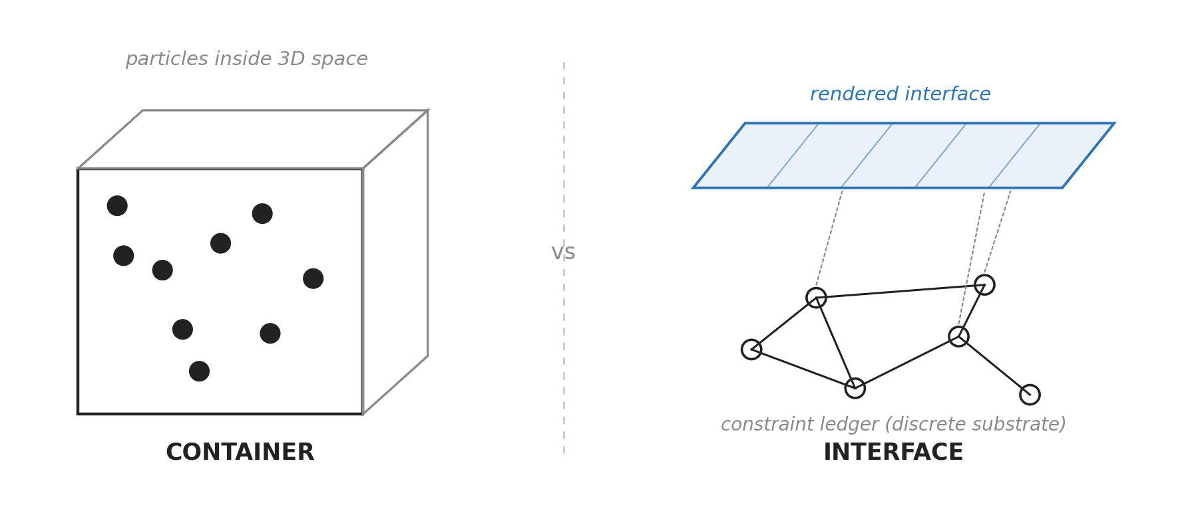
Figure 1. Two ontologies: spacetime as a container versus spacetime as a local readout of a discrete substrate.
The Ledger Beneath the Interface
Start with the substrate. EIM proposes that the base layer of reality is not smooth space but a discrete constraint ledger: a network of relationships recording what is locally consistent with what. Three operations run on it.
Execution is the local update — a single binary commitment, the smallest “this, not that” the system can make.
Interaction is relational possibility — the structure of what could be registered, the field of available distinctions before any one of them is fixed.
Memory is accumulated constraint — the topological debt left by every commitment already made. Memory is what makes the present expensive: it is the weight of consistency the next update must honor.
The claim is not that these three are exotic new forces. It is that they are the grammar of any system that updates itself under constraint. Spacetime, objects, and forces are what that grammar looks like when it is read out locally.
The ledger is not the screen. The screen is the rendered interface. We live inside the interface.
The Observer Is Not a Mind
The word “observer” has done more damage to public understanding of quantum mechanics than any other. It smuggles in a ghost — a conscious watcher whose attention collapses reality.
EIM discards the ghost. An observer, here, is any localized registering subsystem: a read/write operation, a constraint-resolving interface, a small local process forced to convert relational possibility into a definite update. A photographic grain is an observer. A molecule is an observer. So, incidentally, is a person — but only because a person contains a great many such operations, not because consciousness is doing anything special.
The observer is not a ghost in the machine. It is the machine’s local write operation.
Put plainly: an observer takes the Interaction field, weighs it against accumulated Memory, and commits the next Execution.
$I + M → E$
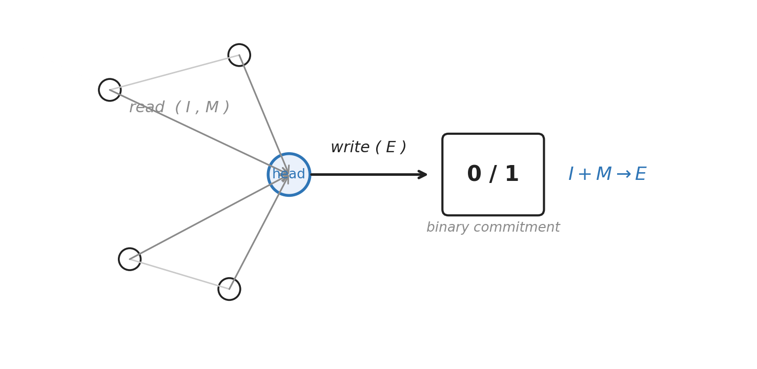
Figure 2. In EIM, the observer is a registering operation — a local read/write head — not a biological mind.
Nothing mystical happens at this step. A distinction that was open becomes closed. The “collapse” that sounds so dramatic is, on this reading, just the interface writing a value it did not previously hold.
Entanglement as Shared Ledger Structure
Now the famous one. Two entangled particles, separated by a room or a galaxy, produce correlated outcomes that no signal travelling between them could explain. Einstein called it spooky action at a distance, and meant it as an insult.
The spookiness depends entirely on taking the rendered distance as fundamental. If the 3D gap between the particles is the deepest fact about them, then their coordination demands a messenger, and no messenger is fast enough.
EIM offers a different picture. The two particles are not two independent objects exchanging notes. They are two projected endpoints of a single constraint seam in the substrate — one underlying relationship, displayed at two places on the interface. The correlation is not transmitted across the gap; the gap is a feature of the readout, not of the thing being read.
The analogy that lands: two icons can sit at opposite corners of a screen while pointing to the same object in memory. Updating that object does not require a signal to crawl across the pixels between them. The pixels were never where the object lived.
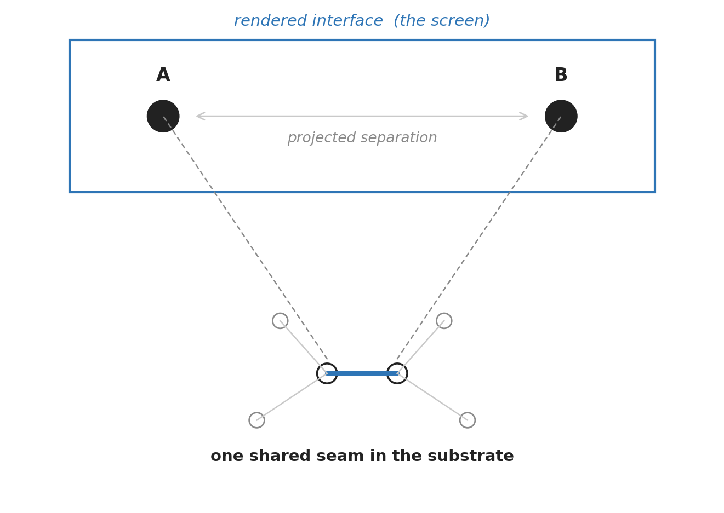
Figure 3. Projected separation need not imply substrate separation: two endpoints, one shared seam.
A discipline note belongs here, because this is exactly where enthusiasm outruns rigor. This is an interpretive reframing of why nonlocal correlations need not be pictured as little messages crossing space. It is not a proof; it posits no hidden variables; it grants no faster-than-light signalling. Bell’s theorem still constrains what any such picture may do, and EIM has to live inside those constraints like everyone else. What changes is the mental image, not the mathematics.
Spin-½ and the Hint That the Base Layer Isn’t Ordinary 3D
Here is a fact that ought to be more unsettling than it usually is. Rotate an electron a full 360 degrees and it does not return to its original state — it returns inverted. You have to turn it all the way around again, a full 720 degrees, before it truly looks the same.
If you picture the electron as a tiny ball sitting in ordinary space, this is nonsense. Balls come back after one turn. But spin-½ systems are not balls, and their double-turn signature is one of the most direct experimental hints we have that the underlying geometry carries covering or projective structure — that the smooth 3D picture is a shadow of something with more folds in it.
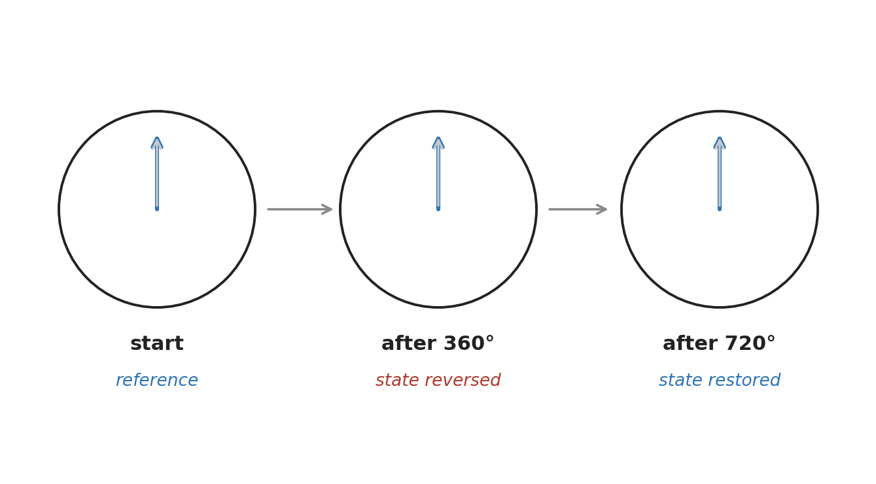
Figure 4. Spinorial behavior already warns against a naive 3D object ontology: one turn inverts, two turns restore.
EIM reads this as a clue rather than a coincidence. Spin-½ is one of the places where nature already warns us that naive 3D object-intuition is not the right ontology. A substrate that renders 3D as a projection would naturally carry exactly this kind of two-to-one structure. The framework does not prove this; it points out that physics noticed the seam first.
Black Holes as Local Projection Failure
Every interface has a region where it breaks down, and for spacetime that region is the black hole. The standard description — singularity, horizon, an information paradox that has resisted half a century of effort — is the language of an interface pushed past its limits.
EIM proposes reading the black hole not as a hole in space but as a local saturation regulator. As accumulated Memory — coordination debt — approaches its cap in some region, the local interface can no longer continue ordinary extrusion: it cannot keep rendering smooth space there. The horizon is the boundary where the projection quarantines the saturated region. Not a tear in the fabric; a buffer limit. A crash boundary with a fence around it.
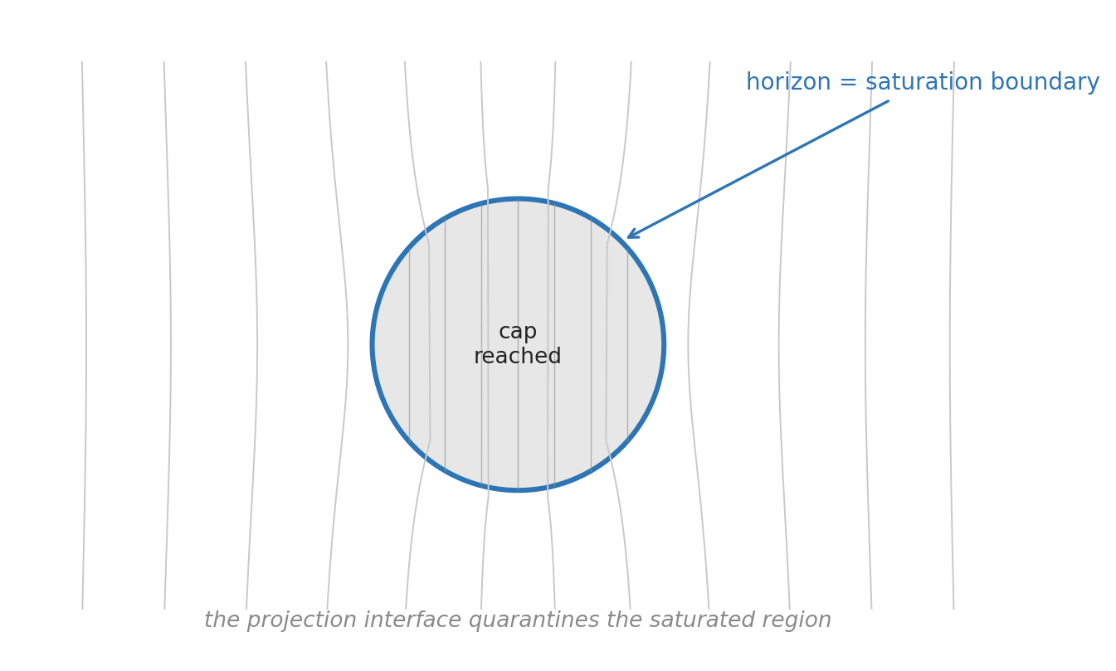
Figure 5. Black holes as local saturation regulators: where the projection interface hits a cap and quarantines the region.
This is a metaphor with a candidate mechanism attached, and it should be held as exactly that. EIM does not solve black-hole thermodynamics, and it does not resolve the information paradox. The honest claim is narrower and, I think, more interesting: horizons are where the projection interface hits a saturation limit — a reframing that suggests where to look, not what the answer is.
Gravity as a Projection-Level Effect
A natural objection arrives here: gravity works. General relativity is among the most precisely confirmed theories in science, and any framework that waves it away is dead on arrival.
EIM does not wave it away. It accepts every equation and asks a different question: is gravity fundamental, or is it emergent — an effective description of how local readouts respond to accumulated Memory and constraint gradients? On this view, forces are not illusions; they are the costs of updating the ledger, felt from inside the interface as pull and resistance.
This is less heretical than it sounds. The idea that gravity might be emergent or thermodynamic rather than fundamental has a serious research lineage of its own. EIM’s contribution is not the emergence claim itself but a specific candidate for what is emerging from what: spacetime dynamics from constraint-ledger bookkeeping.
Why This Matters
The point of all this is not to discard physics. The equations stay. The point is to change the ontology underneath the equations — the story about what the symbols are symbols of.
Standard physics describes reality from inside the rendered interface, with extraordinary success. EIM asks the complementary question: what kind of substrate would make that interface behave exactly this way — including the parts that look weird?
Physics may not be wrong. The interface may be incomplete.
If that reframing is even partly right, the catalog of quantum strangeness reads differently. Superposition, the observer effect, entanglement, spinors, horizons — they stop looking like nature being irrational and start looking like translation artifacts between a discrete substrate and the smooth interface it renders.
Closing
None of this is settled, and the next section says so in plain terms. But the reframing earns its keep by making familiar anomalies look less like miracles and more like the predictable behavior of a system seen through its own readout.
If spacetime is the interface, then quantum mechanics is not the universe being irrational. It is the interface showing us where the hardware begins.
Sidebar — on the substrate. The discrete structure EIM works with is not generic. It is a specific topological object with a high degree of symmetry, chosen because its structure reproduces a number of features the framework needs. Those details belong to the technical papers; this essay deliberately leaves them in the toolbox, because the ontological argument stands or falls on its own terms.
What This Essay Claims — and Does Not
This essay does not claim that EIM replaces quantum mechanics, derives the Standard Model, proves spacetime is fake, solves quantum gravity, resolves black-hole information loss, or constitutes a completed empirical theory. None of those is on the table here.
It claims one thing: that EIM offers a coherent ontology in which quantum weirdness, observer effects, spinorial behavior, entanglement, and horizons look like projection and readout phenomena arising from a deeper discrete constraint structure. That is an interpretive proposal — a way of organizing the puzzles — and it is offered as such, to be argued with rather than believed.

Suggested LinkedIn intro (≈130 words)
Most explanations of quantum mechanics start by assuming space is a container, then act surprised when reality refuses to behave like one. I’ve been developing the EIM framework, which tries the opposite move: treat 3D spacetime as a rendered interface — a local readout — and the deeper layer as a discrete constraint ledger underneath.
It’s an interpretive proposal, not a claim to have solved physics. But under that one reframing, several of the field’s most stubborn puzzles — entanglement, the observer effect, spin-½, black-hole horizons — start to look less like nature being irrational and more like translation artifacts between a substrate and its interface.
New essay: “The Universe Is Not a Container.” Written to be read by skeptics. Pushback welcome.
Visual style notes (for layout)
Clinical / journal-safe: white background, black-and-gray line work, a single restrained blue accent (#2E75B6), clean sans-serif labels. No cosmic fantasy art, no glowing wormholes, no psychedelic spacetime grids. The five figures above are supplied in this style and can be used as-is or redrawn to house brand.

