Infinity as Projected Closure
A Modal-Algebraic Bridge from Number to Physical Law under EIM
Thomas P. Connelly Jr.
GCAS College Dublin
ORCID 0009-0006-8267-1378
Draft, May 2026
Abstract
We propose an inversion of the customary order of foundational explanation. In the standard setting, infinity is treated as primitive—a feature of the number line, the continuum, or the manifold—and any closure relations are imposed afterwards. We argue that this gets the structural order backward. Closure is generative; infinity is what closure looks like when projected. We develop this thesis through a graded account of operational distinction: from no distinction (0), to first distinction (1, Execution), to relation (2, Interaction), to retained distinction (3, the Execution–Interaction–Memory triad), to the operational presuppositions of variability. The natural number line, on this reading, is not a primitive backdrop but the one-dimensional projection of accumulated distinction. The prime subline is infinite in extension yet closed under an irreducibility rule, providing a clean arithmetic exemplar of the slogan that an unbounded extension can issue from a closed generative grammar. We then suggest, as a conceptual proposition rather than a theorem, that the minimal closed orientation surface implicit in distinction is the 2-sphere—‘the line does not contain the sphere; the sphere casts the line.’ Variables are recovered as late-stage bookkeeping coordinates for finite actualization under retained constraint, and general relativity is contextualized as the smooth geometric projection of coordination closure rather than as primitive geometry. The paper is conceptual architecture for the EIM (Execution–Interaction–Memory) program, not an empirical predictions paper; we are explicit about what is theorem, what is proof sketch, what is conjecture, and what is interpretation.
Keywords: foundations of arithmetic; modal structure; primes; closure; projection; emergent geometry; general relativity; EIM framework; philosophy of physics.

1. Introduction: The Linear Projection Error
Foundational work in physics customarily begins by positing variables and then asking what laws those variables satisfy. Time is a real number; a particle’s position is a real-valued function of time; a field is a section of some bundle over a real manifold. The mathematical scaffolding is taken for granted, and the philosophical question of what permits there to be variables in the first place is generally treated as a problem for some other discipline. The same posture extends to the number line itself: ℕ, ℤ, ℝ are background, while the active questions concern what happens on or above them.
This paper argues that the order of explanation is inverted. The natural number line is not a primitive backdrop. It is a one-dimensional projection of something more fundamental: retained distinction. Counting from one to two requires that the first distinction persist while the second is being executed. Without that persistence, there is no ‘two,’ only repeated firstness. Arithmetic, on this reading, is already post-modal in an operational sense. The variables of physics—late objects in this hierarchy—presuppose a still richer structure: events, finite propagation, records, comparability, and boundaries.
If this picture is right, then the appearance of infinity throughout mathematics is misleading in a specific way. Infinity is treated as an absence: an unbounded extension, an open horizon, the lack of a final term. The thesis of the present paper is that this is a category error. The infinity that matters operationally is the unbounded extension of closed generative grammars. The prime numbers furnish the cleanest arithmetic illustration: ℙ ⊂ ℕ is infinite in extension—Euclid—yet membership is fixed by a closed irreducibility condition. The unbounded reach of the primes is therefore not the negation of closure but its image under projection.
We propose to take this seriously as a foundational principle. The slogan is:
Infinity is not the absence of closure. Infinity is what closure looks like when projected.
The project this paper opens is to articulate the grammar of closure that does the projecting. The framework we use is EIM—Execution, Interaction, Memory—whose technical apparatus is developed elsewhere. Here we restrict ourselves to the conceptual architecture: the path from operational nullity through distinction, relation, retention, and variable-readiness, and the resulting reframing of the number line, the continuum, and ultimately the smooth geometry of general relativity.
What this paper does not do is equally important. It does not derive specific physical predictions; the dissertation and the framework manuscript handle that work. It does not present S² as a mathematical theorem—we present it as a conceptual proposition under a stated reading. It does not assert that Planck-scale phenomena establish a literal minimum length; it speaks only of the operational breakdown of independent variation at small scales. And it does not argue that small natural numbers ‘0, 1, 2, 3, 5’ are special because they recur. It argues, more carefully, that these values mark minimal structural thresholds for distinct operational roles.
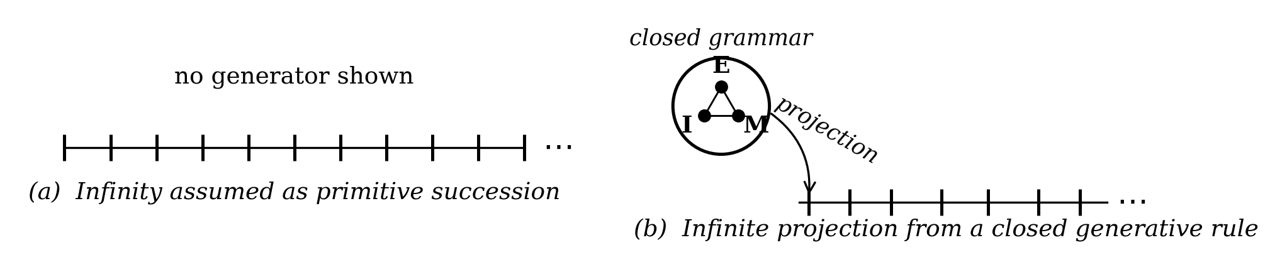
Figure 1. Closure first; projection second. On the left, succession is presented without a generator: the marks accumulate from nowhere. On the right, a closed generative rule (here suggested by the modal triad E, I, M) projects to an unbounded sequence. The conceptual claim of the paper is that operationally meaningful infinities have the structure of (b), not of (a).

2. From Nullity to Distinction
We begin before counting. Let operational distinction denote the existence of any difference that admits a downstream consequence: a difference that, in some accessible sense, can be acted upon, recorded, or compared. We do not yet have variables, units, or any commitment to ordinality. We have only the question of whether a difference is in operational play.
Call the regime in which no operational distinction obtains nullity, and label it 0. We resist the temptation to call this ‘the number zero,’ because no number system is yet available. The 0 here is structural: it names the absence of operational role, not the value of an arithmetic identity. In a strictly nullitous regime, no question of ‘how many’ is well posed, because counting requires the very distinctions that nullity withholds.
The first nontrivial threshold is the appearance of a single operational distinction. Label this 1. We identify 1 with Execution in the EIM sense: an event that produces a difference. Whatever is now distinguished from what was not previously distinguished marks the minimal nontrivial structure. With a single Execution we have firstness—a thing—but no relation between things; relation requires two relata.
Two operational distinctions enable relation, polarity, and comparability. Label this 2 and identify it with Interaction. Once two distinctions are simultaneously available, the structural questions are: are they ordered, are they similar, are they coupled, are they disjoint? It is here that the most primitive relational vocabulary becomes possible. But the structure is still memoryless. Two distinctions in pure simultaneity admit relation; they do not admit succession.
The third threshold is more delicate. Label it 3 and identify it with the persistent triad Execution – Interaction – Memory. Memory adds the structural feature that an earlier distinction can be preserved across the executions that follow it. With Memory in play, succession—not merely relation—becomes coherent. Without Memory, every ‘next’ is a new firstness, and the structure cannot accumulate.
We will treat the EIM triad as a thesis-conditional minimum: under the EIM framework, three operational roles—event, relation, retention—are the smallest set sufficient for a structure that can both act and persist. Other organizations of the same modal content are conceivable; what matters here is the structural fact of finite triadic closure, not the choice of the number 3 as a piece of numerology. The paper makes no claim that 3 is unique by mathematical theorem.
A further threshold appears once we ask what is required for there to be a variable in the sense ordinarily used in physical theory. We argue in §7 that variability in this technical sense requires five operational presuppositions: events, finite propagation, retention, comparability, and boundary conditions. We label this aggregate threshold 5 and emphasize, in keeping with the warning in §1, that 5 is the cardinality of a finite list rather than a magic number. A coarser organization would yield fewer; a finer one would yield more. The structural point is finiteness.
Figure 2 shows this ladder. We caution that we are not arguing that small natural numbers recur in the world because they are mystical. We are arguing the opposite: that certain small values mark minimal cardinalities of distinct operational roles, and so they appear at the boundaries between modal regimes. The recurrence is structural, not magical.
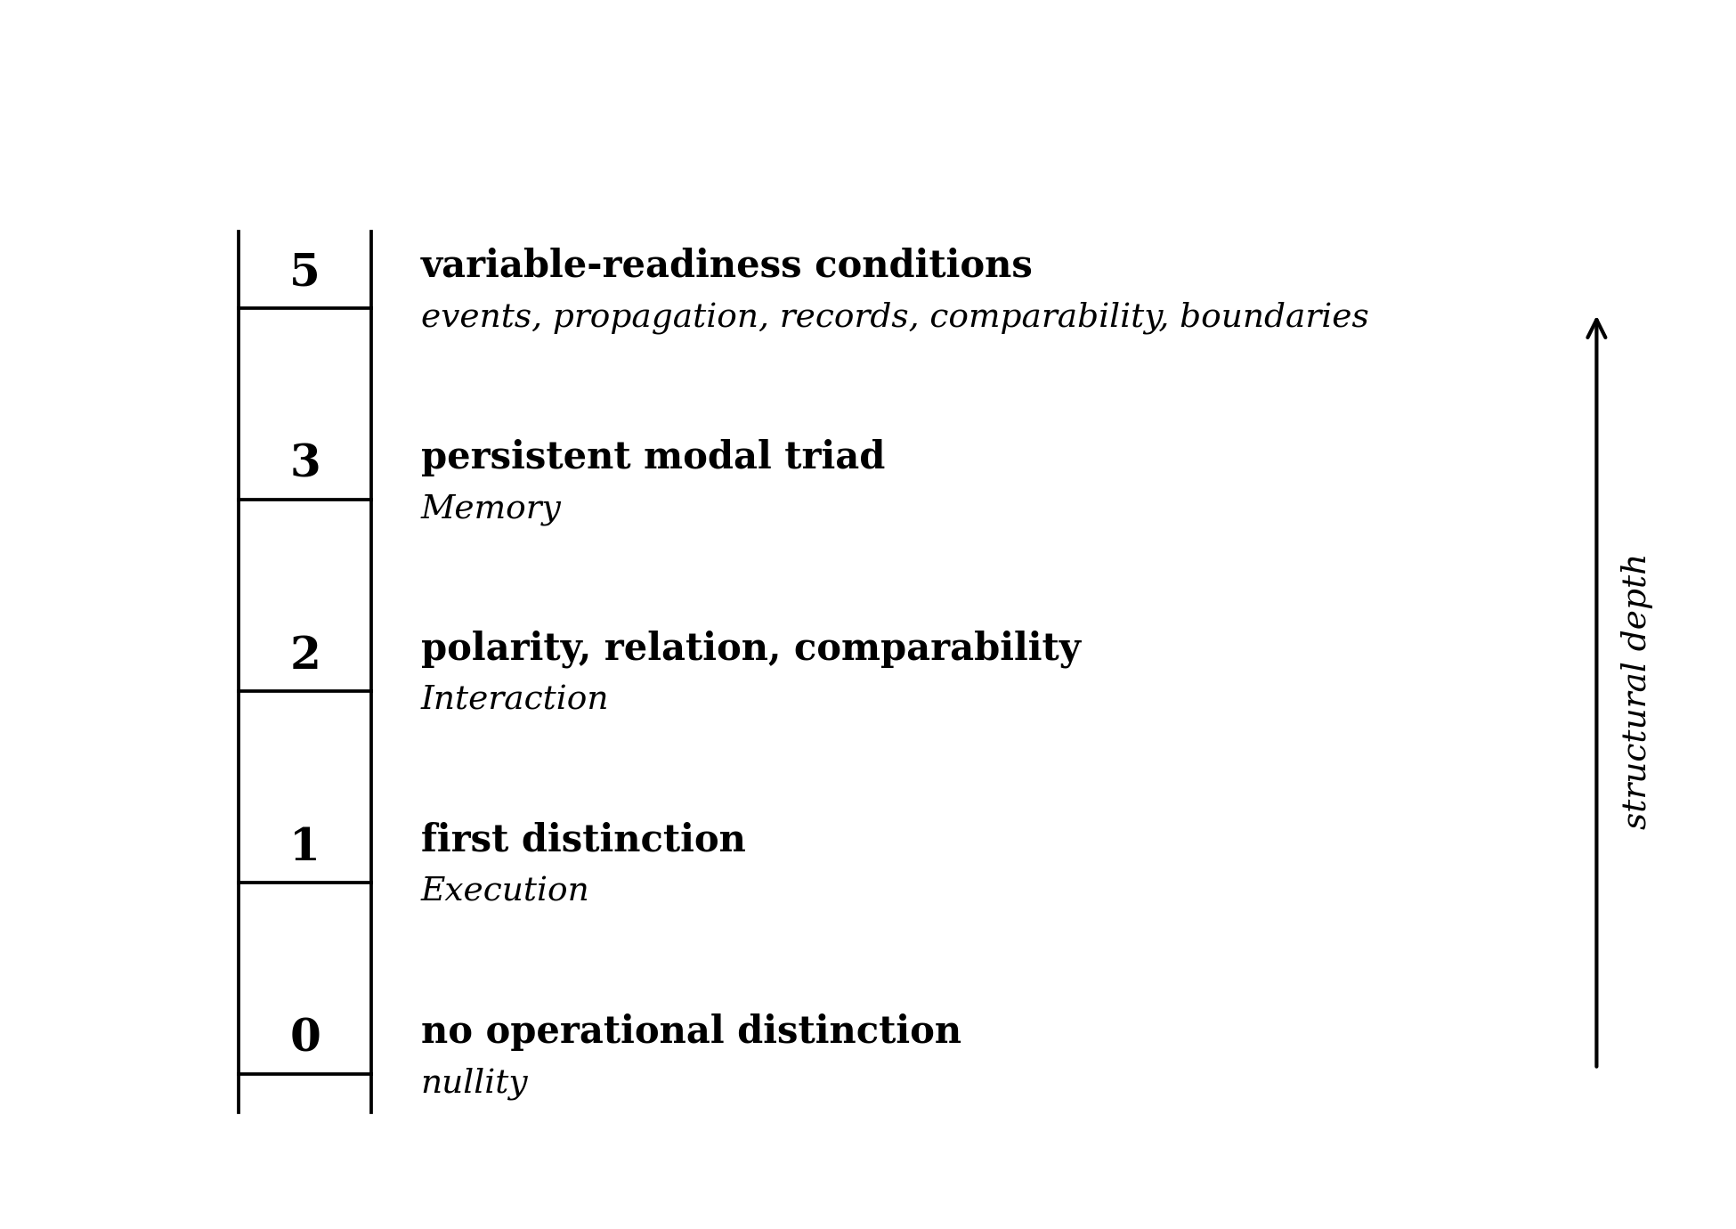
Figure 2. From 0 to variable-readiness. Five structural thresholds, labeled by the minimal cardinality required for the corresponding operational role. The ladder is conditional on the EIM thesis: under that thesis, no role at level k is well posed without all the roles below it. The labels are not numerical magnitudes; they are minimum cardinalities of distinct operational roles.

3. Counting Requires Memory
We now make the structural claim about arithmetic precise. The aim is modest: not to dispute Peano, Dedekind, Frege, or any mathematical formalization of the natural numbers, but to identify the operational presupposition any such formalization quietly relies upon.
Proposition 1 (Counting requires retained distinction). Any operational procedure that produces, as output, a sequence of distinct enumerative tokens whose order is structurally meaningful presupposes that earlier tokens remain accessible while later ones are produced.
Proof sketch. Suppose the contrary: that an enumerative procedure produces token n+1 in a state in which token n is no longer accessible in any sense (no record, no trace, no recoverable mark). Then n+1 cannot be distinguished from a fresh firstness; the apparatus has nothing against which to measure that the new token is the next rather than the same. Order, in particular, has no operational referent. The sequence produced is not a count of n+1 distinct items but a recurrence of token-of-firstness. The hypothesis that we have an enumerative procedure with structurally meaningful order therefore fails. Hence the procedure presupposes retention. □
Several remarks are in order. First, the proposition concerns operational counting, not the mathematical structure of ℕ as an abstract object. The set ℕ remains well defined in any standard set-theoretic foundation regardless of whether anyone is in fact counting. Second, the retention required is minimal: any mark that lets the apparatus discriminate ‘already produced’ from ‘not yet produced’ is enough. Third, this minimal retention is precisely what we have identified with Memory in §2. Hence the slogan: counting is impossible in a memoryless universe.
The historical literature on the foundations of arithmetic does not contradict this point; it generally avoids it. Frege took Number to be a logical object identified with an extension of a concept (Frege, 1884); Dedekind took the natural numbers to be the simply infinite system characterized by a successor function (Dedekind, 1888); Peano gave axioms in which a successor map is primitive (Peano, 1889). In all three frameworks, the successor relation is given. What the present proposition isolates is the operational cost of the successor relation: any apparatus that instantiates successor must retain its previous output. The mathematical existence of the successor function and the operational possibility of using one are different things, and the latter is what the EIM framework is interested in.
A direct corollary follows. If counting requires Memory, and arithmetic on the natural numbers is grounded in counting, then arithmetic—understood operationally—is post-modal. The natural number line is not the floor of mathematical structure. It is the first structured projection of accumulated distinction onto a one-dimensional axis.
$ℕ = π₁ (accumulated distinction under retained constraint)$
Here π₁ names the projection of structured modal content onto a single axis of cardinality. The expression is schematic; the technical content of π₁ is part of the EIM framework manuscript and is not developed in this paper. What we want here is the conceptual orientation: ℕ is a derived object, not a primitive one.

4. The Prime Line: Infinite Extension, Closed Rule
The clearest arithmetic illustration of the inversion proposed in this paper is the prime subline. Define
$ℙ = \{ p ∈ ℕ : p ≥ 2 and p has no divisors other than 1 and p \}.$
By Euclid’s theorem, ℙ is infinite. By the fundamental theorem of arithmetic, every n ≥ 2 has a unique factorization into elements of ℙ. The composites are therefore decomposable; the primes are irreducible. The prime line is the number line with redundancy removed.
Proposition 2 (Infinite extension does not imply open generative grammar). There exist subsets of ℕ that are unbounded in extension yet defined by a closed admissibility condition.
Proof sketch. ℙ is such a subset. The admissibility condition for membership in ℙ—irreducibility under multiplication—is a closed predicate in the language of ℕ. The unboundedness of ℙ is Euclid. The conjunction is the proposition. □
Two clarifications matter. First, the term ‘closed’ here means closed under the relevant operational rule, not topologically closed. The rule ‘is irreducible’ is a finite, decidable predicate for any candidate. Second, the distribution of primes within ℕ is not periodic, not uniform, and not generated by simple linear succession; it is, however, structured. Avoiding the loose word ‘irrational,’ we describe the distribution as non-periodic, sparse, irreducible, and not produced by linear iteration. The point of this section is not to make a claim about the distribution itself but to record that infinite extension and closed admissibility are perfectly compatible.
Why does this matter for the paper’s thesis? Because primes furnish a fully rigorous, fully arithmetic example of the inversion we propose for physics. There is no mystery about the primes’ generative rule; there is no mystery about the primes’ unbounded extension. The slogan that closure projects to infinity is, in this domain, a theorem. The paper’s thesis is that an analogous structural pattern obtains at deeper foundations: that the apparent infinity of the continuum, the unbounded extension of the time axis, and the smooth manifold of general relativity are themselves projections of closed modal structure—not theorems in our hands, but conceptual propositions to be developed.
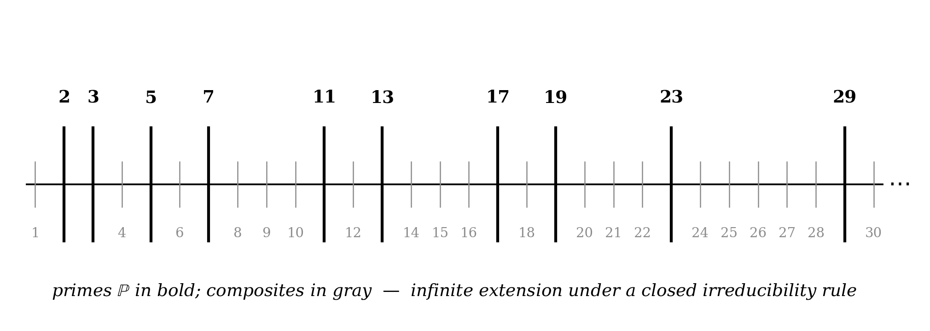
Figure 3. The prime line: infinite extension, closed rule. Primes (in bold) are irreducible elements; composites (in gray) are decomposable products. The prime subline is unbounded in extension yet closed under an admissibility rule. It is the cleanest arithmetic instance of the present paper’s inversion: a closed generative grammar projecting to an infinite sequence.

5. Infinity as Projected Closure
We now state the central thesis of the paper as carefully as the evidence allows.
Operationally meaningful infinities are projections of closed generative grammars.
Three clarifications are needed before this is defensible.
(i) Operational versus set-theoretic infinity. There is a clean distinction between infinities that arise from procedures and infinities that arise from set-theoretic constructions. The infinitude of ℙ is operational in our sense: a closed admissibility condition decides membership, and the extension is unbounded under iteration of the rule. The cardinality of the real line, by contrast, is set-theoretic: ℝ is uncountable, and no closed generative grammar in any obvious sense exhausts it. The thesis above is restricted to operational infinities. We do not claim that every infinity in mathematics is the projection of a closed grammar; we claim that the infinities that play a role in operational physics—those reachable through procedure, observation, or finite specification—have this structure.
(ii) Closure is not finiteness. By ‘closed grammar’ we do not mean a finite set of elements; we mean a finite set of admissibility rules. The Peano axioms are closed in our sense, and they generate ℕ. The irreducibility predicate is closed in our sense, and it generates ℙ. The contrast is not between finite and infinite extension—closure is compatible with either—but between specifiable and unspecifiable rule structure.
(iii) Projection is not abstraction. By ‘projection’ we mean a structural map from a richer domain to a poorer one, in which the richer domain’s closure conditions appear, in the poorer domain, as patterns of extension. ℕ as a one-dimensional axis is poorer than the modal triad that produces it; what looks, on the axis, like unbounded extension is, in the triad, the unbounded reach of a closed generative rule. The infinite is not absent in the source; it is implicit. It is only the projection that makes it look like an external feature of the world.
Under these clarifications, the slogan can be promoted from rhetoric to a working principle. Where the standard view tells us ‘the world is infinite, and we hope to find some closure conditions on top of it,’ the present view tells us ‘the world is closed, and what we see is the projection.’ The methodological consequence is non-trivial: it directs research toward the generative grammar rather than toward a continuum on which we are perpetually adding boundary conditions.
There is a natural mathematical home for the operational notion of ‘closed grammar projecting to unbounded extension’: the recursively enumerable sets. A set S ⊆ ℕ is recursively enumerable when there is a finite, terminating procedure that, given any candidate, halts and answers ‘yes’ if the candidate belongs to S. The procedure is the closed grammar; the set it generates may be infinite. The primes are r.e.; the theorems of any consistent, recursively axiomatizable formal system are r.e.; the set of valid first-order proofs is r.e. Each of these is an infinitely extended, structurally meaningful object whose generative rule is closed and finite. We do not claim that physical infinity is the projection of a recursively enumerable set—the comparison is structural, not literal—but the analogy gives a precise mathematical referent for what we mean by ‘closure projects to infinity.’

6. Why S² Replaces the Line
If the natural number line is a one-dimensional projection of accumulated distinction, what is the structure prior to projection? In this section we offer a conceptual proposition; we do not claim a theorem.
Distinction in the operational sense is, we will argue, not merely cardinal but oriented. To distinguish A from B is not only to register that A and B are not the same; it is to register a side. Polarity is built in: the very act of separating one from the other selects a direction of separation. Once distinction generates orientation, the simplest closed structure that can support orientation in two-dimensional generality is a closed orientable surface.
Proposition 3 (Conceptual; minimal closed orientation surface). Under the modal reading in which distinction is intrinsically oriented, the minimal closed orientable two-surface is the 2-sphere $S^{2}$.
Justification. Among closed orientable surfaces, S² is the unique one of genus zero, the unique one that is simply connected, and the unique one with no nontrivial cycles. If the relevant structure is required to support orientation without committing to any further topological feature—no handles, no holes, no privileged loops—then S² is the minimum. We stress that this argument depends on a choice of category: closed, orientable, two-dimensional. The paper does not establish that those choices are themselves forced by the modal reading; we present them as natural under that reading and label the proposition conceptual rather than proven.
The line does not contain the sphere; the sphere casts the line.
This phrasing is meant literally in the structural sense. A line is a one-dimensional object selected from the surface by axis selection; it cannot, on its own, recover the full orientation structure that produced it. Conversely, the surface admits many lines as projections, none of which is privileged. Once one has accepted that distinction is oriented, one has accepted that linear succession is partial: it captures cardinal accumulation but not relational orientation.
This connects to standard differential geometry in a familiar way. S² is the unit sphere; angular coordinates parametrize it; great circles are its geodesics. None of that is novel. What we are proposing is the conceptual ordering: that the line as we know it in arithmetic and analysis is what one obtains by choosing an axis on a closed orientation surface, not what one obtains by stitching together undirected points. The geometry of the sphere is presupposed by the line in this reading, not assembled from it.
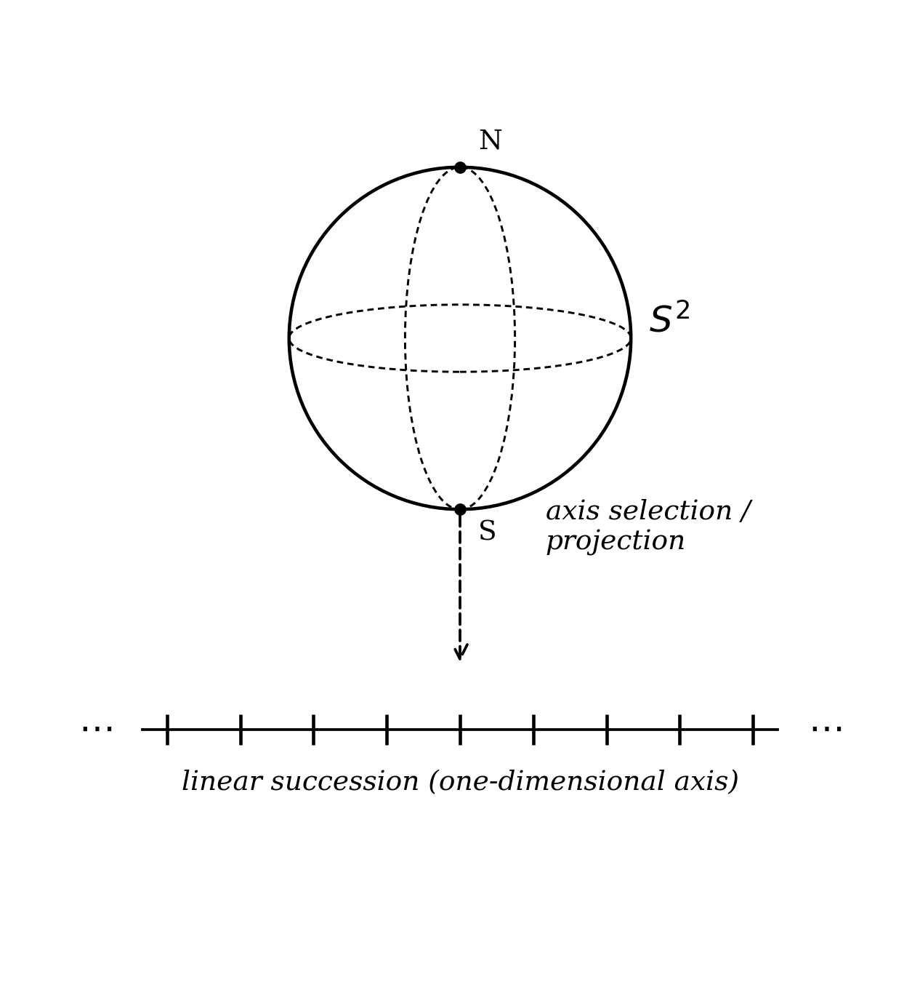
Figure 4. The line is cast by the sphere. Linear succession is recovered from the closed surface by axis selection. The conceptual ordering inverts the usual one: the line is a projection of the sphere, not a building block from which the sphere is assembled.

7. Variables as Late-Stage Objects
We have followed the operational ladder from nullity through distinction, relation, retention, and orientation. We now arrive at variables in the sense used in physical theory: time t, position x, field amplitude φ. What does it take for these to be in operational play?
Proposition 4 (Variables are post-modal objects). An operational variable in the standard physical sense presupposes (i) eventhood, (ii) finite propagation, (iii) retained record, (iv) comparability, and (v) boundary conditions. These five presuppositions are the operational consequences of the EIM modal triad together with the closure conditions required for variability.
Discussion. The five presuppositions are not independent posits; they are the smallest list we have found that closes the conditions for a variable in physical theory.
(i) Eventhood. There must be acts. Without Execution, no value of a variable can come into being; nothing happens that could be measured.
(ii) Finite propagation. There must be a structure that distinguishes here from there—coupling that is bounded in speed or reach. Without finite propagation, nothing is anywhere in particular; comparison degenerates.
(iii) Retained record. There must be Memory. A variable is what survives, not what flashes.
(iv) Comparability. There must be an ordering or metric that lets two values of the variable be related. Comparability is itself a closure condition: which differences count?
(v) Boundary conditions. There must be specifiable closure of the regime in which the variable is defined. Without boundaries, no problem is posed; without a posed problem, no variable is determinate.
We emphasize again that the cardinality 5 is not a magic number. A finer analysis would split (ii) into propagation and locality, or (v) into spatial and temporal boundary conditions; a coarser one would lump (iv) into (iii). The structural point is that a variable is not primitive: it carries with it a finite list of operational presuppositions, and the modal triad delivers exactly the structure on which those presuppositions can be satisfied. We thus reach a phrasing that we would defend without flinching:
Variables are bookkeeping coordinates for finite actualization under retained constraint.
On this view, asking ‘what equation does the variable t satisfy?’ already presupposes that an apparatus has met the five conditions. The standard practice is to begin with t and ask after the equation; the EIM framework asks how t comes to be available in the first place. The two practices are not in competition; they answer different questions.

8. From Modal Closure to Physical Law
If variables are late-stage projections, what is the status of physical law? The EIM framework offers a one-line summary: physical laws are the regularities exhibited by what survives Memory. We do not develop the technical machinery here; the EIM framework manuscript (Connelly, EIM framework manuscript) carries that load. We only stake the conceptual position.
The conceptual position has three parts.
First. Coordination at the modal level supplies the closure conditions. Execution generates events; Interaction couples them; Memory retains what otherwise would dissipate. The conjunction—a coordinated triad with closure conditions—is what we mean by retained constraint.
Second. Retained constraint projects onto variable-readiness. Once the operational presuppositions of §7 are satisfied, the apparatus admits variables; once it admits variables, it admits the asking of equations among them.
Third. Equations express what survives. A regularity that is invariant under the projection is a candidate physical law. The empirical adequacy of the law is the empirical adequacy of the projection at that scale.
This is not a derivation of physical law from modal grammar; it is a placement of physical law within a derivational order. The work of producing specific equations from EIM is done elsewhere. What we wish to establish here is that physical law is not floating free above an indifferent variable structure. The structure of the variables determines what kinds of laws can be expressed, and the structure of the variables is in turn determined by the modal grammar that supplied them.
A useful way to feel the force of this is to consider what ‘law’ means under the placement just stated. A regularity that did not survive Memory would not be a candidate physical law in the operational sense: nothing would track it, nothing would be measured against it, and no apparatus could be built to test it. Conversely, every regularity that does survive Memory is, by construction, available to the post-modal projection that yields variables. Physical law in this picture is therefore the set of regularities that the projection retains. This is why thermodynamic and information-theoretic readings of gravitational dynamics—Bekenstein, Hawking, Jacobson, Padmanabhan, Verlinde—are conceptually congenial to the EIM placement, even where they differ in detail. They share the suspicion that the equations of state we call laws are projections, not primitives.
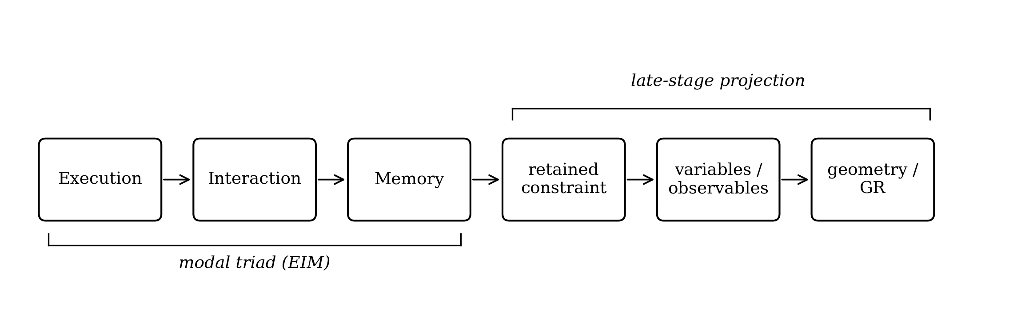
Figure 5. From EIM to physical description. Modal closure (Execution – Interaction – Memory) yields retained constraint, which in turn admits variables and observables, which in turn admit smooth geometric projection. The right end of the chain is what we recognize as physical theory; the left end is what supplies the conditions for there to be physical theory at all.

9. GR as Projected Coordination, Not Primitive Geometry
It would be a misreading of this paper to treat the EIM framework as anti-relativistic. General relativity is not rejected. It is contextualized.
In GR, spacetime is a smooth pseudo-Riemannian manifold; the metric satisfies Einstein’s equations, sourced by the stress-energy tensor of matter and radiation. The framework is empirically magnificent. The question is what it is a description of. Two answers are available. The traditional answer is that the metric is a primitive feature of the world, and matter is what propagates on it. The EIM answer is that the metric is the smooth limit of coordination closure: spacetime geometry is what the modal triad looks like once retained constraint has admitted variables continuous enough to support a manifold structure.
Connections to existing programs are immediate. Jacobson (Jacobson, 1995) derived the Einstein equations from local Clausius relations across causal horizons, suggesting that the equations are equations of state for some underlying microstructure rather than fundamental laws. Subsequent work by Padmanabhan, Verlinde, and others has extended the thermodynamic and information-theoretic readings. The EIM framework is consonant with this family of programs in spirit, though it differs in its particular grammar; we do not pursue the comparison here.
The slogan that compresses the position is:
GR is geometry after Memory becomes smooth.
Two consequences are worth flagging. First, the question of ‘what was there before the Big Bang’ acquires a new shape. ‘Before’ is a temporal predicate, and temporal predicates presuppose retained distinction. To ask what was there before the first distinction is to import post-distinction grammar into the pre-distinction domain. The question is not so much wrong as malformed. Second, horizons—event horizons in particular—become natural sites of structural interest, because they are precisely the regimes in which the smooth projection encounters its own closure conditions. The associated technical work is the subject of the dissertation (Connelly, The Black Hole as Dynamical Bridge); we mention it here only to indicate that the conceptual architecture of the present paper is intended to be cashed out in detailed physical content elsewhere, not left as slogan.
On the Planck scale, we deliberately speak with restraint. The combinations of fundamental constants known as the Planck length and Planck time are scales at which independent variation of the variables of current continuum physics is expected to break down. Whether they correspond to a literal minimum length is a separate question, on which neither this paper nor the EIM framework takes a strong position. What we do say is that, on the EIM reading, the breakdown of independent variation at small scales is the natural place to look for the seam between projection and closure.

10. Discussion: What This Paper Does and Does Not Prove
The thesis advanced here is bold but disciplined. We close by stating, as plainly as we can, what it does and does not establish.

10.1 What is established
Proposition 1 (Counting requires retained distinction) is, we believe, secure as an operational claim about the apparatus required to instantiate enumeration. It does not impugn the mathematical existence of ℕ; it only locates the operational cost of using ℕ. Proposition 2 (Infinite extension does not imply open generative grammar) is a theorem in elementary number theory once one has formalized ‘closed admissibility rule.’ Proposition 4 (Variables are post-modal objects) is a structural decomposition: it identifies a finite list of presuppositions any usable variable must inherit, and locates each presupposition within the EIM triad. None of these depends on unpublished detail.

10.2 What is conceptual
Proposition 3 (the minimality of S² as a closed orientation surface) is offered as a conceptual proposition under a stated reading. The mathematical content—S² has genus zero, is simply connected, has minimal Euler characteristic among closed orientable two-manifolds in the relevant sense—is standard. What is conceptual is the identification of ‘distinction is intrinsically oriented’ with a category-of-surfaces commitment; that identification is part of the EIM thesis, not a free-standing geometric theorem. The slogan that GR is the smooth limit of coordination closure is, similarly, a conceptual placement; the technical machinery that would convert it into a theorem is reserved for the dissertation.

10.3 What this paper does not claim
To prevent overreach, we list explicitly the claims this paper does not make.
(a) We do not claim that the natural numbers fail to exist absent physical instantiation. The set-theoretic existence of ℕ is independent of the operational apparatus that uses it. We claim only that operational counting requires retained distinction.
(b) We do not claim that small natural numbers are physically privileged because they recur. We claim that 0, 1, 2, 3, and 5 mark minimal cardinalities of distinct operational roles under the EIM thesis, and that the recurrence is structural.
(c) We do not claim that S² is forced by mathematical theorem. We claim it is the minimal closed orientable two-surface under the modal reading.
(d) We do not claim that the Planck length is a literal smallest length. We claim it is the operational scale at which independent variation of current continuum variables breaks down.
(e) We do not claim that primes physically generate spacetime. The prime line serves as an arithmetic exemplar of unbounded extension under closed admissibility, and we propose that a structurally analogous pattern obtains in physics; the analogy is not a derivation.
(f) We do not claim a derivation of general relativity. We claim a placement of GR within a derivational order, and we cite ongoing work that aims to make the placement precise.

10.4 Falsifiability
This paper is conceptual architecture and does not, by itself, generate falsifiable predictions. Falsifiability of the broader EIM program rests on the technical sequels: the dissertation’s predictions concerning the dodecahedral backbone, the neutrino mass, the Weinberg angle, and the binary-black-hole regime, which can be tested against current and forthcoming data. We mention this only to indicate that the absence of direct empirical content in the present paper is structural, not evasive.

11. Conclusion
We have argued for an inversion of foundational order. Closure first; infinity as projection. The natural number line is a one-dimensional projection of accumulated distinction. The prime subline is the cleanest arithmetic illustration: infinite in extension, closed under irreducibility. The minimal closed orientation surface implicit in distinction is, we propose, S²; the line does not contain the sphere, the sphere casts the line. Variables are bookkeeping coordinates for finite actualization under retained constraint, and general relativity is the smooth geometric projection of coordination closure rather than primitive geometry.
If the inversion is right, the question of foundations changes shape. We no longer ask which equations the world obeys on top of an indifferent continuum. We ask what generative grammar is doing the projecting, and what closure conditions yield the regularities we observe. The EIM framework offers one such grammar, with an Execution–Interaction–Memory triad as its modal core. Whether it is the right grammar is an empirical question; the present paper aims only to establish that it is the right kind of question.
Closure is generative; projection is infinite.

References
Connelly, T. P. Jr. (in preparation). The Black Hole as Dynamical Bridge. Doctoral dissertation, GCAS College Dublin.
Connelly, T. P. Jr. (in preparation). EIM framework manuscript: Execution, Interaction, Memory as the modal triad of physical description.
Dedekind, R. (1888). Was sind und was sollen die Zahlen? Vieweg, Braunschweig. English translation: “The Nature and Meaning of Numbers,” in Essays on the Theory of Numbers, Open Court, 1901.
Einstein, A. (1916). Die Grundlage der allgemeinen Relativitätstheorie. Annalen der Physik 49, 769–822.
Euclid (c. 300 BCE). Elements, Book IX, Proposition 20. The number of primes is greater than any assigned multitude.
Frege, G. (1884). Die Grundlagen der Arithmetik. W. Koebner, Breslau. English translation by J. L. Austin: The Foundations of Arithmetic, Blackwell, 1950.
Jacobson, T. (1995). Thermodynamics of spacetime: The Einstein equation of state. Physical Review Letters 75, 1260–1263.
Padmanabhan, T. (2010). Thermodynamical aspects of gravity: New insights. Reports on Progress in Physics 73, 046901.
Peano, G. (1889). Arithmetices Principia, Nova Methodo Exposita. Bocca, Turin.
Riemann, B. (1854). Ueber die Hypothesen, welche der Geometrie zu Grunde liegen. Habilitationsvortrag, Göttingen. Published 1868 in Abhandlungen der Königlichen Gesellschaft der Wissenschaften zu Göttingen 13.
Rovelli, C. (2018). The Order of Time. Riverhead Books, New York.
Verlinde, E. (2011). On the origin of gravity and the laws of Newton. Journal of High Energy Physics 2011(4), 29.
Wheeler, J. A. (1990). Information, physics, quantum: The search for links. In Complexity, Entropy, and the Physics of Information, ed. W. H. Zurek, Addison-Wesley.

