Eldo Accessibility Statement

A cream coloured static caravan a ramp



**Parking and Access.**

On arrival you will find a dedicated parking space to the right hand side, when viewed from the front, that is suitable for most WAV's.

Access is via a 1m wide ramp towards the rear at all caravan,  at the top is the entrance to the caravan and the wrap around terrace. Entry to the accommodation is through a 1 and 1/2 width side door (1.4m/140cm wide), and we also provide a threshold ramp that is stored just inside the main entrance.

**Level Access Throughout**

There is smooth, level access throughout, with vinyl fitted to the lounge and kitchen area, a very low pile carpet to both bedrooms and a non-slip moulded floor in the wet room.

**Internal Doors**

All internal doors are sliding doors, with a maximum opening width of 0.75m/75cm.

**Master Bedroom**

The master bedrooms are larger than you would normally find in a static caravan with a single profiling bed (internal length 1.8m/180cm/6 foot), with easily removable bed sides and bumpers fitted. There is also standard double bed 1.98m/198cm/6 foot 6 inches long and 1.37m/137cm/4 foot 6 inches wide. The flooring is low pile carpet.

There are 2 double wardrobes, and 2 USB charging points.

There is also a full room coverage overhead track hoist system with in rail charging (no need to position boom or place controller into a holster).

This room is easily reconfigured to give best access to meet your specific requirements.

All Bed linen is provided, but not towels and tea towels.

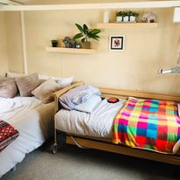

**Second Bedroom**

This contains 2 full size single beds, but there is insufficient access for a wheelchair user into this room. The flooring is low pile carpet.

**Wet Room**

For bathing there is a large wet room – approx. 2m by 2m

Thermostatic controlled "super powerful" shower with extra long hose.

Wheel in shower chair with lap belt. Note that

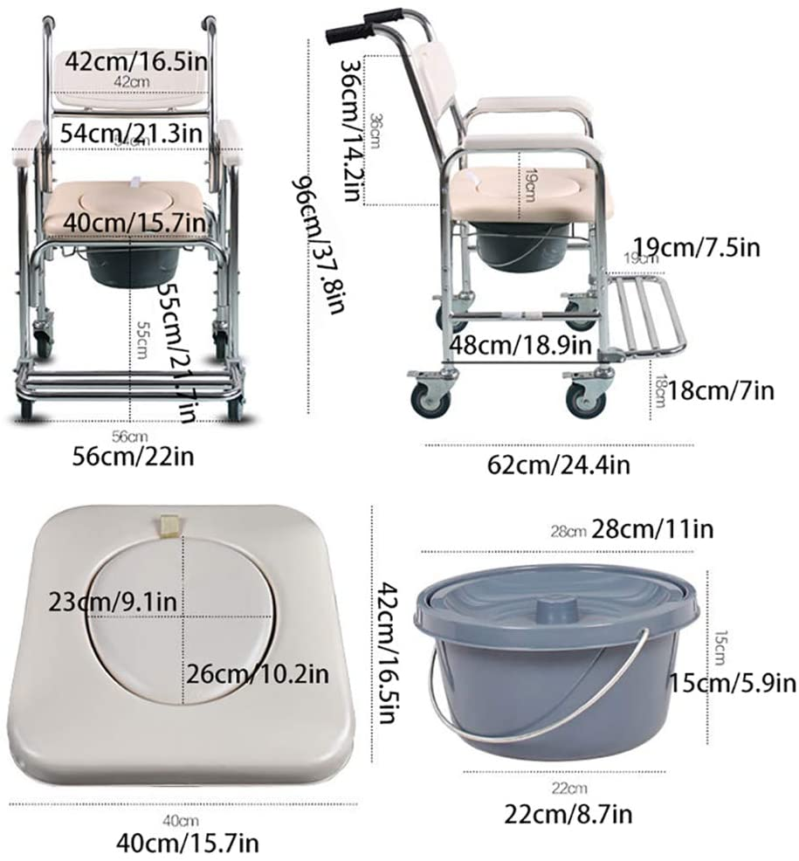

There are fixed hand rails in the shower area, and by the sink, with 1 fixed and one drop down rail by the toilet.

The toilet seat is of the raised variety and sits 0.5m/50cm/1 foot 8 inches from the floor and as a result the commode chair **cannot**  be wheeled over it.

**Kitchen**

Please note that although the kitchen can be accessed easily by a wheelchair, the units are standard height for use by an able-bodied person. Th e floor is lid with vinyl.

Accessories provided include...

Microwave

Kettle

Gas oven and hob

Toaster

Slow cooker

Toastie maker

Hand blender

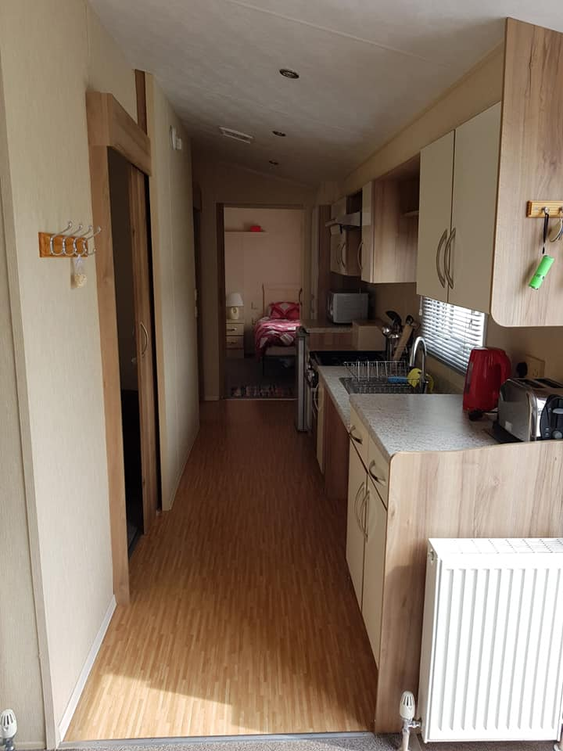

**Lounge / Dining area**

The dining room / living area is open plan with low pile carpet flooring.

32 inch TV, DVD player, Bluetooth speaker and DAB radio.

2 seat sofa bed and a second 2 seat sofa.

Dining table with 1 x 2 seater bench seat, 2 dining chairs, 2 foor stools and a wing back chair (0.5m/50cm/1 foot 8 inches from the floor).

**Outside Storage box**

This houses the Oxford Midi 170 Hydraulic mobile hoist and beach wheelchair suitable for a child or small adult up to 65 Kg in weight.

We also have a size 1 and Size 2 Firefly /Goto seat for use in the beach wheelchair or around the caravan

Rotary Washing Line

It can be, and has been, used for storing specialist breathing equipment and oxygen tanks, all sites are happy to receive on your behalf at reception ready for when you arrive.

A yellow beach wheelchair with grey wheels outside storage box.


**Public Transport**

If arriving by public transport,The distance between Highbridge and Burnham Station and Burnham-on-Sea is 2 miles.  The number 21 bus runs every 10 minutes with a stop just outside the site on Marine Drive and takes around 10 minutes.

**Beach Access**

At Burnham on Sea the prom can be reached from the rear entrance to the site in less than 10 minutes and a further 10 minute walk takes you to a jetty with easy access on to the beach.

**On Site Accessibility**

Burnham on Sea Holiday village is a fairly flat site which generally caters well for wheelchair users. All shops, entertainment venue, pub and take away food outlets are fully accessible. The indoor swimming pool has a beach style ramped entry point and a wheel in pool chair whilst the outdoor pool has a hoist, although the disabled changing facilities are quite limited.

**Accessible attractions**

A range of accessible attractions and places to visit will be listed here soon.

**Changing Places Nearby**

Sedgemoor Service Station,M5 Northbound and Southbound,

Rooksbridge,

Axbridge

Somerset

BS26 2UF

United Kingdom