Rose Accessibility Statement

**Parking and Access.**

On arrival you will find a dedicated parking space to the right hand side, when viewed from the front, that is suitable for most WAV's.

Access is via a 1m wide ramp towards the rear at all caravan,  at the top is the entrance to the caravan and the wrap around terrace. Entry to the accommodation is through a 90cm wide door and we also provide a threshold ramp that is stored just inside the main entrance.

**Level Access Throughout**

There is smooth, level access throughout, with vinyl fitted and kitchen area, a very low pile carpet to the lounge and both bedrooms and a non-slip moulded floor in the wet room.

**Internal Doors**

All internal doors are sliding doors, with a maximum opening width of 0.85m/85cm.

**Master Bedroom**

The master bedrooms are larger than you would normally find in a static caravan with a single profiling bed (internal length 1.8m/180cm/6 foot), with easily removable bed sides and bumpers fitted. There is also standard double bed 1.98m/198cm/6 foot 6 inches long and 1.37m/137cm/4 foot 6 inches wide. The flooring is low pile carpet.

There are 1 double wardrobes, a vanity unit and 2 USB charging points.

There is also a full room coverage overhead track hoist system with in rail charging (no need to position boom or place controller into a holster).

This room is easily reconfigured to give best access to meet your specific requirements.

All Bed linen is provided, but not towels and tea towels.

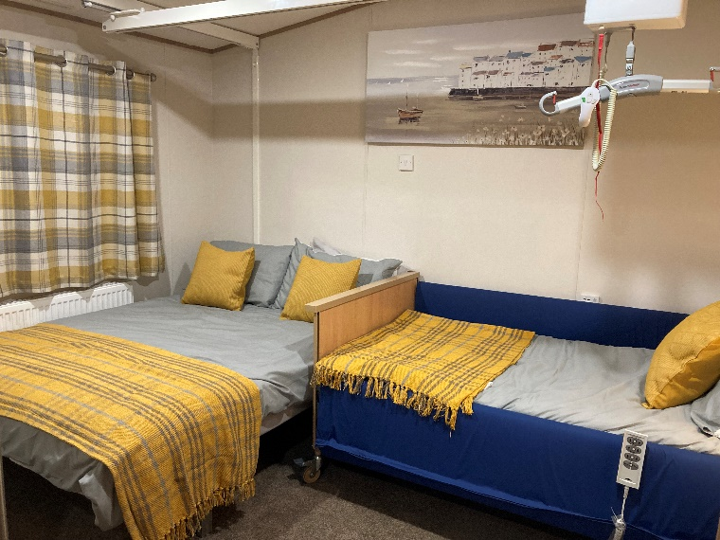

**Second Bedroom**

This contains 2 full size single beds, but there is insufficient access for a wheelchair user into this room. The flooring is low pile carpet.

**Wet Room**

For bathing there is a large wet room – approx. 2m by 2m

Thermostatic controlled "super powerful" shower with extra long hose.

Wheel in shower chair with lap belt. Note that

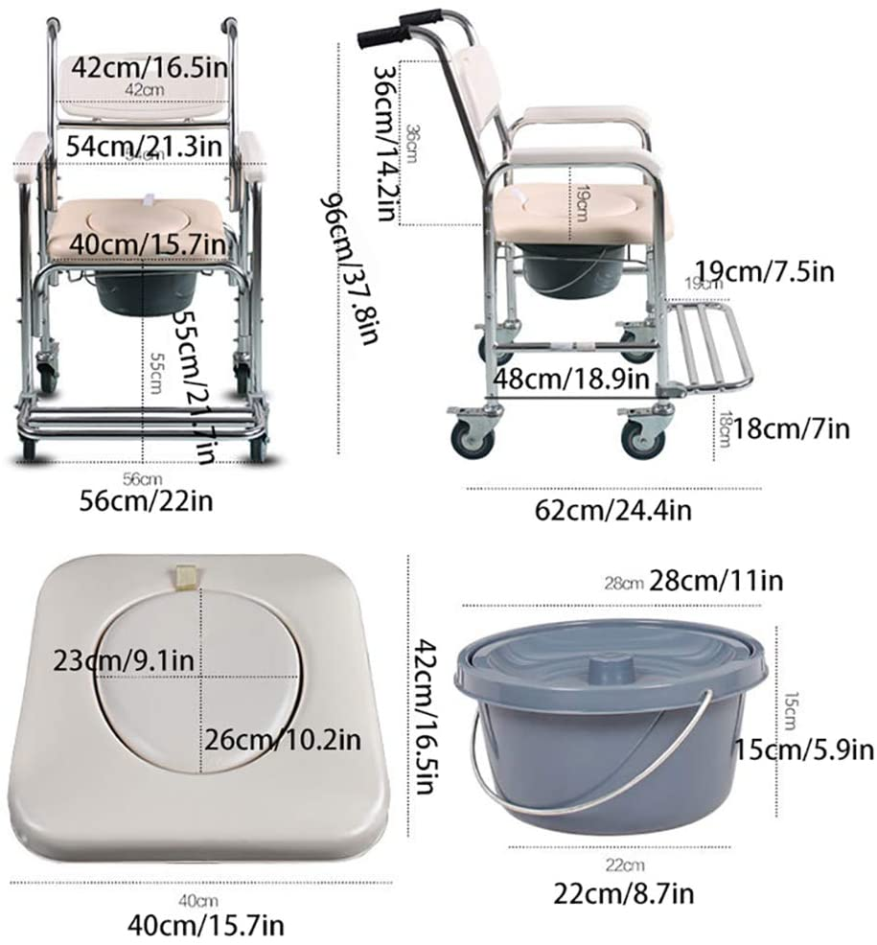

There are fixed hand rails in the shower area, and by the sink, with 1 fixed and one drop down rail by the toilet.

The toilet seat is of the raised variety and sits 0.5m/50cm/1 foot 8 inches from the floor and as a result the commode chair **cannot**  be wheeled over it.

**Kitchen**

Please note that the kitchen can be accessed easily by a wheelchair, the units are low-level and can be accessed by wheelchair users. The floor is laid with vinyl.

Accessories provided include...

Microwave

Kettle

Gas oven and hob

Toaster

Slow cooker

Toastie maker

Hand blender

**Lounge / Dining area**

The dining room / living area is open plan with low pile carpet flooring.

32 inch TV, DVD player, Bluetooth speaker and DAB radio.

2 seat sofa bed and a second 2 seat sofa.

Dining table with 1 x 2 seater bench seat, 2 dining chairs, 2 foot stools and a wing back chair (0.5m/50cm/1 foot 8 inches from the floor).

**Outside Storage box**

This houses the Oxford Midi 170 Hydraulic mobile hoist and rotary washing line.

It can be, and has been, used for storing specialist breathing equipment and oxygen tanks, all sites are happy to receive on your behalf at reception ready for when you arrive.

**Public Transport**

The nearest train station is Chichester on the [Southern Railway](https://www.southernrailway.com/) line; trains can be taken from London Victoria or London Bridge. Both services run via Gatwick Airport.  
  
The [No 51 Stagecoach Bus Route](https://www.stagecoachbus.com/routes/south/51/selsey-chichester/xpao051.i) runs from Chichester Bus station at regular intervals during the week and every 30 minutes on Sundays, travelling the 8 miles (13km) route.

**Beach Access**

Selsey has a pebble beach with a small boardwalk area that is accessible by boardwalk close to the Waterfront Quays entertainment complex on teh West Sands area of the park. There is a lovely sandy beach at West Wittering, 20 minutes drive from Selsey,  where you can also pre-book beach wheelchairs to hire.

**On Site Accessibility**

Seal Bay Resort is a fairly flat site which generally caters well for wheelchair users. All shops, entertainment venue, pub and take away food outlets are fully accessible. The indoor swimming pool has fantastic disabled changing facilities with ceiling hoist and a changing bench and hoisting into the pool.

An accessible changing room with changing bench and ceiling hoist.


**Accessible attractions**

A range of accessible attractions and places to visit can be found here… [Wheelchair accessible Attractions in Selsey near me | VisitRevisit](https://visitrevisit.co.uk/things-to-do/england/south-east/west-sussex/selsey/attractions/wheelchair)

**Changing Places Nearby**

Arun Leisure Centre

Felpham Way

Bognor Regis

West Sussex

PO22 8ED

United Kingdom