Rose Accessibility Statement

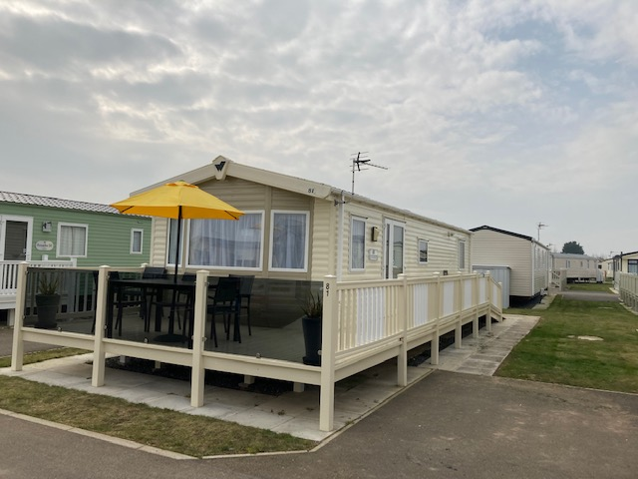

**Parking and Access.**

On arrival you will find a dedicated parking space to the right hand side, when viewed from the front, that is suitable for most WAV's.

Access is via a 1m wide ramp towards the rear at all caravan,  at the top is the entrance to the caravan and the wrap around terrace. Entry to the accommodation is through a 1 and 1/2 width side door (1.4m/140cm wide), and we also provide a threshold ramp that is stored just inside the main entrance.

**Level Access Throughout**

There is smooth, level access throughout, with vinyl fitted to the lounge and kitchen area, a very low pile carpet to both bedrooms and a non-slip moulded floor in the wet room.

**Internal Doors**

All internal doors are sliding doors, with a maximum opening width of 0.75m/75cm.

**Master Bedroom**

The master bedrooms are larger than you would normally find in a static caravan with a single profiling bed (internal length 1.8m/180cm/6 foot), with easily removable bed sides and bumpers fitted. There is also standard double bed 1.98m/198cm/6 foot 6 inches long and 1.37m/137cm/4 foot 6 inches wide. The flooring is low pile carpet.

There are 2 double wardrobes, and 2 USB charging points.

There is also a full room coverage overhead track hoist system with in rail charging (no need to position boom or place controller into a holster).

This room is easily reconfigured to give best access to meet your specific requirements.

All Bed linen is provided, but not towels and tea towels.

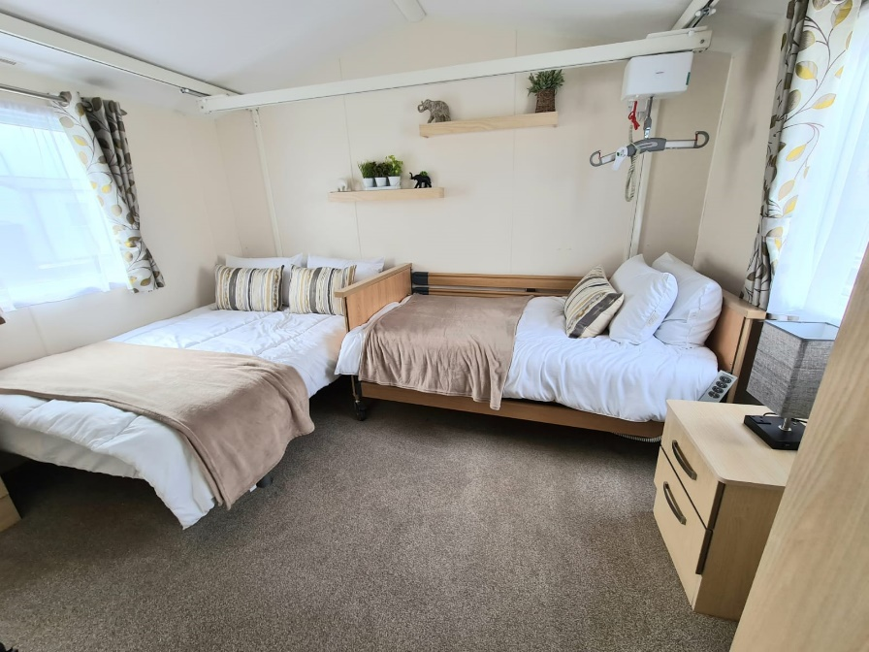

**Second Bedroom**

This contains 2 full size single beds, but there is insufficient access for a wheelchair user into this room. The flooring is low pile carpet.

**Wet Room**

For bathing there is a large wet room – approx. 2m by 2m

Thermostatic controlled "super powerful" shower with extra long hose.

Wheel in shower chair with lap belt. Note that

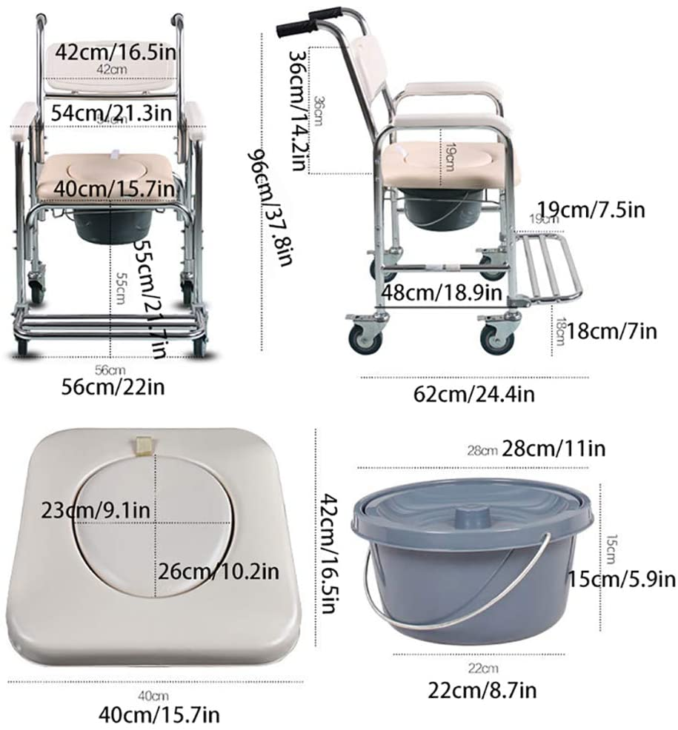

There are fixed hand rails in the shower area, and by the sink, with 1 fixed and one drop down rail by the toilet.

The toilet seat is of the raised variety and sits 0.5m/50cm/1 foot 8 inches from the floor and as a result the commode chair **cannot**  be wheeled over it.

A bathroom with a shower chair/commode, hand rails, toilet and sink

A bathroom with a shower chair/commode and hand rails.



**Kitchen**

Please note that the kitchen can be accessed easily by a wheelchair, the units are low-level and can be accessed by wheelchair users. The floor is laid with vinyl.

Accessories provided include...

Microwave

Kettle

Gas oven and hob

Toaster

Slow cooker

Toastie maker

Hand blender

**Lounge / Dining area**

The dining room / living area is open plan with low pile carpet flooring.

32 inch TV, DVD player, Bluetooth speaker and DAB radio.

2 seat sofa bed and a second 2 seat sofa.

Dining table with 1 x 2 seater bench seat, 2 dining chairs, 2 foot stools and a wing back chair (0.5m/50cm/1 foot 8 inches from the floor).

**Outside Storage box**

This houses the Oxford Midi 170 Hydraulic mobile hoist and beach wheelchair suitable for a child or small adult up to 65 Kg in weight.

We also have a size 1 and Size 2 Firefly /Goto seat for use in the beach wheelchair or around the caravan

Rotary Washing Line

It can be, and has been, used for storing specialist breathing equipment and oxygen tanks, all sites are happy to receive on your behalf at reception ready for when you arrive.

**Public Transport**

If arriving by public transport, The distance between Skegness Station and Chapel St Leonards is 2 miles. The number 1 bus run every 30 minutes with a stop just outside the site on South Road and takes around 30 minutes.

**Beach Access**

Chapel St Leonards probably provides the best access for the beach wheelchair, again no more than 10 minutes from our caravan and up a ramp to the long stretch of tarmac prom and easily accessed sand.

**On Site Accessibility**

Golden Palm Resort is a fairly flat site which generally caters well for wheelchair users. All shops, entertainment venue, pub and take away food outlets are fully accessible. The indoor swimming pool has chair hoist, although the disabled changing facilities are quite limited.

**Accessible attractions**

A range of accessible attractions and places to visit can be found here… [Wheelchair accessible things to do in Skegness near me | VisitRevisit](https://visitrevisit.co.uk/things-to-do/england/east-midlands/lincolnshire/skegness/wheelchair)

**Changing Places Nearby**

Tower Gardens Community Centre

Tower Gardens Pavilion

Skegness

Lincolnshire

PE25 2AX

United Kingdom