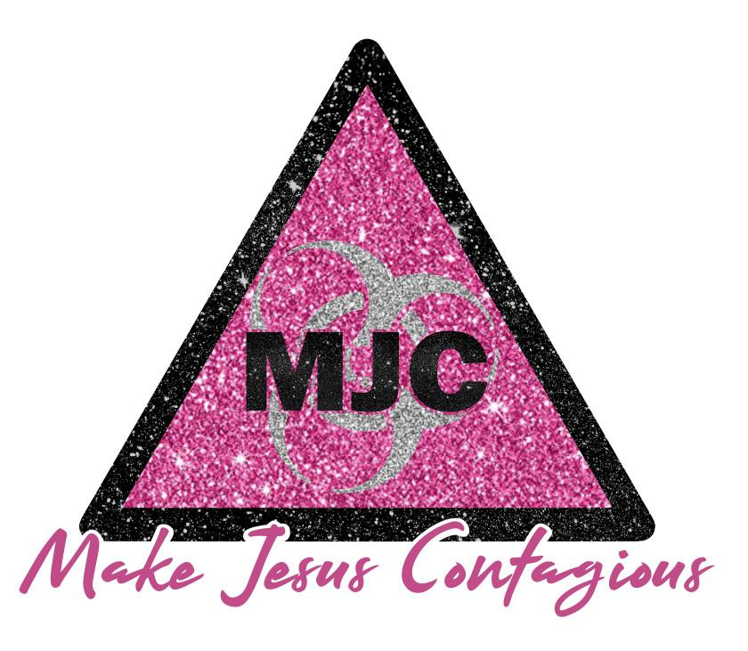

PHOTO RELEASE FORM

I hereby grant permission to Make Jesus Contagious to use photographs and/or video of me taken in publications, news releases, online, and in other communications related to the mission of (Make Jesus Contagious).

(Signature of Adult, or Guardian of Children under age 18)

Name
Address

Phone (day) (evening)
Email Address (optional)

Thank you!

