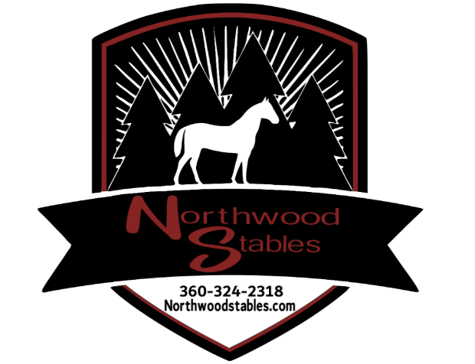

**REALEASE AND HOLD HARMLESS AGREEMENT**

I acknowledge the risks involved in riding and working around horses, which includes bodily injury from using, riding, training or being in close proximity to horses. In addition, it is my clear understanding that both horse and rider can be injured in normal daily activities as well as during lessons, showing and competition.

Name: ________________________, hereby agrees to hold harmless and indemnify Northwood Stables, Alesia Collins, it’s owners, along with any of its affiliates. I release them from any liability or responsibility for accident, damage, injury, or illness to the undersigned or any horse owned by the undersigned or to any family member or spectator accompanying the undersigned on the premises of Northwood Stables:

Riders printed name: ________________________

Signature: ______________________ Date: _______

Parent or guardian Signature: ______________________ Date: _______