2026 Championship Graphic Placement

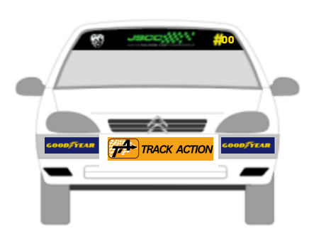Large 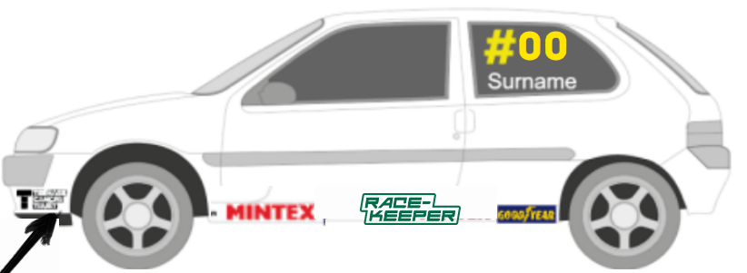 Small


Sherrie Ann Powell


2026 Championship Graphic Price list

Placement | Product | Cost
Front | Winder screen Banner (BARC,JSCC, CAR NO) | £40:00
Front | Front Number plate (TA) | £10:00
Front | TCT and NAS bumper set | £30:00
Front | Emergency set (extinguisher, Electric triangle, Tow Arrow) | £20:00
Sides | Sill Set ( Championship Partners) | £20:00
Sides | Side window (Name and Number) | £35:00
Rear | Junior Saloon Car Championship Bumper Upper | £30:00
Rear | www.juniorsalooncarchampionship.co.uk Bumper Lower | £30:00
Rear | Rear Number plate (Goodyear) | £20:00
Rear | Rear window Surname | £20:00
Rear | Novice Cross | £10:00
Inside Car | Dashboard Panel- Replacement | £40:00

