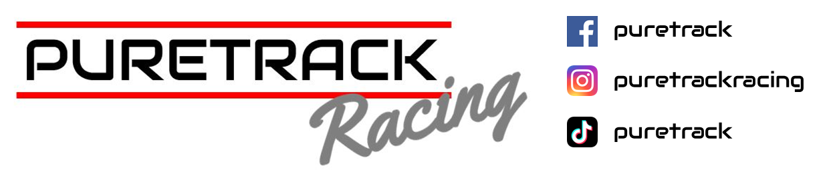
Trackday Driver Rental Contract

Name Of Driver:
Vehicle on Hire:
Circuit:
Date:

Driver Requirements
- Valid UK Drivers Licence:
All drivers must hold a current and valid driver's Licence
- Personal Racing Equipment:
Drivers must supply their own helmet unless hiring from Puretrack, gloves, sensible shoes, long-sleeve T shirts and NO Shorts
- Damage Responsibility:
Any mechanical or accident damage caused by the driver, or occurring while the driver is in control of the vehicle, must be paid for in full within two weeks of the incident.
If payment is not received within this timeframe, Puretrack Racing reserves the right to charge interest at the Bank of England base rate on any outstanding balance.
Payment Details :
Sarah Dennis
Puretrack Racing LLoyds
Sort code: 30-54-66
Account:25187068
Contract Details
Emergency Contact Detail’s:
Name:……………………….…………….. Tel No:………………………………………….. Relationship:……………..
Address: …………………………………………………………………………………………………………………………………

PERFORMANCE DRIVING CAN BE DANGEROUS AND MAY INVOLVE INJURY OR DEATH
You must read and sign the following declaration as a condition of your participation in any track day at the Venue.

Driver Acknowledgement and Agreement
In consideration of being permitted to participate in the hire of a vehicle from Puretrack, I hereby acknowledge, accept, and agree to the following:
- Licence Requirements
I confirm that I hold a current UK Drivers Licence.
- Age Confirmation
I confirm that I am over 17 years of age.
- Fitness to Participate
I confirm that I am not, and will not be, under the influence of alcohol or drugs (prescribed or otherwise). I am fit, well, and free from any medical conditions that could impair my ability to take part in motorsport activities.
- Driving Standards
I acknowledge that Puretrack will monitor my driving standards and mechanical sympathy throughout the hire period. Puretrack reserves the right to immediately terminate the hire should either be deemed unacceptable or abused.
- In-Car Cameras
I agree to in-car camera recording during the hire. I understand that Puretrack may use portions of this footage for marketing purposes across websites and social media channels.
- Awareness of Motorsport Risks
I confirm that I am familiar with trackday event formats and the inherent risks associated with motorsport. I accept that Puretrack cannot and will not be held responsible for any injury or damage to myself or others. I participate entirely at my own risk.
- Liability for Venue Damage
I understand that I am liable for any damage caused at the venue as a result of my reckless or dangerous driving, and I agree to pay the circuit the full cost of any necessary repairs or replacements.
- Safety Equipment
I agree to wear seat belts or harnesses at all times while in a vehicle, and a properly fastened crash helmet while on the circuit.
- Limitation of Liability
I acknowledge that neither Puretrack, nor any company or organisation associated with the event, nor their employees, officers, instructors, or other participants (each a “Relevant Person”), shall be liable for any injury, loss, damage, claims, costs, expenses, or demands suffered directly or indirectly by me as a result of my attendance or participation, except where such liability arises from a Relevant Person’s negligence resulting in personal injury or death.
- Photography and Media Use
I understand that Puretrack may take photographs and/or video footage of me during the event and may use such content (including my image and likeness) for promotional, marketing, or publicity purposes in any media worldwide, without notice or compensation.
- Mechanical Issues
I accept that, due to the nature of race cars, Puretrack cannot be held financially responsible for mechanical issues that may end the hire period early.
- Event Cancellation
I understand that Puretrack cannot be held financially responsible for event cancellations made by trackday organisation companies such as Javalin, Opentrack or MSV
- Liability for Vehicle Damage
I understand that I am liable for all damage caused to the hire vehicle during the hire period, including damage caused through collisions with other vehicles and any mechanical damage not attributable to normal wear and tear.

In signing, I agree and accept the above

Name:………………………………………………………………………………….

Signature:……………………………………………………………………..

Date:…………………………………….

Witness:……………………………………………………………………….

Signature;……………………………………………………………………..

Date:……………………………………………………………………………

