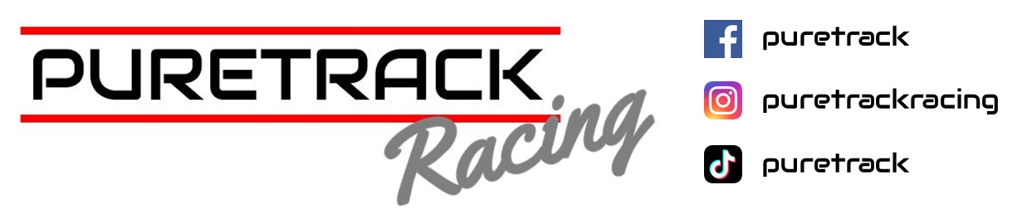

Silverstone GP- Round One

15th March 2025

**PBS BRSCC SUPERSPORT ENDURANCE**

Photo Credit Jamie Ennis

Our first race of the 2025 season fast approached and took place at the iconic circuit of Silverstone on the world-famous Grand Prix Circuit. We were welcomed on Saturday morning with the most incredible sunshine; however, even with the sun shining it was still bitterly cold.

We arrived with our Clio 200 and Megane RS, as well as, for the first time, our new partners, Skegness Tyres. Current champions Adam Read and David Drinkwater were in their BMW Compact back in the Clubman C class.

This year, we have our Clio 200 also in Class C driven by regular driver Jamie Millar, looking to improve his 3rd place in class finish last year and new driver to Puretrack Racing Ben Pemberton.

As a bit of a change-up from last year, Sarah Dennis has moved from the other Renault Clio 197 to partner with her husband Matt Dennis in the Megane RS in Clubman A.

It was an honour to share a garage with a new driver to the championship, but also Puretrack racing new driver coach BTCC Legend Colin Turkington in his Mazda MX5.

Qualifying started at 9.30 a.m., and as the cars prepared to leave the assembly area onto the grid, we saw a few snowflakes fall from the sky. Thankfully, it only affected driving times for a couple of laps before everyone started putting in some impressive times after a very early red flag. Jamie was first out in the Clio, and then it was Ben's turn to learn the circuit and the car.

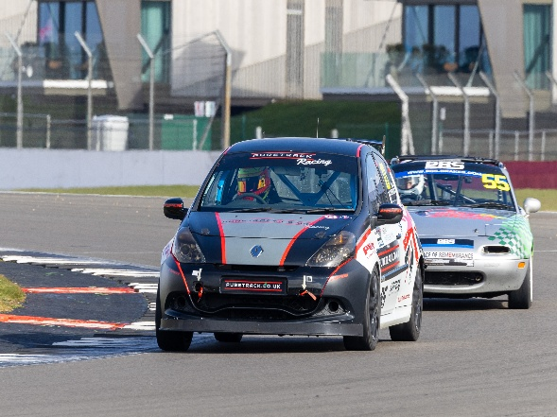 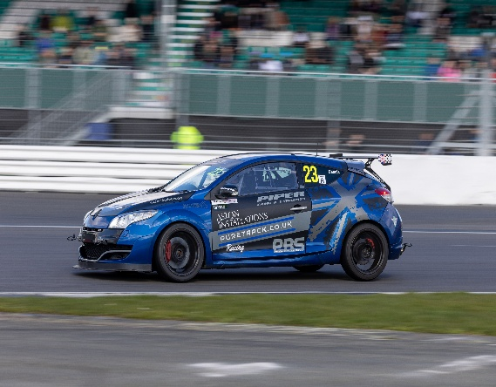

Photo Credit Jamie Ennis

Ben took to the Clio very quickly before unfortunately meeting a very unforgiving sausage kerb, that saw the Clio retire from the rest of the qualifying session with mechanical damage, unfortunately, sausage kerbs, are definitely a car killer. Meanwhile, Matt had handed the wheel over to Sarah, who was also driving the Grand Prix layout for the first time. Sarah quickly got to grips with the circuit before pitting early due to a brake ducting that had become loose and caught up.

Adam was also having a few teething issues in qualifying with a rear brake issue causing the rear brakes to stay on, this did however cause a stunning photo opportunity of glowing brake discs.

As the first race after lunch, we were quite surprised to be called up to the assembly area a full 45 minutes earlier than expected. This wasn’t to our advantage with the Clio still in pieces. Our team of highly skilled guys and girls were flat out on the Renault fitting new parts, including hub, track rod arms, and bearings to get the car ready, but unfortunately, time wasn’t on our side, and due to endurance regulations, we couldn't make the start.

The Megane and Bmw however took the green flag rolling start with Matt Dennis and Adam Both starting. Both cars got lighting starts, overtaking many cars, until they both settled into a rhythm.

The Megane was improving lap after lap, and moved up to 3rd In class, setting personal bests each lap, before disaster struck, with the rear wheel departing from the rest of the car. Under later investigation we discovered the wheel loss was caused by a stud failure, a freak failure and not car or driver error.. The only positive we could take from this mechanical failure that ended our race prematurely was that this occurred during a safety car lap so the Megane wasn’t at full speed, in a corner it would have been driving through at 100mph during the race.

The Megane was recovered back to the pits, but as it was aided off the track by a flatbed, it too would have to retire with the Clio, which was a massive shame as it was an easy fix and would have given Sarah the chance to experience the thrill of the GP track.

The last of the Puretrack Trio, in contrast, was having a fantastic race. Dicing with a Mini, both overtaking each other at least ten times during the race, also entering the battle a few times was another touring car legend Tim Harvey in his BMW 1series. However, it was the BMW compact of Adam & David that came up trumps for the first race of the season coming in 1st in class. A great start for the defending champions.

**Roll on to the next round at Oulton Park on the 19th Of April**

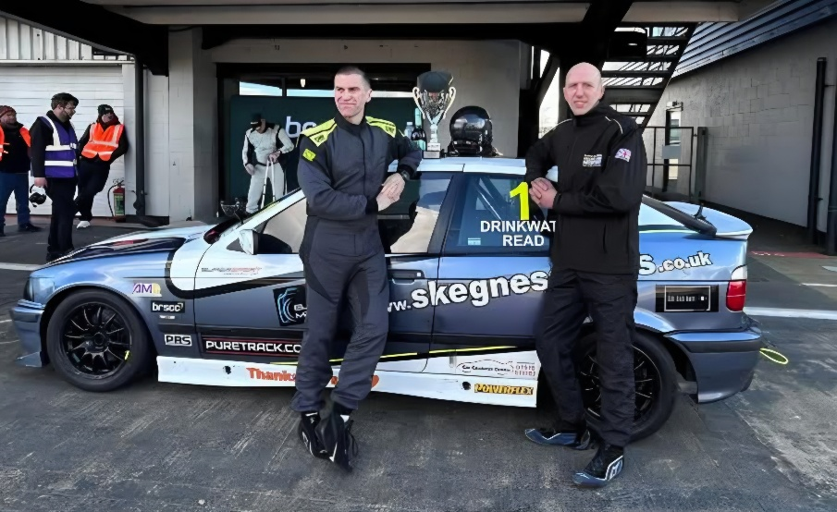

**“Thank You as always to our Partners, Drivers Sponsors & Team “**

PBS BRAKES

PIPER CAMS & EXHAUSTS

SKEGNESS TYRES

INTARACE COMMUNICATIONS

3AMIGOS MOTORSPORT