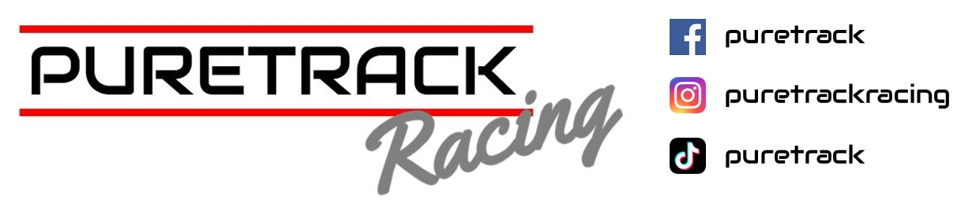

Oulton Park – International

19th April 2025

**PBS BRSCC Supersport ENDURANCE**

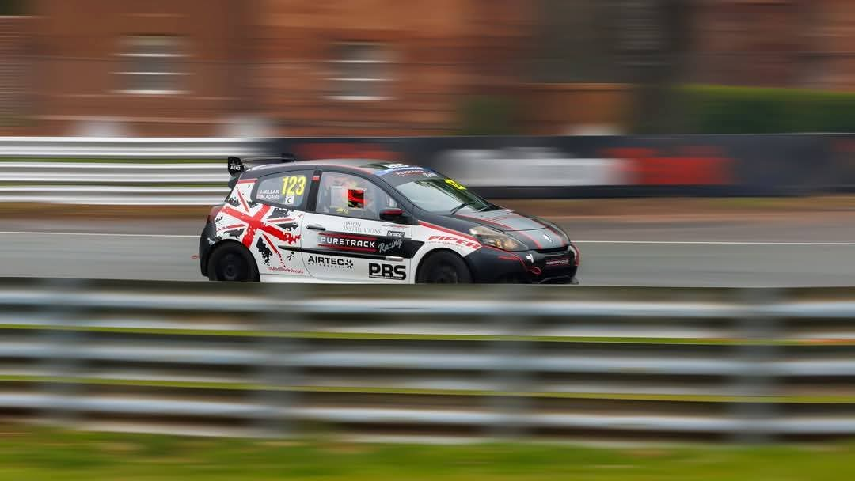

A quick few days’ turnaround for the Clio, and we were off to one of our furthest away race circuits of the season, Oulton Park in Cheshire.

The Easter sunshine was struggling to make an appearance when we arrived, but even with the cold, damp weather, we were determined to fight for class victories in the Megane RS and Clio 200, and not forgetting our BRSCC Supersport reigning champions, in their Puretrack Racing associate BMW Compact.

Qualifying flew by quite literally, in tricky conditions. But as the Clio returned to the pits, making a strange noise, we feared the worst; we were in for a gearbox change in a short period.

We are so graced to have the best team ever, and before I had even had a chance to make a cup of tea the whole front end was off the Clio.

When the cars were called to the assembly area the Clio was still in bits, but with every confidence in the team as the whistle was blown to release the cars on to the circuit, the Clio arrived in the assembly with driver Jamie Millar behind the wheel quite literally just in the Nick of time, to start the race.

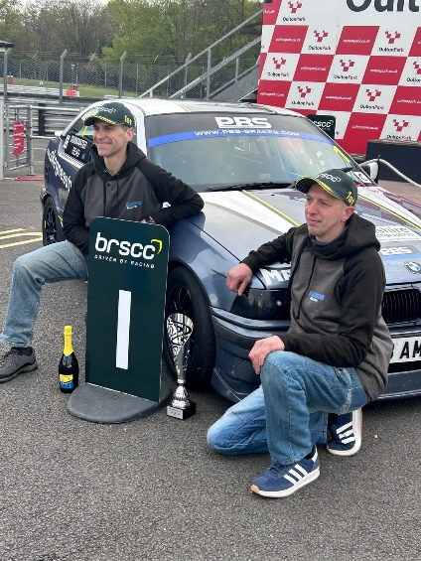 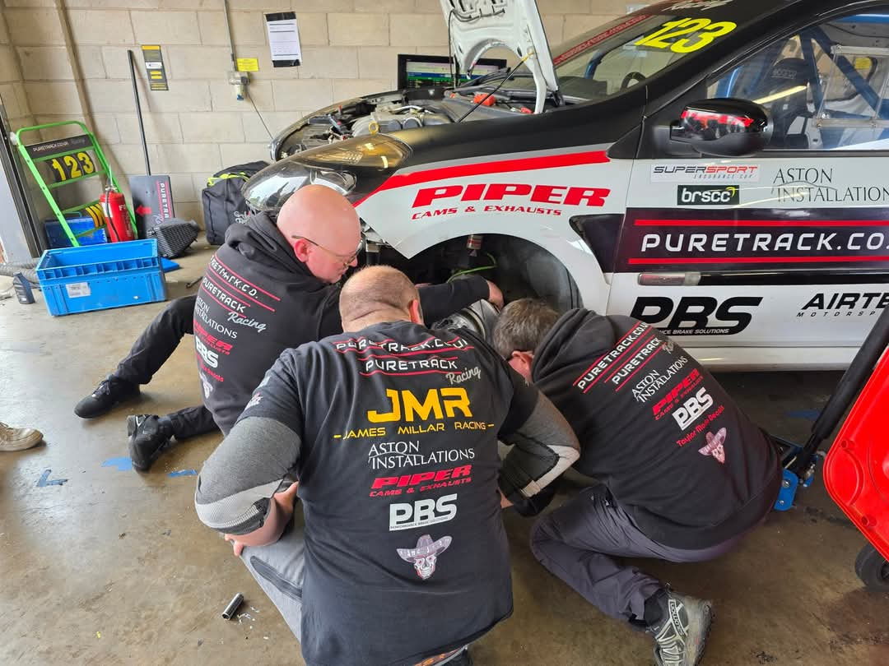

A dry start saw all three cars take the green flag lap, with the BMW, and Megane taking places. However, on the first lap, the Clio decided its new gearbox wasn’t to its liking. She retired out on circuit, which was hugely frustrating, normally vehicle’s in and endurance race are live snatched back, but this wasn’t the case, and it wasn’t until much later in the race with a safety car for another incident that the car was recovered to the pits, leaving our team no time to try and fix the car.

The Megane was faultless until a gear linkage snapped near the end of the race. The team got to work fixing the linkage under extreme heat, but with a few minutes left on the clock we missed taking the flag by 30 seconds.

Meanwhile, another faultless drive by the BMW pairing of Drinkwater and Adam Read to take Class honours for a second round running, making this pairing a sure contender for the title this year.

**Roll on to the next round PBS Clubsport at Silverstone 3rd May**

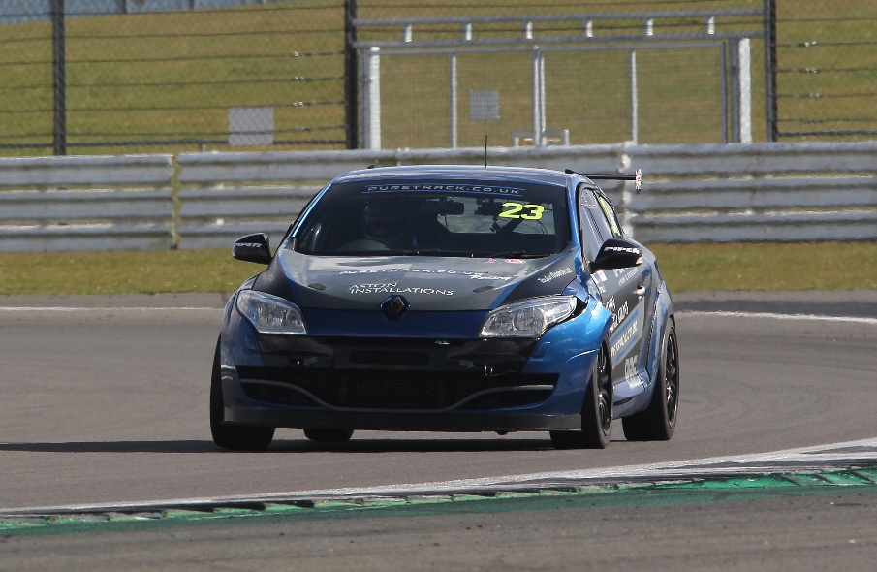

**“Thank You as always to our Partners, Drivers Sponsors & Team “**

PBS BRAKES

PIPER CAMS & EXHAUSTS

SKEGNESS TYRES

INTARACE COMMUNICATIONS

3AMIGOS MOTORSPORT

GODFLEX BUSHES