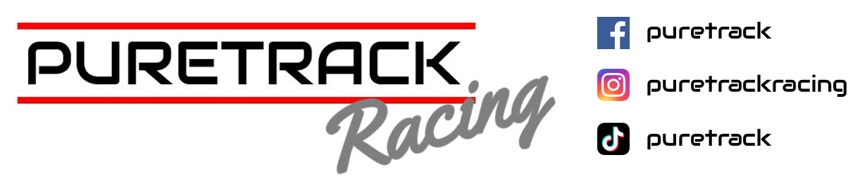

Brands Hatch Indy - Round One

13th April 2025

**PBS BRSCC Clubsport ENDURANCE**

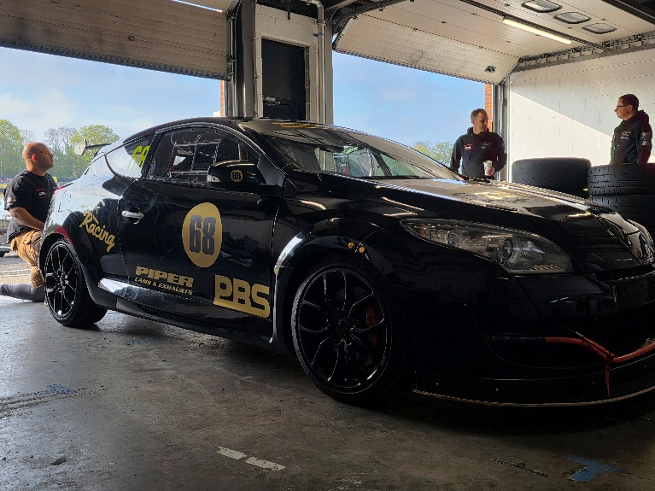

A sunny Brands Hatch greeted us on Sunday morning; the sun cream and sun loungers were out in force, and spirits were high. Unfortunately, our two-car Megane entry for the first round of the 45-minute BRSCC Clubsport sprint race was amended last minute, when driver Graham Price had to pull out due to personal circumstances.

Not to leave the new Megane on its own, Sarah & Matt Dennis entered their Clio RS200 as a shakedown for the upcoming race at Oulton Park.

Qualifying went well with both cars showing great pace and no problems; however, something was looming in the skies above, and that was unwarned monsoon weather.

The heavens opened and quickly flooded the paddock. The action on track for other races was proving that there was no clear tyre choice. One minute dry, one minute wet. And with at least five cars blowing engines over the afternoon, and an oil-covered circuit, it was more like watching rally cross than circuit racing.

The time the last race was about to start, which was ours. It was safe to say the track was more like an ice rink than a race track.

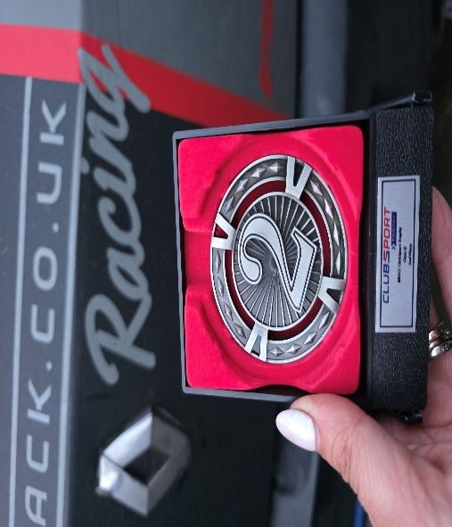 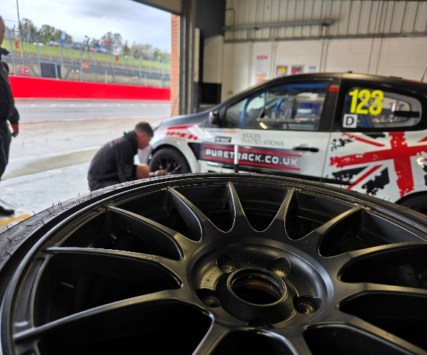

The two Matts, Adams & Dennis, started the rolling start, with Dennis making a few grid positions before being boxed in by another car, and then losing them all. Adams also had a good start; however, the tricky conditions got the better of the Megane, and on the second lap, Adams performed two 360 spins at Surtees. Luckily, no one collected the stranded Megane, but a quick unscheduled pitstop to check the car over was required.

The Clio was struggling in the conditions with a dry setup and wet tyres, braking issues were also adding to the excitement, with the car locking up every corner and every now and then, no brakes at all. As Matt Dennis was about to find out, into Paddock. Thankfully, Matt managed to drive through the gravel to hand over the reins to his wife Sarah.

By now, the track was starting to dry, but this wasn’t to the Clio's advantage, with the pitstop already taken place the wet tyres were now overheating and the braking issues were getting worse with Sarah also trying a new gravel line through Paddock, but by far we were defiantly not the only team struggling for traction. Pretty much every car on the grid had at least one off.

Both cars survived the carnage, with the Clio even picking up 2nd place in Class. Overall, the weekend was a massive success, and the Meganes' 1st Race was under its belt.

**Roll on to the next round at Oulton Park on the 19th Of April**

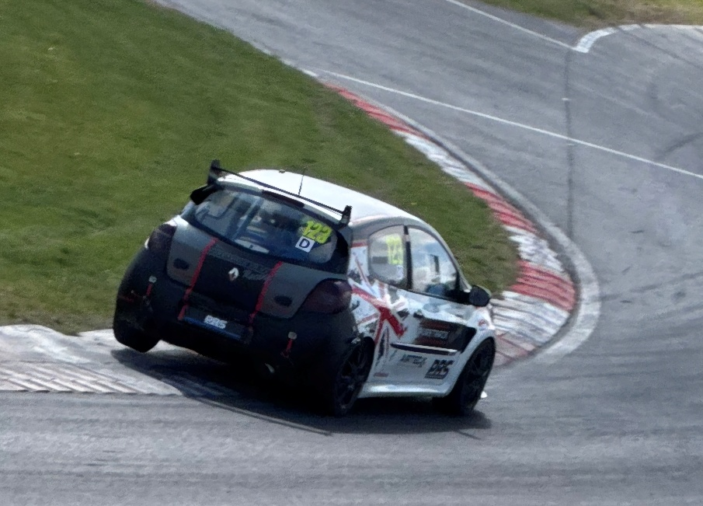

**“Thank You as always to our Partners, Drivers Sponsors & Team “**

PBS BRAKES

PIPER CAMS & EXHAUSTS

SKEGNESS TYRES

INTARACE COMMUNICATIONS

3AMIGOS MOTORSPORT

GODFLEX BUSHES