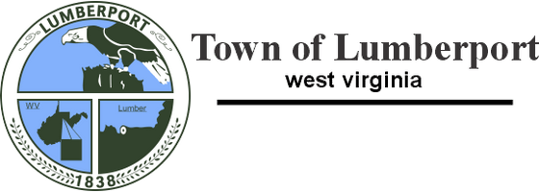
548 Main Street, PO Box 519, Lumberport, WV 26386
Phone: 304-584-4370 Fax: 304-584-4666

BAD CHECK POLICY

The Town of Lumberport (“the Town’), in accordance with the Public Service Commission of West Virginia Rules and Regulations, establishes a Bad Check Policy. The purpose of this policy is to establish uniform procedures for handling bad checks effective January 1, 2026.
When a customer’s check, ACH payment or e-check is returned to the Town by their bank for insufficient funds, the following actions will be taken:
1) The Town will notify the customer in writing (via regular U.S. Mail) that payment for the returned check and a $25 Non-Sufficient Funds (NSF) fee must be made in the form of cash, money order or cashier’s check (from a WV Bank) within 5 days from the date of the notice.
2) If payment is not made within 5 days, the Town will terminate the customer’s water service until all the following charges are paid in full:
a. Amount of returned check, ACH payment, or e-check.
b. $25 Returned Check Fee
c. All past due charges on the account at the time service is to be restored.
d. Reconnection fee

3) After a customer’s check, ACH payment or e-check is returned by the bank, the customer’s check writing privileges will be suspended for a period of 3 months from the time of the returned check.
4) After 3 months, the Town may reinstate the customer’s check writing privileges.
5) If the Town receives a second insufficient funds check after privileges have been reinstated, the above steps will be repeated. However, for a second bad check, the customer’s check writing privileges will be suspended for 12 months.
6) Should a customer have a third insufficient funds check after two reinstatements, the customer will no longer be allowed to pay via check. They will be required to pay via ACH or Credit Card through Nexbill.pay.

