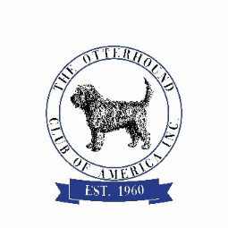
Otterhound Club of America Inc.
Application to Host the National/Regional Specialty or Supported Entry

OHCA National Specialty may only be held in the months of September, October or November and proposals must be submitted by June 1st, no less than a year and half prior to the proposed Specialty i.e. for Specialty held in 2023, application must be submitted by June 1, 2022. If multiple applications to host the OHCA National Specialty for any given year are received before the deadline, the location will be decided by a vote of the General Membership.
Applications to host a Regional Specialty or a Supported Entry must be submitted 9-12 months in advance and approved by the Board of Directors.
This Application is submitted for:
National Specialty Regional Specialty Supported Entry

Year of the Event:
2023 2024 2025 2026

Is the Event Chair willing to Host the Event for 2+ years (with BOD Approval)?
Yes – 2 years Yes – 3 years Yes – Other ________________ No

This will be:
Independent Specialty Part of an All-Breed Show Other _____________________

Event Location (City/State): ____________________________ Dates: _________________________

Show Superintendent/Secretary _____________________ Club/Cluster ________________________
Number of conformation shows held in conjunction with the proposed event: ____________________

Will OHCA have input regarding judges? Yes No ____________________________
Explain________________________________________________________________________________
Other events offered:

Obedience Rally Agility Tracking
Other _________________________________________________

Event Chair Co-Chair/2nd Club Member
Name ______________________________ Name __________________________________
Phone ______________________________ Phone __________________________________
Email ______________________________ Email __________________________________

OHCA Members helping with the event: __________________________________________________
____________________________________________________________________________________

Submitted by (Name) _____________________________________ Date ____________________
Keep a copy for your records and submit the original to OHCA Director Cindy Huffman
(Cindy.Huffman@otterhound.org, 1140 Farley Rd., Pleasant Plains, IL 62677)

