GRANDMA’S HOUSE – A VISION OF HOPE
226 South Blackstone - Tulare, California (559) 631-4200 or (559) 687-0925

EMERGENCY INFORMATION

Name: __________________School: _______________ Teacher: ______________ Phone ____________

- Emergency Contact Person ______________________ _________________ _______________ (Name) (relationship to child) (Phone Number)

- My child is allergic to: ___________________________________________________________

- My child’s doctor: _______________________ 4. Doctor’s phone Number: ____________________

_________________________________ _________________________
(Parent’s Signature) (Phone Number)

Parents’ Email: ________________________________________

AFTERSCHOOL TUTORING

( ) I will pick my child up. ( ) My child will walk home.

Additional Information:
___________________________________________________________________________________________
___________________________________________________________________________________________ __________________________________________________________________________________________ __________________________________________________________________________________________ ______________________________________________________________________________________________________________________________________________________________________________________ _______________________________________________________________________________________.

GRANDMA’S HOUSE – A VISION OF HOPE
226 South Blackstone Ave. – Tulare, California 93274
www.grandmas-house.org
Facebook
January 1, 2022

Dear Parents,

We are excited about being able to provide additional support to our students and assisting them in getting caught up academically, if they are behind, or just need a little additional support. We provide tutoring in reading, math, language arts and homework help Tuesday – Thursday. Our students arrive as soon as they are released from school which is 2:40p.m., for the kindergarten – sixth grade. The middle school students are released from school around 3:00p.m. As a partner in your child’s education, it is important for your child to be at tutoring every day, unless he/she is ill. Students will be dropped if they have three unexcused absences, without a doctor’s note.

When we receive the referral from you or the teacher, the first thing we will do is look at the information received from the teacher as to where the child is functioning academically and what support is needed, based upon his/her grade level. This information will assist us in providing the support your child needs.

The application packet consists of the following:

The referral form – for your child to attend tutoring at Grandma’s House. There is a section for you to fill out. The teacher will fill out the rest. This is important.

Exchange of information form – you will need to sign it. It gives the teacher and the district permission to share academic needs and assessment information about your child, with Grandma’s House

Emergency Card - you must fill this out and leave it with the packet.

Photographing/videotaping of students - as the parent, you will need to read and sign this form. It gives us permission to include your child’s picture in the newspaper or in various video presentations we do for Grandma’s House.

Family Information Form – this form provides information about you and your family that will assist us when applying for grants and other funding.

Total packet, whether initiated by the parent, principal or the classroom teacher, once it is completed, return it to Grandma’s House.

Sincerely yours,
Flora A. Johnson
Ms. Flora A. Johnson
Founder/Director
FAMILY INFORMATION
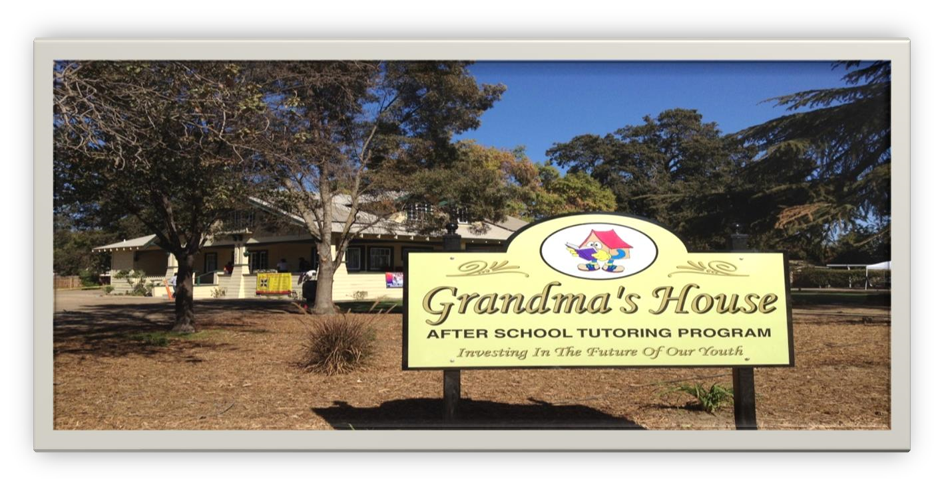
Grandma’s House is a 501 ( c ) ( 3 ) non-profit corporation. We run our program through grants and donations from organizations, businesses and individuals. Many of the grants require the following information. It is this funding that allows us an opportunity to offer this program free to any student. Please assist us by answering the questions below.

Student’s Name: _______________________________ Date: __________________
Ethnicity:

( ) Caucasian ( ) African American ( ) Native American
( ) Latino ( ) Asian ( ) Pacific Islander
( ) Other: _________________

Parent’s Level of Education:
( ) No schooling ( ) K – 8th grade ( ) Some high school
( ) High School GED ( ) Some college ( ) BS/BA
( ) Masters ( ) Doctorate ( ) Trade/Technical./Vocational.

Family Type:

( ) Single mom responsible for the care of the children
( ) Single father responsible for the care of the children
( ) Multi-generations: those consisting of more than two generations living together ( ) Joint/Shared Custody
( ) Kinship Care: care of children by relatives
( ) Foster Care (includes youth living with relatives if it is a formal home placement)

Students School Lunch: All students in Tulare City Schools receive (X) Free

Tulare City School District

Authorization to Release Student Record Information

I (parent or legal guardian) , hereby authorize Tulare City School District, its officers, agents and employees, to release and furnish the following student records:

- State Performance Level or Assessment scores
- Test scores (classroom) or any academic information needed
- Behavioral issues that have impacted learning.
- Socioeconomically Disadvantaged Status

which pertain to my child (name), _______________________________, Grade: ___________a student enrolled in, or formerly enrolled in Tulare City School District. The above student records are to be released to:

Grandma’s House 226 S Blackstone St - Tulare, California 93274 (Name) (Address) (City) (State) (Zip Code)

for the purpose of providing academic support

In giving this authorization and I am agreeing to waive any rights I may have to maintain the confidentiality of such student record information pursuant to law, or to assert any privilege to do so as to the above-named persons; however, this information may not be transmitted to others without my written consent.

Date Signed
(Parent or Legal Guardian)

A Core Theme for Grandma’s House “It Takes a Village to Raise a Child.”

Distrito Escolar de La Ciudad de Tulare

Autorización para Liberar Información de Registro del Estudiante

Yo (padre o guardian legal) ______________________________, dppor este medio autorizó al Distrito Escolar de la Ciudad de Tulare, sus oficiales, agentes y los empleados, a liberar y suministrar lo siguientes registros del estudiante:

- Nivel de rendimiento del estado
- Resultados de las pruebas (aulas) o cualquier otra información académica necesaria
- Problemas de conducta que han afectado el aprendizaje
- Estado de Desventajas socioeconómicas

Que pertenece a mi niño (nombre), ______________________________, un estudiante matriculado adentro, o matriculado antes en el Distrito Escolar de la Ciudad de Tulare. Los registros de los estudiante por encima son para ser lanzado a:

Grandma’s House 226 S. Blackstone St. Tulare, CA 93274_______ (Nombre) (Dirección) (Ciudad) (Estado) (Código postal)

Para el propósito de proveer apoyo académico

En dar esta autorización estoy de acuerdo de renunciar cualquier derecho que pueda tener para mantener la confidencialidad de tal información de registro del estudiante conforme a ley, o afirmar cualquier privilegio de hacerlo a las personas mencionadas anteriormente. Este información no se puede transmitir an otras sin mi consentimiento por escrito.

Fecha ______________________ Firma _______________________________
(Padre o Guardián Legal)

GRANDMA’S HOUSE – A VISION OF HOPE
226 South Blackstone Ave. – Tulare, California 93274
www.grandmas-house.org
Facebook
January 1, 2022

Dear Parents,

We are excited about being able to provide additional support to our students and assisting them in getting caught up academically, if they are behind, or just need a little additional support. We provide tutoring in reading, math, language arts and homework help Tuesday – Thursday. Our students arrive as soon as they are released from school which is 2:40p.m., for the kindergarten – sixth grade. The middle school students are released from school around 3:00p.m. As a partner in your child’s education, it is important for your child to be at tutoring every day, unless he/she is ill. Students will be dropped if they have three unexcused absences, without a doctor’s note.

When we receive the referral from you or the teacher, the first thing we will do is look at the information received from the teacher as to where the child is functioning academically and what support is needed, based upon his/her grade level. This information will assist us in providing the support your child needs.

The application packet consists of the following:

The referral form – for your child to attend tutoring at Grandma’s House. There is a section for you to fill out. The teacher will fill out the rest. This is important.

Exchange of information form – you will need to sign it. It gives the teacher and the district permission to share academic needs and assessment information about your child, with Grandma’s House

Emergency Card - you must fill this out and leave it with the packet.

Photographing/videotaping of students - as the parent, you will need to read and sign this form. It gives us permission to include your child’s picture in the newspaper or in various video presentations we do for Grandma’s House.

Family Information Form – this form provides information about you and your family that will assist us when applying for grants and other funding.

Total packet, whether initiated by the parent, principal or the classroom teacher, once it is completed, return it to Grandma’s House.

Sincerely yours,
Flora A. Johnson
Ms. Flora A. Johnson
Founder/Director
GRANDMA’S HOUSE – A VISION OF HOPE
226 South Blackstone – Tulare, California 93274 www.grandmas-house.org Facebook
(559) 631- 4200 – (559) 687- 0925

(REFERRAL FORM)

Date: _____________

Student Name: ________________________________ Parent’s Name: __________________
Grade: ____________ Age: ________ Birthdate: _____________________________________
Address: _______________________________________ Phone Number: ________________ Parent / Guardian e-mail address: _________________________________________________
Emergency Contact: ______________________________ Phone Number: ________________
Health / Medical Issues: _________________________________________________________

School / Teacher Information

School: _______________________________ Teacher:_______________________________ Teacher’s e-mail Address: _______________________________________________________

Academic Performance

Test Scores: English-Language Arts:

Adv ______ Prof. ________ Basic ________ Below _______ Far Below __________

Test Scores: Math:

Adv ______ Prof. ________ Basic ________ Below _______ Far Below __________

ROLA Level: ____________ Grade Equivalency: _____________

TCSD Writing Rubric Score: _______________________

I give my consent for Grandma’s House – A Vision of Hope – to work with my child, collaborate with his/her classroom teacher and you regarding academic and behavioral issues to increase his/her academic performance and modify behaviors that have impeded his/her learning.

( ) My child can walk home. ( ) I will pick my child up on time.
_________________________ _________________________
Parent Signature Teacher Signature

PHOTOGRAPHING AND VIDEO TAPING STUDENTS AT
GRANDMA’S HOUSE

On occasion, students may be spontaneously photographed or videotaped by the news media or staff at Grandma’s House while learning or in the special events we participate in (i.e., fairs and /or Christmas parades).

Our director is often called upon to give various presentations to local organizations and businesses about the program at Grandma’s House. This presentation often consists of a PowerPoint that provides a virtual tour of Grandma’s House, students learning and staff members delivering instruction.

Below, please check the areas that reflect your desire as it relates to your child being pictured in various activities and events held at and by Grandma’s House.

( ) you have my permission to use any pictures taken by the staff or the media at Grandma’s House.

( ) I would prefer that my child’s picture not be shown in presentations or website.

Parent’s Name: ___________________ Student’s Name: ______________ Date: ____

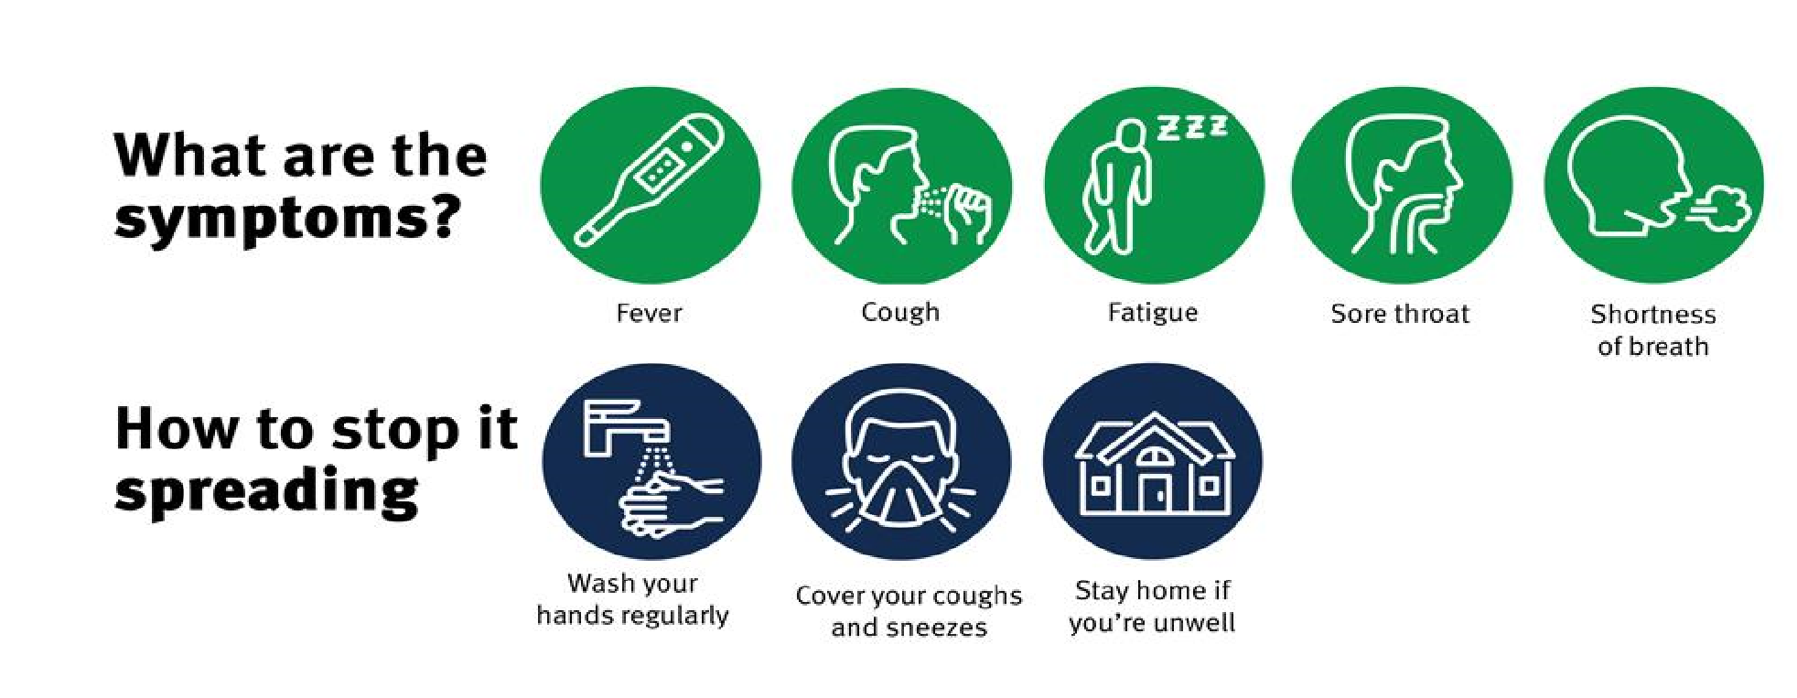
SAFTEY PROTOCAL WILL BE ENFORCED

Mask wearing with effective ventilation Hand washing and sanitizing
Social Distancing, Daily temperature and health screening.

