**CAPABILITIES STATEMENT**

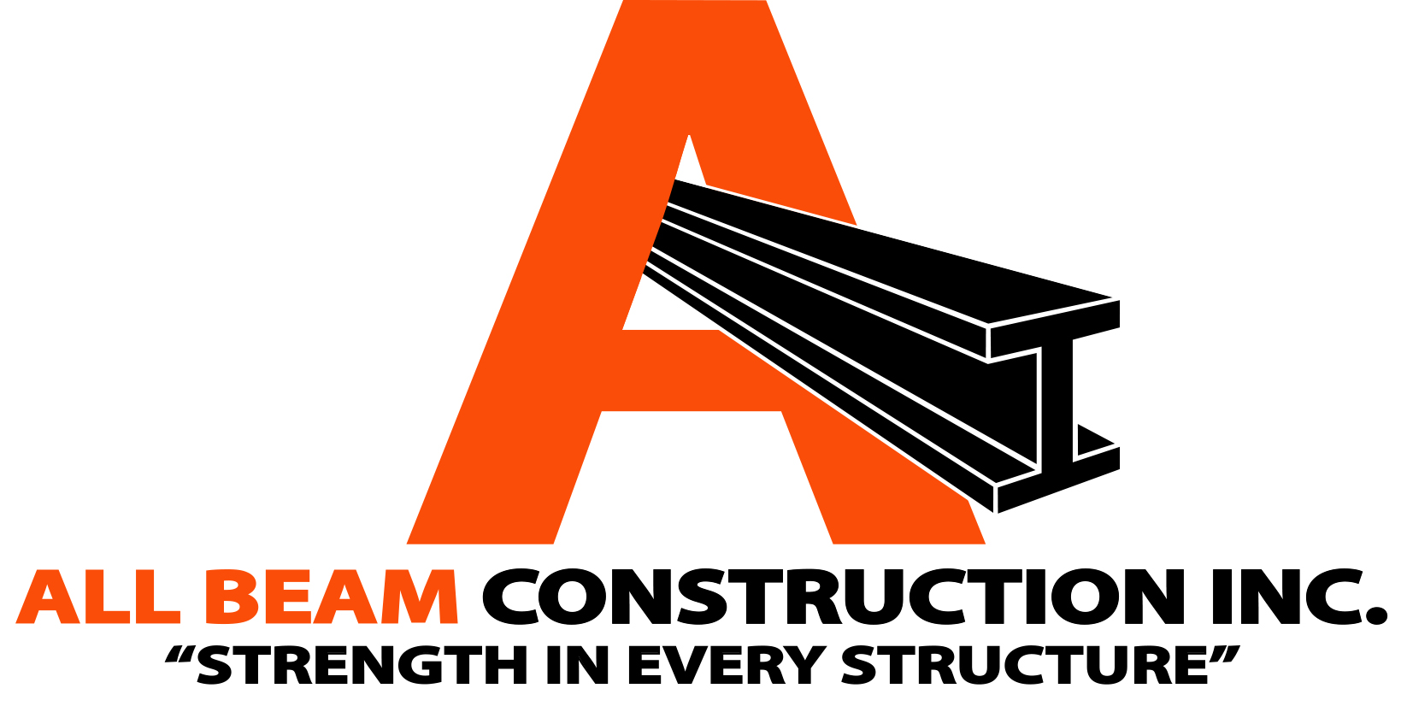

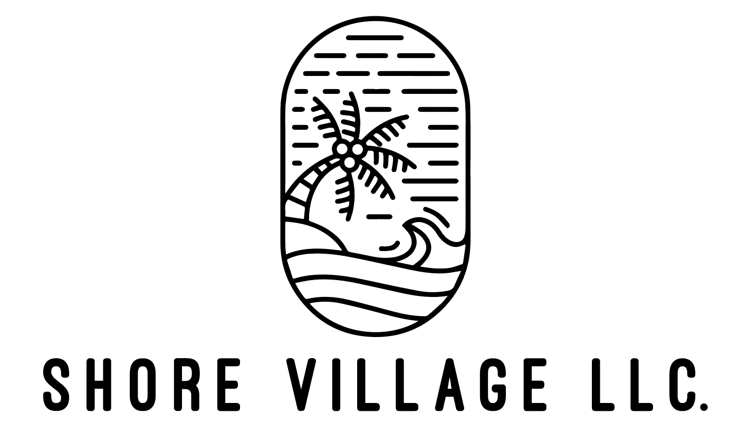

**Company Snapshot**

Established: 2022

CAGE: 9X5H6

UEI: WV7VGS74GTQ9

Accept Credit and Purchase Cards

Currently not enrolled in any contract vehicles.

Primarily serves Southern California region.

**Pertinent Codes**

236220 - Commercial and Institutional Building Construction

238110 - Industrial Building Construction

238130 – Framing Contractors

238140 – Masonry Contractors

238160 – Roofing Contractors

238220 – Plumbing, Heating and Air Conditioning Contractors

238310 – Drywall and Insulation Contractors

238320 – Painting and Wall Covering Contractors

238330 – Flooring Contractors

238350 – Finish Carpentry Contractors

**Licenses & Certifications**

Contractors’ license #1115678

SDVOSB

DVBE

OSDBU

**Key Clients**

All Beam Construction Inc. is a veteran-owned general contracting company specializing in residential and commercial construction, serving local and federal public work organizations. Our mission is to deliver exceptional craftsmanship and quality, ensuring every project is executed with precision and integrity. Driven by a commitment to excellence, we transform visions into reality with meticulous attention to detail. Founded on principles of accuracy and reliability, we consistently exceed client expectations and have earned the trust of a diverse clientele.

i

**Your Company(If it is not clearly in the logo)**

**Core Competencies**

* Federal Building Construction
* Infrastructure Development
* Facility Upgrades and Renovations
* Project Management for Federal Projects
* Design-Build Services for Government Contracts
* Compliance and Regulatory Expertise

**Differentiators**

* Veteran-owned with a disciplined and precise approach to every project
* Extensive experience in federal contracting with a proven track record
* Highly skilled team with specialized expertise in government regulations and compliance
* Commitment to exceptional craftsmanship and quality, ensuring every project meets the highest standards
* Accredited by the Better Business Bureau, reflecting our integrity and reliability

**Contact**

POC: Jeff Lore

Email: [jeff@allbeamconstruction.com](mailto:jeff@allbeamconstruction.com)

Phone: 562-645-6741

Address: 30 Corona Ave.

Long Beach, CA 90803

**Visit Our Website:** [**www.allbeamconstruction.com**](http://www.allbeamconstruction.com)

______________________________________________________________________________________________________________________

**562-645-6741 | Long Beach, CA 90803 |** [**www.allbeamconstruction.com**](http://www.allbeamconstruction.com)

**Past Performance**

* Client: Shore Village LLC
* Description: Managed several multi-unit building repair projects, encompassing roof, plumbing, and electrical systems.
* When: Duration of 6 months.
* What: Oversaw and coordinated repairs and maintenance across multiple units, ensuring timely completion and adherence to quality standards.
* Compensation: Total project budget of $160,000.