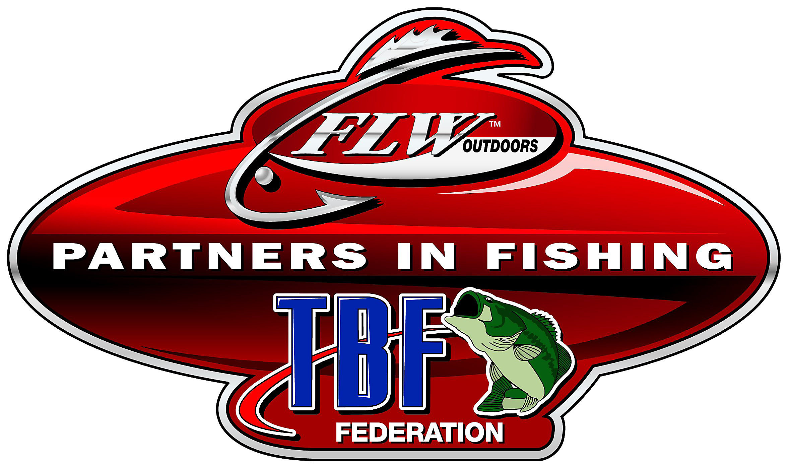

TBF OREGON TOURNAMENT RULES

1. **SPORTSMANSHIP -** any Contestant who displays poor sportsmanship, violates these Rules or violates the state fishing laws or lake rules may be disqualified. This includes conduct on and off the water including conduct in and around the host facilities for any event including hotels, casinos, retail establishments, etc. Misconduct is a bad reflection on organized fishing. Misconduct may be deemed as an infraction of our sportsmanship rule and is grounds for disqualification from any event
2. **BOAT AND HORSEPOWER REGULATION -** There is no minimum length or minimum horsepower requirements to compete in the TBF Oregon Events. Horsepower shall not exceed the horsepower rating for that boat or the U.S. Coast Guard rating plate attached to the boat by the manufacturer. Each boat must contain all required U.S. Coast Guard safety equipment. Boats must contain a properly aerated or re-circulating live well to maintain, alive, a team limit catch of fish. An ice chest with an aerator is acceptable upon approval of the Tournament Director. Any vessel deemed "unsuitable" by a Tournament Director will not be allowed to participate in that event. Contest banners are required for all non-permitted events in the State of Oregon.
3. **SAFETY -** All boats must meet Coast Guard regulations. Boat owners must carry a minimum of $300,000 Combined Single Incident Liability Insurance. Safe boating shall be practiced at all times. During competition, each contestant is required to wear a Coast Guard approved life jacket anytime the combustion engine is in operation. Anyone found operating a boat in an unsafe manner, in the opinion of the Tournament Director, may be disqualified. All boats must be equipped with an emergency ignition shut-off device, which must be securely attached to the drivers’ body whenever the combustion engine is in operation. The Tournament Director must approve any non-lanyard shut-off systems. All boats must have a float cushion on board. Each contestant is responsible to have proper safety equipment to meet state and local regulations. **It is not the responsibility of TBF Oregon or any tournament sponsor to provide assistance in on-the-water repairs or rescues at any time. Each contestant shall provide their own on-the-water assistance if needed. TBF Oregon and its sponsors are not responsible to assure that any contestant has returned at the end of any contest.** For safety, each contestant should inform another contestant as to the location(s) that they would be fishing and have that contestant check to assure that the other contestant has returned safely at the end of the contest and have a plan for assistance if needed.
4. **EQUIPMENT FAILURE OR EMERGENCY -** In the event of equipment failure or emergency, contestant’s boat may be towed to the check-in. If it is necessary to transfer fish to another boat, it must be another contestant’s boat. At least one member of the team must accompany the fish to the weigh-in site.
5. **BOAT INSPECTION -** Boat inspection instructions will be given at the sign-up site. Failure to obtain a sign-off at boat inspection may result in disqualification.
6. **PERMITTED FISHING METHODS AND TACKLE -** All fish must be caught live in a conventional and sporting manner. Trolling, also referred to as ripping / sweeping or jerking, is prohibited. Cast and retrieve methods of ripping and jerking are legal. Only artificial lures may be used with the exception of pork rind or deer hide. No prepared or live bait may be used. The *intentional* snagging of fish is strictly prohibited. **Landing nets are permitted in this event.** Only one “rod and reel” may be used at a time.
7. **PERMITTED FISHING WATERS –** **5 DAY** **OFF LIMITS PERIOD will be (Staring 12:01 AM) five (5) calendar days prior to the start date of the event.** Contestants may fish anywhere accessible by boat, except areas designated as “off limits” or “no fishing” by the Tournament Director, local, state, or federal officials or within 50 yards of any marina gas pump. All angling must be conducted from the boat. At no time may a contestant leave the boat to land a fish or to make the boat more accessible to fishing waters. No contestants are permitted to leave their boat in an effort to propel or float their boat to fishing waters they could not otherwise reach, however, the use of push poles is permitted. The boat must remain in the tournament waters during the tournament day. Contestants must leave from and return to the official check-in by boat.
8. **ENCROACHMENT -** A "25 yard rule" is in effect at all times during competition. No contestant's boat may move within 25 yards of another contestant's boat at any time for the purpose of fishing without the consent of all contestants involved. A boat moving from one area to another may infringe upon this zone as long and the parties that are moving do not fish and do not intentionally disrupt the area. Judging distance is very difficult on the water. As a general rule of sportsmanship, all anglers should give all others enough room to make a reasonable cast to fish an area. Exception: In the case of fishing docks or piers, no contestant's boat may "tie up," or "protect" more than a single dock at one time regardless of the distance involved.
9. **FISHING HOURS AND LATE PENALTY -** Official fishing hours will be announced at tournament sign-up prior to each event. All contestants must check in at the weigh-in site. Contestants who are not at the official check-in area at the appointed time will be disqualified. DON’T BE LATE!
10. **CULLING OF FISH -** **Culling of dead fish is prohibited and will result in disqualification**. No culling of fish in the host marina or weigh-in area.
11. **LIVE FISH -** Contestants shall make every effort to keep all fish alive through the use of a properly aerated live well. Half a pound (½lb) will be deducted from the total weight for each dead fish presented for weigh-in
12. The Tournament Director, or a designee, will make all judgments of fish mortality**.**
13. No Dead Fish Shall be weighed as Big Fish.
14. **SCORING -** Scoring will be determined by the total weight of each teams catch. The limit shall be five (5) fish per two-angler team, or five (5) fish for an angler fishing alone. The official minimum length for bass shall be twelve (12) inches **unless otherwise stated** at sign-up, or longer if the lake limit is greater than twelve (12) inches. Bass will be measured lying down, mouth closed / tail fanned, on a **FLAT board**. Bass presented for weigh-in, which fail to measure the prescribed minimum length limit, shall be removed from the catch and a penalty of one (1) pound will be deducted from the remaining weight. Each team’s catch must be presented in an official weigh-in bag. The team weighing the heaviest bass at that event will break all ties.  In the event that one of the team members is unable to fish then the team may be represented by one of the team members for no more than one weekend. First place will be awarded 100 points, second place 99 points and so forth. Paid contestants who fail to weigh a fish will be awarded 20 points less than the contestant with the lowest weight.
15. **PROTESTS –** Any protests must be made no later than 5 minutes after the last competitor has weighed in their catch. No protests will be allowed after this period. A formal protest form is available from the tournament director. All decisions will be made by the TD and are final.
16. **WAIVER AND RELEASE -** Each contestant must sign a waiver / release form prior to entering the event.
17. **NO ALCOHOL / NON-PRESCRIPTIONS DRUGS -** No alcoholic beverages and or non-prescription drugs are allowed during tournament hours. No alcoholic beverages or non-prescription drugs are allowed in any tournament boat.
18. **CITATIONS -** A contestant cited by officers for violation of Local, State or Federal fishing or boating regulations will be disqualified.
19. **HOG LINES –** defined as 2 or more vessels/boats anchored or moored within close proximity of another vessel/boat (defined as less than 10 ft apart). Tournament participants are to come off full speed pad 25 yards prior to approaching these vessels and idle completely past the anchored or moored vessels near or in the navigation channel. This is to protect our anglers and other users of the waterways. Please use common sense when approaching any anchored or slow moving vessels as if you were the ones being approached. **NO WAKE ZONES –**Will be identified as needed for each tournament waters by the Tournament Director, which may be in addition to any posted No Wake Zones.
20. **CELL PHONES / TEXTING –** No cell phone usage / texting is permitted to communicate the location or fishing status of any angler. Only in an emergency situation, a participant may use a cell phone to address the situation. Violation of this rule will result in disqualification from the event.
21. **National Semi-Finals** - NSF Qualification will be based on the number of points accumulated by the team for either the River or the Coastal Circuit. Points accumulated in one circuit cannot be combined with points accumulated in any other circuit. The top boaters and non-boaters in each circuit will qualify. TBF Oregon is currently allocated a minimum of 6 boaters and non-boaters as qualifiers for the District National Semi-Finals. Three of these teams will be provided by each of the two TBF Oregon circuits (Coastal and River). Each circuit can increase the number of NSF qualifiers based on the current participation requirements as prescribed by the National Office which is currently defined as 10% of participant days.
22. **RULE UPDATES –** Will be provided to all participants at the morning drivers meeting on the day of the event

## 

## FOR ALL EMERGENCIES, PLEASE CALL 911

**Reviewed/approved for 2020**