National Association of Food Distribution Programs on Indian Reservations  P.O. Box 908  Lawton, OK 73502  Phone (580) 360-0537  Email jaime.prouty@comanchenation.com | INVOICE# | 2026
 | Date:

To:  FDPIR Contact Name:  Tribe:  Address:  City: State: Zip:  Phone:  Fax:  Email: | For:  NAFDPIR Dues-2026

DESCRIPTION | AMOUNT
NAFDPIR 2026 ANNUAL DUES January 2026 to December 2026 | $350.00
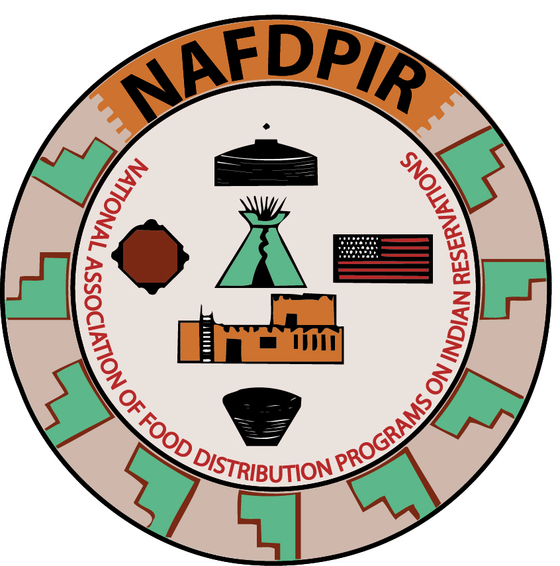
 | $350.00

Make checks payable to NAFDPIR
c/o Jaime Prouty, NAFDPIR Treasurer

