National Association of Food Distribution Programs on Indian Reservations  P.O. Box 908  Lawton, OK 73502  Phone (580) 492-3327  Email jaime.prouty@comanchenation.com | INVOICE# | 2025
 | Date:

To:  FDPIR Contact Name:  Tribe:  Address:  City: State: Zip:  Phone:  Fax:  Email: | For:  NAFDPIR Dues-2025

DESCRIPTION | AMOUNT
NAFDPIR ANNUAL DUES | $350.00
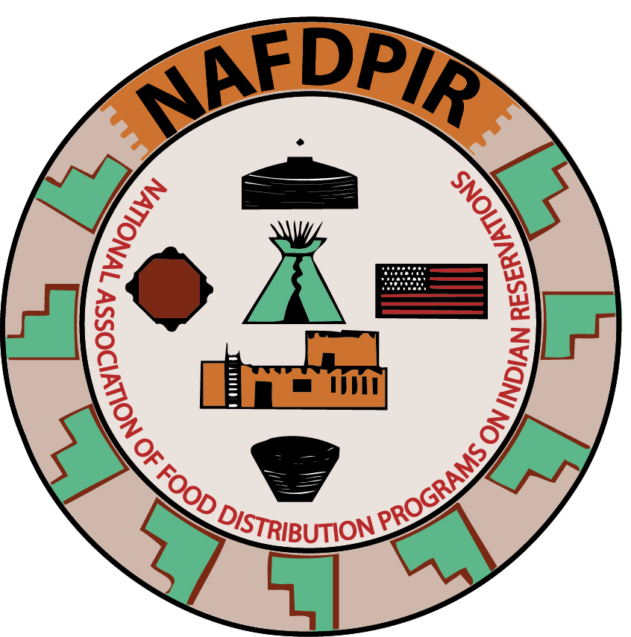
 | $350.00

Make checks payable to NAFDPIR
c/o Jaime Prouty, NAFDPIR Treasurer

