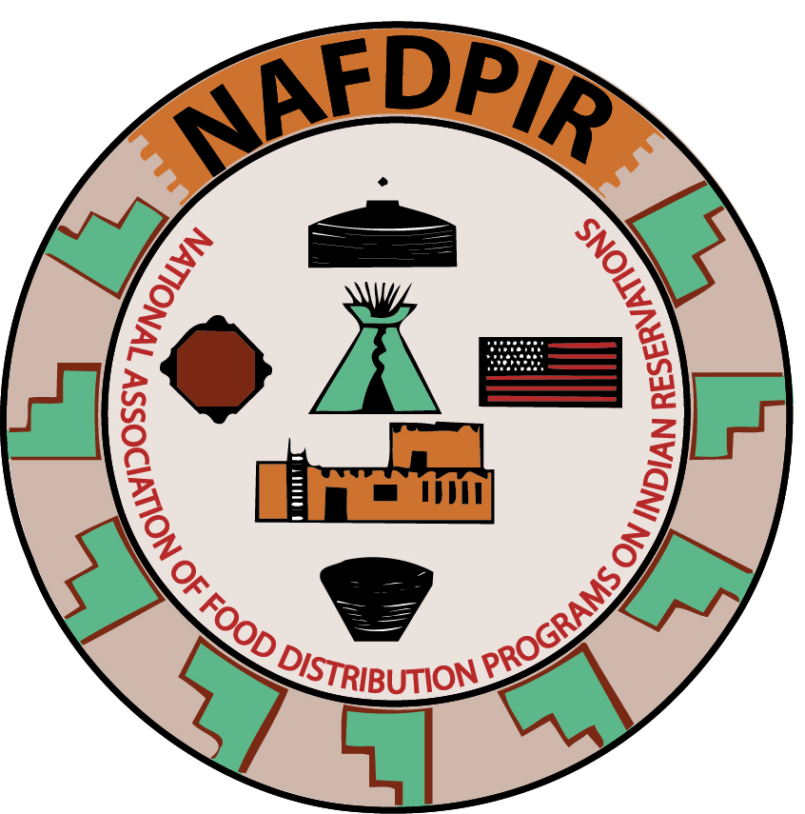

**Mary Greene-Trottier, President**

Spirit Lake Tribe

Mt. Plains Region

P.O. Box 414

Fort Totten, ND 58335

Phone: (701) 766-4684

mgreene@spiritlakefdp.com

**Marisa Fuller, Secretary**

Omaha Tribe of Nebraska

Mt. Plains Region  
P.O. Box 135  
Macy, NE 68039

Phone: (402) 837-4189

**Jaime Prouty, Treasurer**

Comanche Nation

Southwest Region

P.O. Box 908

Lawton, OK 73501

Phone: (580) 492-3327

**Rex Hailey,**

**Parliamentarian**

Seminole Nation

Southwest Region  
P.O. Box 111

Seminole, OK 74818  
Tel: (405) 234-5240

MIDWEST REGION

**Joseph VanAlstine, VP**

Little Traverse Bay Band of Odawa Indians

MOUNTAIN PLAINS

**Blake Garrison**

Prairie Band Potawatomi Nation

SOUTHWEST REGION

**Perry Martinez, VP**

Eight Northern Pueblo

WESTERN REGION

**AC Sanchez, 1st VP**

Coeur d’Alene Tribe

**National Association of Food Distribution**

**Programs on Indian Reservations**

June 11, 2025

Dear FDPIR Program Director’s, USDA/FNS Staff,

We are excited to invite you to the 36th annual National Association of Food Distribution Programs on Indian Reservations conference. The theme for this year’s conference is “**Resilience for Food Security”** hosted by the Southwest Region. The conference will provide FDPIR staff with resources and vital information for Director’s, warehouse staff, certification staff and Nutrition Educator’s an opportunity to collectively discuss policies and upcoming FNS & USDA guidance and pertinent information.

The NAFDPIR annual conference will work collectively with the USDA/FNS staff to successfully host the Nutrition Education Symposium. The presenters will bring vast knowledge to promote healthy eating and educational information to help all those in attendance grow in a positive way as well as enrich and encourage the sharing of knowledge for participants from the respective regions and ITO’s.

The NAFDPIR conference will be held Aug 24-29, 2025, at Gila River – Wild Horse Pass located at 5040 Wild Horse Pass Blvd, Chandler, AZ 85226. Phoenix Sky Harbor International Airport would be the local airport which is 14 miles from the airport. Uber is estimated $30.00 one way.

The room rate is $113.00 plus 13% tax per night for a single occupancy. The Reservation Line is 800-946-4452 X 4900 and then Option #1 or locally at 520-796-4900 please mention 2025 NAFDPIR Conference when making reservations. You can also book online using the booking link: <https://reservations.travelclick.com/75936?groupID=4553473> Reservation **Cut-Off**  is Noon on Thursday, by July 24,2025.

The registration fee for the conference is $800.00, after July 15th the late fee will be $900.00. No exceptions and No Refunds. We look forward to seeing everyone at the conference.

Sincerely,   
Mary Greene Trottier  
Mary Greene Trottier

NAFDPIR President