DELAND ELKS #1463 NNAPRIL 2023
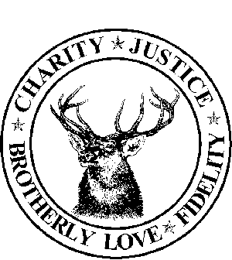
SUNDAY | MONDAY | TUESDAY | WEDNESDAY | THURSDAY | FRIDAY | SATURDAY
1
4:30P LODGE OPEN

2 | 3  6:30p HOUSE COMMITTEE MEETING  7-8:30p SCOUTS | 4  5p-? LODGE OPEN  ROTARY 5P-7P | 5  5p-9p LODGE OPEN 6P-8P DINNER  6:30P-7:30P CUB SCOUTS  6:30P PER MEETING | 6  5p-9p LODGE OPEN 6P-8P DINNER | 7  5P-10P LODGE OPEN 6P-8P WING NIGHT  8P-QUEEN OF HEARTS | 8  4:30P LODGE OPEN  5PM-STETSON LODGE RENTAL ?
 | 10   7:00p-Trustee meeting  7:30 PM Lodge Meeting-  7-8:30p SCOUTS | 11  5p-? LODGE OPEN  ROTARY 5P-7P | 12  5p-9p LODGE OPEN 6P-8P DINNER  6:30P-7:30P CUB SCOUTS | 13  5p-9p LODGE OPEN 6P-8P DINNER  6:30P BAR BINGO | 14  5P-10P LODGE OPEN 6P-8P WING NIGHT  8P-QUEEN OF HEARTS  FFA BINGO | 15  4:30P LODGE OPEN
16 | 17  6:30p HOUSE COMMITTEE MEETING  7-8:30p SCOUTS | 18  5p-? LODGE OPEN  ROTARY 5P-7P | 19  5p-9p LODGE OPEN 6P-8P DINNER  6:30P-7:30P CUB SCOUTS | 20  5p-9p LODGE OPEN 6P-8P DINNER  6:30P INITIATION | 21  5P-10P LODGE OPEN 6P-8P CAJUN NIGHT-WREATHS ACROSS AMERICA  8P-QUEEN OF HEARTS | 22  4:30P LODGE OPEN
23 | 24  7:00p-Trustee meeting  7:30 PM Lodge Meeting  7-8:30p SCOUTS | 25  5p-? LODGE OPEN  ROTARY 5P-7P | 26  5p-9p LODGE OPEN  6P-8P DINNER  6:30P PAINT WITH LISA  6:30P-7:30P CUB SCOUTS | 27  5p-9p LODGE OPEN 6P-8P DINNER  6:30P BAR BINGO | 28  5P-10P LODGE OPEN 6P-8P WING NIGHT  8P-QUEEN OF HEARTS | 29  4:30P LODGE OPEN
30 |  |  |  | 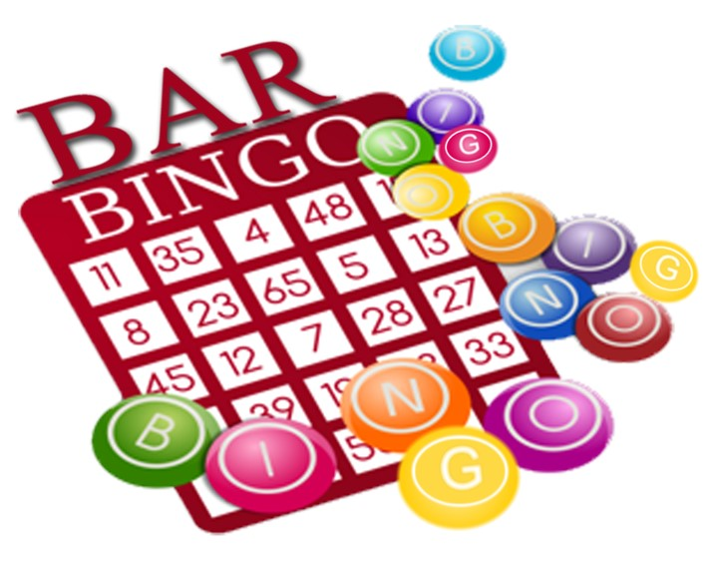 | 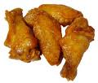

DELAND ELKS LODGE 1463 614 S. ALABAMA AVE.
LOUNGE 386-738-1463 DELAND, FL 32721
SECRETARY 386-734-0292

