DELAND ELKS LODGE #1463 OFFICERS 2023-2024
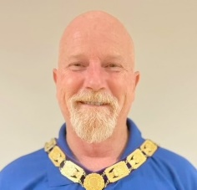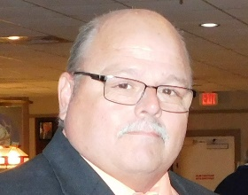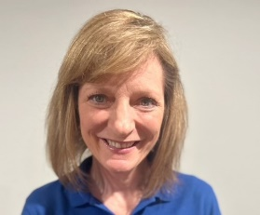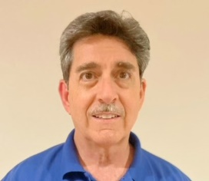
EXALTER RULER LEADING KNIGHT LOYAL KNIGHT LECTURING KNIGHT
SCOTT SANDERSFIELD GLEN FANNIN LAURA JONES ROBERT HENNESSEY

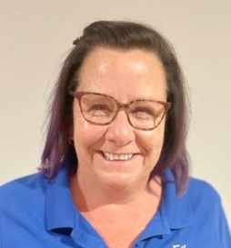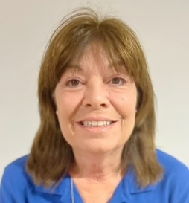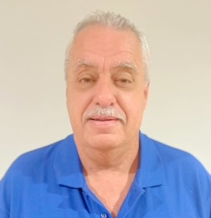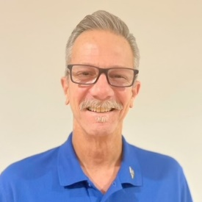
SECRETARY TREASURER TILER ESQUIRE
ALICIA VANOPDORP BARBARA THOMPSON SCOTT BROWNING SCOTT TUELL

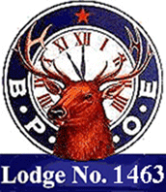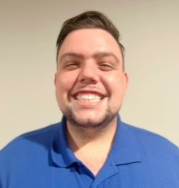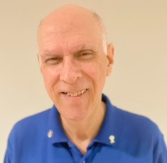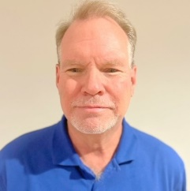
CHAPLIN INNER GUARD ORGANIST LODGE ADVISOR
ANITA NIXON JEREMY LOCY FRANK SCALIA MARK THOMPSON,PDDGER

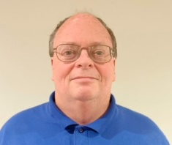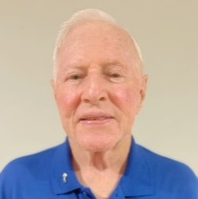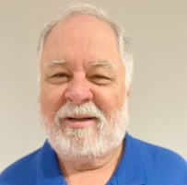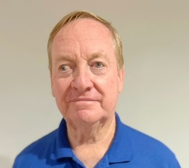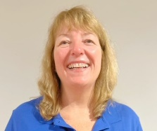
1 YEAR TRUSTEE 2 YEAR TRUSTEE 3 YEAR TRUSTEE 4 YEAR TRUSTEE 5 YEAR TRUSTEE
DEAN YEAGER. PER DAN DRAGONETTI BILL GRUMHAUS DAVE McCRANIE, PER BETH GRUMHAUS

