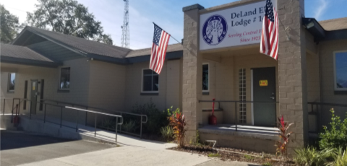

**DELAND ELKS LODGE 1463**

**LOUNGE 386-738-1463**

**SECRETARY 386-734-0292**

**614 S. ALABAMA AVE., DELAND, FL 32721**

**Mailing address:**

**P.O. Box 567, Deland, FL 32721**

July 2019

**EXALTED RULER’S MESSAGE**

Our Exalted Ruler is away in St. Louis attending the National Elks Convention along with Mark and Barbara Thompson. He’s asked me to share his thoughts with you.

What a great June at our lodge!!! Brotherly Love spreads as we welcomed 15 new members! A great way to get to know each other is Movie and Game Night on July 27th (Board games, card games, movie to be determined). We will start this event a little earlier so that it is a family friendly event-yes, bring the kids and/or grandkids. Kids are always welcome at the lodge until 9pm then lounge becomes 21 and over. Details to follow on Game Night.

As you all know, our lodge is run by volunteers and without you we would not be able to pull off the daily and monthly events without your continued help and support. Scott Sandersfield (386-837-3923), is our volunteer kitchen manager who has been providing, creating and cooking endlessly for our members. He would like to thank all those who have helped out in the kitchen (Tony McGhee, Warren Kerswill, Brian Zipse, Marshall Puckett, Phil Watercutter, Mike Alvarez, Mary Lou Carroll, Jody Emmons-Hyatt, Barbara Thompson, Mark Thompson, and the many other members who help serve and clean up). If you have talents in the kitchen and would like to volunteer, please call Scott – he’s accepting volunteer help all the time!!

Phil Watercutter is not only our Lodge Advisor but our volunteer bar manager. Our bartenders are paid employees who are required to follow the bylaws and statutes of the Elks which includes asking to see your current member ID. Phil also runs the monthly Birthday Steak Dinner. Please call him at 386-547-3703 to RSVP for steak dinner night (current members with a July birthday receive a free steak dinner on July 19th and their guests pay $15.00 per adult, $7.50 per child 10 and under).

We had a great turnout for volunteers on Saturday’s Western Dinner and Dance! Judy Beaty has outdone herself again with the decorations that she made herself!! We had a great crew help decorate (Jody Emmons-Hyatt, Missy Elkins, Beth Thompson, Barbie Felker, Lucy Hill, Phil Watercutter, Dan Dragonetti, Diane Massaro, David Caskey)! Please sign up at bulletin board to be part of our decorating team and Judy will be in touch with you!

Our next lodge workday is July 20th. We will be working on organizing and enhancing what we can in the back building. Please show up at 8:30a and bring tools for enhancements.

As always, we have many committees (activities, drug awareness, Soccer Shoot, Hoop Shoot, veterans, Membership, etc.). Please give me a call and let me know how you are looking to volunteer-one hour per month to several hours per week! We have something for everyone.

Respectfully,

Davina Jones, Secretary 386-734-0292



**NEXT INTERLODGE VISITATION FOR TOM HOPP, ECDVP**

**JULY 20TH AT MERRITT ISLAND 5PM**

**SIGN UP ON BULLENTIN BOARD OR CALL DAVINA TO RSVP 386-734-0292**

**RENTALS AND STETSON PARKING CONTACT:**

**DAVID MCCRANIE 386-228-7259**

**ACTIVITIES: CHIP HAVERTY 386-956-2716**