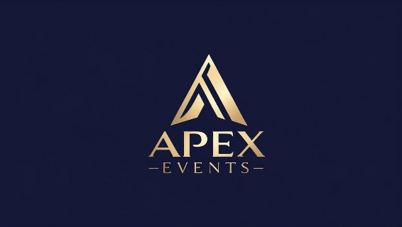

Sponsorship

PRETTY TIED UP
GUNS n ROSES
TRIBUTE BAND
&
The Ultimate Ozzy Experience
Madman’s Diary
Waukesha County Expo, Waukesha County, Wisconsin
April 10th, 2026, from 7 P.M. – 10:00 P.M.
April 11th , 2026 from 7 P.M. – 10:00 P.M.
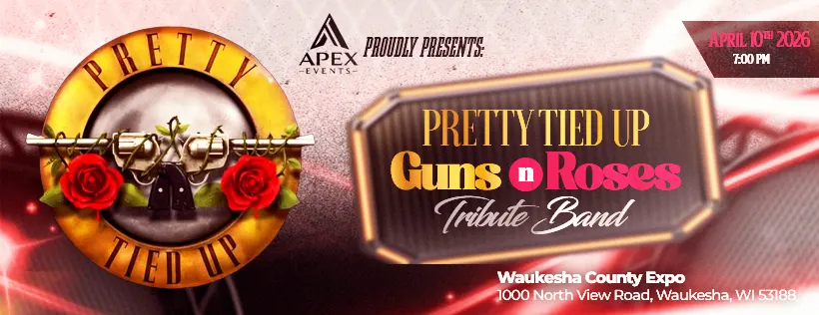
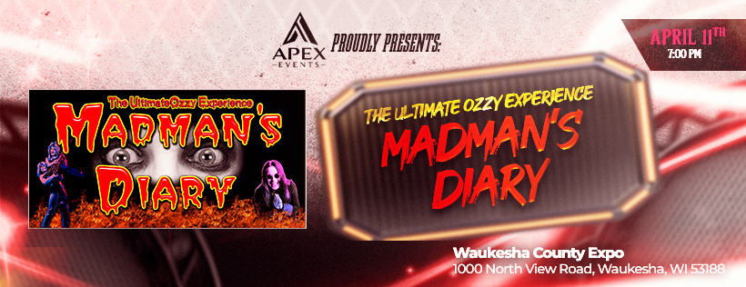

Your support is so greatly appreciated. Thank you for your interest in being a sponsor for our Pretty Tied Up Guns n Roses Tribute Band on April 10th and The Ultimate Ozzy Experience on April 11th.

We are beginning to offer limited sponsorship opportunities for companies we think would be a good fit for our audience.

We are happy to customize an advertising / sponsorship package that puts your name and your brand in front of attendees who will migrate to Waukesha County Expo. Packages can be designed to meet every budget with prices ranging from $800 to $2,500 and tailored to help you reach specific segments within your clientele.

Advertising and promotional opportunities include high quality banners for stage and entrance, radio coverage on 2 local stations, TV, social media advertising with mentions, and much more. We really have something for every advertising budget!

Benefits of Being a Sponsor

Your brand will be in front of a large crowd of music fans.
Sponsorship Opportunities

PLATINUM PACKAGE
$2500.00

The Platinum Package is our top level of Sponsorship. There will only be 8 sponsors in this category. This package includes the following:

- Sponsor logo will be on the entrance banner at the event.
- Sponsor logo will be on television commercials and mentioned on radio commercials.
- Sponsor logo will be on the stage banner.
- Sponsor logo will be included in print media and social media marketing.
- Sponsor logo on VIP tables
- Logo will appear on Apex Events website
- 4 individual social media posts one month before event
- 8 General admission music fest passes to the event.

GOLD PACKAGE
$1000.00
The Gold Package is our premier level of Sponsorship. This package includes the following:
- Sponsor logo will be on the entrance banner at the event.
- Sponsor logo will be included in print media and social media marketing.
- Logo will appear on Apex Events website
- 2 individual social media posts two weeks before event
- 4 General admission music fest passes to the event.

SILVER PACKAGE
$800.00

The Silver Package is our entry level of Sponsorship plans. This package includes the
following:
- Sponsor logo will be included in print media and social media marketing
- Logo will appear on Apex Events website
- 1 individual social media post one week before event
- 4 General admission music fest passes to the event

- LEVEL I: Platinum Package
- LEVEL II: Gold Package
- LEVEL III: Silver Package

Please accept my payment of $ ________ by: Check ____ Money Order ____
We can also send you an online invoice to pay online. ___________

Signature _____________________________________
Today’s date___________________________________
Company Name ________________________________
Contact Name _____________________________________
Address________________________________________________________________
City / State / Zip Code ________________________________________________________________
Telephone ___________________________
Email Address ___________________________________

COMPLETE AND RETURN TO: Apex Events
Make checks payable to Apex Events– 5220 Medina Road Pensacola, Florida 32507
www.apexevents-co.com
Christie Sachse, Owner • 850-376-9350 apexevents05@gmail.com

