
Sponsorship
2026 Fall Fest at Biloxi Towne Greene
710 Beach Blvd
October 17th, 2026 10a.m. – 5p.m.

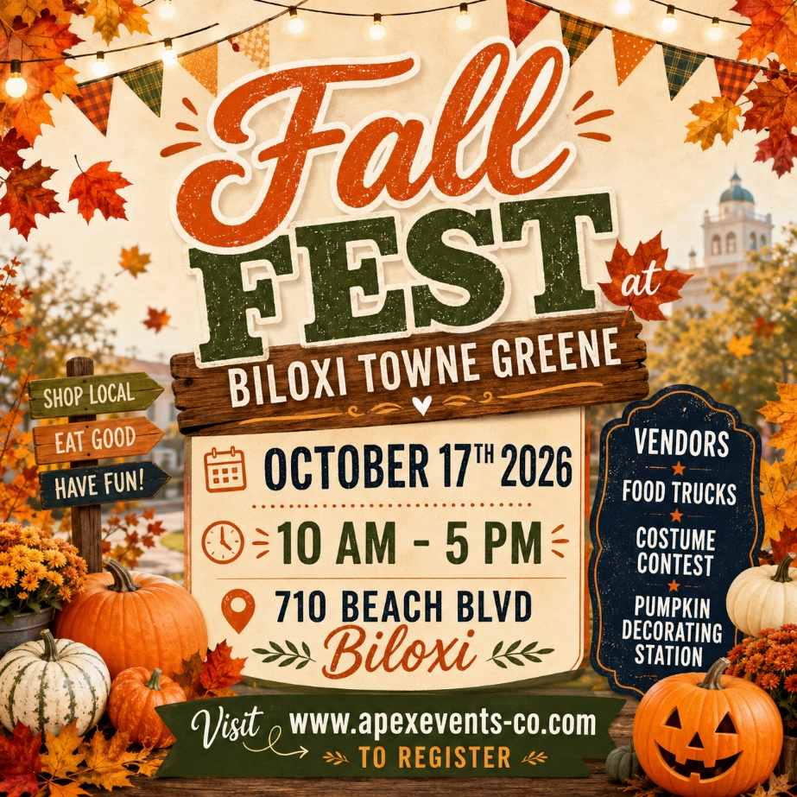

Come and join us at the Fall Fest at Biloxi Towne Greene, a vibrant and exciting festival located at Biloxi Towne Greene. This festival promises a day filled with vendors, fun, laughter, and great memories.

Benefits of Being a Sponsor

Your brand will be in front of a large crowd of kids and families.
Sponsorship Opportunities

PLATINUM PACKAGE
$1500.00

The Platinum Package is our top level of Sponsorship. This is available to eight Sponsors. This package includes the following:
- Sponsor logo will be on the entrance banner at the event
- Sponsor logo will be included in print media and social media marketing
- Logo will appear on Apex Events website
- 4 individual social media posts one month before event
- Sponsor name recognition on 30 second event radio commercial with 2 local stations a week before the event.
- Sponsor name on vendor maps
- 12x12 Vendor Booth Space if needed. (Sponsor to provide tent)

GOLD PACKAGE
$750.00
The Gold Package is our premier level of Sponsorship. This package includes the following:
- Sponsor logo will be on the entrance banner at the event
- Sponsor logo will be included in print media and social media marketing
- Logo will appear on Apex Events website
- 2 individual social media posts two weeks before event
- Sponsor name on vendor maps
- 12x12 Vendor Booth Space if needed.

SILVER PACKAGE
$300.00

The Silver Package is our entry level of Sponsorship plans. This package includes the
following:
- Sponsor logo will be included in print media and social media marketing
- Logo will appear on Apex Events website
- 1 individual social media post one week before event

- LEVEL I: Platinum Package
- LEVEL II: Gold Package
- LEVEL III: Silver Package

Please accept my payment of $ ________ by: Check ____ Money Order ____
If you pay by credit card a 3% service fee will be added.

Signature _____________________________________
Today’s date___________________________________
Company Name ________________________________
Contact Name _____________________________________
Address________________________________________________________________
City / State / Zip Code ________________________________________________________________
Telephone ___________________________
Email Address ___________________________________

Apex Prestige Events LLC
5220 Medina Road
Pensacola Florida 32507
• 850-376-9350
Apexevents05@gmail.com
www.apexevents-co.com

