
Sponsorship
Orange Beach Holiday Market at Orange Beach Community Center

November 29th from 9 a.m. – 5 p.m.

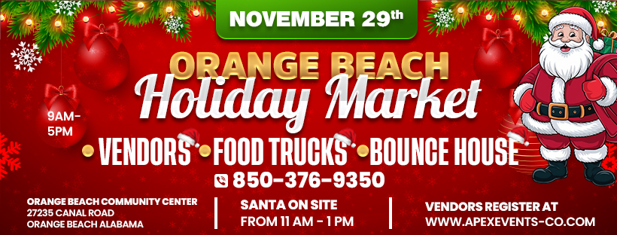

Come get your Holiday shopping done early at the Orange Beach Holiday Market at the Orange Beach Community Center from 9- 5 PM. Vendors, Food Trucks, and Bounce House. Santa will be stopping by to greet the kids for the day between 11 and 1 PM.

Benefits of Being a Sponsor

Your brand will be in front of a large crowd of kids and families.
Sponsorship Opportunities

GOLD PACKAGE
$750.00
The Gold Package is our premier level of Sponsorship. This is available to five Sponsors. This package includes the following:
- Sponsor logo will be on the entrance banner at the event
- Sponsor logo will be included in print media and social media marketing
- Logo will appear on Apex Events website
- 2 individual social media posts two weeks before event
- Sponsor name on vendor maps
- 12x12 Vendor Booth Space

SILVER PACKAGE
$300.00

The Silver Package is our entry level of Sponsorship plans. This package includes the
following:
- Sponsor logo will be included in print media and social media marketing
- Logo will appear on Apex Events website
- 1 individual social media post one week before event

- LEVEL II: Gold Package
- LEVEL III: Silver Package

Please accept my payment of $ ________ by: Check ____ Money Order ____

Signature _____________________________________
Today’s date___________________________________
Company Name ________________________________
Contact Name _____________________________________
Address________________________________________________________________
City / State / Zip Code ________________________________________________________________
Telephone ___________________________
Email Address ___________________________________

www.apexevents-co.com
• 850-376-9350
Apexevents05@gmail.com

