**Step-by-Step Guide to Removal and Cleaning of Compression Block Housing Screw Holes**

**Problem Description:** cigarettes rolled in a machine with an incorrectly installed or aligned compression block assembly will often not be filled to the tip or the base near the filter.  
  
**Problem Troubleshooting:** check the compression block for correct installation, tightness, and alignment.  If there is tobacco in the screw holes or caught between the compression block and the housing, then, the block will be out of alignment thereby preventing the tobacco forming knife from properly fitting with the block to cut the tobacco load.    
  
We use two different tests to check the proper installation of the compression block:  
  
**Test 1: Knife Former and C8 Injector Rod Test:**  
  
During the “Cut” stage of movement, the tobacco forming knife moves toward the front of the machine and actually enters the compression block far enough to block the injector rod from being able to enter the compression chamber area.  To check this:  
  
1)      Lay down the empty dozer and carefully clean all loose tobacco from the compression block area.  Make sure the air to the machine is OFF.  
  
2)      Reach under the dozer and pull the tobacco forming knife all the way toward the front of the machine until it stops against the compression block.  Hold it in place.  
  
3)      Try to move the C8 Injector rod into the compression chamber.  If the C8 rod hits the side of the tobacco forming knife and cannot enter the compression chamber, then, the block is likely installed correctly.  
  
4)      If the C8 rod can slide past the tobacco forming knife while it is being held to the front of the machine, then, the block is likely installed with tobacco under the block and/or there is tobacco debris in the screw holes that is preventing the screws from properly tightening in the housing.  
  
**Test 2: Compression Block Screw Depth Test:**  
  
The screws that hold the block in place are critical to the proper installation and alignment.  To check the proper functioning of the screws:  
  
1)      Lay down the empty dozer and carefully clean all loose tobacco from the compression block area.  Make sure the air to the machine is OFF.  
  
2)      Remove the compression block from the housing.  
  
3)      Leave the compression block out of the machine and reinsert the two screws and thread down until they are snug but not tight.  
  
4)      Take 4 standard 5 cent nickels and stack them next to the screws.  If the stack can slide UNDER the head of either screw, then, there is tobacco debris in the screw holes that is preventing the screws from properly tightening in the housing.  Please follow the instructions for removing the compression housing and cleaning the screw holes.

**Removing the Compression Block Housing**

[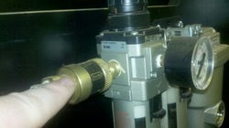](http://ryomachineservice.com/6678780_orig.jpg)

1)      Turn off air by sliding air valve inside machine from front top left side toward the front of the machine.

[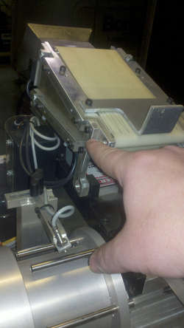](http://ryomachineservice.com/8075946_orig.jpg)

2)      Pull the red handle and lay dozer down toward back of machine. Remove the 2 screws on the left side of dozer assembly arm bracket.  
3)      Lift dozer up to about 30 degree angle and work the right side bracket off of its pivot point so that the dozer comes free from housing. Lay the dozer  down in back of machine without removing wires.

[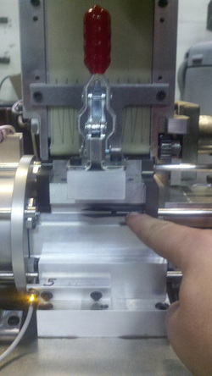](http://ryomachineservice.com/1587732_orig.jpg)

4)      Remove Flex tip by unscrewing it from the C9 Tube Former Rod.

[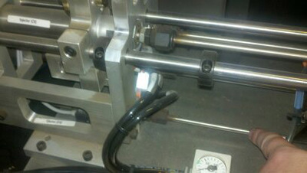](http://ryomachineservice.com/3451237_orig.jpg?403)

5)      Extend the C4 Ejector Rod slightly into the drum assembly by sliding it to the right from rear of machine.  This will make the reassembly easier since it will already be aligned.

[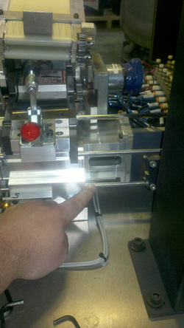](http://ryomachineservice.com/2100382_orig.jpg)

6)      Extend the C5 Rejecter Rod slightly into the drum assembly by sliding it to the left from the front of machine.  This will make the reassembly easier since it will already be aligned.

[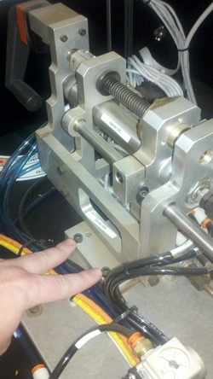](http://ryomachineservice.com/9209721_orig.jpg)

7)      Remove the back 2 screws from the base of the crank assembly from behind the machine or from the side door.

[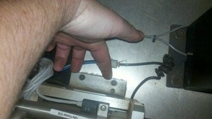](http://ryomachineservice.com/9933560_orig.jpg?291)

8)      Remove front 2 screws from the base of the crank assembly from side door.

[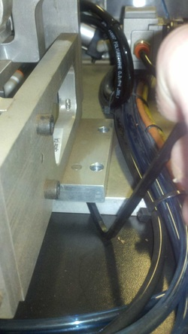](http://ryomachineservice.com/8032831_orig.jpg)

9)      Using a screwdriver or a large Allen wrench, pry the crank assembly off the base plate. This will take a little force because there are 2 guide pins that line this part up and are pressed in place.  The base of the crank assembly will lift off of the deck of the machine.

[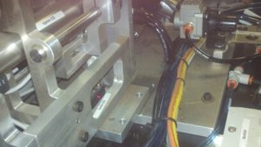](http://ryomachineservice.com/2367275_orig.jpg?304)

10)      Once loose, lift up crank assembly just enough to clear the pins and then pull back toward the side door just enough so that the injector and flex tip rods are clear of compression area.

[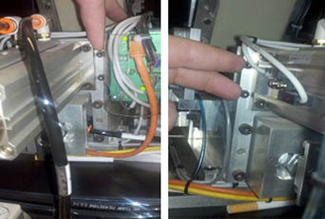](http://ryomachineservice.com/8723207_orig.jpg?393)

11)      From behind machine, locate the 4 screws that hold the extended compression housing in place 2 are on the left side of tobacco former cylinder and 2 are on the right side of tobacco former. Depending of version of machine, you may or may not have to do this step if there are no screws in this area then continue to next step.

[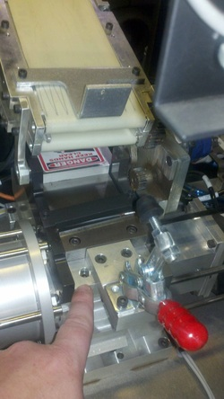](http://ryomachineservice.com/6792360_orig.jpg)

12)      Remove 2 screws on the left and right side of the red handle. Note these 2 screws are parallel to the compression block screws and out past the red handle screws.

[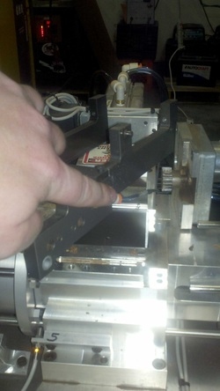](http://ryomachineservice.com/8111902_orig.jpg)

13)      Remove the compression housing by tapping under the red handle housing or by just lifting up and wiggling the red handle housing. Once removed, you will need to remove small air line on right side of housing. This is done be squeezing the orange ring to the beige elbow allowing the hose to be pulled out of the orange ring.

[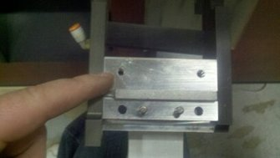](http://ryomachineservice.com/1588517_orig.jpg?338)

14)      Once housing is out of machine, remove the compression block housing and turn the housing over to note the tobacco in the holes.

Using a small eyeglass screw driver, dig out the tobacco from the screw holes.  Once you can get the screwdriver through the holes, put the compression block mounting screws back into the holes without the compression block. Tighten down screws until they get tight then back them off and tighten again continue this process until the screws go all the way through the bottom of the housing.   Clean the holes thoroughly with cue-tips and alcohol.  
  
**Reassembly of Machine**  
  
1)    Clean out all dust from the compression housing area on the drum assembly.  
  
2)    Reattach the small air line to the compression housing by pushing the air line into the orange coupling.  
  
3)    Position the compression housing into place.  
  
4)    Insert the 2 screws on either side of the red handle assembly and snug these down in place so that there is no space between the housings, and then, loosen the 2 screws up slightly.  
  
5)    If your machine had the 4 screws that attached through the back of the extended compression housing on the left and right side of the tobacco former cylinder, replace these and tighten them into place.  
  
6)    Tighten the front 2 screws on the left and right side of the red handle.   
  
7)    Extend the C8 Injector Rod and the C9 Flex Tip Rod into the compression area.   
  
8)    From the side door of the machine, push the crank assembly back into place so that the pins drop into position.  
  
9)    Start all 4 screws in the crank assembly base plate and snug them down in an X pattern order starting with front left then back right then back left then front right until they are fully tightened into position.  
  
10)    Reattach flex tip to the C9 Tube Former Rod.  
  
11)    Position the dozer back into place from the front of machine putting right side on first then putting the screws back in the left side bracket arm.  
  
12)    Push the C8 Injector Rod fully to the right into the retracted position and reinsert the compression block putting your fingers in the opening to hold the compression block secure to front of machine and tighten the compression block screws.  
  
13)    Perform the compression block tests again to confirm that the block is installed and aligned correctly.  
  
14)    Lock dozer into position and turn the air on.