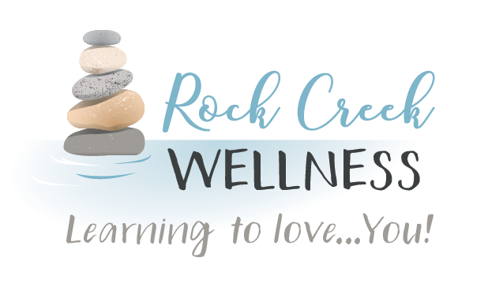

*RockCreekWellness.org*

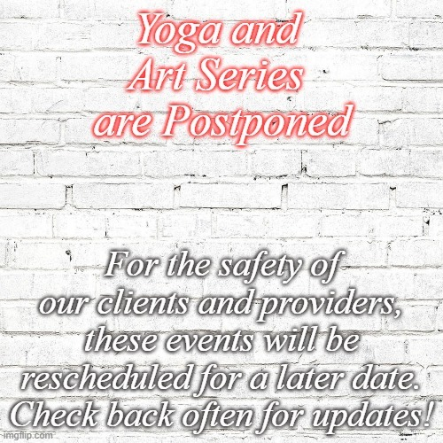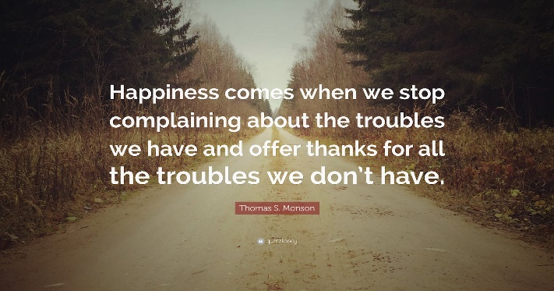

***Stay tuned for the rescheduling of our Art and Yoga Series!***

**If you start to experience anxiety or feel yourself becoming negative or complaining, pause, take a deep breath, and try one of the exercises above. Taking care of your mental health is important and gratitude practice has shown to activate dopamine and make you feel better!**

**While your feelings and many of your concerns are valid, exercising gratitude during this confusing and overwhelming time may help alleviate some of your anxiety or improve your mood.**

**Interrupt anxiety with gratitude by engaging in the following activities:**

* **Make a list of your worries/complaints and counter them with things you're thankful for given that circumstance i.e., my internet connection is slow, and it’s taking too long to get my work done; I am grateful that I am able to work from home.**
* **Acknowledge your own personal skills, traits, or accomplishments i.e., I am great at multi-tasking, I am showing compassion, or I made a meal for myself or family.**
* **Reach out to someone and tell them the things you appreciate about them i.e, send your child’s teacher a message and thank them for their work with your child.**
* **Keep a daily journal where you list 3-5 of the blessings from your day. Think small, ex. my home is warm, I have food in the cupboard, and the sun is shining.**
* **Set a gratitude reminder on your phone. Each time it goes off, bring your awareness to the present moment and identify what you are grateful for in that moment.**

Krista Armstrong LPC

April

*60 B Franklin Rd.*

*Mercer, PA 16137*

*724.269.7222*

*office@rockcreekwellness.org*

*Current Events***>>>**

Go to Gratitude



*At Home Nutrition*

Katelyn Struthers NASM CPT

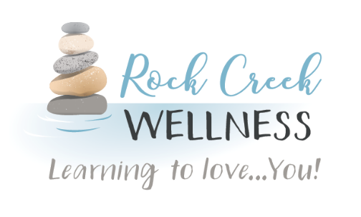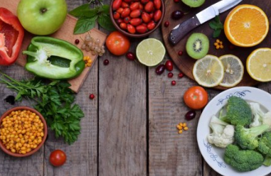

Rock Creek Wellness is available to provide education to your business on a wide variety of wellness topics, contact us today for more information!

***A great big thanks to all of our current clients who have been wonderful at accepting virtual therapy appointments with our providers!***

***We are pleased to offer virtual services via Google Hangouts. Hangouts is a unified communications service that enables text, voice, or video chats, either one-on-one or in a group. Hangouts is built into Google+, Gmail, YouTube, and Google Voice.***

***Google Hangouts is available on iPhone, iPad, Android devices, PC, and Mac. It can be downloaded as an app on your smart device or an internet browser extension for your desktop or laptop.***

***By providing virtual services we are able to make healthcare accessible to anyone, anywhere with everyday telemedicine. Google Hangouts is HIPAA compliant, your interactions with our providers are protected.***

Thank You!!

**3. Plan your meals, make it a family event:** You can actually reduce your food costs and waste by having the whole family chime in on what meals will be made! You can buy ingredients that can stretch for several meals. Cooking chicken in your slow cooker and shredding it can give you meals such as tacos, salads, soups or sandwiches. Fruits or veggeis can be the main dish for one meal and a side dish for another.

**4. Drink plenty of water:** Drinking at least 64 ounces of water a day is one of the ways to help improve our immune systems. While we’re home it’s easy to reach for a canned beverage, so instead of grabbing your favorite pop find a sparkling water with a flavor that you like. There are many brands on the market today with no added sugar and taste great. Tea is an option as well.

**1. Stock up on frozen fruits and veggies:** While fresh is usually best, frozen fruits and veggies are an excellent alternative and allow you to stock up. These are great heart-healthy foods. Make sure to load half your plate with the rainbow of fruits and veggies at each meal.

**2. Find nutrient dense non-perishables:** Typically non-perishables are processed with additives to last longer. Lentils (beans) can be stored for months bought dried in bulk or cooked in cans (easier for meal prep too!) Don’t forget about alternative protein sources like powders or eggs, which can keep for roughly five weeks!

We are typically creatures of habit when it comes to our diets. We fix the same meals, dine at the same restaurants, indulge in the same favorite treats. But what happens to our diets when our typical routines are disrupted? While many are stocking up on non-perishable foods right now, are you left wondering how to stay healthy while staying at home? It’s easier than you think! food.

*Coming Up* **>>>**