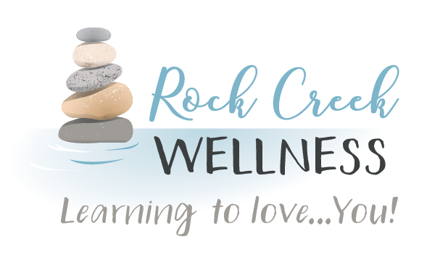

*RockCreekWellness.org*



August

Krista Armstrong LPC

Oakview Elementary School held a wellness camp for students July 20th-23rd and 27th-31st. The kids got to engage in physical activity, art, STEM activities, and had a lot of fun! Krista Armstrong was able to participate as a counselor at the camp and provided social-emotional education and support. The students learned about emotions and emotion regulation and practiced these skills throughout the camp!

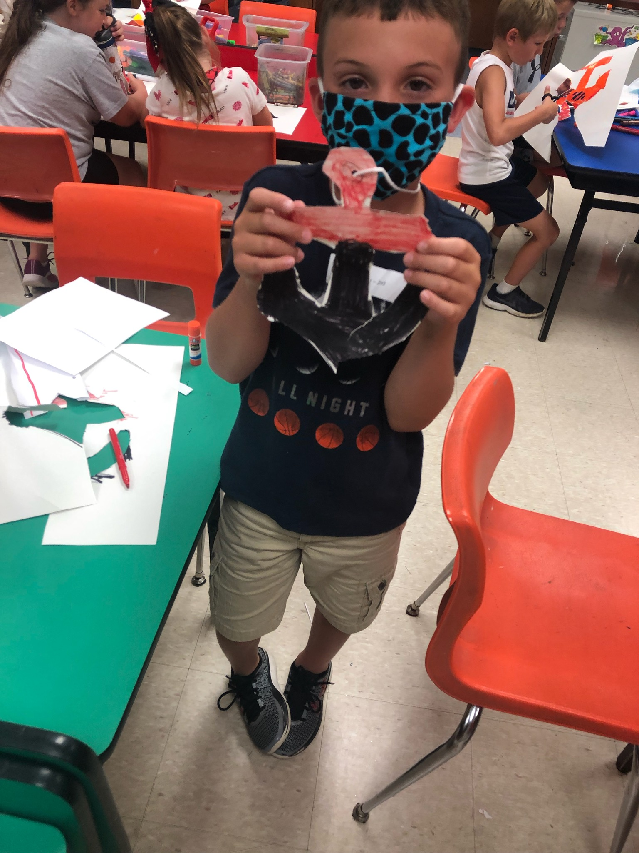 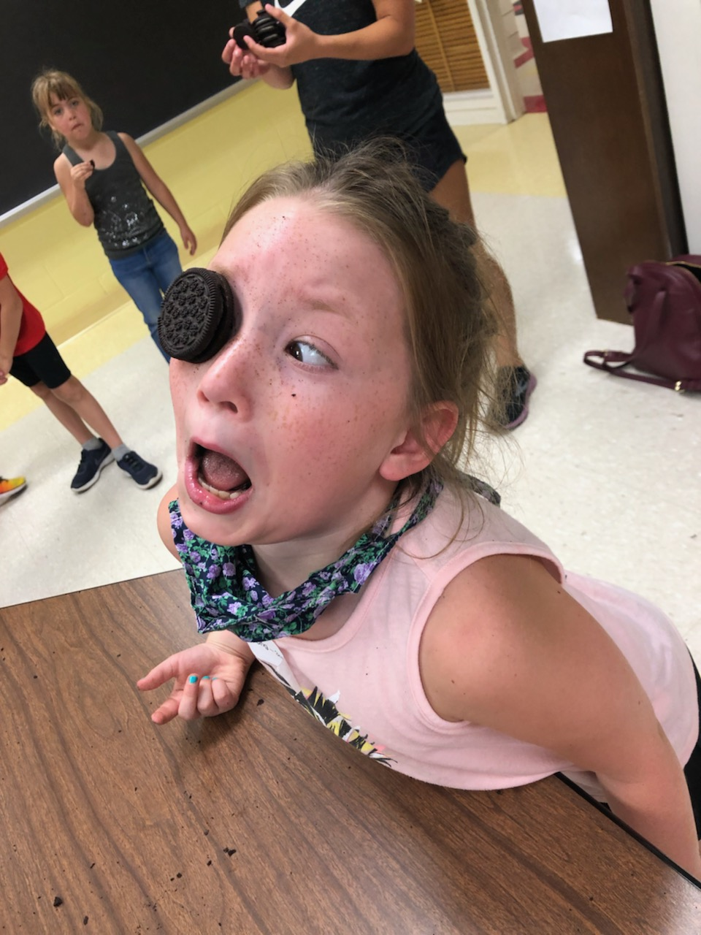 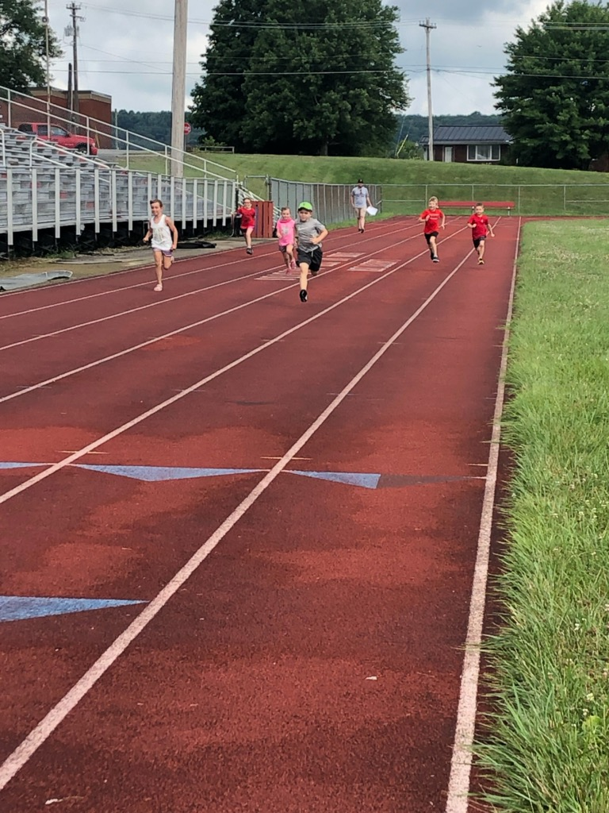

“For many of us, stress not only has mental and emotional symptoms, it has physical symptoms too: headaches, back pain, and heartburn are just a few of the stress-related ailments we may experience.

By mentally scanning yourself from head to toe, you are bringing awareness to every single part of your body, noticing any aches, pains, tension, or general discomfort. Staying present with and breathing into these sensations can help bring relief to our minds and bodies by evolving our relationship to pain, aches, and discomfort.

For More Informaion Visit: headspace.com/meditation/body-scan

Mindful Technique of the Month: Body Scan

Oakview Elementary Wellness Camp

*60 B Franklin Rd.*

*Mercer, PA 16137*

*724.269.7222*

*office@rockcreekwellness.org*

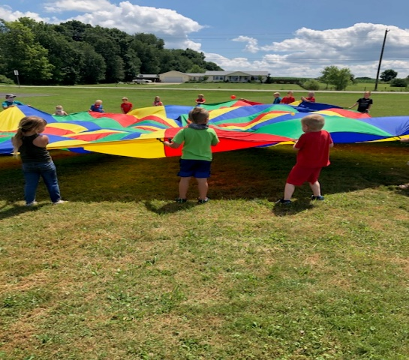

*Listening to your body*

Katelyn Struthers NASM CPT

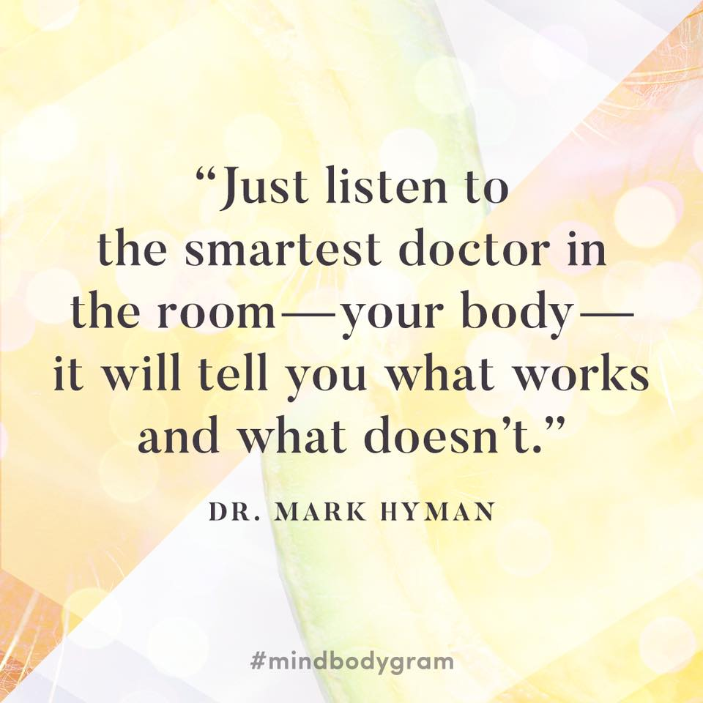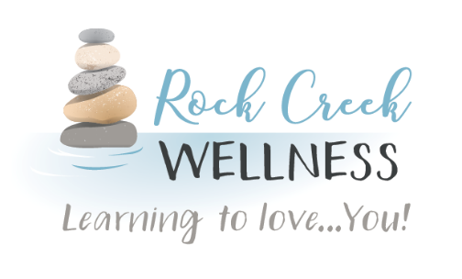

Thank you to our clients, wellness partners, friends, and family – without you, we would not be able to serve our mission of providing multiple services to create a safe, experiential learning environment with a holistic healthcare approach.

If you have not done so already, we would love to connect with you! You can find us on Facebook, Instagram, Linked In, and our website: RockCreekWellness.org. Be sure to “like” and follow our pages and sign up for our email list. There youll receive this monthly newsletter, information on new services, and connect with us regularly on what services you would like to see next.

We remain committed to finding new ways for Learning to Love…You!

Thank You

Movement is good for us, but often we are pushing our bodies beyond their means or exercising for too long or at too high an intensity. Instead of struggling to find the happy balance, simply listen to your body. If you have extended periods of fatigue, energy crashes, or a nagging ache or pain these are all signs that you could be overtraining, not managing pain or conditions properly, or suffering from a lack of

sleep or poor quality sleep. These issues can have a snowball effect leading to increases of stress, hormone fluctuations, and poor diet choices.

We lead busy lives today with family, education, work and much more. It takes effort to gain conscious perspective on how we are physically getting through it all. We need to seize the opportunity to check in with our bodies to assess how our schedule or routine is affecting us physically. We often give up the chance to rest or eat healthy for things we give more priority to than our own selves. Deciding to be mindful of our bodies' cues could be the difference in lost time at work, catching a condition early, or suffering burnout.

Sometimes popular sayings for motivation are just not good advice. Have you ever heard someone say (or even said yourself): "pain is weakness leaving the body," “sweat is just your muscles crying,” “go until you can’t go anymore, then do one more.” While these things might sound like encouragement in the moment of making progress towards health and fitness goals, they are actually putting us at risk for injury and setbacks. When we say these things to others or ourselves, it is usually not long before a physician is asking us when the problem started, or if we felt the pain or injury coming on. And then it dawns on us too late, we should have listened to our body.

Rock Creek Wellness is available to provide education to your business on a wide variety of wellness topics, contact us today for more information!

*Coming Up* **>>>**