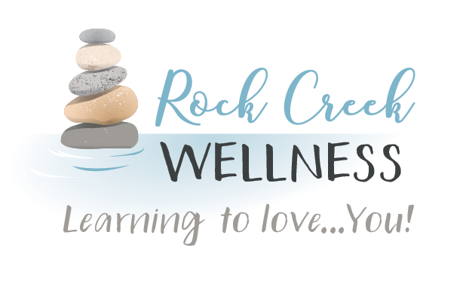

*RockCreekWellness.org*

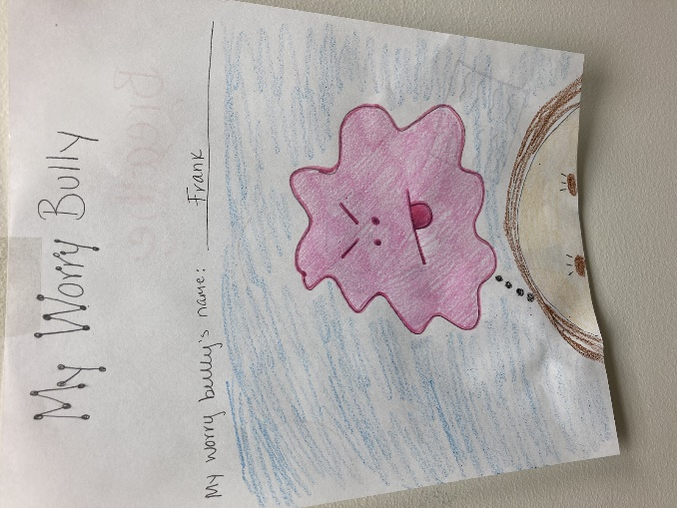

Worry is when our brains get stuck on thinking about problems or potential problems and it often comes with a feeling of anxiety and/or uncertainty that is pretty uncomfortable to feel. Kids experience worries but sometimes don’t have the awareness or words to share what is going on and because of where they are in their development, might not have or be able to use some of the tools adults use to manage these feelings or change these thoughts.

To help your child with worry, read stories together to help them understand what is happening for them. Some stories I like to share are *Ruby Finds a Worry, A Little Spot of Anxiety*, and *Don’t Feed the Worry Bug*. It can also be helpful to have kids draw what their worry bug or bully looks like, give it a name, and even talk about the things the bully will say and how they feel when the bug shows up. Then, you can use this to help your child notice when they’re feeling worried by asking questions like, “Is Frank bugging you again?, “What is the bully telling you.. Is that true?” “What can we do or say to him to make him go away?”

Helping your kids recognize and talk about worries helps them to be more in control and manage these uncomfortable feelings.

Krista Armstrong LPC

Visualize walking down a familiar street when you look up and see someone you know on the other side of the street. You wave, however, the other person doesn’t respond and continues to walk right past.

Reflect by asking yourself these questions:

1. As you were imagining, did you notice any of your thoughts?  
2. As you were imagining, did you notice any of your emotions?

Consider your emotions and thoughts that came up, how this affects your behavior, and whether the exercise was helpful.

https://positivepsychology.com/mindfulness-exercises-techniques-activities/

Worry

Mindful Technique of the Month: Mindful Walking

December

*60 B Franklin Rd.*

*Mercer, PA 16137*

*724.269.7222*

*office@rockcreekwellness.org*



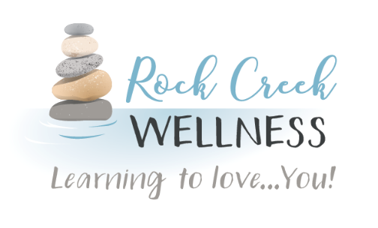

Massage Specials

*Tis the season…for massage*

Connie Maun LMT

The holiday season is upon us!  The weather is cooler but the sales are heating up, and the stress is mounting.  We are planning meals, making our lists, shopping, decking the halls...phew that’s a lot to pack into our already hectic schedules.  Just like that, our stress levels sky rocket, anxiety creeps in and we find ourselves unable to revel in the joy of the holidays.   Massage might just be the best gift you can give yourself.

As we begin to feel the pressures of life, we move into that “fight or flight” response, our bodies increase production of cortisol, the stress hormone, while decreasing the production of the feel good hormones: dopamine, serotonin, and endorphins.  The result is increased anxiety, poor sleep, and decreased mood.

Massage can reverse that cycle.  It turns off the sympathetic nervous system that controls our basic physical and mental responses to stress and turns on the parasympathetic nervous system.  As the body is massaged, blood and lymph circulation increase, bringing with it those good hormones.  The result is feeling calm and relaxed, which will allow us to sleep better so the body has a chance to rejuvenate itself.

Swedish or Relaxation massage is most commonly used to achieve these results but even a deep tissue massage will net the same results. Wringing out the muscles can literally equate to wringing out the stress!  Book your massage for your very own holiday de-stress.  And check out our holiday sales!

Black Friday promotions Nov. 25th thru Dec. 4th.

Special 1: Purchase a gift certificate online ($60 or more) and get a $10 off coupon for your next massage!

Special 2: Book and prepay for a massage online and get $10 off!

Visit us on our booking site, Fresha, to purchase your vouchers for these specials. Links to Fresha can be found on our website or by clicking “Book Now” on Facebook.

For the month of December, upgrade and save 33%! Purchase a 60-minute relaxation massage and upgrade to a 90-minute massage for free!

Rock Creek Wellness is available to provide education to your business on a wide variety of wellness topics, contact us today for more information!

*Coming Up* **>>>**