

*Rockcreekwellness.org*

February

*60 B Franklin Rd.*

*Mercer, PA 16137*

*724.269.7222*

*office@rockcreekwellness.org*

sleep and help with low blood pressure.

**Eating a Healthy Breakfast:** This can also jump-start our brain and boost our ability to be more productive and focus throughout the morning. The 5 “brain foods” that are said to be especially helpful with this are blueberries, walnuts, avocados, egg yolks andgreentea. Skipping breakfast can give us a little more time, but also compromise our health.

**Drink At least Two Glasses Of Water:** Since we spend so many hours during our sleep without drinking water, hydration is extremely important in the morning. Water is helpful with many bodily functions such as temperature regulation and brain function. Experiencing a lack of energy in the morning could simply be due to a lack of hydration.

**Brush Teeth with Your Non-Dominant Hand:** This is a fun little tip to jumpstart your brain in the morning. You will find it challenging no doubt, but brushing teeth with your non-dominant hand can help with cognitive stimulation as the brain is learning to change itself and adapt to new skills. Try it out!

**Visit The Gym:** Although this may sound like a cliché, keeping our body active is an important part of maintaining our health. According to many sources, starting our day with exercise can boost our mood and energy, decrease stress, help us get into a routine, improve our

***Have you ever wondered what an ideal morning would look like if you were to plan it out? Are there things you want to change about your morning habits? Have you ever thought about why morning routines are seen by so many as being crucial for a productive day? Here are some small tips that can help you jumpstart your morning and begin your day on a positive note:***

**Please join us for this FREE Healing Flow Yoga with Laurie Joanow. This a trauma- informed practice. We aim to create a safe space for participants to use movement and flow as emotion regulation. Relaxation is achieved through connection with breath and increased body awareness.**

*Monday February 10th at 6 P.M. Please call the office at 724.269.7222 or email office@rockcreekwellness.org if you’re interested in learning more or attending.*

***FREE Healing Flow Yoga Class***

*Current Events***>>>**

Tanvi Gupta MA LPC

Five Morning Habits to Start the Day Right



*Mindful Eating*

Katelyn Struthers NASM CPT

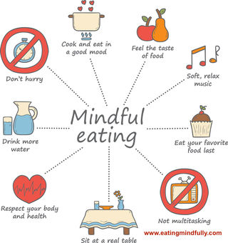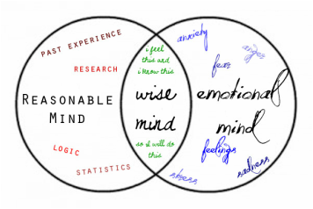

Contact us today at

724.269.7222 or at

office@rockcreekwellness.org

to learn more about our upcoming Mindfulness Training group. Times and dates are flexible and will be planned around those committed.

February Mindfulness Training Begins Soon!

*Coming Up* **>>>**

**Take your time:** savor your food, especially if it’s a favorite. Notice the smell, color, texture of the food. Enjoy the food slowly, it helps us to eat less while noticing each bite rather than munching while we’re distracted by other things. Eating with your non-dominant hand may help as well.

**Pay attention to your body:** Notice hunger and fullness feelings. It’s important to listen to our bodies but we also need to take caution as sometimes we can be tricked into thinking we need more. Sugar and fats can trick our brains into craving more because they are not “calorie dense” foods (foods that fill us up, satisfy hunger).

If you joined us for the recent pop up kitchen, one of the topics we covered was the idea of mindful eating. Mindfulness is a practice of truly being present in the moment both in how you are feeling and what’s going on around you. This practice can be applied to our relationship with food. with food.

***Many thanks to Breese Heating & Cooling for having us at one of their recent staff meetings to talk about stress management skills! Also thank you to the Lakeview School District for allowing us to be a part of a recent health and wellness fair for school employees. We provided information, as well as stress management and mindfulness talks to participants. Rock Creek Wellness is available to provide education to your business on a wide variety of wellness topics, contact us today for more information!***

Thank You!!

We have both physical and emotional connections to the foods we eat. We all have that favorite comfort dish when we’re feeling low, and we also celebrate with food (birthdays, parties, holidays). There are many ways to practice mindful eating, here are a couple of ideas to get you started: