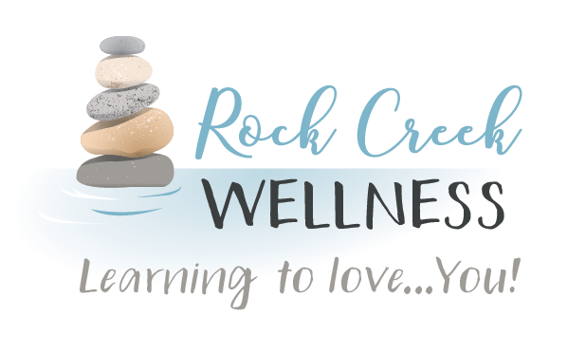

*RockCreekWellness.org*

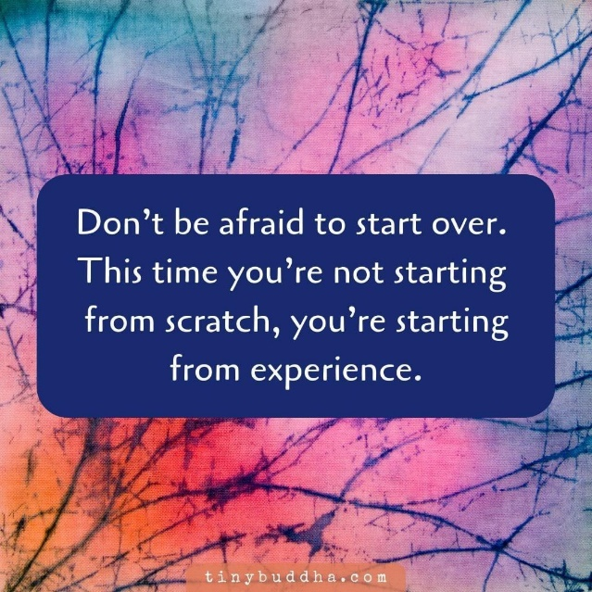

the course. If progress was hard to see, try new ways of measuring and acknowledging how far you’ve come. If you managed to accomplish something, think about how you did it, and DO MORE OF THAT.

While we may want a totally blank slate, that doesn’t always serve us well. Take some time to reflect on the last year. Identify your priorities and what you really need or want to work on this year. Take what you’ve learned and jump back in. You got this! Happy New Year!

So 2020 didn’t go how anyone planned, which means maybe you didn’t get a fair opportunity to work on your goals or make the positive changes you’d set out to make. It’s a new year and another chance to save money, take on that project, cut out pop, start an exercise program, or practice daily self care. No matter what you did to reach those goals in 2020, know that while this is a new beginning, you’re not back at square one. Last year was challenging to say the least, and you survived! ..with that much more experience. Use it!

Using our experience is so valuable! If it didn’t work for you before, it’s likely time to try a different strategy. If it’s a goal that’s not realistic for your given current circumstances, reevaluate it. If those people or situations were stressors, identify ways to avoid or cope in order to stay

Krista Armstrong LPC

There’s nothing like heavy traffic and impatient drivers to trigger the “fight or flight” response. In fact, the snarliest traffic jam can provide an [excellent opportunity to build your mindfulness](https://www.mindful.org/three-powerful-mindfulness-practices-try-road/) muscle, increase your sense of connection to others, and restore some balance and perspective. **1. First, take a deep breath.**

**2. Ask yourself what you need.** It may be in that moment that you need to feel safe, at ease or you just need some relief. Understanding what you need will bring balance.

**3. Give yourself what you need.**

**4. Look around and recognize that all the other drivers are just like you.**

**5. Take another deep breath.**

https://www.mindful.org/take-a-mindful-moment-5-simple-practices-for-daily-life/

Using your experiences

Mindful Technique of the Month: Mindful Driving

January

*60 B Franklin Rd.*

*Mercer, PA 16137*

*724.269.7222*

*office@rockcreekwellness.org*

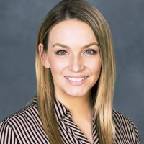

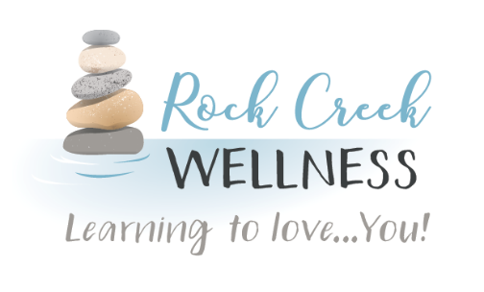

*What is fascia?*

Connie Maun LMT

“The Fabric of Our Bodies”

Fascia is the connective tissue within our bodies. It wraps around every vessel, nerve, muscle, organ, and bone. As new research emerges, we now know that fascia is more of a body system in and of itself. Each muscle spindle is wrapped in fascia, the spindles are wrapped together to create muscle fiber which is bundled together to form each muscle and wrapped in fascia. Phew! That’s a lot of fascia!

Fascia is made up of water, collagen, fibers. Healthy fascia has a sticky gel-like quality to it. When fascia becomes restricted or traumatized, it loses that gel-like quality and will harden. When this happens, movement is affected, range of motion is limited, often resulting in Myofascial Pain Syndrome. In this condition, pressure on sensitive points in your muscles (trigger points) causes pain in the muscle and sometimes seemingly unrelated parts of your body, also known as referred pain.

Enter your friendly massage therapist! Deep Tissue massage will help to soften the fascia and break down fascial adhesions (knots). Myofascial Release (MFR) specifically addresses the fascia, it uses gentle, sustained pressure to eliminate pain and restore motion. While there are techniques used, one of my go-to techniques is known as Skin Rolling. It is extremely effective and the progress can be immediately seen. Want to know more, head on over to our Facebook page to catch a video of me demonstrating this technique.

January Massage Special

Head over to like and follow our facebook page, watch Connie’s video to get a code for 15% off your next massage!

Welcome Clarissa Arbuckle LC

Rock Creek Wellness is proud to welcome our newest provider, Clarissa Arbuckle!

Clarissa Arbuckle is a Nationally Certified Counselor known for her expertise in career and lifestyle counseling. She is a down-to-earth, culturally competent counselor who meets clients where they are, creating a safe and non-judgmental space. Clarissa utilizes CBT and a strengths-based approach to help clients with anxiety/depression, relationship conflicts, and job loss/change.

Visit our website or call the office at 724.269.7222 to schedule with Clarissa.

*Clarissa is in the process of being credentialed with major insurances and accepts self-pay.