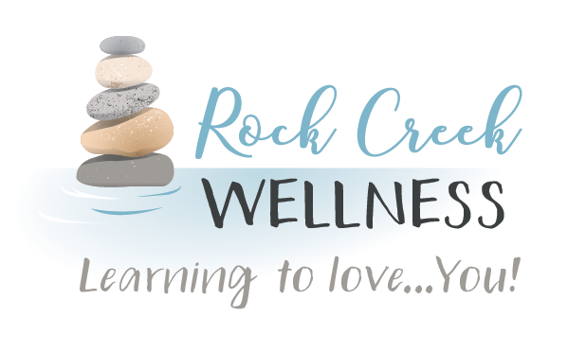

*RockCreekWellness.org*

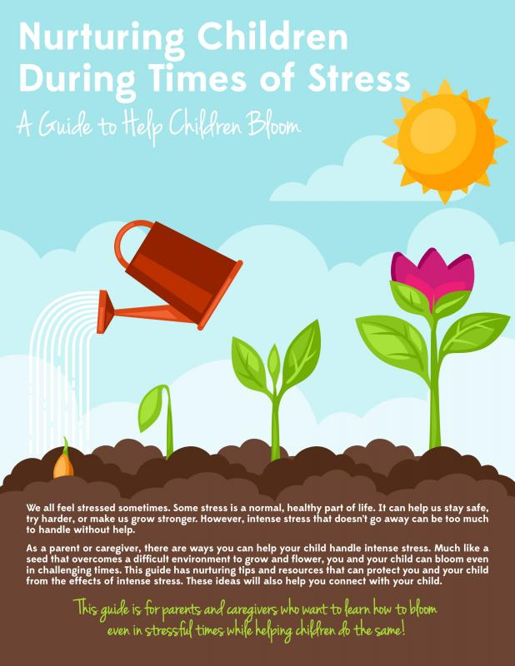

Parenting is HARD! Parenting is especially hard when your kids (and teens!) are going through a stressful time. When children experience trauma or a confusing, upsetting experience, their brains are affected, which means that their emotions and behaviors may be too. If you notice that your kids are “more emotional,” now throwing tantrums, talking back, defiant, or having other problematic changes in behavior, it’s important to recognize that your child’s behavior is likely related to the big emotions they’re feeling. Often, when kids have or are going through a highly stressful or difficult time, parents can be hesitant to reinforce consequences. Despite understanding where the behaviors may be coming from, all kids need safety, predictability, and to learn how to deal with those feelings appropriately. As parents, you can help your kids by continuing to provide consistent rules and expectations, boundaries, and warmth. Giving your kids a sense of safety and security and punishing unacceptable behavior are imperative for your child to successfully navigate their experience and develop self-regulation strategies for resilience. Here are four Parenting Strategies to help you manage your child’s behavior:

**ALWAYS Acknowledge/Validate your child’s feelings in the moment.** “You’re mad I’m not allowing you to..,” “All of this is really hard for you..,” “It’s stressful when things change..,” “I see you’re overwhelmed..”

**Make consequences, rewards, and/or punishments predictable and consistent.**

Use a sticker chart, follow through with what you say you will do, use one effective method that you introduce and explain ahead of time (time out, taking away electronics, rewarding with money/activity) and do it every time the behavior occurs.

**Talk and teach when calm**. Don’t lecture when your child is upset. At a neutral time when you’re *both* calm, talk about what’s going on and how you’re both feeling, discuss relaxation and coping strategies and practice them together.

**Practice Mindfulness.** Acknowledging your own feelings and how you’re reacting to the situation and your child’s behavior can help you control your reactions so that you can both model how to effectively communicate your feelings and remain calm and make better decisions for your child in the moment.

Krista Armstrong LPC

Parenting During Stressful Times

June

*60 B Franklin Rd.*

*Mercer, PA 16137*

*724.269.7222*

*office@rockcreekwellness.org*

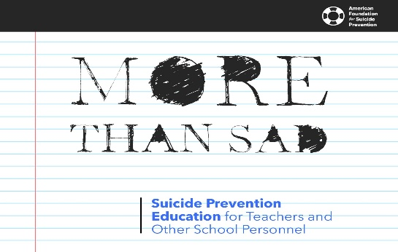

*Baby Steps Lead To Progress*

Katelyn Struthers NASM CPT



More

Than

Sad

***The More Than Sad family of programs teaches educators and other school personnel how to recognize mental health conditions, the warning signs of suicide, and the steps they can take to get help for at-risk students.***

***Our providers are trained to help your education setting staff learn these valuable and lifesaving skills. Summer is a wonderful time to prepare for the coming school year with these types of trainings.***

***Contact us today to learn more!***

If you do not like running, you are not going to stick to a routine of it! Gardening, walking, canoeing/kayaking, and many other leisure activities are excellent exercise. It is much easier to get in 30 minutes a day or 3 hours per week when you are doing something you enjoy.

**3. Get enough sleep**: Sleep is so important to achieve good health, both physically and mentally. The way we feel upon waking can determine the course of our day and our decisions. It is that simple!

**4.Manage your stress:** Stress is cited more than any other factor when it comes to something getting in the way of making health a priority. It is also one of the main factors contributing to underlying disease and chronic conditions. By managing our stressors, we can elevate both mood and physical wellbeing.

It is also important to remember that getting healthy is not a one-time deal, but a lifelong endeavor, so be gracious with yourself when you make mistakes and let them help you learn. Here are a few of my favorite tips for leading a healthy lifestyle:

**1.Start by eating breakfast!** Often the start of the day is rushed, but this is the most important meal of the day and can influence your cravings and food choices the rest of the day. Make some time to whip up some eggs, enjoy yogurt and fresh fruit or granola, make oatmeal if you are a cereal lover.

**2. Exercise by finding something you enjoy:** Often exercise is viewed as a punishment, and it should not be!

Rock Creek Wellness is available to provide education to your business on a wide variety of wellness topics, contact us today for more information!

When it comes to making substantial changes in your life, often baby steps are the best way to go to ensure that new habits stick, and you can be comfortable with the process of change. Healthy eating and physical activity are no different than any other changes, and the bigger the goals, the longer the journey will be. Keep in mind why you are making the changes, then it will get easier as you learn a new way of living. .

*Coming Up* **>>>**