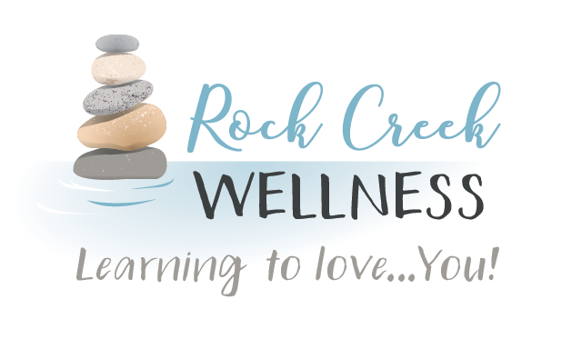

*RockCreekWellness.org*

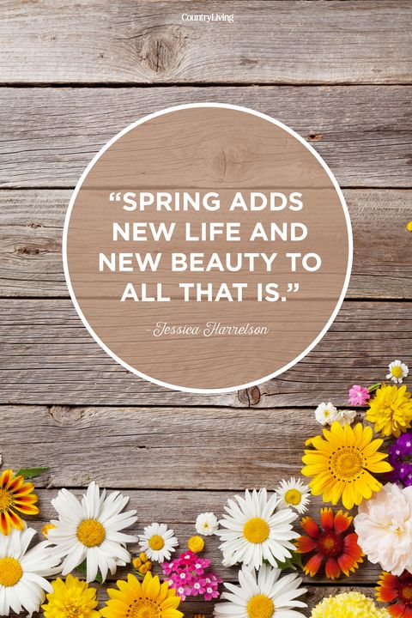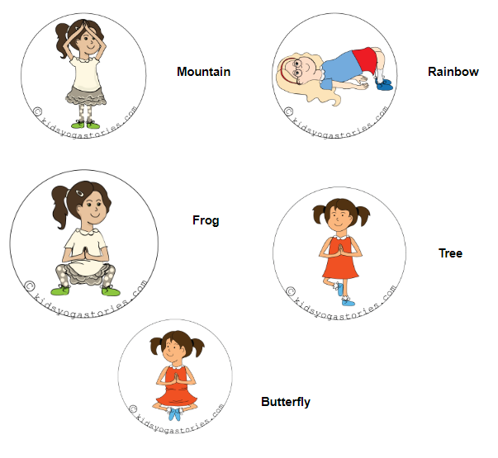

**Happy Spring! Here are some outdoor activities that you can use to enhance your kids’ coping skills toolbox and improve their self regulation skills while enjoying the weather and having some fun!**

1. **Blow Bubbles!**

**Blowing bubbles is a great deep breathing exercise. Instruct kids to breathe in through their nose to fill their lungs with air, then blow out slowly through their mouth. The goal is to make BIG bubbles!**

**Add a challenge: Have your kids just watch the bubbles float away, resisting the urge to pop them!**

1. **Grounding with 5 Senses**

**Stop what you’re doing and find 5 things you can see, 4 things you can touch/feel, 3 things you can hear, 2 things you can smell, and 1 thing you can taste.**

1. **Play Red Light Green Light, Freeze Dance, or Simon Says**
2. **Do Nature Yoga Poses**

Krista Armstrong LPC

May

*60 B Franklin Rd.*

*Mercer, PA 16137*

*724.269.7222*

*office@rockcreekwellness.org*

Spring Has Sprung



*A Healthy Identity*

Katelyn Struthers NASM CPT

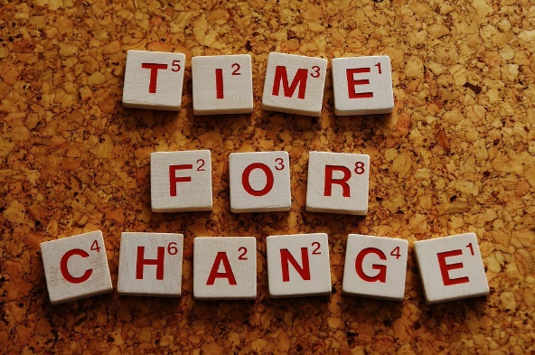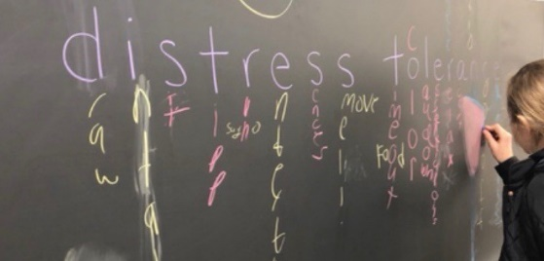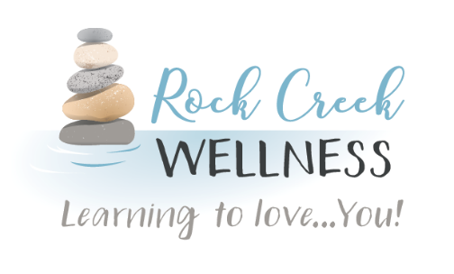

Our everyday behaviors are often based in part on our routines and how we identify ourselves. Are you a family-oriented person? Then likely you are coming home from work on time, spending the weekends devoted to your family. Are you good with your money? Then you are not likely spending outside your budget each week. Are you community-oriented?

Thank You!!

***Krista’s 4th & 5th grade students finished learning distress tolerance skills to help them deal with intense feelings! They made coping skills toolkits to take home which included calm-down bottles, sensory items, stress balls, & activity prompt cards. Each group section ended with a fun word puzzle review!***



***Thanks to the Shenango Valley Chamber for allowing us to share some of our knowledge across their social media channels about staying STRONG! “Healthy habits are important for helping you manage your emotions, especially during highly stressful and uncertain times. You can reduce your vulnerability to intense emotions like anxiety by staying STRONG!”***

*Coming Up* **>>>**

goal. Just like family, money, or community-oriented behaviors; being healthy means eating well and exercising regularly because that is what healthy people do.

When you have your goal, then you can take the steps that are fitting for you to change that behavior and make health your identity. Making health a part of your identity gives meaning to the behaviors behind staying healthy and makes them a positive habit in your life!

What can you do today to identify as a healthy person? It may not just be about exercise and nutrition; it may be practicing mindfulness, taking time each day to journal or read, or spending more time outdoors or with family.

Then you are spending your time in service to and socializing at community events. Many people say that they struggle with identifying themselves as healthy. You can change that by asking yourself one simple question: what does being healthy mean to you?

What kind of eater are you? What kind of exerciser are you? The answers to these questions are a way to assess where you are and where you would like to be. If you currently say you are a somewhat unhealthy eater and an occasional exerciser, then you have a baseline. You can then say I would like to be a mostly healthy eater and a regular exerciser. Now you have an end

Rock Creek Wellness is available to provide education to your business on a wide variety of wellness topics, contact us today for more information!