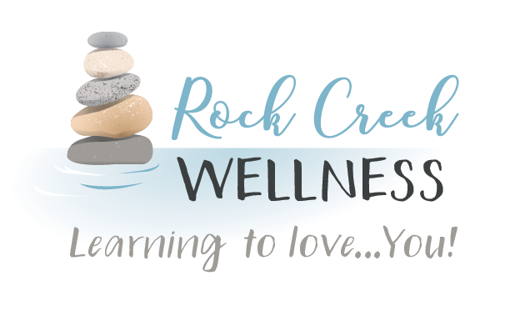

*RockCreekWellness.org*

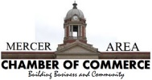

This exercise is called “five senses,” and provides guidelines on practicing mindfulness quickly in nearly any situation. All that is needed is to notice something you are experiencing with each of the five senses.

* Notice five things that you can *see*.
* Notice four things that you can *feel*.
* Notice three things you can *hear.*
* Notice two things you can *smell*.
* Notice one thing you can *taste.*

This is a quick and relatively easy exercise to bring you to a mindful state quickly. The five senses exercise can help you bring awareness to the current moment.

https://positivepsychology.com/mindfulness-exercises-techniques-activities/

Massage – Changing the Mindset

Mindful Technique of the Month: Five Senses

When someone says massage, what immediately comes to mind?  I bet it’s thoughts of a fancy spa, soft music, dim lighting, and a sense of pampering or treating yourself.  It’s often been synonymous with luxury, not need.  It’s time to change the mindset. **Massage is alternative medicine, it is healthcare, self-care, and even treatment.**  It can be a luxury but it is so much more than that.

The healthcare community has begun to make a shift in the way massage is viewed.  For years chiropractors have understood how important massage can be for their patients.  They can move the structures but if the muscles will not release, the structures return to the same unhealthy positions.  The medical community is using massage to aid in the treatment of a multitude of disorders and dysfunctions such as: anxiety, digestive disorders, Fibromyalgia, headaches, Insomnia, Myofascial Pain Syndrome, soft tissue strains and injuries, sports injuries, Temporomandibular Joint Pain, and many more (Mayo Clinic, 2016).  What is really exciting though, is the advancement of massage in dealing with pain management, opioid addiction recovery, depression, trauma, & PTSD (VHA Directive 1137).

So who is recommending massage? 51% of Chiropractors, 49% of Physical Therapists, and 46% of Physicians.

What consumers are reporting:

88% considered Massage to be effective in reducing pain

70% agreed it should be considered a form of healthcare

25% of Massage Therapists reported in 2018 that they received reimbursement by insurance companies, up from 22% just one year prior.

Now that we’ve uncovered this information, do you see it differently?  Have we changed your mind?

Connie Maun LMT

November

*60 B Franklin Rd.*

*Mercer, PA 16137*

*724.269.7222*

*office@rockcreekwellness.org*



*New Normal, New Health Plan*

Katelyn Struthers NASM CPT

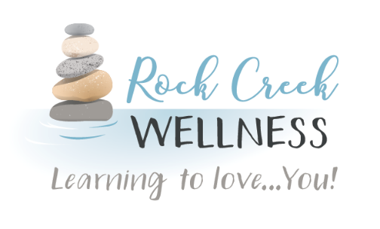

* **Take an online Yoga class.**
* **Do some weighted exercise with household items like soup cans or gallon jugs.**
* **Create plank hold or push up challenges with your kids or co-workers. Stand at your computer and step in place.**
* **Go for a walk after lunch or dinner, ride bicycles, play catch.**

**Family Meal Night**: Get the whole family involved by having each person take a step in the cooking process. Turn this into an opportunity to be more mindful of what you are eating! Try to make sure that most of your meals and snacks are coming from nutrient-dense foods such as whole grains, fruits, vegetables and lean proteins. Cooking from scratch is a great way to enjoy your take out favorites from home.

**Have fun!** The aim is not on fitness, muscle building, or weight loss but should be fun and light. Basic movement, good nutrition, and self-care will fill our cups so we can continue working and learning from home and be energized and ready to take on the challenges we face!

**Exercise:**

* **Set alarms or your smart device to notify you to move around and take some steps.**

In our “new normal” we are all adjusting to life at home. That means working and meetings done virtually, online schoolwork, and video calls with family. All these activities are great, but they are not leaving much time for getting up and getting moving! Now, more than ever, it is so important to keep our bodies and minds in shape with physical movement and good nutrition.

Massage Gift Cards

Massage Gift Cards are available for purchase in our office! Get a jump on your holiday shopping by giving someone the gift of wellness.

Be sure to follow us on Facebook as Connie Maun, LMT introduces you to all the varieties of massage she offers as well as the numerous benefits!

Have you joined our mailing list yet?

When you book your massage online, be sure to enter your address for special offers such as a birthday treat, reward for regularly scheduled massages and exclusives on new services! You can also email [massage@ rockcreekwellness.org](mailto:massage@rockcreekwellness.org) to be added to our mailing list.

If you have already received a massage, we would appreciate a review! You can do so on our Facebook page, Google, or Yelp!

Rock Creek Wellness is available to provide education to your business on a wide variety of wellness topics, contact us today for more information!

*Coming Up* **>>>**