

*RockCreekWellness.org*



*Rock Creek Wellness is excited to include massage therapy back in our services! Connie Maun, LMT offers a range of techniques to help relieve stress, anxiety, muscular and chronic pain. She includes many modalities in each individual massage session to aid in the whole wellness of the client.*

*To learn more about Connie or these services, visit our website at rockcreekwellness.org/massage. You can book an appointment via our website or by clicking “Book Now” on our Facebook page or call the office. Connie will be offering the following services:*

***Pain Relief -*** *A therapeutic massage that employs deep tissue work, trigger point therapy, stretches, and range of motion techniques to deal with chronic pain, injuries, muscle tension, and work to restore functional movement.*

***Relaxation/Swedish –*** *Using long, gliding movements and a calming pace, this modality will allow your mind and body to let go as your parasympathetic system takes over, some of the many benefits are reduced stress, lower blood pressure, and increased circulation.*

***Sports -*** *Sports massage is for athletes, student-athletes, weekend warriors, or those with an active lifestyle. Sports massage can enhance flexibility, aid in recovery from the competition, and prevent injuries from occurring.*

***Hot Stone -*** *Smooth Basalt stones infuse the muscles with a therapeutic heat that penetrates deep into the muscles while increasing relaxation and a sense of calm.*

***Massage Cupping -*** *Cupping creates a reverse deep tissue that will break down connective tissues, separate muscle fibers, and encourage blood flow through adhesions to promote healing and restore the normal quality and tone of muscles and soft tissues.*

Connie Maun LMT

Fall into Relaxation with a Massage

**1. On waking, sit in your bed or a chair in a relaxed posture.** Close your eyes and connect with the sensations of your seated body.

**2. Take three long, deep, nourishing breaths.**

**3. Ask yourself: “What is my intention for today?”**

**4. Set your intention for the day.**

**5. Throughout the day, check in with yourself.**

Notice, as you become more and more conscious of your intentions for each day, how the quality of your communications, relationships, and mood shifts.

<https://www.mindful.org/take-a-mindful-moment-5-simple-practices-for-daily-life/>

Mindful Technique of the Month: Wake Up

October

*60 B Franklin Rd.*

*Mercer, PA 16137*

*724.269.7222*

*office@rockcreekwellness.org*



*Show How You Support*

Krista Armstrong LPC

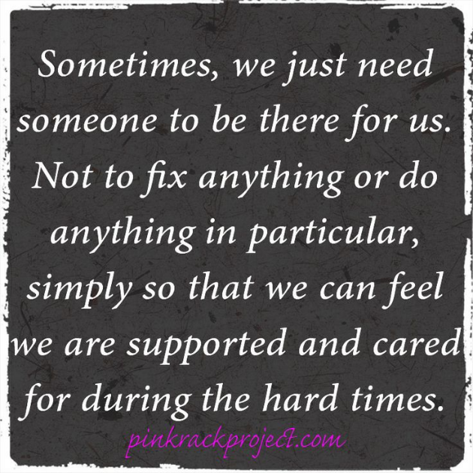

Thank You

Book your massage today! You can book on our website, on Facebook, or by calling the office!

* **Acknowledge their willingness to talk to you; thank them for sharing.**
* **Make eye contact and give your full attention to the person speaking. Put down your phone, pause from making dinner, stop typing.**
* **Reflect back/ paraphrase what the person is saying to you.**
* **Keep from interrupting.**
* **Refrain from giving advice unless they specifically ask you for it.**
* **Validate their feelings.**

How you attend to someone when they are sharing their experiences with you affects the level of support they feel. This is true for a friend sharing about a significant stressor in his or her life or a child telling you about not getting a turn on the swings at recess. Feeling heard, understood, and supported is something we all need. The next time someone shares something with you, be sure to:

Thank you to those of you who participated with our team in the virtual Out of the Darkness walk with the Lawrence County Suicide Prevention Coalition!

Funds raised at this event benefit the entire Western Pennsylvania region in suicide prevention and awareness.

If you walked, we would love to see your pictures on social media!