Massage Therapy Client Information

Name ______________________________________ Email ___________________________________________
Phone (Cell) __________________________ Phone (Home) __________________________
Address______________________________________________________________________
City ___________________________________________ State ______________ Zip _________
Date of Birth __________________ Occupation _____________________
Emergency Contact ________________________ Phone _____________________________
Primary Cary Physician_____________________________ Phone ____________________________
Massage History and Preferences
Have you had a professional massage before? Yes No
What are your goals for this massage session? _____________________________________
Is there a particular area of the body where you are experiencing tension, stiffness, pain, or other discomfort? Yes No
Do you have any difficulty lying on your front, back, or side? Yes No
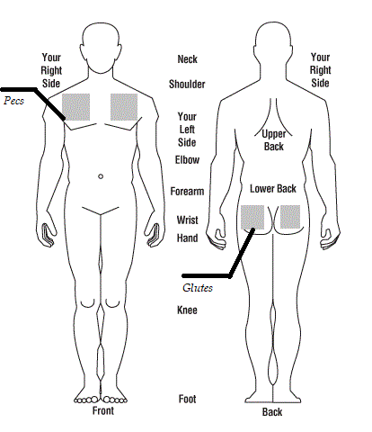
What is your preferred conversation level during the massage? Quiet Indifferent Talkative
What is your pressure level preference? Light Medium Deep
- Circle the areas of the body that are of concern.
- Mark an X over the areas to be avoided.
- Check the following areas for consent to massage:

head/face hands feet pecs glutes
________________________________ _____________
Client Signature Date
________________________________ ______________
Massage Therapist Date
Current Health
Do you sit for long hours at a workstation, computer, or driving? Yes No
Do exercise regularly and/or participate in any sports? Yes No
Do you perform any repetitive movement in your work, sports, or hobby? Yes No
Do you experience stress in your work, family, or other aspect of your life? Yes No
If yes, how do you think it has affected your health?
Muscle tension anxiety insomnia irritability other ________________________
Have you recently had an injury, surgery, or areas of inflammation? Yes No
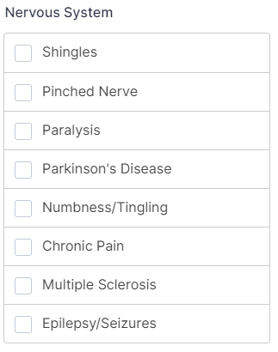
Do you have any of the following conditions? Please check all that apply.
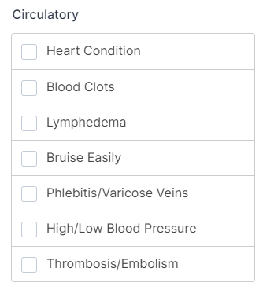
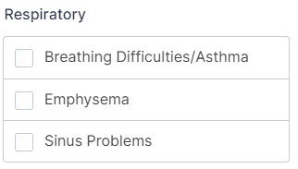

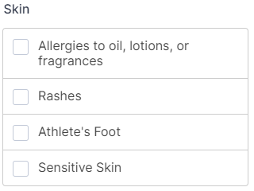
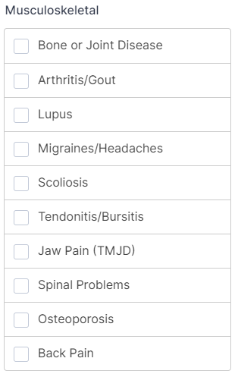

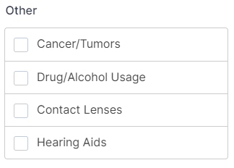
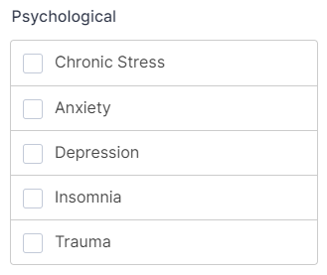

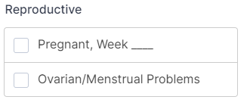
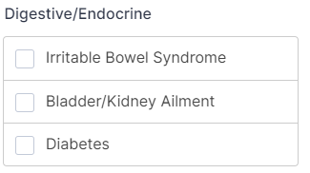

Any other medical condition(s) or concerns not listed: ___________________________________________________

