Preliminary Report: Determine the effectiveness of Xtreme Bio® in Inactivating African swine fever virus

**Objective:**

To determine the effectiveness of XTREME BIO® (XB) in inactivating the infectivity of Arican swine fever virus (ASFv).

***In vitro phase:***

*Note: All ASFv work were performed in BSL3 laboratory facility.*

**Materials needed:**

* + PB-derived macrophages at day 3 to 5 in culture in 96-well plate
  + Cell culture media, phosphate-buffered saline (PBS) and water for dilution
  + 160mmPetri dishes, Multichannel tips, 96-well and 24 plates
  + XB and XB high foam (HF) provided by sponsor/manufacturer – prepared at 0.5 oz/gallon and 2.0 oz/gallon
  + Peroxigard (perox) disinfectant as positive control
  + ASFv – working concentration of 100HAD50. Pigs die of ASFv at lower than 100 HAD50 infection.

**Treatments:**

(1) 0.5oz/gallon XB + ASFV

(2) 2oz/gallon XB + ASFV

(3) 0.5oz/gallon XBHF + ASFV

(4) 2oz/gallon XBHF + ASFV

(5) Peroxigard + ASFV

(6) PBS +ASFV

(7) PBS no ASFV

**Methodology:**

1. 2 ml pure culture 100HAD50 ASFv was added in petri dishes #1 to 6. Negative control is PBS.
2. 1 ml of XB was added and mixed thoroughly. This was repeated two more times to have a final volume of ~5ml of ASFv/XB or PBS mixture. Adequate mixing was done per XB or PBS addition with 10 minutes of contact time.
3. To determine the working concentration without killing the cells, different concentrations of mixtures were prepared by serial dilution (dilution 1:10, 1:20, 1:40 and 1:80) in 96-well plate and with cell culture media as diluent.



1. 200ul mixture was added to PB-derived macrophages cultured in 96-well plate (Passage 1 or P1).
2. P1 was cultured in CO2 incubator for 3 days.
3. Multiple dilutions of P1 were to determine the dilution in which cells will not be killed.

* Dilution 1:20 is the determined lowest concentration in which the cells were not killed (Figures 1 to 3).

1. The succeeding passages were from dilution 1: 20 (P2 and P3). At P3, culture upscale was performed to 24-well plate.
2. P2 and P3 supernatants were collected for nucleic acid isolation and RT-PCR for virus detection.

**Results:**

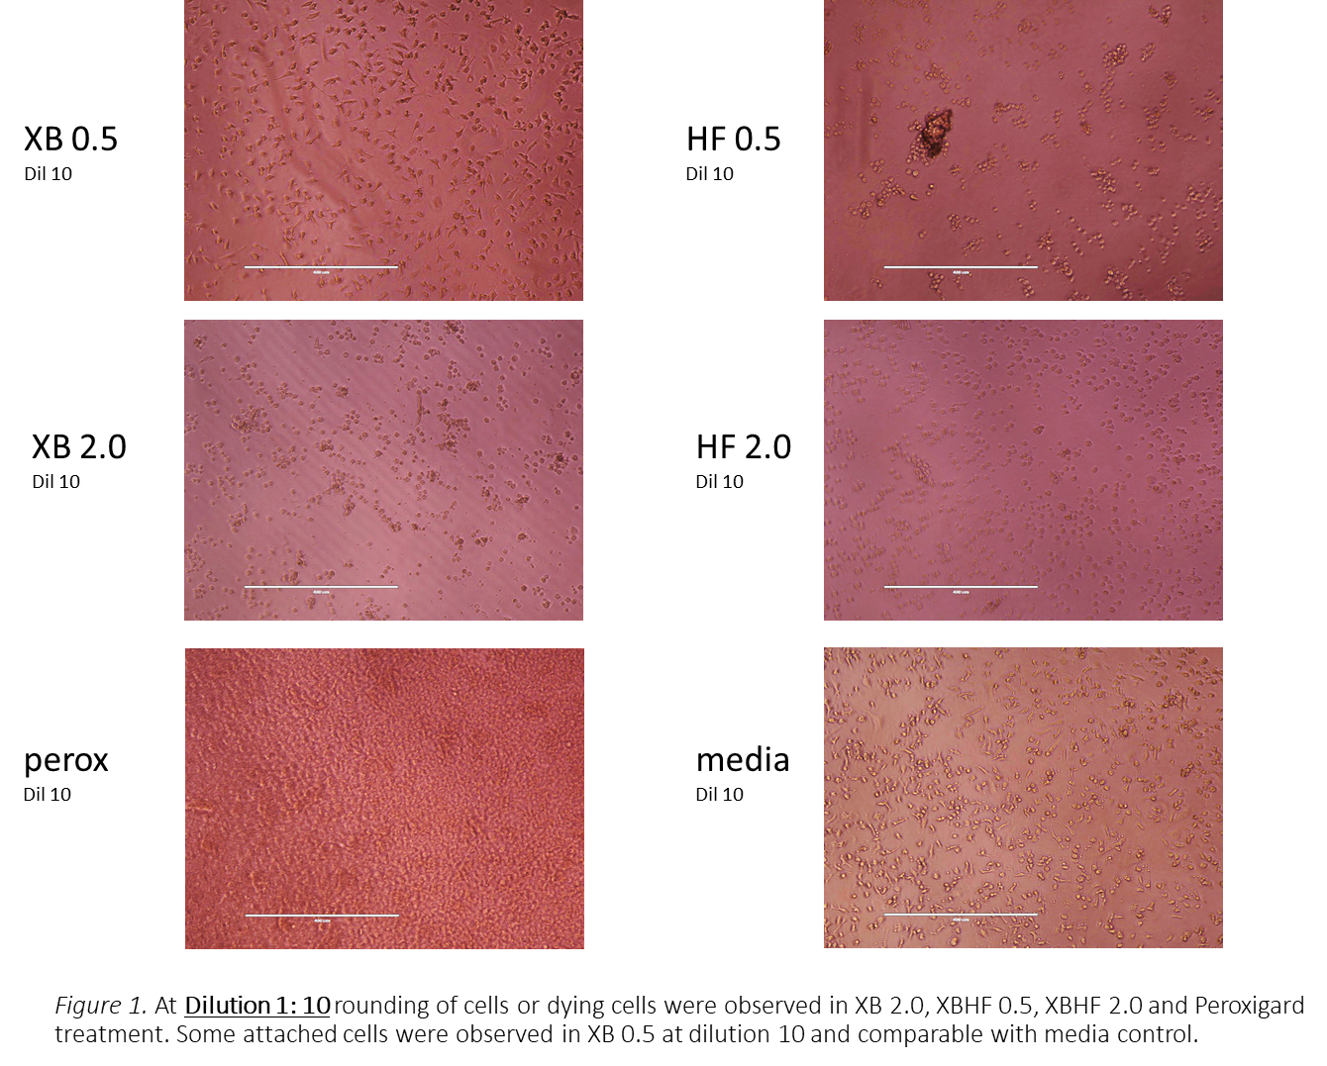

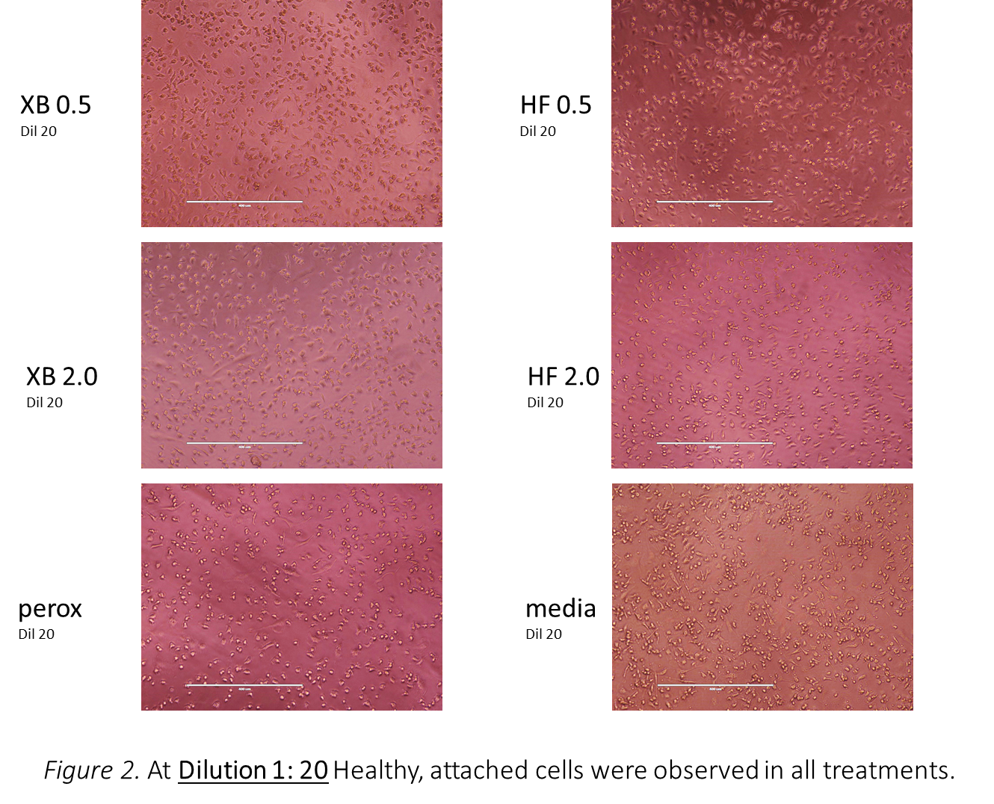



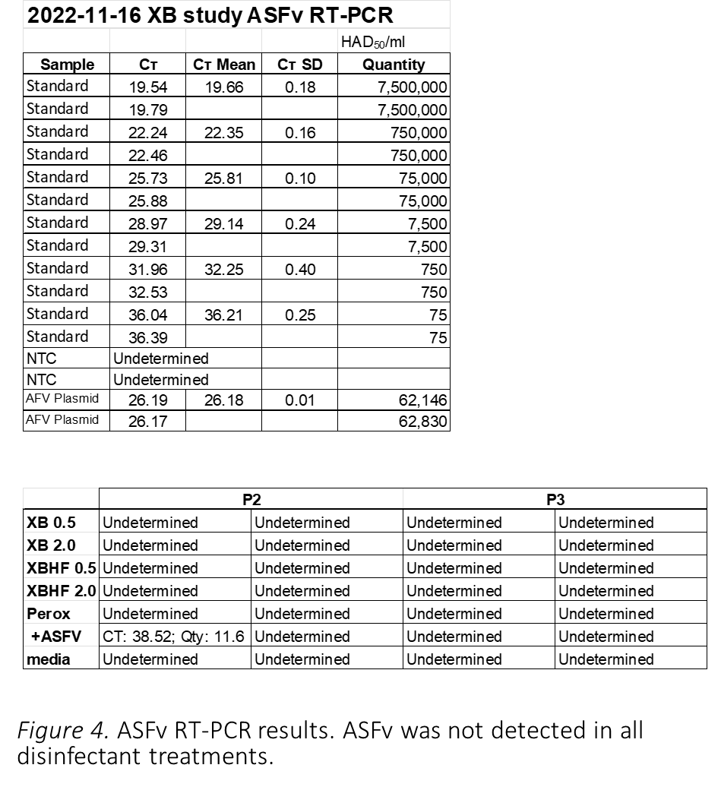

**Preliminary Observations/Future Experiments:**

* Mixture dilution of 1:20 is the concentration that is not toxic to cells.
* ASFv was not detected by RT-PCR in all mixtures with disinfectants.
* However, ASFv was barely detected in only one of two duplicates in P2 ASFV and none on P3 ASFV.
* Suggested plan of action on future experiments (to be done after reverification – February 2023)
  + Continue passaging of cells. Samples were frozen and will be thawed for further passaging upon facility re-opening.
  + Increase cultivation from 3 to 5 days to allow ample virus amplification. In this preliminary experiment, passages were only every 3 days due to limited time before facility shutdown.
  + Increase number of passages to allow ample virus amplification (if there is any virus remaining after treatment), that would be detected by RT-PCR.
  + Possibly increase virus concentration at the start of experiment.

Prepared by RM 2022-11-17