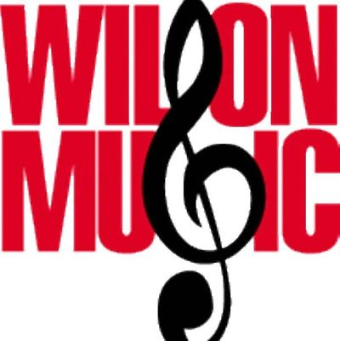

NEW FUNDRAISER – R-Phils!!!

A book of 6 General Admission Tickets for only $27?? That’s a great deal!

The Wilson Music Promoters will be selling RPhils Ticket books. 6 tickets per book for a total of $27. Please complete the top portion of each brochure listing your home address so that the ticket books can be sent directly to your home address from the RPhils ticket office.

Please return all order forms and payment to the Red Boxes BY **4/30.** NO CASH PLEASE! All checks are to be made out to **READING BASEBALL LP**.

Each student will receive a credit of $3 per book sold! As a reminder, these credits can be used toward any music department trips, band fees…

Thank you so much for your support! If you have any questions, please don’t hesitate to contact me. I can be reached via email at [vicepresident@wilsonmusicpromoters.org](mailto:vicepresident@wilsonmusicpromoters.org) or on my cell at 484.599.2943.

~ Jessica Johnson