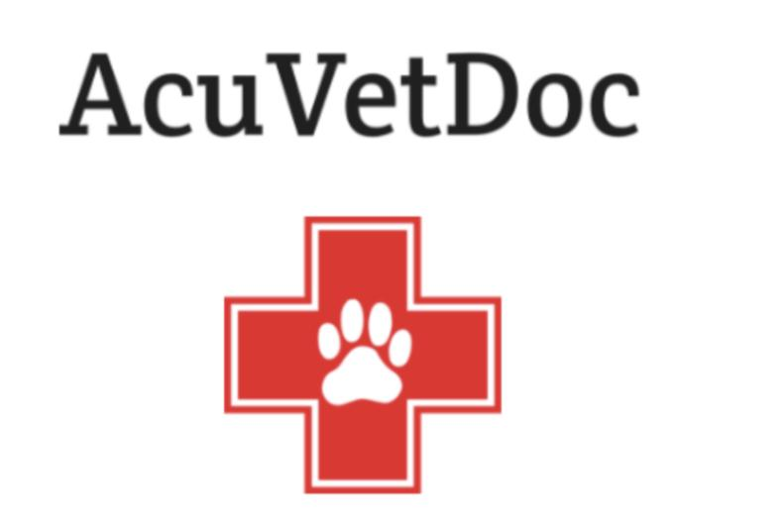
Karina Salvo DVM, CVFT, CTPEP, CVMMP, CVTP
- Elite Fear Free Certified-
1480 Royal Palm Beach Suite B RPB,FL 33411
561-250-2031
www.AcuVetDoc.com
For new puppy owners who present a Health Certificate that has been issued by Dr. Salvo at AcuVetDoc :
Will NOT BE CHARGED an initial exam AND will not be charged continued. “ Vaccine Series” exams.
This applies to their new puppy while the puppy is within the initial vaccination series. Vaccine Series means that the puppy is within the booster stage of their vaccinations. Boosters are given on an every 3-4 week interval. Rabies vaccination is given at 4 months and IS included within the initial ‘ Vaccine Series’ .
Owners ARE responsible for cost of vaccinations or anything other than the examination.
~~~~~~~ Below are a few Recommendations ~~~~~~~
- Heartworm Disease Prevention: Heartworm disease is a serious and potentially fatal disease in dogs throughout the United States. It is transmitted through a bite of a mosquito. The dog is a natural host for heartworms! This means that heartworms that live inside the dog: mature into adults, mate and produce offspring. If untreated, their numbers can increase, and dogs have been known to harbor several hundred worms in their hearts. Heartworm disease causes lasting damage to the heart, lungs and arteries, and can affect the dog’s health and quality of life long after the parasites are gone.
Heartworm prevention can be started by new owners as soon as they get their puppies. Because heartworm prevention is a prescription only medication, owners who establish their new puppies at AcuVetDoc will be approved for this prescription to prevent this deadly disease. Here is the link for the online pharmacy: https://acuvetdoc.securevetsource.com/index.pml?retUrl=https://acuvetdoc.com/&cms
- Leptospirosis: What is it & Why to have a vaccine against it? It is a bacteria that lives within the cells and can cause multi organ failure. It is transmitted through the urine of wild animals ( rats, squirrels, opossums, fox, raccoons, skunks, and deer) AND can spread to the humans within the home. Puddles, drinking contaminated water and even dried urine on grass/concrete can be a source of infection. This vaccination can be incorporated with the booster vaccination so that only ONE injection is given. Two vaccines are required for a one year duration of immunity, then continued yearly.

- Bordatella Vaccination: or better known as ‘kennel cough’ vaccine. This is a single ORAL (no needle) vaccine given yearly. If a puppy is of a breed that will absolutely or even possible ever go to a groomer, play date, training class, dog park or anywhere other dogs may be or have been; I recommend to have this vaccination to help prevent infection. After the first vaccine; it is repeated yearly based on that pet’s lifestyle.

IMPORTANT POINTS
- NOT going outside until the puppy is vaccinated with at least TWO vaccines!
- If new owners have come in contact with any other animal, to wash their hands and or change clothes before handling their new puppy.
- Allow the puppy to acclimate to the new home, schedules, people, smells, sounds for 7-10 days before inviting friends and family over to visit or visiting the local petstores, markets, etc. A new experience is fun and exciting, but also stressful…and this can stress their immune systems.
- EVERYTHING should be a positive experience! Puppyhood is the ground work for who and how they will become and respond to situations in life.
- Socialization is paramount: discuss with your breeder as they are most knowledgeable of their breeding stock temperament and needs.
- Training: discuss with breeder for the same reason above. A Cockapoo will need different training than a Rottweiler!
- Veterinary exams every 6 months ( pet’s age faster than their human counterparts and changes can occur very quickly and undetected)
- Heartworm testing at 7 months ; then yearly. Heartworm prevention monthly.
- Keeping vaccines up to date and based on individual pet’s lifestyle.
- Monthly preventions: heartworm/flea/tick: I NEVER recommend over the counter products as I have seen many neurologic/skin cases having to be transferred to Emergency Clinics.
- Exercise based on pet’s age and ability.

If you have any questions, as always, you are welcome to text Dr. Salvo directly at 561-250-2031.

