Title: The Aerophysics Lab at North American Aviation (1948-1959)
Subtitle: North American Aviation and the Birth of Inertial Guidance
Author: Gregory W. Evans

Engineering History Series: The Development of the Root-Locus Method
From research behind Into Stability: Walter R. Evans and the Story of Root Locus

Abstract:

In the late 1940s North American Aviation established its Aerophysics Laboratory as a center for advanced research in automatic control, guidance systems, and aerospace engineering. Under the leadership of John R. Moore, the laboratory recruited a remarkable group of young engineers who would contribute to major advances in missile guidance and inertial navigation during the early Cold War. This paper describes the formation of that engineering community and examines the role of Walter R. Evans within it, including the early application of the root-locus method to guidance and control problems. The laboratory’s work on systems such as the XN-1 inertial navigator and the Navaho missile illustrates how new analytical tools and organizational approaches accelerated the development of modern aerospace guidance technology.

Keywords:

- Aerophysics Lab
- North American Aviation
- Inertial Guidance Systems
- XN-1 Inertial Navigator
- Navaho Missile Program
- Cold War Aerospace Engineering
- Missile Guidance Technology
- Aerospace Control Systems

The Aerophysics Lab at North American Aviation (1948-1959)
North American Aviation and the Birth of Inertial Guidance
The end of World War II had precipitated a bust to the aviation industry boom years of 24/7 factory aircraft assembly lines. Industry executives realized they would have to reinvent their companies to survive.
Companies like North American Aviation (NAA), which had thrived on the wartime demand for bombers, fighters, and trainers, were suddenly faced with the challenge of peacetime adaptation. Southern California, a hub for aircraft manufacturing during the war, now teetered on the edge of economic uncertainty as thousands of skilled workers and engineers wondered what the future held.
For many aerospace firms, survival hinged on diversification and innovation. Some transitioned to civilian markets, producing commercial aircraft or leveraging their expertise in other industries. Others sought opportunities in the nascent fields of guided missiles, jet propulsion, and experimental technologies. North American Aviation distinguished itself during this period by taking bold steps into uncharted territories of aerospace engineering.
Dutch Kindelberger and Lee Atwood at NAA understood that this new industry, to become known as “aerospace,” would be founded on technologies that World War II had either jump started or promoted to a new level. These included radar, propulsion, materials science, inertial guidance, and automatic control systems based on servomechanisms. Applying these wartime advances to their business would require retraining their workforce and college hires, most of whose textbooks bore prewar publication dates.
With this lofty goal, NAA established its Aerophysics Laboratory to spearhead advancements in aerodynamics, propulsion systems, and materials science. This farsighted act set NAA apart from competitors. NAA not only maintained a foothold in the shifting defense industry, but it also positioned itself as a pioneer in the exploration of supersonic and even spaceflight capabilities.

The Aerophysics Laboratory became a crucible of innovation, fostering a collaborative environment where physicists, engineers, and technicians tackled complex technological challenges. As one of the first facilities of its kind in the United States, it embodied a broader shift in which private industry assumed roles traditionally held by academia or government laboratories. NAA’s strategic foresight in establishing this facility ensured its relevance through the uncertain postwar years and well into the Cold War.
Dutch Kindelberger, the founding president of NAA, hired J. Lee Atwood as chief engineer in 1934. Atwood eventually became chief executive officer. In a 1989 interview for an oral history project, Atwood described NAA’s postwar challenge. He noted that during World War II, the company peaked as a military aircraft manufacturing powerhouse, employing over 100,000 workers nationwide. However, at the war's end, production ceased abruptly, reducing the workforce to about 5,000 employees. Atwood explained NAA’s strategy for survival. 24
When the [US-built] atomic bomb exploded [in August 1945] and the obvious connection with the possible missiles work and all that became fairly apparent to us, we began to realize that there was going to be a need for a considerable national defense. The measures we took immediately after the war were to bring back everybody we had sent to these inland plants and to push some things we'd started in engineering. By 1948, we had 18,000 people. We were going to do missile work.
At the beginning of 1948, Walter was in his second year of teaching a graduate-level class in servomechanisms at Washington University. Only a week later, John Moore began his tenure at NAA and immediately set to work recruiting talent for the Aerophysics Lab. Walter must have been high on Moore's list. Moore described his vision for the team and the qualities he sought in its members:
… we set about building an organization which was to become unique among the electronics and control organizations of the defense industry. This was because we concentrated to the maximum extent on hiring generalists, extroverts and entrepreneurial types. The reason for this was that we were seeking leaders with drive and personal stamina, who could identify the important issues and recognize points of diminishing returns rather than solving the wrong problems very accurately.

“Much of this early hiring was done out of universities, where many of the grads were World War II veterans, attending on the GI Bill. We ultimately ended up with so many outstanding professionals that suffice it to say we had top stars among our industry in all aspects of our work. 19
Sometime after February, Walter accepted an offer for the summer of 1948 that would begin immediately after he fulfilled his teaching responsibilities. Walter’s primary summer assignment at NAA would be to teach employees the same graduate-level servomechanism class he had taught at Washington University. The course would begin in July. His Santa Monica apartment, located on the Pacific Coast, felt like heaven compared to the oppressive heat of St. Louis summers and the harsh winters of Schenectady. Even more inspiring was his audience: professional engineers who were deeply interested in the subject and eager to apply it to their work.
These factors, combined with John Moore’s persuasive power, led to Walter and Arline’s joint decision for him to accept a permanent position with NAA rather than return to St. Louis at the end of the summer. The move marked a pivot in Walter’s professional trajectory. NAA offered him both a platform for research and a technically sophisticated audience to test, critique, and refine new ideas.
Walter and his family were among tens of thousands of Americans who relocated to the Southwest in the 1940s. It was a decade in which the state of California saw its population increase by 50%. His brother Sam would accept an offer from Shell Oil. At first, Sam moved his family first to Connecticut, but eventually made his way to Houston, Texas.
A virtual army of recent engineering graduates, many like Walter from Midwestern cities, flocked to Southern California. Having benefited in their youth from midwestern values and education emphasizing practical engineering principles, their expertise and creativity played a pivotal role in shaping the trajectory of American aerospace innovation.
By investing in theoretical research and experimental projects, NAA attracted top scientific talent and forged a path toward groundbreaking achievements that would define the aerospace industry for decades.

The military’s goal was to develop an inventory of bombs. They assumed that each bomb would weigh 5,000 pounds. They would require a new unmanned delivery system capable of carrying a payload that heavy more than 5,000 miles from launch sites in the continental United States to Soviet targets, with a precision within one mile of the intended target. Achieving these objectives demanded technological breakthroughs in rocketry and guidance systems.
Control systems had to remain stable under conditions and deliver precise performance at speeds and ranges never before attempted. Classical analysis tools—while mathematically sound—provided little intuitive guidance. And perhaps the biggest gap: While it was clear that poles and zeros controlled a system’s behavior, there wasn’t a reliable way to move them around on the complex plane. That made it hard to design for specific dynamics, especially when stability had to be rock-solid.
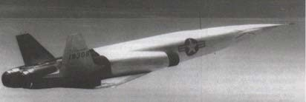

Navaho Missile circa 1955
I think we moved much faster and much stronger than other companies who had more conventional work lined up. … We hired quite a number of scientists. This was started as early as 1946–47. Dr. Bill Bollay was hired; he was the leader. We set him up with a department—what we called an Aerophysics Department—and that was given a kind of license to explore scientific advancements. … We had Niels Edlefsen in electronics. It wasn’t too long before we had quite a stable of well-qualified scientific people, most of them with Ph.D.’s in their fields. This began to grow because nobody else in the airplane business was looking at things quite that way. Bollay initiated the inertial guidance program during this time.
At the same time, of course, the gyroscope authority was Stark Draper of MIT, at the Instrumentation Lab. He'd been working that before the war, during the war, and after, and our Autonetics Division (sic) was not exactly a competitor and not

exactly a spinoff, but it was starting to parallel what was going on at the MIT lab and developed a guidance system for the Navaho. There wasn't anybody in the industrial sense prepared to develop that guidance system. And so, we undertook it. The guidance system was tested aboard an old Army transport plane, C-97 (sic), one that the Army could afford to direct to us for test purposes.
The biggest contract awarded to the Aerophysics Lab was a powered rocket called the Navaho. During the development of the rocket in the early 1950s, Walt began to ascend the management ladder. “Headed for the vice-presidency?” his Washington University professor Roy Glasgow might have asked. Fueling America’s aerospace industry in the 1950s was the threat posed by the Soviet Union. The US and USSR were in an arms race. Schoolchildren were subjected to duck-and-cover drills, in fear not of a shooter, but of an atom bomb.
Here it is appropriate to explain why Walt’s contribution to the design of servomechanisms using the root locus method was critical to achieving NAA’s strategic goal of becoming the aerospace industry’s leader in the production of high-accuracy inertial guidance systems. They use servomechanisms to achieve precise and responsive control of its components, which is essential for accurate navigation and stability.

Inertial Guidance Systems Use Servomechanisms
Inertial guidance systems rely on gyroscopes and accelerometers to measure angular velocity and linear acceleration. These sensors must be oriented and stabilized accurately to maintain the integrity of the measurements. Servomechanisms ensure precise control of these sensors, adjusting their positions in response to external forces or changes in orientation.
Servomechanisms are used to counteract vibrations dynamically, keeping the sensors aligned. They use feedback loops to continuously monitor the system's performance and make real-time adjustments. This feedback ensures that the system remains accurate over time, compensating for drift or deviations caused by environmental factors. Servomechanisms allow the inertial guidance system to respond dynamically and maintain accuracy, ensuring the navigation solution remains reliable.

Dr. James R. Burnett, an executive at Ramo Wooldridge, was envious of the talent Johnny Moore had recruited to work in the Aerophysics Lab. In an oral history recorded in his Thompson Ramo Wooldridge office on June 19, 1989, with Martin Collins, Burnett remarked,
“Johnny Moore at one time had really the cream of the crop of control system engineers in the country. He had the guy who invented the Spirule—I'll think of his name in a minute—which is a handy tool for determining control system stability.
He had Kochenberger over there for a while, who figured out how to do the stability of nonlinear control systems. I mean he had really a bright bunch of guys. Of course, Johnny's very bright himself.”
Walt Evans was not the only rising star recruited by Johnny Moore, the consummate recruiter. When one examines the names on Moore’s Group 63 bullpen seating chart, dated March 30, 1949, President John F. Kennedy’s statement in 1962 at a White House dinner honoring Nobel Prize winners comes to mind: “I think this is the most extraordinary collection of talent …”
The group contains the names of forty young engineers, several of whom were destined to become CEOs. It was the envy of executives at other aerospace companies. So much engineering talent!
Moore occupied the executive office cubicle pictured in the lower right-hand corner of the chart. In the previous thirteen months, he had hired many of the forty engineers he could see when he looked across the room. These men became more than work colleagues. Many, like Walt, were recent arrivals to Southern California. Their network of new friends came from their coworkers. Married employees socialized, forming groups that met regularly for contract bridge, for example. Families met one another at company-sponsored picnics.
The author remembers hearing names from the seating chart at the family dinner table, when Walt talked about his day at work. He sat next to his future boss, Fred Eyestone; a few desks away from two excellent engineers—Doyle Wilcox and Bill Goddard. Goddard would later receive one of IBM’s biggest awards for his patent on floating disk drives.

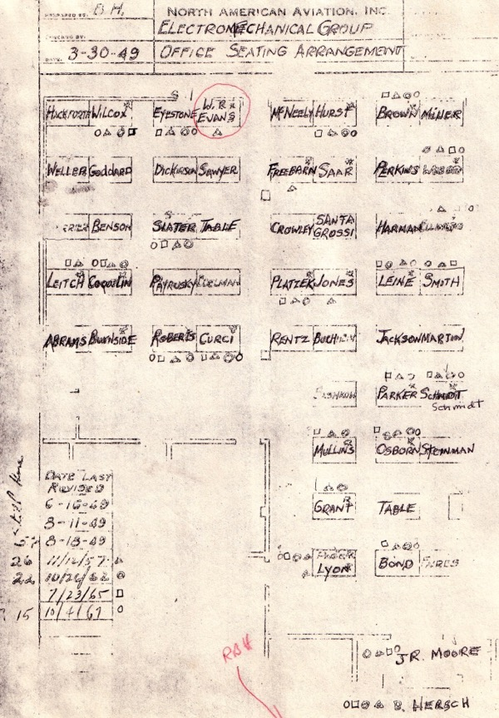

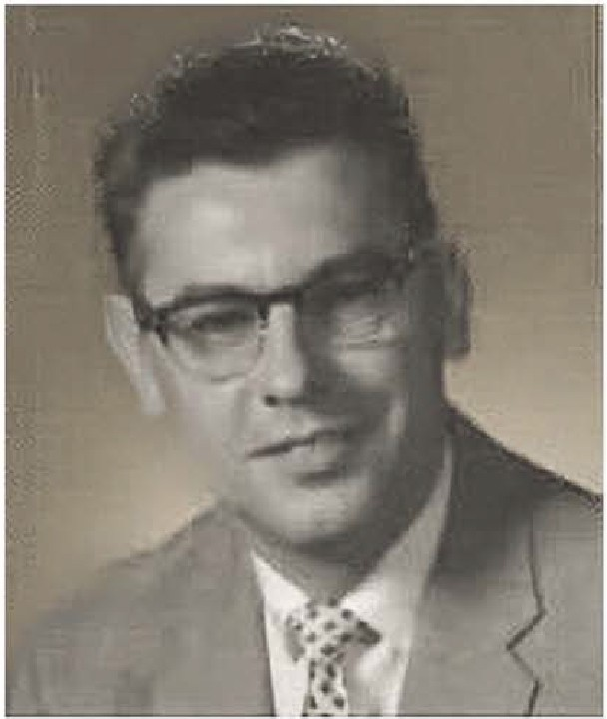
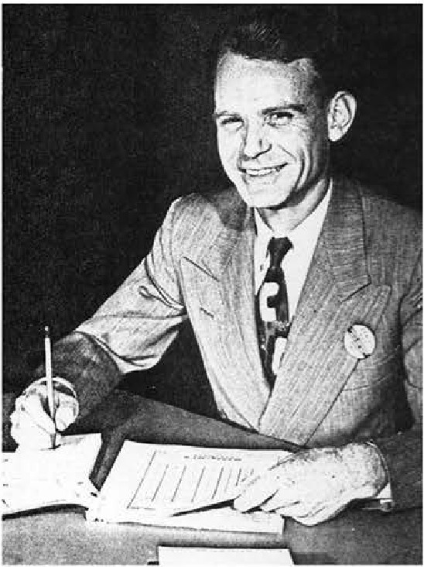
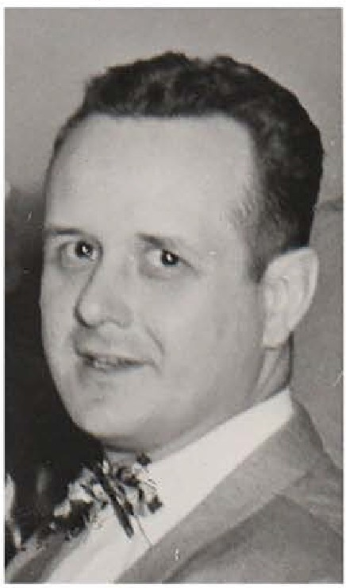
Aerophysics Lab Engineers in John Moore's 1949 Group 63 "Bullpen"
Bill Mullins Jeff Schmidt Fred Eyestone
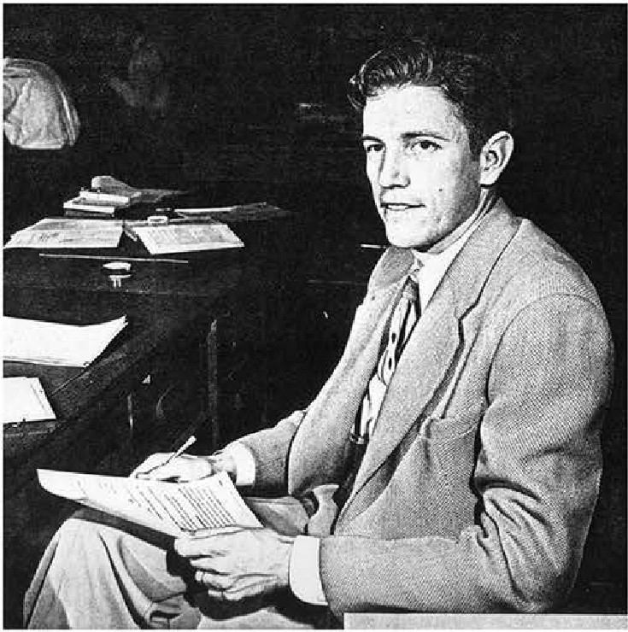

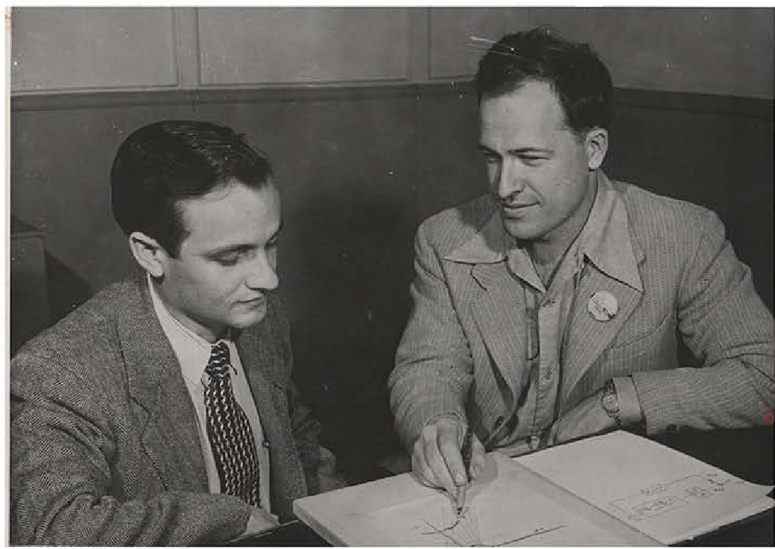
Norm Parker Larry Page Walt Evans
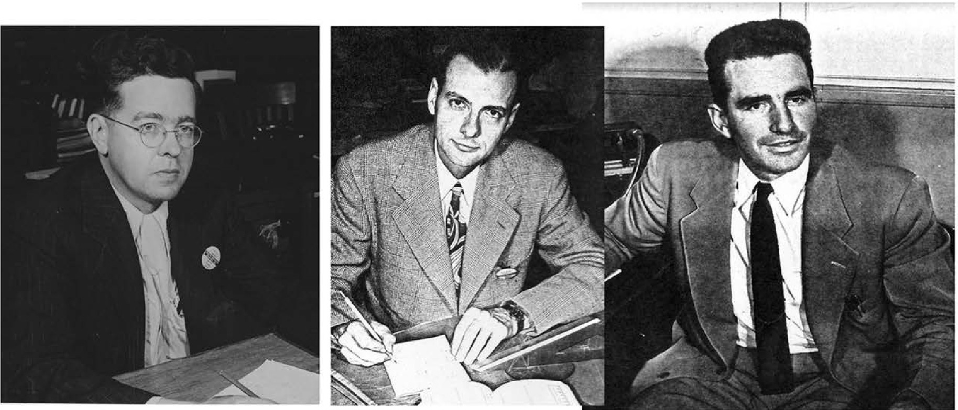

John Slater Robert Osborn John A.Moore

John Slater led the development of the XN-1’s Gyroscope; Jeff Schmidt built the first Spirule. Bill Mullins was the most enthusiastic user of the root locus method. (In 1951 he tutored Dr. William Bollay when he prepared for his Wright Brothers talk. Walt believed Bollay put the method on the map.) Al Grant and Robert Osborn sat near Moore. Osborn would play a lead role in administrative decisions about the Spirule. DeWitt Lyon became a Christian missionary to Japan in 1959.
Ward Harman was another good friend who later would promote Evans’s ideas at Stanford. Like Eyestone and Moore, Norm Parker became a company president. The novel, bleeding-edge technology they were developing blurred the lines between industry and academia. NAA employees taught night classes at UCLA. Seminars were attended and led by NAA engineers. It was a very special era.
The first application of the root locus method was the XN-1 auto-navigator. DeWitt Lyon wrote the official version of the 1950 XN-1 flight test program in the book Twenty Years of Inertial Navigation at North American Aviation. He described for the author in private correspondence what really happened. The paper concludes with John Moore’s only reference to Walt’s role at NAA in his 22-page report “Legacies of North American Aviation Experts.” Here are excerpts from Lyon’s official XN-1 account.
In 1948, J. R. Moore joined NAA and assumed direction of the guidance and control effort. Under his leadership, work on inertial guidance was carried on without a break in the basic philosophy, but at an accelerated pace.
Components of the XN-1 auto-navigator began to be assembled in September 1949; the system work falling under the direction of S. F. Eyestone and being handled by
W. R. Evans, J. Y. Bowman, and W. D. Lyon. The system included the XN-1 platform mentioned above, a gyro speed control system which synchronized the gyro speeds to an airborne chronometer, and an analog computer for position computation, acceleration corrections to the distance meters, and earth-rate torquer currents to the gyros.
Laboratory tests of this system were made in March and April 1950 and the first flight, installed in a C-47 airplane (Serial No. 065), was made on 3 May 1950. The flights were made [from Downey] east to Arlington, near Riverside, California, and return. These flights were from approximately 40 minutes to 1 hour in duration,

covering more than the designed flight time for this type of autonavigator (approximately 30 minutes). Flight testing continued through the Summer and Fall of 1950 with this system.
Two employees onboard the C-47 for the initial test flight of an NAA inertial guidance system were Walt Evans and his friend and colleague DeWitt Lyon. Here is DeWitt Lyon’s account of what really happened:
DeWitt Lyon: "Walt, Jesse Bowman, and I rotated as system engineers with the X-1 in the C-47 [military DC-3] flying out of Downey. Each one would work two shifts, flying with the system in the day followed up by working up the data at night. The next day, the next system engineer would do the same, using the previous day's data as reference, while the previous engineer had the day off.
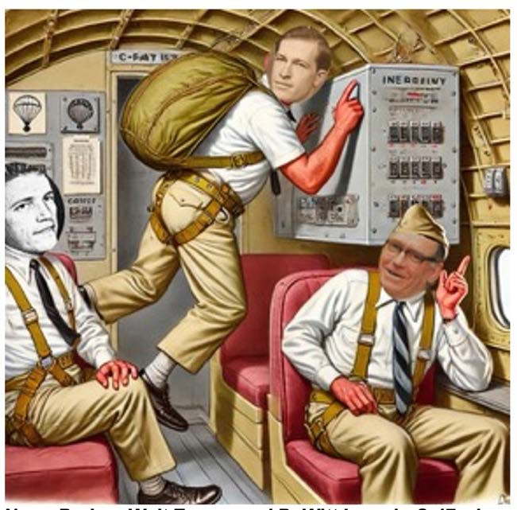
To the best of our knowledge at the time, that was the first airborne inertial

Norm Parker, Walt Evans, and DeWitt Lyon in C-
47. Evans’ parachute hit the B+ switch, terminating the test.
guidance system
anywhere. You probably have lots of information on the incident when … Walt’s parachute backpack inadvertently tripped a B+ switch in the gyro power supply. The
stabilized platform started to drift, but feedback through synchros made the scopes monitoring the gyros look as if they were still synched in!"

Someone in the company, hearing of the way Walt had terminated the world’s first flight test of an inertial navigator, commemorated the event with an inscription in concrete near the Downey main strip to document it. In Part 4 of “Legacies Left By Former North American Aviation Experts and Executives,” John Moore wrote,
“I think that one of the great desecrations of modern times was the removal of the historic inscription in concrete near the Downey main strip, with its deathless line:
“From this point in Euclidean space, Man first attempted to trace, His path through the heavens, And in spite of Walt Evans, Safely returned to this place.” 19
Despite the mishap, the Aerophysics Lab developed more generations of inertial navigation systems to become the undisputed world leader. The technology, aided by root locus, would serve as the guidance systems for the U.S. Air Force and Navy ballistic missile systems Minuteman and Polaris, which—together with the B-1 bomber force—form the triad of the United States strategic defense systems. But applications of the root locus method extend well beyond its historic role on national defense systems.
In those heady days of the 1950s, beyond being a consummate engineer and recruiter, Johnny Moore was also the best marketing executive at North American Aviation. His frequent trips to Washington, supported by outstanding technical work in California, contributed to the growth of the Aerophysics Lab. Moore counted on the ability of his stable of engineering talent to deliver on his promises—especially those associated with the Navaho Missile program and the Polaris submarine fleet.
Over just ten years, the program accomplished several technological firsts.. 31 The X-10 test drone became the first turbojet-powered vehicle to exceed Mach 2 and the first aircraft to fly a complete mission under inertial (computer) guidance. Later, the G-26 ramjet-powered vehicle became the first jet aircraft to reach Mach 3 and an altitude of 77,000 feet.
The accomplishments of the Aerophysics Lab laid the groundwork for dramatic growth in inertial guidance technology. This technology evolved through multiple generations, from XN-1 to XN-6. The XN-1 was the first inertial guidance system to be tested in an airplane.

The guidance and control computer for the Navaho was completely digital, with a rotating disc, non-volatile memory. It made its first flight in 1955 as the first transistorized digital computer with a rotating disc memory ever flown. 31
The Navaho program is one of the least-known, yet most important early missile programs in the United States. The project achieved advancements in every discipline of engineering and electronics. It introduced the airborne digital computer, modular electronic circuitry, and the first fully inertial navigation system. James Gibson wrote an excellent reference: The Navaho Missile Project.
In 1955, North American Aviation restructured its MACE (Missile and Control Equipment) division, which focused on guided missile systems and control equipment. This restructuring led to the creation of Autonetics, a division specializing in avionics, guidance, and control systems. As general manager of Autonetics, John Moore then led a division of more than 7,000 people.
Autonetics continued to expand, securing ambitious contracts for equipping the Navy’s Polaris submarine fleet and the Air Force’s silo-based Minuteman missile installations. In 1958, the XN-6 navigator, originally developed for the Navaho, would guide the Navy’s nuclear submarine Nautilus to the North Pole. When I interviewed John Moore in 2003, he expressed how he was proud that he and the company had had the foresight to ensure the XN-6 inertial navigation system would fit through a submarine hatch. In Moore’s memoir “Legacies Left by Former North American Aviation Experts,” he wrote:
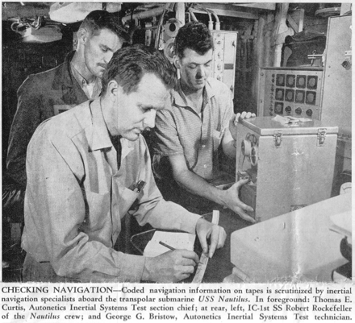
In the early 1950s, our gyro engineers came up with a paired, reversing gyro design which automatically canceled almost all of the error torques dependent upon the gyro angular momentum vector. This six-gyro stable platform, in which three gyros performed the h function while the other three were reversing their angular momentum vectors, provided a concept which seemed to meet the Navaho accuracy requirements without

Tom Curtis onboard the Nautilus enroute to North Pole guided by the XN-6 inertial guidance system

depending upon a star tracker called ‘NAVAN’ [North American Vehicle Auto Navigator]. Tom Curtis was the project engineer on the NAVAN, which was selected as the guidance system for the Navaho missile. This concept had so much promise that we recognized its potential application as an inertial navigator for submarines. Accordingly, we established as one design criterion that the stabilized platform and associated guidance electronics had to be small enough to pass through a submarine hatch.
The Aerophysics Lab’s entrepreneurial culture, which encouraged individual accomplishments, gradually gave way to a more bureaucratic culture. John Moore admitted that mistakes were made, some of them his. He wrote:
Autonetics had gone from a nadir of 5,400 people at the beginning of 1958 to a requirement for rapid growth. … It soon became evident that for such a buildup as all of these new programs required, the original Autonetics organization structure was totally inadequate. Accordingly, in 1959, Autonetics was reorganized on product lines.
However, I made the mistake of affecting this organization without first changing the existing organization's operating policies, procedures, specified authorities, and responsibilities to relate to the new organization. This produced so much chaos that the division escaped meltdown only because of the dedication, skills, and stamina of its key people …
One consequence was a loss of talent. Some engineers went to other companies, and others struck out on their own, most notably, Henry Singleton who left and founded Teledyne, becoming a multi-millionaire.
No single individual had a more profound influence on the career of Walt Evans than John R. Moore. The men met at Washington University in St. Louis in 1937 upon Moore’s graduation and Dad’s matriculation. Dad followed Moore to Schenectady in 1941, to Washington University in 1946, and to North American Aviation in 1948. They were different in many ways but shared in their commitment to national security during the Cold War. Washington University’s McKelvey School of Engineering awarded John R. Moore and Walter R. Evans its Engineering Alumni Achievement Awards in 1988 and 1990, respectively.

“Walt was one of my best friends, and I brought him from GE to Washington University and from Washington University to North American Aviation. One of Walt's major characteristics was his sense of humor.”
In 1959, Walt supported Moore’s nomination for an honorary degree from Washington University with the following letter:
John Moore was the key driving force behind the North American Aviation team which developed and manufactured inertial guidance equipment from 1948 through his presidency of the Autonetics Division in the 1960s. This guidance equipment, used in the Minuteman and Polaris Missiles, achieves an accuracy of a fraction of a mile based upon acceleration measurement and computing alone.
John’s leadership covered recruiting, error analysis, sales as well as management. He was selected executive vice-president of North American Aviation just before the Rockwell merger, which led to Rockwell's taking over the management of the company, … John is now a vice-president of McDonnell Douglas. However, the team which he formed still dominates the Electronics Groups of Rockwell International.
In conclusion:
These two men—the consummate aerospace executive and the brilliant electrical engineer—served their country at a decisive moment in history and left a lasting imprint on the engineering achievements of the Cold War era.

About this Pape::
This paper is derived from research presented in Into Stability: Walter R. Evans and the Story of Root Locus (Evans, 2025) and examines the historical development of the root-locus method within the engineering culture of the early Cold War.
About. the Author:
Gregory W. Evans is a graduate of the California Institute of Technology (1969) and Stanford University (1975) and served as a Distinguished Technical Fellow at TRW. He is the author of Into Stability: Walter R. Evans and the Story of Root Locus (Evans Heritage Press, 2025) and is the son of Walter R. Evans
More information is available at WalterREvans.com. [greg@walterrevans.com]

