Title: The Spirule (1948-1985)

Subtitle: An Analog Computing Tool for the Root-Locus Method
Author: Gregory W. Evans

Engineering History Series: The Development of the Root-Locus Method
From research behind Into Stability: Walter R. Evans and the Story of Root Locus

Abstract:

The Spirule was a simple mechanical device developed to assist engineers in constructing root-locus plots quickly and accurately. Conceived during the early adoption of Walter R. Evans’s root-locus method, the tool combined a circular protractor with a logarithmic spiral to allow simultaneous addition of phase angles and multiplication of vector magnitudes. This paper recounts the origin of the Spirule in the engineering culture of North American Aviation in the late 1940s and its subsequent production and distribution through a small mail-order enterprise operated by Evans and his wife. Although later superseded by digital computation, the Spirule played an important role in teaching and applying graphical control-system design methods during the formative decades of modern control engineering.

Keywords:

• Spirule
• Analog Computing Device
• Root-Locus Construction
• Graphical Control Design
• Engineering Instruments
• Logarithmic Spiral
• Analog Engineering Tools
• History of Engineering Computation

The Spirule (1948-1985)
An Analog Computing Tool for the Root-Locus Method
Joined at the hip with the birth of the root locus method was the need for a tool to help designers sum angles and multiply distances from a trial point “p” on the s-plane to other fixed points. Walt’s 1948 classroom notes captured his early attempt to meet that need. “Place a transparent sheet on top of the diagram, draw the red line for reference, stick a thumbtack through at the guess point to serve as a pivot.”
Engineers rejected his makeshift solution. They wanted something better—something precise, durable, and repeatable. Yet few at the time, including Walt himself, could have anticipated how dramatically this problem would shape the next stage of his career. The tool’s journey from plexiglass prototype to globally distributed teaching aid was a story no less remarkable than the method it served.
Jeff Schmidt was one of Walt’s colleagues. His assignment in the summer of 1948 was to design an analog autopilot for the NATIV missile. It had to work without adjustment throughout the changing mass and center of gravity during the launch phase. Schmidt was stymied until Walt presented root locus. In 2003,
Schmidt recalled:When Walt first started discussing root-locus in his class, I saw a ray of hope. While the problem was still very difficult, I could at least get a feel for what I was trying. As more people started to use Walt’s method, many ideas for automating the plot were thought of. I was looking for something better than transparent paper to add angles.
I went over to the engineering shop and made an “angle adder” out of a circle of plexiglass with a straight arm held on with a small bolt. This worked much better than the transparent paper for determining the locus, but I still had to measure lengths and multiply them to get loop gains. Walt and I were kicking this problem around one day, and we came up with the idea of adding a logarithmic spiral to my angle adder. This worked well and became the first Spirule.

The spiral-shaped curve was key to simultaneously using the principles of a linear slide rule (i.e., multiplication by addition of logarithms) and performing the addition with the circular protractor. DeWitt Lyon, a colleague of Schmidt and Walt, looked at the spiral curve on Schmidt’s device and coined “Spirule” as a contraction of “spiral” and “slide rule.”
In the spring of 1949, Moore invited Schmidt to lecture his graduate servo course at UCLA on the use of his Spirule. Schmidt recalled in 2003:
After the first Spirule had shown its worth, a design was made for a more precise model. A bunch were made for use in the department. After my demonstration in John Moore’s servo class, employees of several large aerospace companies asked for a set of drawings. Hughes had several hundred made, but the person doing the assembly looked at the assembly drawing and cemented the parts together.. Since nothing could rotate, they were worthless..
A milestone in the history of the Spirule occurred in January 1950 when Walt’s root locus ideas gained their first national platform at the January 1950 winter meeting of AIEE’s Feedback-Control Systems Group. Walt traveled to New York to present his paper. Surprisingly, the paper’s only mention of the Spirule is as a do-it-yourself project: “The reader can duplicate the ’spirule’ with two pieces of transparent paper, one for the disk and one for the arm.” Hence, many in the audience would have never seen a real Spirule.
During his talk, Walt introduced the Spirule. Afterward, approximately 70 attendees expressed interest in obtaining one. Walt encouraged listeners to duplicate the Spirule for themselves with pieces of transparent paper and some additional words of explanation beyond those in the published paper. This was one of many occasions on which he suggested to others that they need not purchase a Spirule from him to teach or learn the principles involved in root locus—they could create their own. To Walt’s surprise, engineers wanted Spirules.
Walt returned to California expecting dozens of follow up calls. He received exactly three, all in March. The first, dated March 1, came from W. C. Osterbrock, head of the University of Cincinnati’s Electrical Engineering Department. On March 21, Professor R.C.H. Wheeler from the U.S. Naval Postgraduate School asked, “Have you made the Spirule for sale? If so, how can I obtain one?”

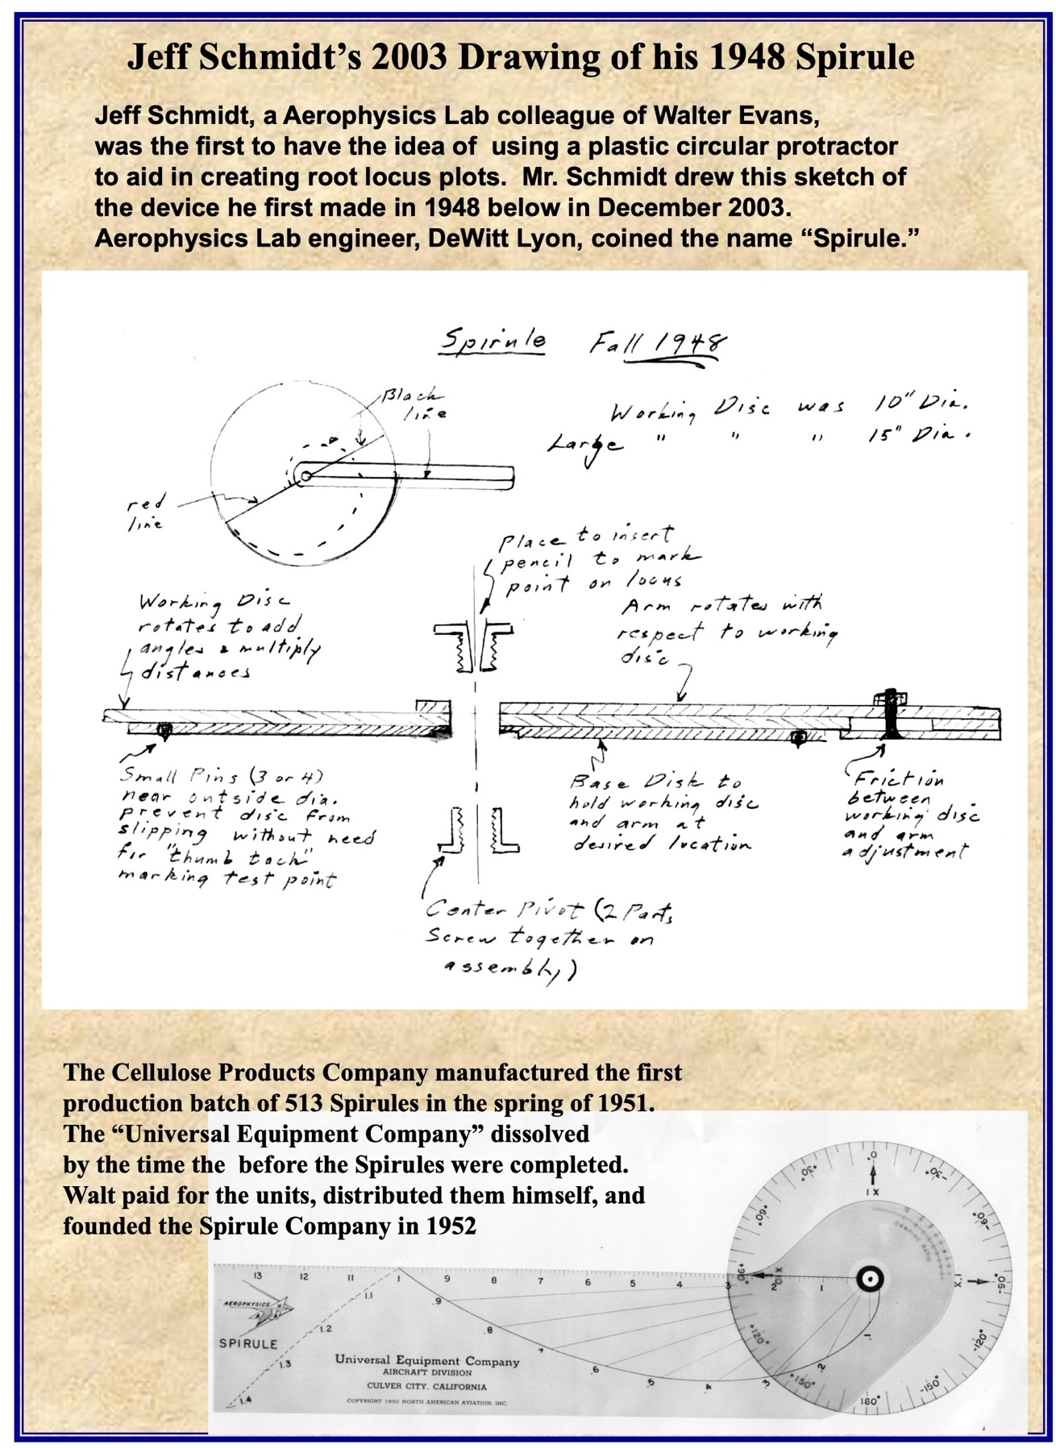
On March 27, W. E. Meserve, Professor of Engineering at Cornell, reminded Walt that he had promised to provide more information on obtaining the slide rule device. Walt waited until April 1950 to respond, explaining that he had delayed until he could distribute copies of his AIEE paper. His response to all three correspondents included the following:
Thank you for your interest in the root-locus idea. At the AIEE meeting, approximately seventy attendees expressed interest in obtaining a Spirule. Since then, only three have written. This presents a cost issue: $30 per unit for a machine shop model or 50 cents each for a stamped model in a lot of 500. The Spirule isn’t worth $30, and the demand is far short of 500!
It looks like they won’t be manufactured until I find an intermediate production method or finish writing a book in which the Spirule will be enclosed.
W.C. Osterbrock replied prophetically, encouraging Walt to manufacture Spirules and make them available for sale.
I wonder whether you are justified in your doubts about the demand for the ‘spirule.’ We could have disposed of 65 at a reasonable price, and we shall have another class of about 80 students in servo this summer. Other schools teaching the subject would likely recommend it if properly advertised. I hope you will find a way to produce and make it available.
The earliest Spirule drawing is an undated blueprint likely created in early 1950. The "final drawing" (was dated September 5, 1950) An October 19, 1950, NAA memorandum from R. M. Osborn to W.J. Toher requested funding to produce 500 Spirules.
Osborn noted that engineers at NAA, Hughes Aircraft, and Northrop had built their own Spirules and that root locus was already part of servomechanism curricula. He estimated production costs at 35 cents per unit in a batch of 500. He also suggested distributing them as souvenirs to visitors and educational institutions. Despite the appeal, the request became mired in bureaucracy. One week later, Dr. William Bollay delivered the Wright Brothers Lecture at the Institute of Aeronautical Sciences in Washington, D.C.
Meanwhile, interest in root locus, fueled by word of mouth, kept the idea and method alive, even without Spirules. Former NAA colleague Ward Harman had left NAA for a position at Stanford; he enthusiastically promoted root locus. Joseph Chadwick of Stanford’s Electronics Research Laboratory wrote on January 8, 1951:
Ward Harman has been such a convincing salesman of your root-locus method that he’s exceeded his ability to inform. Could I obtain a couple of your celluloid gadgets for summing angles, etc.?"
And yet, at the dawn of 1951, funding for Spirule fabrication remained elusive. “Our efforts to produce Spirules have been snarled in accounting procedures because the logical approach is to manufacture them in bulk and distribute them." Walt sought manufacturers, with three companies rejecting the project and three others not responding. Finally, Cellulose Products in South Gate agreed to fabricate the Spirule. NAA contracted with Universal Equipment Company in Culver City, which received the first bill for 513 Spirules on April 30, 1951. When the partnership dissolved, Walt personally paid the bill and all Spirule orders were routed directly to him.
On March 27, 1952, Walt sent a Certificate of Business form to The Whittier News. On April 8, 15, 22, and 29, the following notice appeared in the classifieds: “The undersigned does hereby declare that I am conducting a mail sales business at 1706 Maple Street under the fictitious name of “The Spirule Company. “Orders continued to flow in, some sent directly to Walt at his Whittier home, some to him at his NAA Downey address, and some to the Universal Equipment Company in Culver City. The most significant development in the first quarter of 1952 was the enthusiasm of two engineering professors from the University of California—Joseph Beggs of UCLA and Otto Smith at UC Berkeley.

The UC schools’ embrace of root locus and the Spirule into their departments’ feedback control classes laid the foundation for Spirule sales to university bookstores. Joe Beggs and Otto Smith were in a vanguard of professors at UCLA, Berkeley, Stanford, and Caltech who chose to introduce the new root locus methods into their classes. Many used Brown and Campbell’s 1948 Principles of Servomechanisms book as their text. In March, orders were received for 55 Spirules for resale by UCLA bookstore, 30 for resale by the University of California at Berkeley bookstore, and 20 for Charles Wilts’s servomechanism class at Caltech.

The Spirule

A plastic device with a disk and an arm with a common pivot point. The disk and arm are held together with a light friction fit by an eyelet; a small pin is held in the center of the eyelet by a clear plastic plug.
The pin is stuck in the vector plot at the desired s point to form a pivot for all measurements at the point. Note that all phase angles and vector lengths on the plot have this s point in common.

The total phase angle is obtained by rotating the arm with respect to the disk through each of the phase angles in succession; the total angle is read on the disk at the radial edge of the arm. The spiral curve on the arm is plotted such that the angle V from the radial edge to the curve is proportional to the logarithm of the radius to that point on the curve. The arm is rotated through each of these angles in succession in order to add logarithms.

The numerical value of the product is read on the curve in line with an arrow on the disk subject to the correction xn, in which x is the numerical value on the plot corresponding to 5" and n is the excess of poles over zeros. Any such correction factor can be set into the Spirule initially and marked on the frosted surface so that all further calculations give the final value directly. Terms in F(s) of the form (1+Ts) must be treated as a ratio (1/T + s)/(1/T). The factors such as 1/T can be set in by first pivoting the Spirule at the origin and rotating the arm opposite to the usual sense.
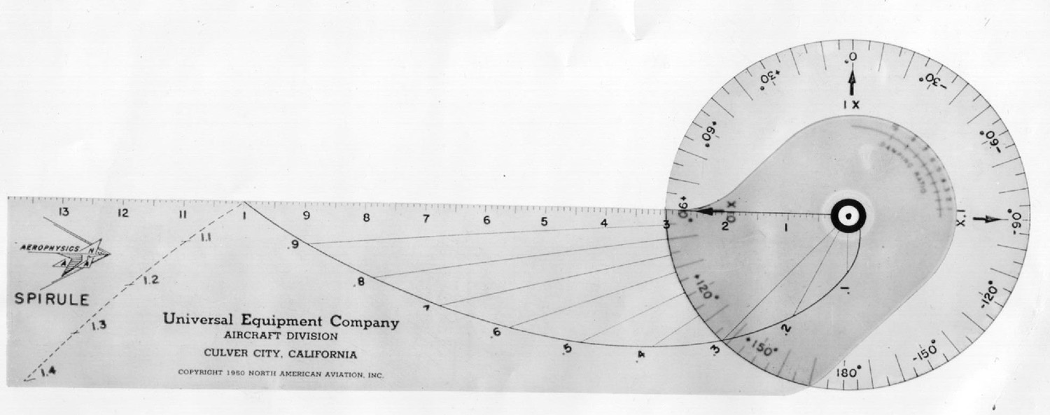
The supply from the initial batch of 500 had begun to run dry. Even worse, the Universal Equipment Company partnership had dissolved; the new owner wanted to raise the price of the Spirule. Walt worried about the affordability of the Spirule for students.

Having successfully completed the assembly, correspondence, billing, and shipping himself for the entire manufacturing run of 500 units, Walt offered and was granted permission to assume full responsibility in the future. And so, in a modest, 1200 square foot residence in Whittier, California, the Spirule Company was born. Coincidentally, Walt and Arline celebrated their tenth wedding anniversary the same day.

Ironically, it had been exactly two years since Professors Wheeler, Osterbeck, and Meserve had learned from Walt that NAA had no plans to manufacture Spirules because they were “not worth $30 and the demand is far short of 500 [for a $0,50 stamped model.]”

On the face of it, the decision to launch a mail-order business out of their residence seemed ill-advised. In April 1952 Arline was six-months pregnant and burdened with Randy and me. Walt’s and Arline’s parents and siblings lived 2000 miles away. Walt had demands at work and faced hard-to-meet publication deadlines for Control-System Dynamics.

Why then, did he choose to assume responsibility for Spirules? In part because he underestimated demand. Of all the feedback he received from the root locus method, the universal desire of designers and students to plot root loci with Spirules rather than two transparent pieces of plastic pinned with a thumbtack to a “genius pad”, was probably the least expected. He once remarked in a letter, “Engineers must love gimmicks,” Jeff Schmidt deserves credit for the design. Walt “closed the loop” with a business model that met the demand.

Luckily for him, in Arline, he had married a woman with high energy and finely-tuned time-management skills, who was fully committed to his success, and content to work quietly behind the scenes. She was his executive assistant, corresponding secretary, accountant, and filing clerk in addition to being an efficient home maker, and mother to his children. When anyone complimented Walt on his children, his response was always the same: “it’s not me, it’s Arline.”
One Sunday morning, Walt’s son answered the front doorbell still in his pajamas. A bewildered engineering student stood there and asked, “Is this The Spirule Company?” He’d driven to their house—likely desperate on the eve of an exam. The Spirule was sold in bookstores, but for him, salvation lay closer to the source.

Instructors worldwide adopted the Spirule for control systems courses; it appeared in dozens of textbooks, particularly throughout the 1960s and 1970s. From universities to defense contractors, its influence was pervasive. Between 1952 and 1986, Spirule sales reached more than 101,000 users in 50 states and 76 countries.

Among the thousands of orders, several stood out. In February 1959, about one year after Walt revamped the Spirule design, he received a kind letter from Professor John G. Truxal, now head of the prestigious engineering department at the Polytechnic Institute of Brooklyn.

Dear Mr. Evans,
Thanks very much for sending me the new model Spirule. I am very impressed with the construction of this model and I anticipate that we will ask our students to obtain it in the fall’s classes. I certainly am sold on your root locus method implemented with the Spirule and consider this the outstanding postwar contribution to the control field.

Sincerely, John G. Truxal

Noteworthy letters need not have been written by noteworthy authors. In 1973, Arline received a letter from the Philippines. Its author, Ho Hwa Hui, asked simply, “How much does a Spirule cost?” Without hesitation, Arline mailed one out the same day, trusting he'd pay. He did—and more.
His reply read:

You have unknowingly given me a two-fold surprise package. First, you sent the Spirule to a complete stranger thousands of miles away without even a guarantee that you’d get paid! Secondly, you are Mrs. W. R. Evans—wife of one of the most respected and prestigious control engineers in the forefront of this highly technical field. Of course, I don’t have to tell you.

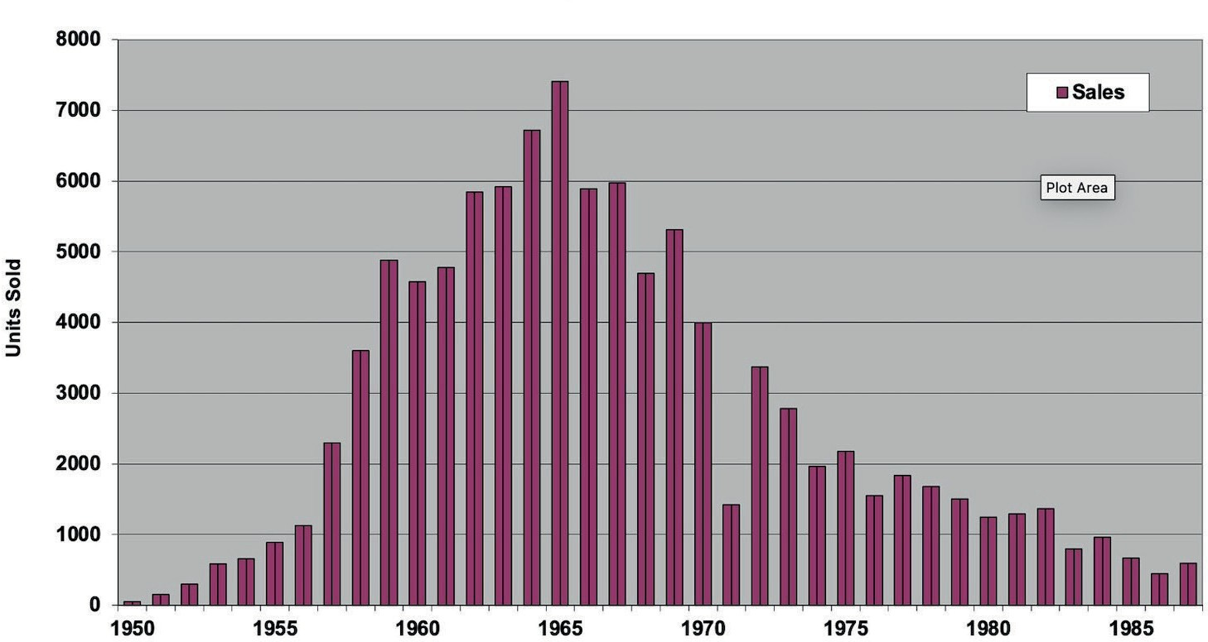
Annual Spirule Sales
Year (1971 = 6mo)
Annual Spirule Sales (Top)
List of Countries where Spirules have been shipped (bottom.)

Argentina | El Salvador | Kenya | Saudi Arabia
Australia | England | Korea | Scotland
Austria | Finland | Lebanon | Singapore
Belgium | France | Libya | South Africa
Brazil | Guatemala | Mexico | Soviet Union
Canada | Greece | Mozambique | Spain
Ceylon | Honduras | The Netherlands | Sudan
Chile | Hong Kong | New Zealand | Sweden
China/Taiwan | Iceland | Nigeria | Switzerland
Columbia | India | Norway | Thailand
Costa Rica | Indonesia | Oman | Turkey
Cuba | Iran | Pakistan | Uganda
Cyprus | Iraq | Panama | United States
Czechoslovakia | Ireland | Peru | Uruguay
Denmark | Israel | Philippines | Venezuela
Dominican Republic | Italy | Poland | Wales
Ecuador | Japan | Portugal | West Germany
Egypt | Jordan | Puerto Rico | Yugoslavia

Walt priced the Spirule barely above cost, aware that most of his customers were students. Orders arrived for decades, addressed to the home he moved into in August 1954: 9728 El Venado Drive, Whittier.

The Spirule was the physical manifestation of Walt’s root locus method. It was a tool that embodied the core principle of plotting how the roots of a characteristic equation move with changes in system parameters. It transformed abstract mathematics into a designer’s tool—repeatable and fast.

Because of that, it outlived the era of analog computing and slide rules. The root locus method became embedded in MATLAB code and CAD tools. Its teaching value—as a graphical, hands-on, geometry-based approach—remains foundational in control theory instruction to this day. That is the legacy of The Spirule Company. And it is inseparable from the vision and values of Walter R. Evans.

About this Paper:
This paper is derived from research presented in Into Stability: Walter R. Evans and the Story of Root Locus (Evans, 2025) and examines the historical development of the root-locus method within the engineering culture of the early Cold War.
About the Author:
Gregory W. Evans is a graduate of the California Institute of Technology (1969) and Stanford University (1975) and served as a Distinguished Technical Fellow at TRW. He is the author of Into Stability: Walter R. Evans and the Story of Root Locus (Evans Heritage Press, 2025) and is the son of Walter R. Evans
More information is available at WalterREvans.com. . [greg@walterrevans.com]

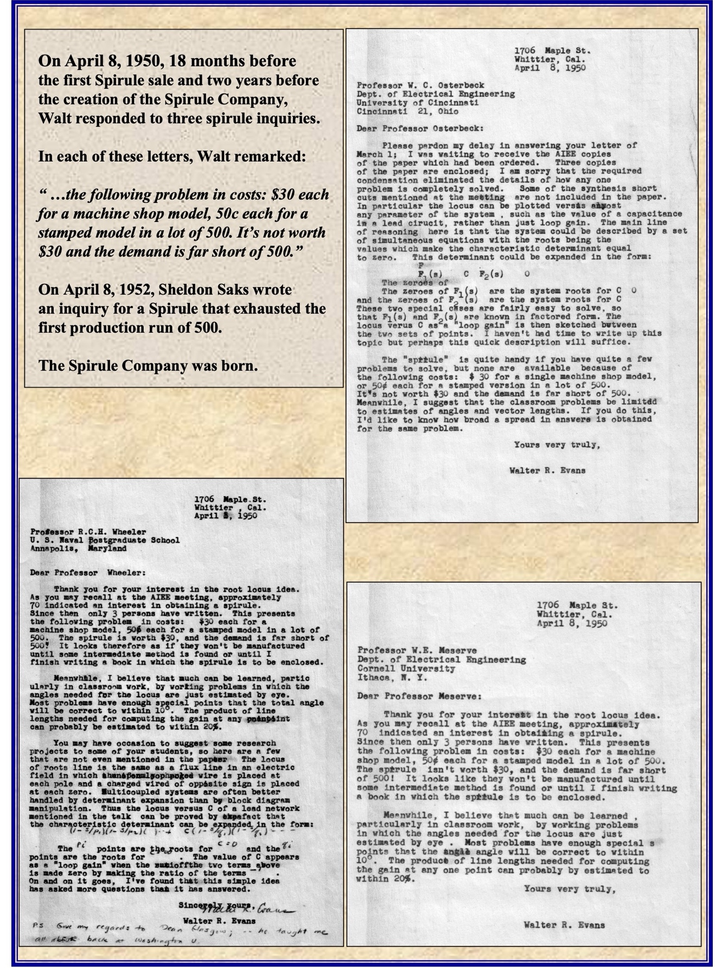
Spirule Historic Documents from the Vault
April 1949: Walt's response, “It's not worth $30 and demand is far short of 500.”
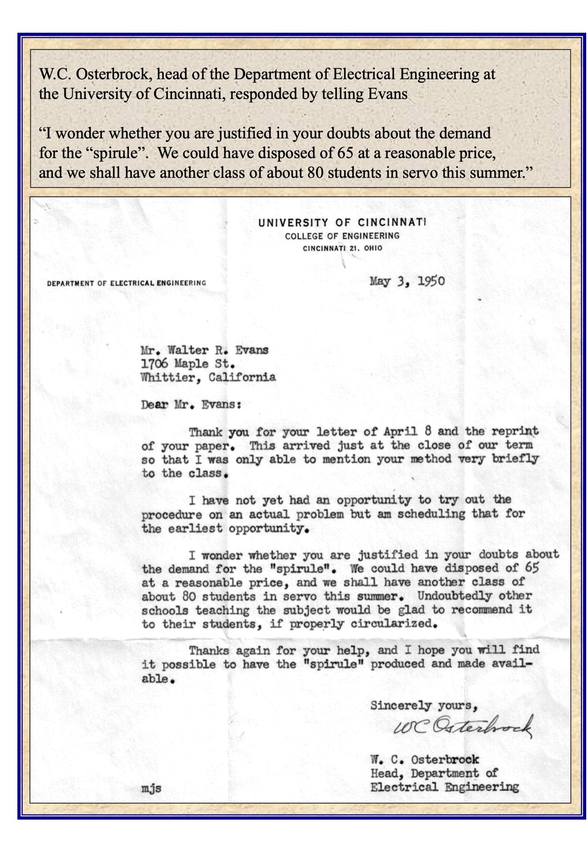
May 1949: W.C.Osterbrock Feedback: “I wonder whether you are justified in your doubts?”

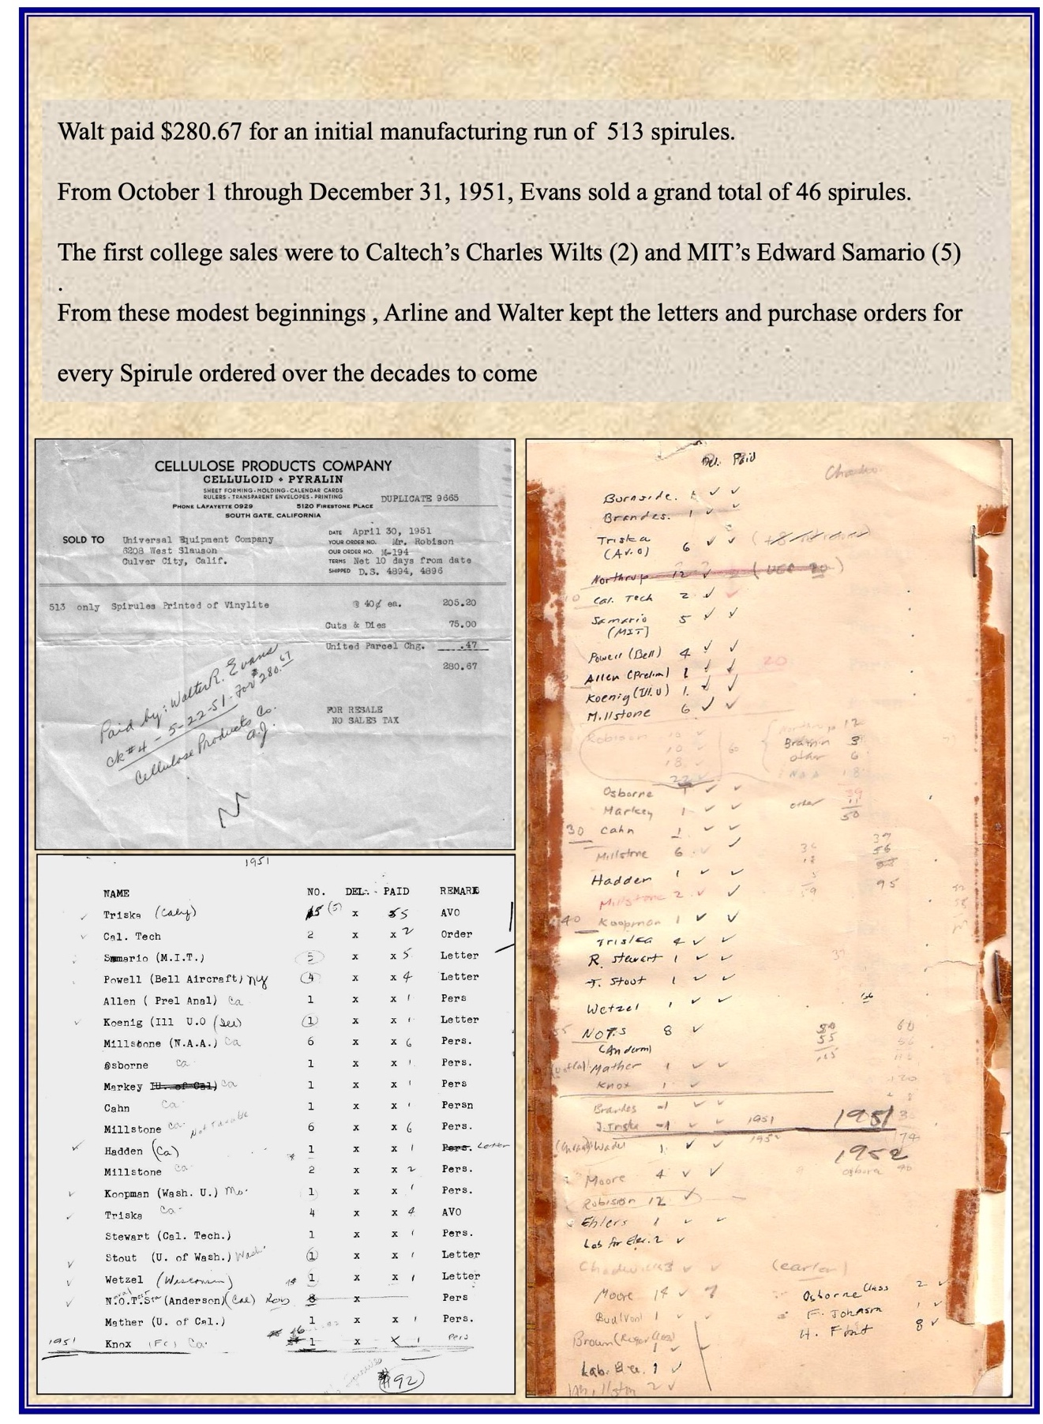
Oct - Dec 1951: NAA makes 513 Spirules. Walt takes orders. Caltech is the first institutional sale.
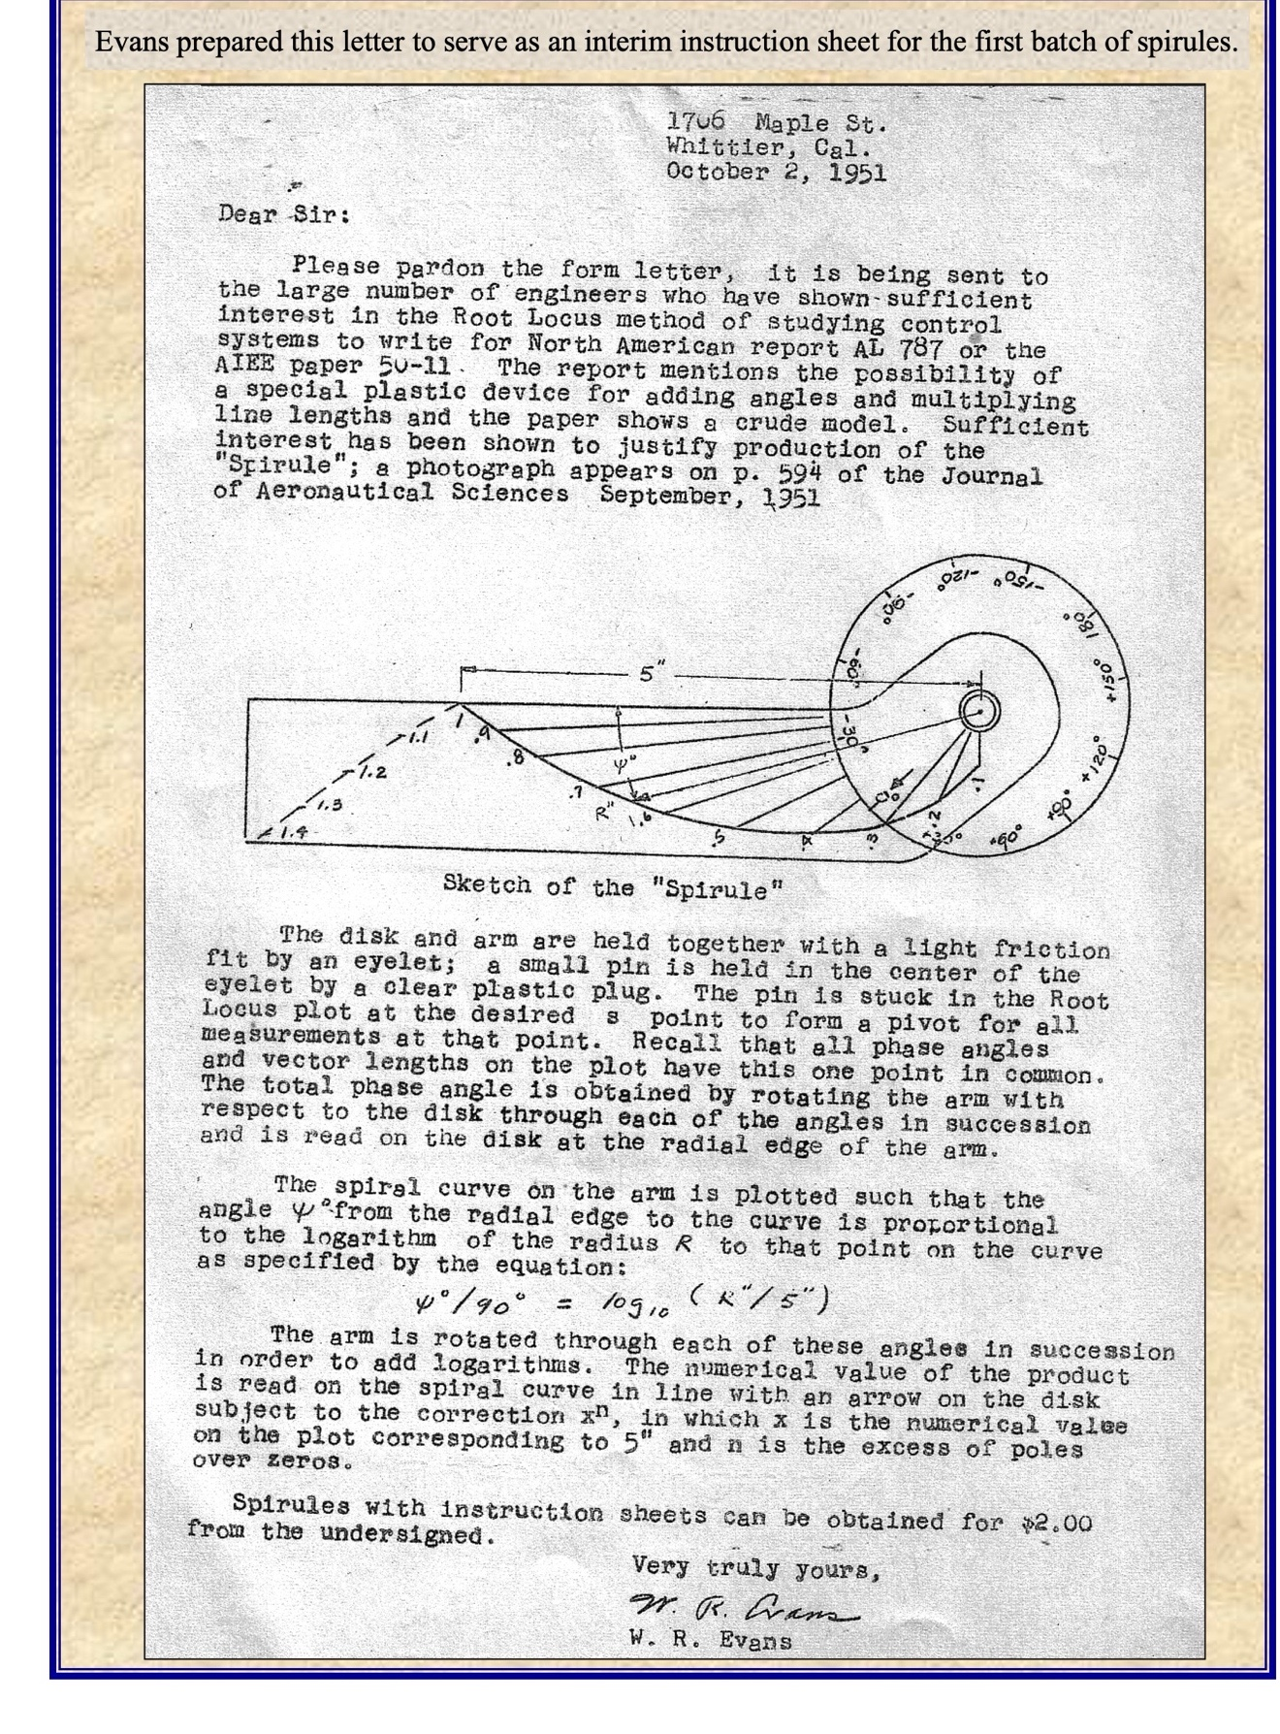
October 1951: Spirules with instruction sheets could be obtained for $2.00
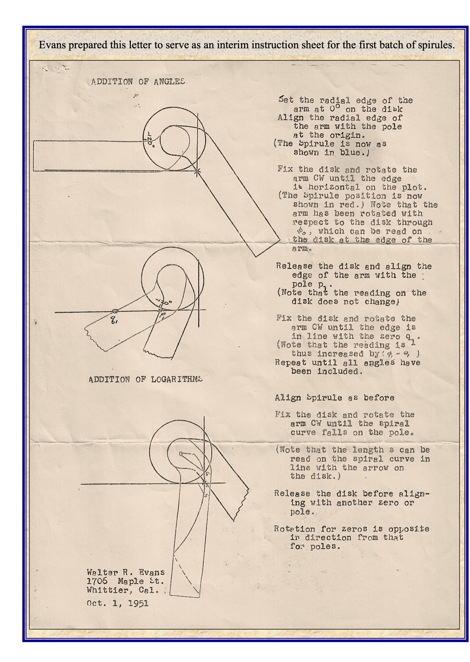
October 1951: Spirule's use as a circular protractor.
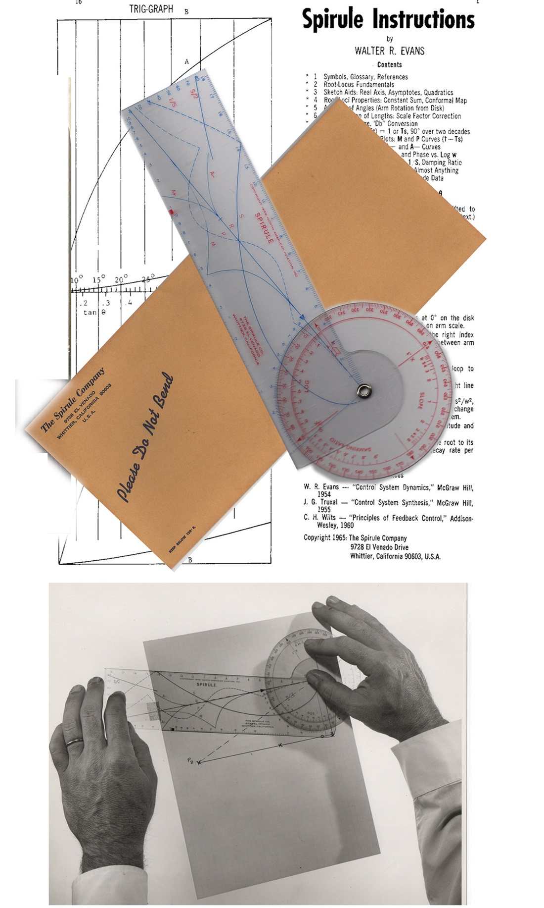
1959 New Model Spirule and Instruction Sheet

