Title: The Struggle to Publish the Root-Locus Method
Subtitle: Walter R. Evans and the Road to the 1950 AIEE Paper (1948-1950) Author: Gregory W. Evans
Engineering History Series: The Development of the Root-Locus Method
From research behind Into Stability: Walter R. Evans and the Story of Root Locus

Abstract:
Walter R. Evans’s landmark 1950 paper introducing the root-locus method appeared in the Transactions of the American Institute of Electrical Engineers only after an extended and uncertain review process. This paper examines the publication struggle surrounding the submission, review, and eventual acceptance of Evans’s work between 1949 and 1950. Drawing on correspondence, archival materials, and contemporary accounts, it describes the challenges of presenting a new graphical design method to a professional community accustomed to frequency-response analysis. The study places the episode in the broader context of the rapid expansion of control-system engineering during the early Cold War and highlights the role of conferences, textbooks, and early adopters in spreading the method. The publication history illustrates how an innovative engineering idea gradually gained acceptance within the professional literature

Keywords:
- Scientific Publication Process
- Peer Review History
- Root Locus Paper 1949
- Engineering Knowledge Dissemination
- AIEE Transactions
- History of Engineering Journals
- Technical Publishing History
- Control Theory Development

The Struggle to Publish the Root-Locus Method

Walter R. Evans and the Road to the 1950 AIEE Paper (1948-1950)

Two things came together in the late 1940s: The remarkable young people in the auto-navigator division of North American Aviation's Aerophysics Laboratory and one of its new leaders, Walter Evans. This team was solving very difficult engineering problems one after another, to produce, for the first time anywhere, precise navigation systems for very long-range, unmanned aircraft and for submarines among many firsts. These were very hard systems to achieve.
Control systems had to remain stable under conditions and deliver precise performance at speeds and ranges never before attempted. Classical analysis tools—while mathematically sound—provided little intuitive guidance. And perhaps the biggest gap: While it was clear that poles and zeros controlled a system’s behavior, there wasn’t a reliable way to move them around on the complex plane. That made it hard to design for specific dynamics, especially when stability had to be rock-solid.
Walter Evans, better known to his colleagues as Walt, was a person of remarkable insight whose historic contribution was the invention of the root-locus method for seeing instantly the natural dynamic behavior a linear system will have, seeing it directly in terms of the control parameters at the designer's disposal. The method presents—in seconds—a plot of the system's stability, speed of response, and the damping quality of all of its natural motions.
It was in September 1948, in the process of formulating a response student’s question about his “method of roots” graphical analysis method the AIEE had recently published, that he recognized his method’s potential to design for stability. colleagues were very smart young people. They saw at once the power of Evans’s Root-locus method, and it spread very quickly through their culture at North American Aviation. It was just very easy to learn and use and place at the center of discussion of every control system design.

In November 1948, Evans submitted for publication in the AIEE transactions a paper ultimately entitled “Control System Synthesis by Root Locus Method.” His hopes for early publication ran into a thicket of critical reviews: “too long,” “unclear,” “nothing new.” Twelve months would pass before the AIEE approved it for publication, where it first appeared in March 1950. The author’s access to all of the correspondence supports this fully documented account of why one of the most oft cited journal articles in the history of the journal appeared 18 months (September 1948 to March 1950) after Evans’s “Eureka!” moment.

Saturday, May 7, 1949
Occasionally history delivers a coincidence so startling, it defies explanation. July 4, 1826, was such a date. Fifty years to the day following the signing of the Declaration of Independence, two giants of the Revolutionary War, John Adams and Thomas Jefferson—at times bitter political rivals but by then reconciled—both passed into history within hours of each other, one in Massachusetts and one in Virginia. Saturday,
May 7, 1949, may fall short of that standard. However, as the AIEE review committee extended its six-month resistance to publication, the coincidence highlights the significance of what Walt believed was at stake.
The Soviet Union and the United States were in an arms race in an undeclared war. Unlike the World War recently ended, this new “Cold War” would not be led by generals or fought by soldiers on battlefields. Rather, it would be led by scientists and waged by engineers in their laboratories and rocket test ranges. All the engineers working in Johnny Moore’s bullpen knew the stakes.

May 7, USA—Location: 1706 Maple Street, Whittier, California
Despite Saturday being a day off, Walt was angry. At the Polo Grounds, the New York Giants had delivered a 9–1 drubbing to the St. Louis Cardinals—his hometown team. But his frustration had less to do with the loss of one game and more to do with six months of waiting.
In December 1948, he had submitted his second servomechanisms paper to the American Institute of Electrical Engineering (AIEE). As in 1947, he found himself caught in the agonizingly slow review process. He had already missed the 1949

winter general meeting because one critic complained about the paper’s length. Now, two months after submitting a shorter version, he was still in the dark about its acceptability.
Would it take a full year, just as it had with his 1947 graphical analysis paper, before his new root locus idea would get a hearing at a general meeting? Were open-minded reviewers assessing his work, or was his paper in the hands of close-minded critics? At work, younger engineers embraced his new method.

Dear Prof. Brown (First Attempt)
Frustrated, Walt sat down on May 7 to vent his anger toward the one person he believed controlled the fate of his paper: Professor Gordon S. Brown, founder and director of MIT’s Servomechanism Laboratory and chairman of the AIEE Technical Program Committee’s servomechanism subcommittee.
Dear Prof. Brown, The AIEE has now had the ‘Root Locus’ paper for nearly six months. In my humble opinion, this is a pathetic record for an Institute that claims the ‘dissemination of new theories’ as one of its fundamental aims. This is a subject on which I might write in undeniably clear language if there were reason to believe that it might do some good.
He finished the draft of his letter and set it aside.

May 7, USSR—Location: Kapustin Yar Launch Complex Near Volgograd
On this day, the Soviets carried out their first test flight of the P-1A rocket. It was a success. A variant of the R1-A rocket, this new version was equipped with a detachable warhead. The R1-A “Scunner” rocket was a version of the German V-2 rocket that had been used with devastating effect in World War II. The Soviet engineers had apparently overcome their most vexing problem—maintaining stable flight control—to achieve a successful 270-km flight. Five more successes would follow in the month of May. 34
If Walt had known of the critical milestone that the Soviet Union had just achieved in their rocketry program, only hours before he had sat down to vent, his anger at the AIEE review committee would have been magnified. Walt had been a key contributor for nearly twelve months in Jn Moore’s Group 63 brain trust.

Thus, he knew the potential national security implications if defense contractors at other companies remained ignorant of the best available methods for achieving stable flight control of their unmanned warhead delivery systems—whether they were powered rockets like the Navaho at NAA or ballistic missiles under development at other defense contractors.
This Soviet success on May 7 was unknown to Evans, but he was well aware of America’s competition with the Soviet Union. Three years had passed since Winston Churchill had famously declared in Fulton, Missouri:
From Stettin in the Baltic to Trieste in the Adriatic, an iron curtain has descended in the continent.
By May 1949, the USA–USSR relationship, never without issues, had grown more tense. Less than a year had passed since the Soviet Union tried to block western access to Berlin, Germany. President Truman had responded with the Berlin Airlift, a vital lifeline for the besieged residents of West Berlin.

Dear Professor Brown (Second Attempt)
Later that evening, Walt returned to his draft. Should he send it? What good would it do? His mind churned. Creative but impatient by nature, he seldom settled on the first solution that came to him. Instead, he sought out alternate perspectives that might reveal a better approach. Walt knew that John Moore and Gordon Brown had met recently and likely discussed his paper. Moore would surely report back soon.
Though we cannot read his mind, we know what Walt did: He rewrote the letter, this time laced with sarcasm and a veiled threat to publish in a different journal.
“The Root Locus idea … has been chasing around for six months in some ‘multiple loop’ with no visible ‘output.’ The only ‘feedback’ has been rejection and your recent letters. There must be something ‘nonlinear’ in the system. … The obvious alternative is to submit the paper to a different organization."
He sent the second draft letter airmail. On his first draft, he wrote “Not sent.”

Dear Professor Brown (Third Attempt)

Sunday, May 8, was a better day—at least for the St. Louis Cardinals, who trounced the Brooklyn Dodgers 14–5 at Ebbets Field. The 1949 baseball season was still in its early stages. As it turned out, so was the review of Walt’s paper. The Cardinals were recent (1946) world champions, led by 1948 batting champion Stan Musial, and had their sights set on the pennant. To get there, they would have to outlast the Brooklyn Dodgers.
On Monday morning, May 9, Walt drove down Imperial Boulevard from his modest home in Whittier to the Aerophysics facility in Downey. There, he learned from John Moore that the March 28 revision of his paper was still unacceptable to Brown. Worse, Moore’s comments suggested that Brown had not yet grasped the value of the root locus method. Anxious to understand exactly what Brown didn’t see, Walt wrote a third letter before Brown had received the one sent on May 7.
Dear Prof. Brown, John Moore returned with news that the ‘Root Locus’ paper is still unacceptable to you. Therefore, I would appreciate a copy of the paper marked with your questions.
He ended with a veiled ultimatum,
I see no alternative to starting some action in parallel with your committee. The slow and inconsistent record on the A.I.E.E. decisions on this paper and T885 do not justify any further delay. Sincerely yours, Walter R. Evans
At home that evening, Walt vented further. He took out his manual typewriter and banged out four more letters in one night. Each was to men he hoped would be more receptive than Brown. They included his former General Electric colleague, Gordon Walter; his first-year supervisor, Orrin Livingston; his old instructor and now head of the department, Louis (Doc) Rader; and his Washington University contact, Phil Michel. To Louis Rader, he wrote bluntly:
Remember the low opinion I had of the AIEE technical paper in Pittsburgh? Well, it has now sunk even lower. The enclosed paper was first submitted to the Winter Meeting. Every bit of information I’ve received has been the result of needling them. The engineers here at North American’s Aerophysics Lab have already adopted it over standard methods. If you or any of the boys have questions, I’d be happy to answer them.

On Tuesday, May 10, Brown received Walt’s May 7 letter. He responded with a carefully worded yet unmistakably stern reply. Taking the unusual step of requesting his secretary send it by airmail, he enumerated his points, five of which began with “please.” By Thursday evening, May 12, Walt had the letter in hand. He opened it to find a structured rebuke—polite but sharp One passage stood out:
Please remember that anyone who seriously undertakes the job of reviewing manuscripts spends a great deal of time in the interests of the author’s professional reputation. This work is purely voluntary and part of the code of professional ethics.
The final note advised: “Please … talk to Mr. Moore upon his return to California and get his advice before you let this matter go too far.
At the bottom of the letter, Walt saw that Brown had forwarded copies to three members of AIEE’s Technical Committee and John Moore. Walt was both contrite and angry. He immediately drafted a point-by-point response. To Brown’s fourth comment, he typed,
You may excuse my overlooking the time volunteered by reviewers when you realize that ‘too long’ and ‘show contribution to synthesis’ were essentially the only reasons given for the initial rejection. The hundreds of hours I spent developing the method were fun, but they have now been matched by write-ups and revisions. More importantly, think of the thousands of hours wasted by AIEE members on inefficient methods due to this publication delay.
By the time he finished, it was late. He set the letter aside to sleep on it

Dear Professor Brown (Fourth Attempt)
Following Gordon Brown’s suggestion, Walt sought guidance from John Moore. This time, he learned that Brown had told Moore he had spent hours reviewing the root locus paper and had even considered rewriting it himself. From colleagues, Walt discovered that their compliments on his paper stemmed partly from their awareness of the time he had devoted to it. His anger dissolved into a mix of contrition and embarrassment.

Setting aside the defiant draft he had written the previous evening, Walt composed a letter of apology for his secretary to type and send to Brown. For the fifth time in six days, he began with:
Nothing seems less funny than an attempt at humor that is out of place. I wish to apologize for my letter of May 7; it was an ill-considered outburst of long-accumulated frustration. Any effort you can make to ignore my recent letters would be appreciated. I am completely deflated. The only thing I’m sure of at this time is my duty to revise the paper until it is acceptable.
Over the next two weeks, Walt did just that. On May 29, he submitted his revised paper to the AIEE in New York, changing the title to "Control System Synthesis by Root Locus Method" and removing the term "servomechanism." He also sent a copy to Gordon Brown at MIT.
The next response, however, came neither from Brown nor the AIEE. Instead, it was from GE’s Orrin Livingston, replying to one of the four letters Walt had written on May 9. Livingston confessed his bewilderment:
I struggled through a few pages and am now referring to some of the other boys, hoping they can explain it to me in words of one syllable. Incidentally, if you have anything of a more elementary nature, we’d like to receive a copy.
By this point, Walt had already made another attempt to clarify the root locus method. Though Brown controlled the fate of his paper, Livingston’s confusion bothered him, and another idea began to take shape. A week later, a letter from MIT arrived. This time, Brown’s comments were significantly more favorable. Walt’s apology and revised paper had their intended effect, as Brown wrote:
I am pleased to acknowledge receipt of the carbon copy of the final manuscript of your paper. I believe you have done an excellent job incorporating the reviewers’ suggestions. I assume you sent the necessary extra copies for review.

Of course, Walt knew better than to assume this was the final step; he had already sent the required copies for further review.
Meanwhile, Livingston’s request for a simpler explanation gave Walt another project. The formal tone required for AIEE papers had been a challenge. While his intelligence commanded respect, his colleagues—his wife, John Moore, and others—were drawn to him just as much for his sense of humor. (Years later, for example, he would hire an applicant while playing touch football with him.)
Realizing he had never described root locus informally, Walt used Livingston’s letter as an opportunity. By June 13, he had written four handwritten one-page sections titled “The Root Locus Idea”; “The Frequency Response Technique”; “Roots—Their Lives and Habitats” and “The Root Locus Plot.” He kept a copy in his files but never had it typed or published. His letter to Livingston explained:
Actually I’ve long thought it would be a sporting idea to write up the root locus method the way I came to understand it—free from approved terminology. I came to understand that it might be a while before getting around to it. It seemed wise to write immediately with another approach.
Forget the synopsis and introduction. Let’s concentrate on the simple cubic system. That’s just tough enough to illustrate the idea and no more. Incidentally, it took from 1946 to 1949 to hit upon the idea, and all the rest was worked up in three weeks, so I’m sure you can work out all the rest anyway. Good luck with the enclosed write-up.
“Servo” in “servomechanism” means “slave” in Latin. One example of a servomechanism is the complex machinery that causes the Hubble Telescope to point exactly at a particular galaxy when an astronomer enters the galaxy’s coordinates. The servomechanism tries to reduce to zero the difference between the direction the astronomer has told the telescope to point and the direction its sensors tell it is pointed. Machines take time to respond to commands, however, and these delays induce an oscillatory behavior. Servomechanism designers want the amplitude of these oscillations to always decrease over time. This behavior is “stable.” Oscillations that grow over time are “unstable.” Walt’s root locus method provided a new way for engineers to be confident their designs moved into stability.

That summer, Walt set aside any further revisions on hand and turned his attention to writing a book on root locus. It began with a letter to John Wight, Editor of Engineering Books at McGraw-Hill in New York. In it, Walt outlined his vision: “The main purpose of the book is to demonstrate the root locus method."

Events on the global stage underscored the urgency Walt felt in 1949
Meanwhile, global events underscored the importance of his work at the Aerophysics Laboratory. On August 29, news broke that the Soviet Union had detonated its first atomic bomb, “Joe 1,” in Kazakhstan. It was a near-exact replica of the American weapon, built with intelligence obtained from sympathizers and spies.
Three days later, on September 1, Walt signed a memorandum of agreement with McGraw-Hill to prepare and supply a book titled Control-System Dynamics.
Regarding his root locus paper—still under AIEE review—Walt received unexpected support in August from G. D. McCann of Caltech, who wrote to one of the reviewers, Sy Herwald:
I believe this is such an important contribution to the art of steady-state analysis of linear systems that every effort should be made to have it accepted by the AIEE as soon as possible.
In September, the baseball season ended. Although it went down to the wire, the Dodgers edged out the Cardinals for the National League championship by a single game. Stan Musial’s 0.338 batting average fell a few points short of the 0.342 posted by the Dodger’s new leader, Jackie Robinson, who won the batting championship. Just as it had with his graphical analysis paper, an entire baseball season had come and gone while he had seemingly struck out again with the AIEE.
Finally, in mid-October, Walt received the word he had long been waiting for: The AIEE would recommend his root locus paper for publication. However, due to a packed fall schedule, it would probably be presented at the 1950 Winter General Meeting. 27 Which is exactly what happened.
The ideas that Walt finally had the opportunity to present in New York in January 1950 made a very positive impression on one man whose opinion would really matter: MIT graduate student John G. Truxal.

In August he published his dissertation, "Servo-mechanism Synthesis Through Pole–Zero Configurations,” before joining Purdue University and, in 1954, the Polytechnic Institute of Brooklyn. He would devote three chapters and 190 pages of his 1955 textbook Automatic Feedback Control System Synthesis to Walt’s method (Chapter 4) and its application to system design (Chapter 5 and 6), leading to root locus reaching thousands of engineering students.
Another influential advocate was George J. Thaler, destined to become an award-winning teacher and textbook author. Years later, in 1974, Thaler, now a professor of engineering at the Naval Postgraduate School in Monterey, California, compiled and edited Automatic Control: Classical Linear Theory, a book of 21 classic papers.
The last papers he chose to include were the 1948 “Graphical Analysis of Control Systems” and 1950 “Control System Synthesis by Root Locus Method” papers that Walt had persisted through years of waiting, wrangling, and rewriting from 1947 to 1949 to have published in AIEE Transactions. In his introduction of them
This group of two papers comprises the only post-World War II contributions in this volume. In these papers Evans introduced the now-famous root-locus method.
The first of these papers is essentially background, in the sense that it shows the kind of thinking that later led Evans to the root-locus method, and it also shows the elementary form of protractor which later became the Spirule. Some of the conformal mapping ideas are useful and informative.
Our last paper is, of course, an exposition of the root-locus method itself. Little need be said here, except to point out that the paper is very concise yet contains a wealth of ideas.On careful reading one realizes that, at the time of publication, Evans’ understanding of his method and his ability to use it was at a level that most of us did not reach for another fifteen years.

We have terminated this volume with the classic papers by Evans primarily because they mark the last of the major, fundamental contributions to what is commonly known as the classical theory of linear, continuous feedback control systems. There have been many contributions to classical theory since 1950, but such contributions have been expansions, clarifications, and applications of the fundamental ideas. Shortly after 1950 the explosion in technical publications began. Many of these papers are of major importance, but none seems to be classic in the same sense as the ones presented here. 2
Evans’s persistence paid off.
About this Paper:

This paper is derived from research presented in Into Stability: Walter R. Evans and the Story of Root Locus (Evans, 2025) and examines the historical development of the root-locus method within the engineering culture of the early Cold War.

About the Author:

Gregory W. Evans is a graduate of the California Institute of Technology (1969) and Stanford University (1975) and served as a Distinguished Technical Fellow at TRW. He is the author of Into Stability: Walter R. Evans and the Story of Root Locus (Evans Heritage Press, 2025) and is the son of Walter R. Evans.

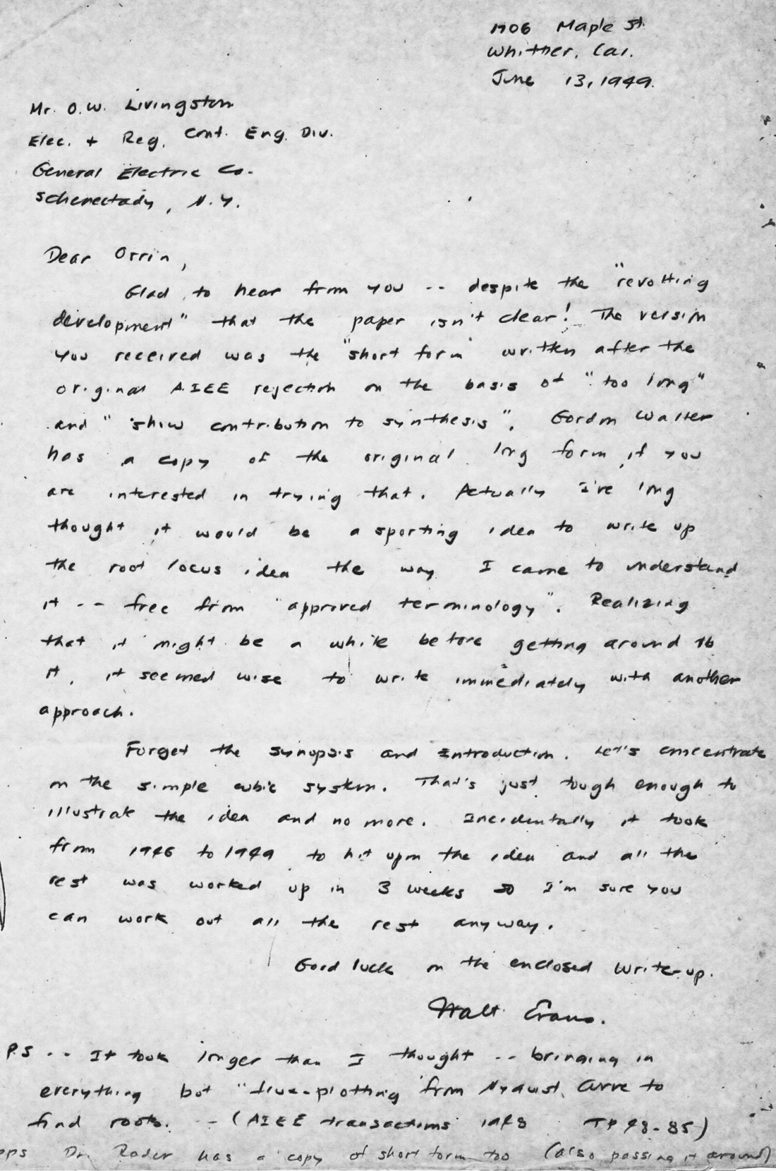

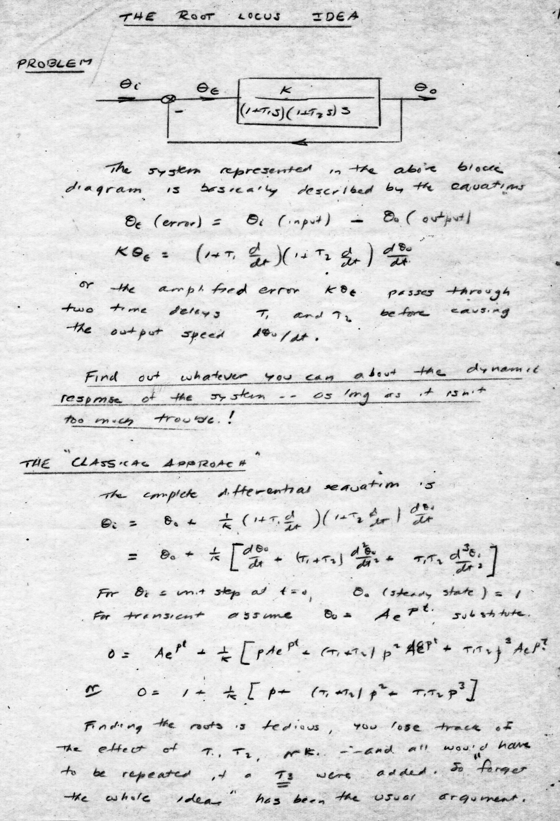
Orrin – I’ve long thought it would be a sporting idea
to write up root locus the way I came to understand it.
…. Let’s concentrate on the simple cubic system. That’s just tough enough to illustrate the idea. … Walt
The Root Locus Idea
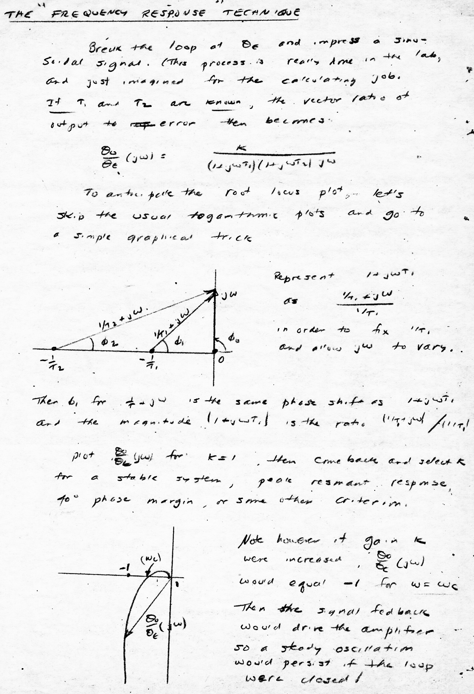
The Frequency Response Technique
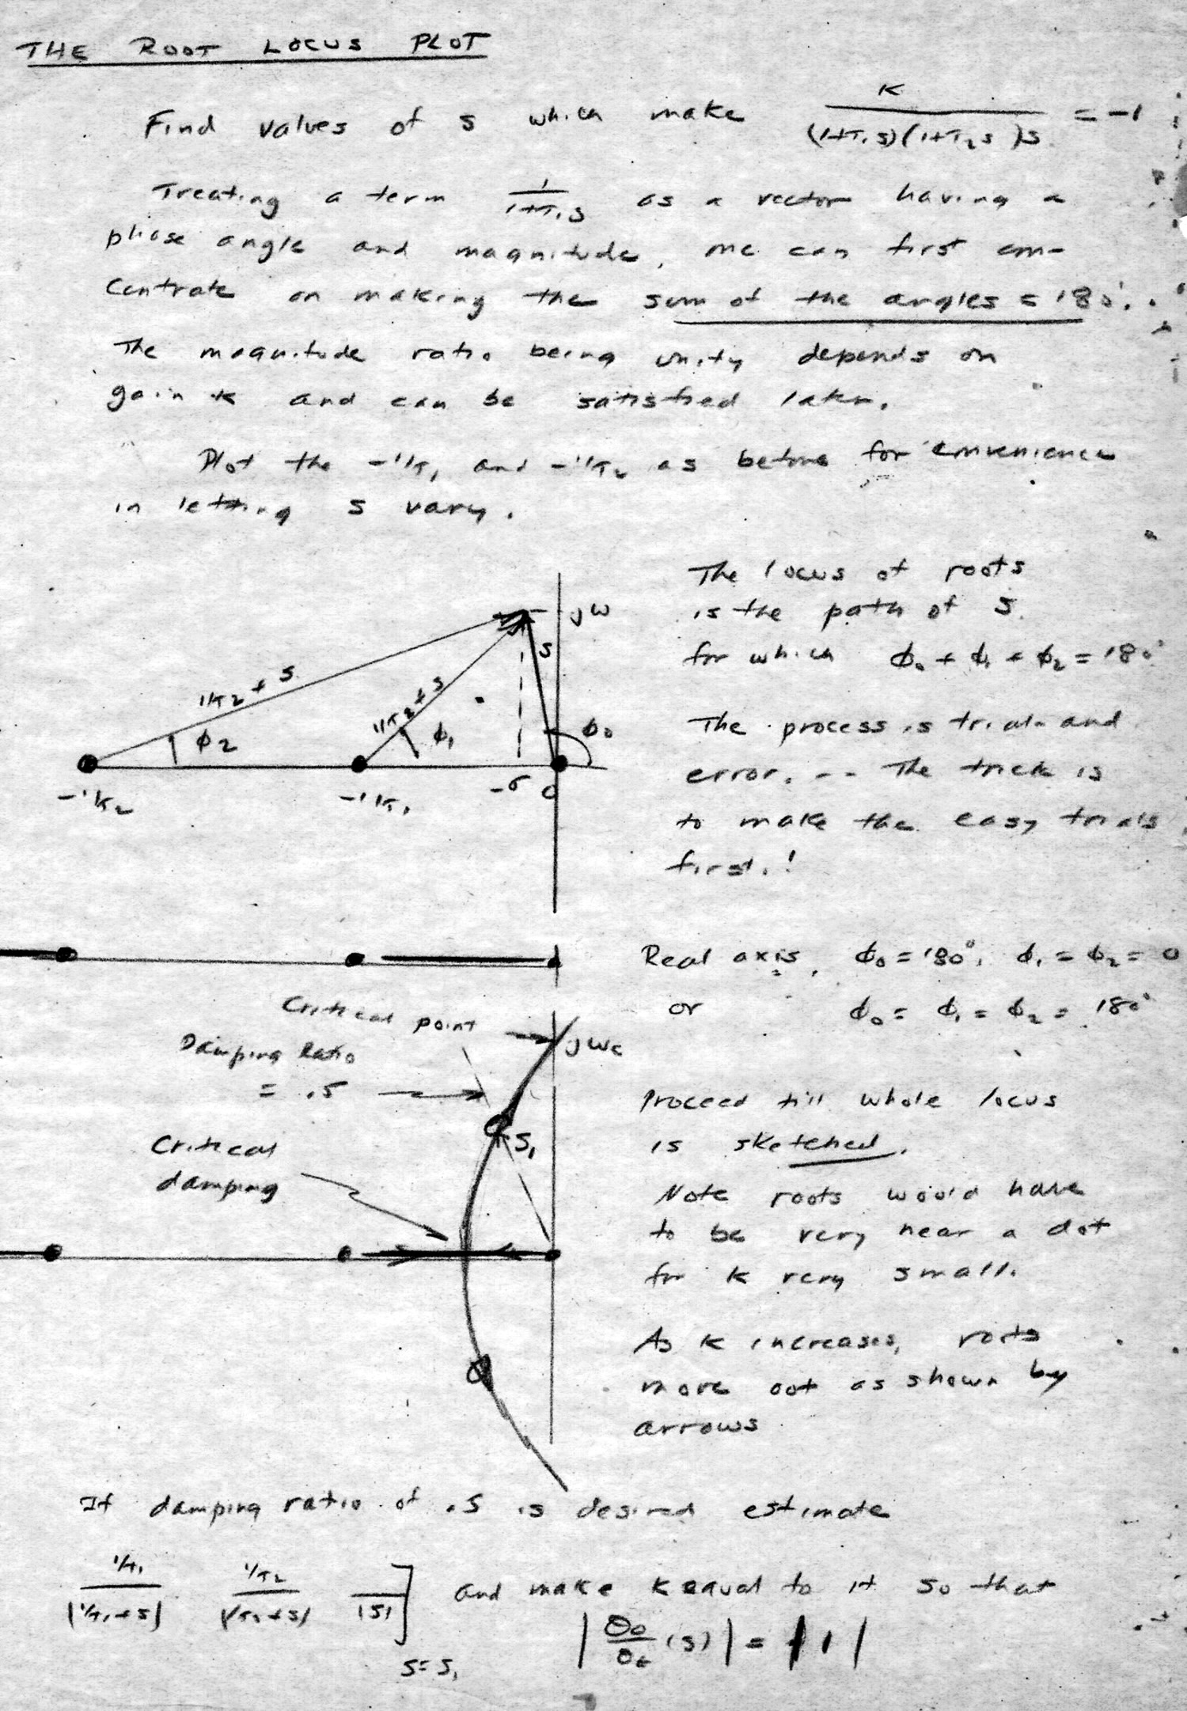
The Root Locus Plot
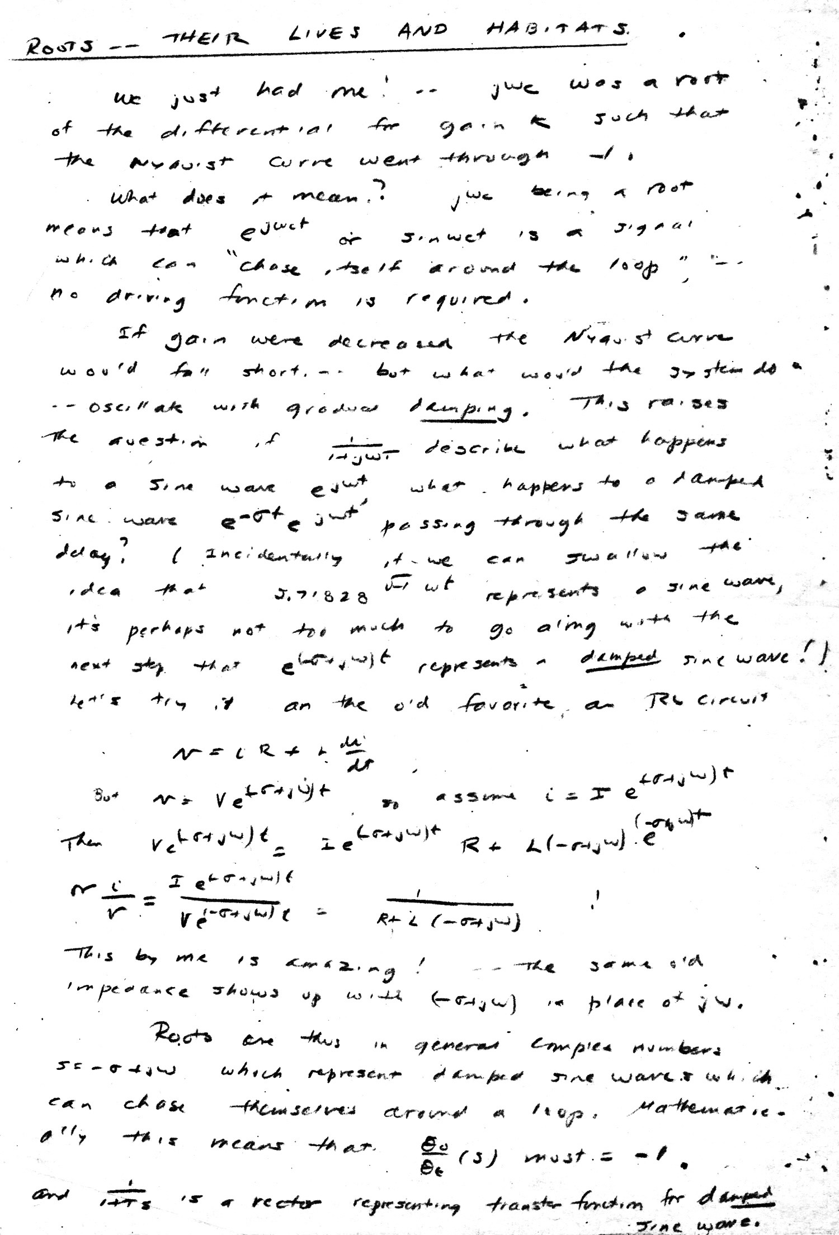
Roots - Their Lives and Habitats

