Title: The Origins of the Root-Locus Method (1948-1959)

Subtitle: Walter Evans and the Roots of Root Locus

Author: Gregory W. Evans

Engineering History Series: The Development of the Root-Locus Method
From research behind Into Stability: Walter R. Evans and the Story of Root Locus

Abstract:
The root-locus method, introduced by Walter R. Evans in 1948, transformed the practice of control-system design by providing engineers with a graphical means to visualize how the roots of a system’s characteristic equation move as system parameters change. Developed while Evans was teaching servomechanism theory and later refined at North American Aviation’s Aerophysics Laboratory, the method offered an intuitive bridge between mathematical theory and practical engineering design. This paper traces the intellectual and institutional origins of the root-locus method, including the influence of the General Electric Advanced Course, Evans’s classroom teaching, and the emerging challenges of missile guidance and automatic control during the early Cold War. The study highlights how a pedagogical insight evolved into one of the most widely used tools in modern control engineering.

Keywords:

• Root-Locus Method
• Walter R. Evans
• Paul Profos
• Servomechanism Theory
• Graphical Stability Analysis
• Control System Design
• General Electric Advanced Course
• Early Cold War Engineering

The Origins of the Root-Locus Method (1948-1959)
Walter Evans and the Roots of Root Locus

Walter R, Evans’s journey to revolutionizing control systems engineering started in St. Louis, Missouri, a city that had shaped generations of thinkers, innovators, and engineers. His roots, both familial and intellectual, were deeply embedded in this city’s educational institutions, its intellectual circles, and its values.
Walter Evans was the youngest of four children in a family that placed a high value on education. His maternal great-grandfather, James X. Allen, served as a surgeon in the Civil War. In the 1870s, James attended a medical college that later formed the foundation for Washington University’s Medical School, a remarkable achievement for the time. Walter’s maternal grandfather,
His maternal grandparents were educated scholars and prominent St. Louis citizens. Samuel Burgess was a founder of the West End Chess Club, and his wife, Eveline Allen Burgess was the United States Women’s Chess Champion in 1906. Walter’s mother, Sybilia Burgess Evans was second in her high school class. Walter’s father, Gomer Evans, and his two brothers, Cedric and Samuel Evans, graduated from Washington University with Engineering Management degrees, solidifying a family legacy steeped in analytical rigor and disciplined thought.
Walter would follow in his brothers’ and father’s footsteps at Washington University. Rich with intellectual rigor and pioneering engineers, Washington University was where Walter honed his analytical abilities, built critical relationships, and encountered mentors who would shape his thinking for decades.
Among those mentors were four professors: Alexander Langsdorf, Roy Glasgow, Frank Bubb, and Ross Middlemiss. These men were not just instructors; they were intellectual guides who introduced Walter to the nuances of engineering analysis, mathematical rigor, and practical problem-solving. They instilled in him a disciplined approach to thinking—one that would later manifest in his groundbreaking work in control systems.
Fortunately, copies of letters he wrote to his professors, decades after graduation, elucidate the impact these men had in his own words. To Roy Glasgow, on the occasion of his retirement in 1966.
Dear Dean Glasgow.
Fond memories provided by you are so numerous that I will have limit this letter to those comments which triggered some key decisions in my life, or remarks that I have modified for various occasions. It is hard to believe now that, as a sophomore, I was planning on Engineering Administration. You advised that it would be better to prove myself as an engineer first and worry about the vice-presidency later.
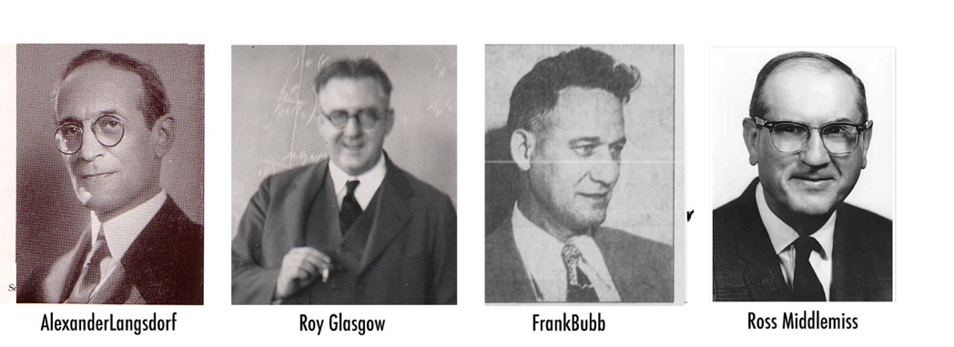
The choice at graduation was between GE and Wagner Electric. You advised me of the glowing comments from alums of GE's Advanced Course but warned about the entrance exam. Fortunately, the exam was full of your kind of problem.[You] set the hook on my liking to attack problems to achieve as much of a solution as permitted by the initial conditions of knowledge and response time allowed..
The primary attraction for Walter when seeking employment at General Electric Corporation was its famed Advanced Course, an elite training program for promising engineers. Washington University had developed a tradition of its top engineering graduates applying for entry into the program, and Walter followed in the footsteps of several distinguished predecessors. In 1941, he was one of two Washington University graduates to be accepted into the Advanced Course.
The educational approach of GE’s Advanced Course would have a profound impact on Walter’s views of engineering and learning. Robert E. Doherty, a nationally respected educator, had designed the program in 1922. By 1941, Doherty was the President of Carnegie Institute of Technology, and his vision for engineering education was deeply embedded in the course’s philosophy. Walter kept in his Advanced Course notebook a copy of Doherty’s address to students.
So, I urge you to take the initiative and learn to use your heads. In the first place, dig yourself out of confusion. Insist on understanding! Do away with superficiality! Stop memorizing words and formulas that you don’t understand, merely for a grade.
In the spring of 1945, servomechanism design and analysis became Walter’s full-time focus. One of his key projects involved designing a remote-controlled gun turret—a classic servomechanism problem. The system compared the direction in which gunners aimed their sight with the actual angle of the gun; it used motors to drive the error signal to zero. Gordon Walter shared an office with Walter Evans. In a 2004 letter, he recounted a pivotal moment in Walter’s intellectual journey:
Walt and I spent quite a few evenings together in the otherwise deserted Advanced Course office, preparing material for our students while managing our day-to-day jobs on B-20 fire control. One evening, Walt began reading a paper by a Swiss mathematician on a different way to analyze the roots of a polynomial equation. He was intrigued, spent more time thinking about it, and eventually developed an interest in applying it.
We had been exposed to feedback theory in Advanced Course classes, and Nyquist diagrams [Harry Nyquist] were in vogue. Our assignments involved servo systems. For whatever reason, this was when Walt caught the bug that led to root locus analysis and the Spirule. He had the insight, determination, and ability to take the initial concept to a higher theoretical and practical level. I just happened to be in the room when the bug first bit him.
The Swiss mathematician was Professor Paul Profos, whose 1945 article “A New Method for the Treatment of Regulation Problems,” published in Sulzer Technical Review, arrived at the General Electric library in June 1946. Walter was captivated by it, as it added a new dimension to Nyquist’s frequency response method. Shortly thereafter, Walter and Arline made a career-defining decision: Walter would leave General Electric for a faculty position at Washington University in St. Louis.
Many factors likely influenced the Evanses’ decision, with family and familiarity playing a significant role. “You easily make acquaintances among strangers, but genuine friendship requires time to develop," Walter had written his mother in 1942.
As an instructor at Washington University, Walter would have the opportunity to further his studies, engage with students and faculty, and, perhaps, publish a paper inspired by Paul Profos’s graphical techniques. At Washington University, he would have found colleagues willing to discuss and critique his and Profos’s ideas. When Walter believed he had developed a sufficiently novel graphical analysis method to merit publication, he wrote to C. F. Wagner, secretary of the Committee on Servomechanisms of the AIEE, and inquired about submitting a paper.
Walter continued teaching while refining his paper. In June, he took a summer job at Emerson Electric, arranged for him by Roy Glasgow. In July 1947, Walter submitted his paper, hoping for publication in November. July 30, 1947. Walter also sent a letter to Paul Profos, expressing appreciation for his work. August 11: Letter to Paul Profos
Your idea of using the Nyquist plot as a single line of a conformal map to determine the complex root of the differential equation seemed to me to be the foundation for a very practical method.
In September, 1946, I became an instructor of Electrical Engineering at Washington University in St. Louis, Missouri, and worked off and on with your idea during the fall and winter ... I believe you made a real contribution to the analysis of regulators, and I hope this paper succeeds in calling attention to it.
Sometime after February, Walter accepted an offer from North American Aviation (NAA)for the summer of 1948 that would begin immediately after he fulfilled his teaching responsibilities. Walter’s primary summerassignment at NAA would be to teach employees the same graduate-level servomechanism class he had taught at Washington University.
The course would begin in July. His Santa Monica apartment felt like heaven compared to the oppressive heat of St. Louis summers and the harsh winters of Schenectady. Even more inspiring was his audience: professional engineers who were deeply interested in the subject and eager to apply it to their work. These factors, combined with John Moore’s persuasive power, led to Walter and Arline’s decision for him to accept a permanent position with NAA. The move marked a pivot in Walter’s professional trajectory. NAA offered him both a platform for research and a technically sophisticated audience to test and refine new ideas.
In the second week of August 1948, Walter took a 10-day break from teaching. Upon his arrival in St. Louis, he and Arline packed their belongings into their 1947 Oldsmobile and drove west from St. Louis to Santa Monica—a short drive to NAA’s Aerophysics Laboratory. Walter resumed teaching. His co-workers preferred “Walt” and so from here on he will be Walt–unless Arline is nearby. He was always “Walter” to her. In her 1974 senior report, “Study of the Spirule,” at California Polytechnic State University, Walt’s daughter Nancy provided the following expanded account:
In the summer of 1948 he was teaching a servomechanism course at NAA in which all possible ways of solving a simple quadratic system had been presented. One of the students then asked how these results changed when the system became “slightly cubic.” An extra time constant was added to this plot and the roots shifted. This description was instantly preferred by most students.
Walt proposed a graphical root location technique—what he called the “locus of roots” method. It visually represented how pole locations evolved as a parameter (usually gain) varied. This visual and parametric approach, to become known as the root locus method, offered immediate pedagogical and analytical value. His students grasped it quickly and applied it readily. On September 14, Walt held his classroom session. His notes are instructive, revealing his application of two lessons learned from his Washington University professor Roy Glasgow. First, referring to a point on the s-plane which lies on the locus (i.e., is a root for some value of gain K), he wrote “the ‘p’ point is just a guess that would have been right for the quadratic in which the second time delay was neglected.” He went on,
“the above procedure represents a trick which is often handy: simplify the problem down to one in which the answer is known. Then change the answer slightly to allow for the extra complications. Another handy trick: Take extreme cases.” In November 1948, he submitted his second servomechanisms paper to the American Institute of Electrical Engineering (AIEE). In October 1949 Walt received the word he had long been waiting for: The AIEE would recommend his root locus paper for publication. However, due to a packed fall schedule, it would probably be presented at the 1950 Winter General Meeting. ²⁷ Which is exactly what happened.
The ideas that Walt finally had the opportunity to present in New York in January 1950 made a very positive impression on one man whose opinion would really matter: MIT graduate student John G. Truxal. In August he published his dissertation, "Servo-mechanism Synthesis Through Pole–Zero Configurations,” before joining Purdue University and, in 1954, the Polytechnic Institute of Brooklyn. He would devote three chapters of his 1955 textbook Automatic Feedback Control System Synthesis to Walt’s method (Chapter 4) and its application to system design (Chapter 5 and 6), leading to root locus reaching thousands of engineering students.
Another influential advocate was George J. Thaler, destined to become an award-winning teacher and textbook author. Years later, in 1974, Thaler, now a professor of engineering at the Naval Postgraduate School in Monterey, California, compiled and edited Automatic Control: Classical Linear Theory, a book of 21 classic papers.
This group of two papers comprises the only post-World War II contributions in this volume. In these papers Evans introduced the now-famous root-locus method. The first of these papers is essentially background, in the sense that it shows the kind of thinking that later led Evans to the root-locus method, and it also shows the elementary form of protractor which later became the Spirule. Some of the conformal mapping ideas are useful and informative. Our last paper is, of course, an exposition the root-locus method itself. Little need be said here, except to point out that the paper is very concise yet contains a wealth of ideas. On careful reading one realizes that, at the time of publication, Evans’ understanding of his method and his ability to use it was at a level that most of us did not reach for another fifteen years.
We have terminated this volume with the classic papers by Evans primarily because they mark the last of the major, fundamental contributions to what is commonly known as the classical theory of linear, continuous feedback control systems. There have been many contributions to classical theory since 1950, but such contributions have been expansions, clarifications, and applications of the fundamental ideas. Shortly after 1950 the explosion in technical publications began. Many of these papers are of major importance, but none seems to be classic in the same sense as the ones presented here.

The impact of the September 1951 publication of Dr. William E. Bollay’s 14th Wright Brothers Lecture, originally given on December 16, 1950, at the Institute of Aeronautical Sciences in Washington, D.C., cannot be overstated. Bollay, founder and head of the Aerophysics Laboratory at North American Aviation, was a nationally known and respected figure. He was in a position to influence perceptions about root locus across the entire aerospace community. In preparation, Bollay stayed late at NAA and met with Bill Mullins to understand the root locus method thoroughly.
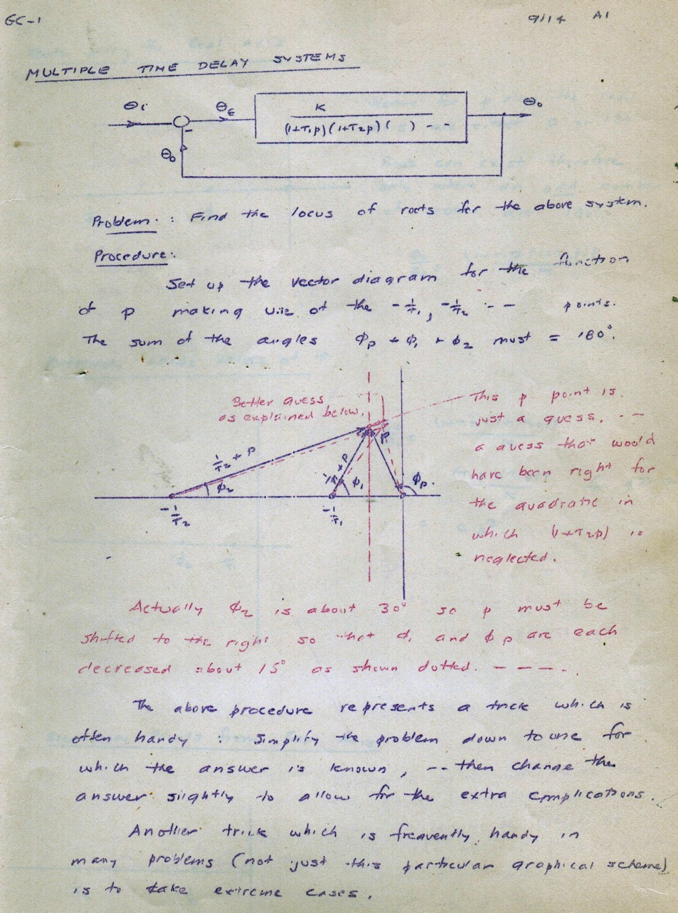
First Page of Evans 9/14/1948 Course Notes
Dr. Bollay began his remarks on his topic, "Aerodynamic Stability and Automatic Control," with words chosen to get the attention of the audience.
The practical achievement of satisfactory stability and control is probably the greatest contribution of the Wright Brothers in the development of the airplane. At present, the airplane is going through another period of transition similar to that a half-century ago. Probably the major development in aircraft stability in the past 10 years has been the evolution of analytical and experimental techniques that permit an engineering calculation of the motion of an airplane when under the control of an autopilot
The principal techniques that have made this development possible are the following: The graphical methods of analyzing the dynamic performance of a system, particularly the diagrams associated with the names Nyquist, Bode, and Evans. There it is! The equal billing Walt received referred to a March 1952 letter to friend Jack Clark, He gave root-locus equal billing with the classical stuff, and that really got it started.
Uncommented upon by Walt, but more significant to the flying public, was the “billing in parallel” Bollay gave these three little-known engineers with the legendary Wright brothers. Viewed in their entirety, Dr. Bollay’s opening remarks on December 16, 1950, may be summarized as follows: Harry Nyquist, Henrik Bode, and Walter Evans deserve recognition for ensuring the stable flight of high speed aircraft, just as Orville and Wilbur Wright deserve the recognition afforded them for ensuring stable flight on low-speed aircraft.
But Bollay did not stop there. He then compared the relative utility of Walt’s root locus method to the analysis methods of his two servo-analysis “siblings.” The Evans root-locus method presents directly a complete picture of the stability and transient response characteristics that are most important ... The root-locus gives the roots of the closed-loop system directly and by a simple calculation, the transient response. The degree of stability can be read from the root-locus directly. Complicated systems can be set up in such a fashion that the effect on transient response and stability of changing any parameter can easily be visualized. There is no ambiguity in the interpretation of plots even for complex systems having any number of roots and poles in the right or left half plane. ²⁶
When William Bollay’s December 1950 Wright Brothers Lecture appeared in print in the September 1951 Journal of Aeronautical Sciences, it did more than put the root locus method on the map. It put it on a veritable mountain top!
The root locus method was not born in a journal, but in a lecture hall. It was crafted in response to a student’s question, refined in dialogue with practicing engineers, and strengthened by Walt’s pedagogical instincts. What made it transformative was both its novelty and its utility: It provided a graphical, scalable, and intuitive method for assessing system stability and performance as a function of gain. The root locus method endures because it fills a gap between theory and practice, and between abstraction and intuition. It became part of the working vocabulary of control engineers because it made invisible dynamics visible. From a question in a summer lecture to a method that would appear in virtually every control systems textbook for a half-century, root locus stands as a paradigm-shifting contribution.
And it began at North American Aviation, in the summer of 1948 Today, root locus continues to play a critical role in advancing safety, precision, and efficiency across a wide range of industries. The widespread adoption of Walt Evans's Spirule—with more than 100,000 units sold—underscores its versatility far beyond missile guidance systems. Modern commercial aircraft rely on advanced control systems to ensure safety and reliability under unpredictable conditions. Autopilot systems, flight control surfaces, and stability augmentation systems must adjust dynamically to turbulence, mechanical faults, and shifting weight distributions.
The exponential growth of drones and autonomous vehicles has brought feedback control to the forefront of technological innovation. Whether delivering packages or conducting aerial surveys, drones must maintain precise altitude, speed, and directional stability. Autonomous vehicles require similar precision for speed control, steering, and braking. Root locus helps optimize these systems, ensuring they remain safe under a wide range of conditions.
In factories and production lines, where precision and efficiency dictate profitability, root locus continues to be invaluable. Industrial robots, conveyor systems, and temperature control processes all rely on well-tuned feedback mechanisms. Root locus helps engineers fine-tune these systems. Life-supporting medical devices must operate with extreme precision to safeguard patient health. Ventilators, insulin pumps, and cardiac monitors use feedback control systems to maintain critical physiological parameters within safe ranges. Root locus techniques are instrumental in designing these systems.

About this Paper:
This paper is derived from research presented in Into Stability: Walter R. Evans and the Story of Root Locus (Evans, 2025) and examines the historical development of the root-locus method within the engineering culture of the early Cold War.
About the Author:
Gregory W. Evans is a graduate of the California Institute of Technology (1969) and Stanford University (1975) and served as a Distinguished Technical Fellow at TRW. He is the author of Into Stability: Walter R. Evans and the Story of Root Locus (Evans Heritage Press, 2025) and is the son of Walter R. Evans. [greg@walterrevans.com]
More information is available at WalterREvans.com. greg@walterrevans.com

