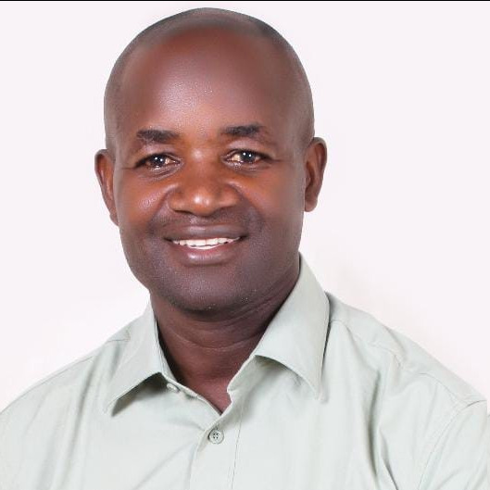

**MODORATOR**

Sam Ouma

ToT,CAM,CEO- Kisumu Mediation Center(KMC),

Proprietor MODI ADR Consultant

Kenya

**SPEAKER**

|  |  |
| --- | --- |
| |  | | --- | | **Shane Morrow** | |

Chief Executive Officer | Legal Software

ADR PA - Matter Management Platform

South Africa

**SPEAKER**

|  |  |
| --- | --- |
| |  | | --- | | **mediator xxx** | |

xxxxxx

South Africa

**Topic : STANDING OUT AS A MEDIATOR FOR PRIVATE MATTERS**

**Date :** Tuesday, March 4th  
**Time :** 4:00 PM – 6:00 PM (Nairobi Time)  
**Platform :** Microsoft Teams