MINUTES

Minutes of the “Month-End Town Board Meeting & Public Hearings” of the Sodus Town Board held January 23, 2018 beginning at 5:00 pm in the Sodus Town Court Room located at 14-16 Mill St. Sodus, NY 14551
All Town of Sodus Board Meetings are open to the public.

Present: Steve LeRoy, Sodus Town Supervisor
David LeRoy, Councilperson (Deputy Supervisor)
Jim Quinn, Councilperson
Scott Johnson, Councilperson

Recording Secretary: Lori Diver, Town Clerk

Absent: Don Ross, Councilperson (Meeting with WCWSA)

Others Present: Dale Pickering, Highway Superintendent
Anthony Villani, Town Attorney
John Addyman, Sun & Record
Anne Marie Keese, T/Sodus Resident
Freida VonSchiller, T/Sodus Resident
James & Arlene Gashlin, T/Sodus Resident

Supervisor Steve LeRoy opened the meeting at 5:00 pm with the Pledge of Allegiance.

ABSTRACT
RESOLUTION TO PAY ABSTRACT N0. 2
(06 1-2018)
WHEREAS, the following bills were presented for payment on Abstract 2:

General 15-41 $ 37,058.04
Highway 15-41 $ 100,967.15
Water 2-2 $ 1,299.81
Trust & Agency 21-22 $ 1,310.01
GRAND TOTAL: $ 140,635.01

NOW BE IT RESOLVED, Councilperson David LeRoy motioned to approve payment of these bills as reviewed for Abstract No. 02, which was seconded by Councilperson Scott Johnson. Upon roll call the following votes were heard, Supervisor LeRoy, aye; Councilperson David LeRoy, aye; Quinn, aye; and Johnson, aye. Resolution adopted.

Innovative Solutions submitted a quote for commercial Wi-Fi 2.4 & 5 MHZ for the Town and Village of Sodus Offices. The cost total in the quote is $1,045.00. The Village of Sodus and Town of Sodus will split the cost; hence it is for both municipalities.
Councilperson David LeRoy motioned to approve Town of Sodus Municipal Building Wi-Fi available to only Town of Sodus Employees was seconded by Councilperson Scott Johnson. Upon roll call the following votes were heard, Supervisor LeRoy, aye; Councilperson David LeRoy, aye; Quinn, aye; and Johnson, aye. Motion carried.

Councilperson David LeRoy motioned to approve the Sodus Point Fire Department (per Tim Jones) requesting the use of Town Property for parking across from the Sodus Point Fire Dept. on 6/2/2018, 8/4/2018, and 11/2/2018 was seconded by Councilperson Scott Johnson. Upon roll call the following votes were heard, Supervisor LeRoy, aye; Councilperson David LeRoy, aye; Quinn, aye; and Johnson, aye. Motion carried.

RESOLUTION
RE-APPOINTING DENNIS GRABB, JIM HOPKINS, NANCY ROSS PLANNING BOARD
(07 1-2018)
NOW BE IT RESOLVED, Councilperson Jim Quinn motioned to re-appoint Dennis Grabb and Jim Hopkins to the Town of Sodus Planning Board (Regular Member) to a 2 year term and Nancy Ross to Planning Board as Ad-Hoc for a 1 year term which was seconded by Councilperson David LeRoy. Upon roll call the following votes were heard, Supervisor LeRoy, aye; Councilperson David LeRoy, aye; Quinn, aye; and Johnson, aye. Resolution adopted.

RESOLUTION
RE-APPOINTING BILL LESNIAK & JAMES RUSSELL
(08 1-2018)
NOW BE IT RESOLVED, Councilperson David LeRoy motioned to re-appoint Bill Lesniak to the Town of Sodus Zoning Board (Regular Member) to a 2 year term and James Russell to Zoning Board as Ad-Hoc for a 1 year term which was seconded by Councilperson Scott Johnson. Upon roll call the following votes were heard, Supervisor LeRoy, aye; Councilperson David LeRoy, aye; Quinn, aye; and Johnson, aye. Resolution adopted.

RESOLUTION
TIME CLOCK POLICY
(09 1-2018)
Supervisor LeRoy offered the following resolution for its adoption,
(See page 3 for resolution)

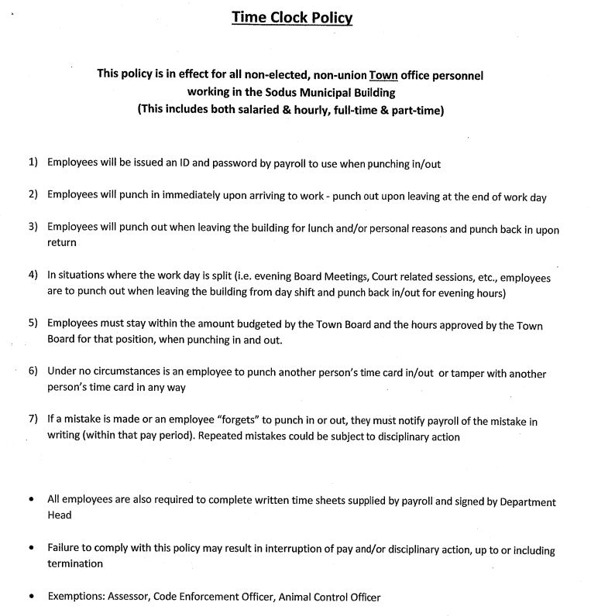

NOW BE IT RESOLVED, Councilperson David LeRoy motioned to adopt the Time Clock Policy as written which was seconded by Councilperson Jim Quinn. Upon roll call the following votes were heard, Supervisor LeRoy, aye; Councilperson David LeRoy, aye; Quinn, aye; and Johnson, aye. Resolution adopted.

RESOLUTION
COST SHARING SERVICES
(10 1-2018)
SEEKING COUNTY AND SCHOOL (VILLAGE)
PARTICIPATION IN ARTICLE 7 LITIGATION EXPENSES
FOR THE YEAR 2017

WHEREAS, Sodus Benton Place Estates, L.P. has commenced a proceeding pursuant to Article 7 of the Real Property Tax Law for the year 2017 in Wayne County Supreme Court under index number 81072, and

WHEREAS, because the litigation costs of these challenges can be more than the Town can anticipate and afford, and the effects of such litigation extend additionally to the school, village and county tax base, the County of Wayne has adopted a policy of municipal participation in the costs and expense of such litigation by resolution 522-017 Dated October 17, 2017 and

WHEREAS, the Town of Sodus attorney has advised the Town Board that this litigation meets the requirements of municipal participation in that the real property in question has an assessed value of $1,000,000 dollars and the petitioner is desirous of a change in assessment of (10) percent, or a change of at least $100,000 less than the assessed value, to wit: assessment of $840, 000 is sought to be reduced to $480,000 and

WHEREAS, the Town of Sodus, desires to qualify this litigation for Wayne County, Village of Sodus and Sodus Central School District participation to equally share the legal and appraisal costs of this litigation,

NOW, THEREFORE, BE IT RESOLVED that the Town of Sodus does hereby agree to share equally in the legal and appraisal costs of this litigation and does hereby request Wayne County, Village of Sodus and Sodus Central School District participation to share equally in the legal and appraisal costs of this litigation; and

BE IT FURTHER RESOLVED that proceedings will involve the County Attorney and Real Property Tax Services Director as consultants regarding appraisals and/or settlement strategies and the Town Attorney is authorized to communicate pursuant to common defense confidentiality agreements with the County of Wayne, Village of Sodus and Sodus Central School District; and

BE IT FURTHER RESOLVED that the Town of Sodus hereby requests approval for County of Wayne, Village of Sodus and Sodus Central School District participation in this litigation commenced under the index number set forth above for the year 2017, and

BE IT FURTHER RESOLVED, that the Town of Sodus will pay its equal share of the legal and appraisal costs of this litigation, and

BE IT FURTHER RESOLVED, that the Town Supervisor be and the same is hereby authorized to request participation by the County of Wayne, Village of Sodus and Sodus Central School District for equal participation in the legal and appraisal costs of this litigation by sending a copy of this resolution to the Wayne County Attorney with a copy to the Wayne County Real Property Tax Services director, to the Village Board of the Village of Sodus and to the Superintendent of the Sodus Central School District.

NOW BE IT RESOLVED, Councilperson David LeRoy motioned to adopt the updated “Cost Sharing Resolution” which was seconded by Councilperson Scott Johnson. Upon roll call the following votes were heard, Supervisor LeRoy, aye; Councilperson David LeRoy, aye; Quinn, aye; and Johnson, aye. Resolution adopted.

RESOLUTION
DANIEL VANACKER WATERLINE
(11 1-2018)
Supervisor LeRoy offered the following resolution for its adoption,

NOW BE IT RESOLVED, Councilperson Scott Johnson motioned to adopt the resolution authorizing the Town of Williamson to extend their public waterline to Daniel VanAcker property located at 7131 Redman Rd.; Tax ID # 67118-00-456729 which was seconded by Councilperson Jim Quinn. Upon roll call the following votes were heard, Supervisor LeRoy, aye; Councilperson David LeRoy, aye; Quinn, aye; and Johnson, aye. Resolution adopted.

RESOLUTION
EXEMPTING THE TOWN OF SODUS COURT FROM THE RESIDENCY REQUIREMENT
(12 1-2018)
Supervisor LeRoy offered the following resolution for its adoption,

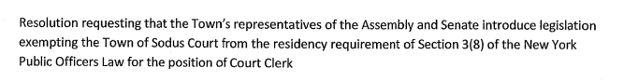
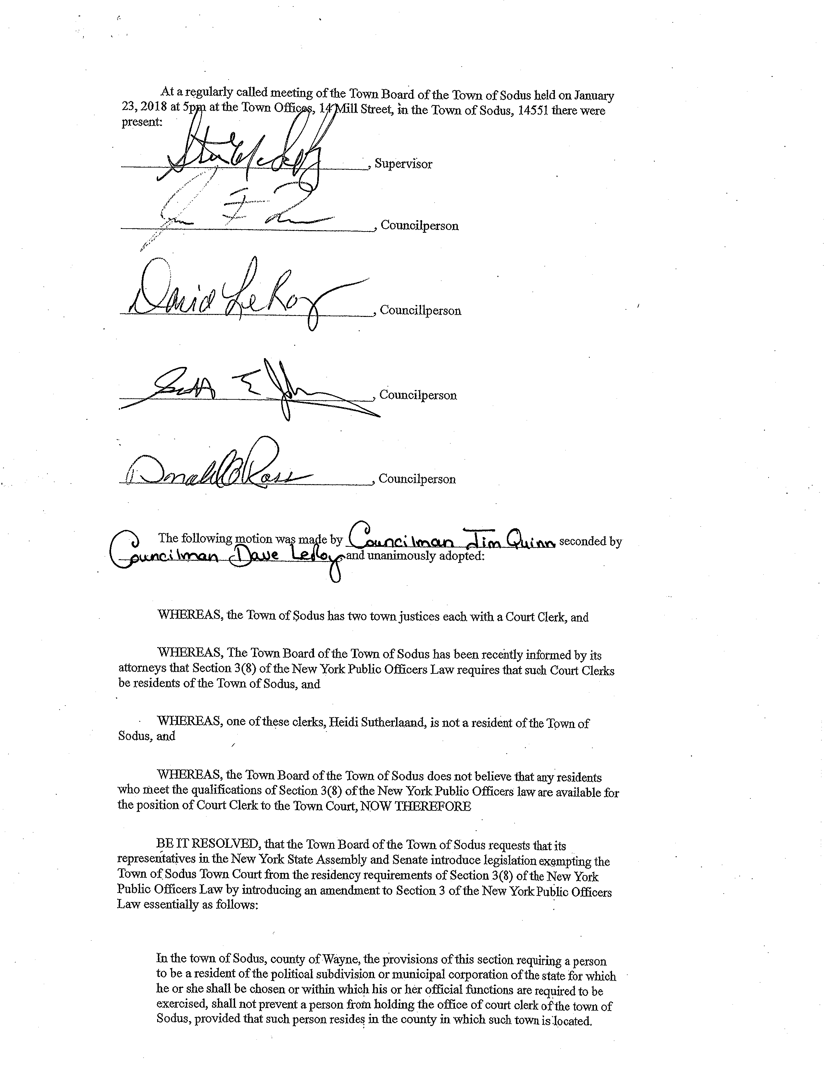
NOW BE IT RESOLVED, Councilperson Jim Quinn motioned to adopt the resolution (12 1-2018) which was seconded by Councilperson David LeRoy. Upon roll call the following votes were heard, Supervisor LeRoy, aye; Councilperson David LeRoy, aye; Quinn, aye; and Johnson, aye. Resolution adopted.

Councilperson David LeRoy motioned to make the Sun & Record the Town of Sodus Legal Paper which was seconded by Councilperson Scott Johnson. Upon roll call the following votes were heard, Supervisor LeRoy, aye; Councilperson David LeRoy, aye; Quinn, aye; and Johnson, aye. Motion carried.

PUBLIC HEARING FOR WATER DISTRICT No. 11:
Councilperson Scott Johnson motioned to open the Public Hearing for WD No. 11 which was seconded by Councilperson Jim Quinn. Upon roll call the following votes were heard, Supervisor LeRoy, aye; Councilperson David LeRoy, aye; Quinn, aye; and Johnson, aye. Motion carried.

Councilperson Jim Quinn motioned to waive the reading of the Legal Notice for WD No. 11 which was seconded by Councilperson Scott Johnson. Upon roll call the following votes were heard, Supervisor LeRoy, aye; Councilperson David LeRoy, aye; Quinn, aye; and Johnson, aye. Motion carried.

ORDER FOR PUBLIC HEARING:

At a meeting of the Town Board held at the Town Hall, 14-16 Mill Street, Sodus, Wayne County, New York, on the 27th day of December, 2017:

WHEREAS, it is proposed to construct a water distribution system to be known as the Town of Sodus Water District No. 11 in the Town of Sodus, Wayne County, New York, and

WHEREAS, the Town Engineer has prepared a map, plan and report for the proposed Sodus South Geneva Road Water District and duly filed said map, plan and report in the office of the Sodus Town Clerk, and

WHEREAS, the proposed district includes portions of Maple Ridge Road and South Centenary Road in the Town of Sodus, the boundaries of which are more particularly described in Schedule A to the Engineers Report on file and available for inspection in the Office of the Town Clerk, and

WHEREAS, the maximum amount proposed to be expended for the establishment of said Water District and the construction of said water distribution system is $1,224,000.00, and

WHEREAS, the proposed method of financing for the District includes a combination of grants and loans through the United States Department of Agriculture/Rural Development, with anticipated grant of $500,000 and loan of $724,000 (payable over 38 years at interest rate of 2.25%), with the estimated annual cost to the typical property or typical dwelling unit (single-family home or equivalent dwelling unit) in the proposed District of $815, which includes debt service and cost of water, to be assessed to each such unit in the proposed District, calculated as follows:

Water Use $308.00 (Based on average annual use of 50,000 Gal/Year per unit)
Debt Service $472.00 (Average annual debt service charge over 38 years)
$ 35.00 (Average Annual charge regional storage tank over 38 years)
$815.00
and

WHEREAS, there is anticipated a one-time connection fee estimated at $1,600 per unit inclusive of the meter, appurtenances and inspection charges to the right of way line, and

WHEREAS, costs for each homeowner to construct a service line from the right of way line to the home and any plumbing modifications necessary to connect, are the responsibility of the individual owners and will vary depending on the distance of the house/unit from the right of way, size of service and conditions, and houses 200 linear feet or more from the road may be required to install a residential meter pit on the property at associated additional cost, and

WHEREAS, copies of the map, plan and report describing the proposed district are on file and available for review at the Sodus Town Clerks Office during regular business hours.

Now on motion of Councilperson Jim Quinn , seconded by Councilperson David LeRoy, all members present voting therefor, it is

ORDERED that a meeting of the Town Board of the Town of Sodus be held at the Town Hall, 14-16 Mill Street, Sodus, New York on the 23rd day of January, 2018, at 5:15 P.M. for the purpose of conducting a public hearing on the proposal to establish said Town of Sodus Water District No. 11 with the improvements specified above, at which time and place all persons interested in the subject thereof may be heard concerning the same, and it is further

ORDERED, that the Town Clerk is hereby authorized and directed to publish a copy of this order in the official Town newspaper and post a copy of the same in the time and manner required by law.

4 Ayes 1 Absent

Supervisor LeRoy opened the Public Hearing for comments; hearing none the Public Hearing was closed.

RESOLUTION
WD # 11 MRB GROUP
(13 1-2018)
Supervisor LeRoy offered the following resolution for its adoption,

NOW BE IT RESOLVED, Councilperson David LeRoy motioned to adopt and approve the proposal by MRB Group for Professional Services relative to the Town of Sodus Water for WD No. 11 which was seconded by Councilperson Scott Johnson. Upon roll call the following votes were heard, Supervisor LeRoy, aye; Councilperson David LeRoy, aye; Quinn, aye; and Johnson, aye. Resolution adopted.
RESOLUTION
FINAL ORDER WD No. 11
(No Resolution Number –Amendment)

At a duly noticed and held meeting of the Town Board of the Town of Sodus, New York held at the Town Offices, 14-16 Mill Street, Sodus, New York on January 23, 2018, the following resolution and Order was introduced by Council Member David LeRoy and seconded by Council Member Scott Johnson and unanimously adopted.

WHEREAS, Section 190 of the Town Law of the State of New York empowers the Town Board of the Town of Sodus to provide for the establishment in the Town of Sodus a Water District, and

WHERAS, a map, plan and report have been prepared by the Towns Engineers, MRB Engineering, P.C., David M. Doyle, P.E., relating to the proposed Sodus Water District No. 11 in the Town of Sodus and the construction of related improvements; and

WHEREAS, an Order Calling a Public Hearing was duly adopted by this Town Board on December 27, 2017, reciting the filing of said map, plan and report, the improvements proposed, the boundaries of the proposed extended district, the fact that the map, plan and report described in said Order also contained the method of financing any improvements, and that said map, plan and report were on file in the Town Clerk's Office for public inspection, and stating all other matters required by law to be stated and specifying January 23, 2018, as the date, at 5:15 p.m. on said day as the time, and the Town Hall, 14-16 Mill Street, Sodus, New York as the place where the Town Board would meet for a Public Hearing to consider said map, plan and report, and to hear all persons interested in the subject thereof, concerning the same, and to take such action thereon as is required or authorized by law; and

WHEREAS, such Order was duly published in the official newspapers for the Town and duly posted, with both Publication and Posting in full compliance with Town Law; and

WHEREAS, a Public Hearing on the proposed Sodus Water District No. 11 was duly held by the Town Board on January 23, 2018, at 6:15 p.m. on said day, in the Town Hall, 14-16 Mill Street, Sodus, New York, at which all interested persons desiring to be heard were heard, including those in favor of, and those opposed to, the proposed Water District and construction of related improvements; and

WHEREAS, in connection with Sodus Water District No. 11, a Short Environmental Assessment Form was filed with the Town Board and in the office of the Town Clerk from which the Town Board duly considered and reviewed all potentially significant environmental impacts as required by Environmental Conservation Law Article 8 (State Environmental Quality Review ActSEQRA and 6 NYCRR Part 617).

WHEREAS, by Resolution dated January 23 , 2018, the Town Board declared itself Lead Agent, adopted findings that the proposed Water District will give rise to no adverse environmental impacts, and issued a Negative Declaration under SEQRA; and

WHEREAS, The Town Board having duly resolved and determined following such hearing that the notice of hearing was published and posted as required by law and otherwise sufficient, that all the property and property owners within the proposed district were benefitted thereby, that all property and property owners benefitted were included within the limits of the proposed district, and that it was in public interest to grant in whole the relief sought, it is hereby

FOUND, ORDERED AND DETERMINED, that the petition for the establishment of the Sodus Water District No. 11 in the Town of Sodus, New York, is signed, approved and acknowledged, as required by law, and is otherwise sufficient and complies with the provisions of Article 12 of the Town Law; and it is further

FOUND, ORDERED AND DETERMINED, that it is in the public interest to grant the relief sought by said petition, and that all of the property, property owners and interested persons within the proposed water district benefitted are included therein, and that no property or property owners of interested persons benefitted thereby have been excluded therefrom, and it is further

FOUND, ORDERED AND DETERMINED, that the proposed water district be established in the Town to be designated as the Sodus Water District No. 11 and the boundaries of said water district as hereby established shall be as described in Schedule A attached hereto, and it is further

FOUND, ORDERED AND DETERMINED, that pursuant to the provisions of the Town Law of the State of New York, as amended, the expense of the establishment of said Sodus Water District No. 11 and the construction of said water distribution system therein and the maintenance thereof shall be assessed, levied and collected from year to year from the several lots and parcels of land within the Water District in proportion as nearly as may be to the benefit which each lot or parcel of land in said District will derive therefrom, and it is further

FOUND, ORDERED AND DETERMINED, that the Town Clerk is hereby authorized and directed to cause a certified copy of this order to be duly recorded in the office of the Wayne County Clerk and the Office of the State Department of Audit and Control in Albany, New York within ten (10) days after the adoption of this order.

Dated: January 23, 2018.

Steven M. LeRoy, Supervisor aye
David LeRoy, Council Member aye
Jim Quinn, Council Member aye
Don Ross, Council Member aye

Scott Johnson, Council Member aye

Absent:

(See Next Page for Public Hearing)

ORDER FOR PUBLIC HEARING CENTENARY SHORES & SPRONG’S BLUFF PRIVATE DRIVES 5:20 pm:

LEGAL NOTICE
TOWN OF SODUS
NOTICE OF PUBLIC HEARING

TO CONSIDER WHETHER THE TOWN OF SODUS
SHOULD ACCEPT DEDICATION OF CENTENARY SHORES
WHICH APPEARS ON A FILED PLAT

PLEASE TAKE NOTICE that a public hearing will be held by the Town Board of the Town of Sodus on the 23rd day of January, 2018 at 5:20 p.m. at the Sodus Town Hall, 14-16 Mill Street, Sodus, New York to hear and consider comments from the public in regard to:

Whether and under what conditions the Town of Sodus should accept dedication of Centenary Shores right of way in the Town of Sodus as shown on subdivision map of the Centenary Shores subdivision made by Harnish and Lookup. dated October, July 11, 1950, and filed in the office of the Wayne County Clerk on September 7, 1950, as authorized by New York Town Law §279(4) and New York Highway Law 189

Copies of the map are available for inspection at the Town Hall of the Town of Sodus.

BY ORDER OF THE TOWN BOARD
OF THE TOWN OF SODUS
Lori K. Diver, Town Clerk
Dated: December 27, 2017

After Lori Diver read the legal notice for the Public Hearing on Centenary Shores Supervisor LeRoy opened the floor for public comments. James and Arlene Gashlin asked many questions regarding Centenary Shores. The Board, the Town Attorney, and the Gashlin residents discussed the options available to them regarding plowing their private drive. Centenary Shores will not be dedicated as a Town Road to the Town of Sodus because, the subdivision map of Centenary Shores is identified as, “right away” according to Villani.

Councilperson David LeRoy asked Tony Villani, Town Attorney if he would draw up a resolution available at the next Town Board Meeting. Villani indicated the resolution will be provided for the Town Board at the next meeting to deny Centenary Shores being dedicated as a Town Road in the Town of Sodus.

No further questions were asked by the public, hearing none the Public Hearing was closed.

LEGAL NOTICE
TOWN OF SODUS
NOTICE OF PUBLIC HEARING

TO CONSIDER WHETHER THE TOWN OF SODUS
SHOULD ACCEPT DEDICATION OF SPRONG’S BLUFF
WHICH APPEARS PARTIALLY ON A FILED PLAT

PLEASE TAKE NOTICE that a public hearing will be held by the Town Board of the Town of Sodus on the 23rd day of January, 2018 at 5:20 p.m. at the Sodus Town Hall, 14-16 Mill Street, Sodus, New York to hear and consider comments from the public in regard to:

Whether and under what conditions the Town of Sodus should accept dedication of Sprong’s Bluff right of way in the Town of Sodus as shown on subdivision maps of the Sprong’s Bluff subdivision made by George Lookup dated December, 1938, and filed in the office of the Wayne County Clerk, as map #10666 showing the rights of way along lots 1-31, 32-39 and 42 and 43 along Lake Ontario, and a plan of addition to the Sprong Subdivision prepared by Harnish and Lookup dated December 15, 1960and filed as map # 5714 in the office of the Wayne County Clerk showing the rights of way along lots 54-68, and a map prepared by Calvin Barcomb dated 1987 showing the rights of way along lots A, B, and C and filed in the office of the Wayne County Clerk under map # 19592, and maps showing the remainder of the land purchased by the state of New York of approximately 138 acres showing rights of way to the lots described above as shown in maps filed in the office of the Wayne County Clerk numbers 27776 and 28825, as authorized by New York Town Law §279(4) and New York Highway Law 189

Copies of the map are available for inspection at the Town Hall of the Town of Sodus.

BY ORDER OF THE TOWN BOARD
OF THE TOWN OF SODUS
Lori K. Diver, Town Clerk
Dated: December 27, 2017

Town Attorney, Tony Villani stated there was no reason to hold a Public Hearing for Sprongs Bluff and notified the public the same applies to Sprongs Bluff as it is with Centenary Shores. The Town cannot dedicate Sprongs Bluff as a town road. Villani stated he will provide a resolution for Sprongs Bluff along with Centenary Shores for the next meeting denying dedication of both private drives as town roads.

EXECUTIVE SESSION:
Councilperson David LeRoy motioned to enter into Executive Session at 6:16 pm to discuss a personnel issue relative to a particular individual was seconded by Councilperson Scott Johnson. Upon roll call the following votes were heard, Supervisor LeRoy, aye; Councilperson David LeRoy, aye; Quinn, aye; and Johnson, aye. Motion carried.

Councilperson David LeRoy motioned to exit Executive Session at 6:36 pm and enter Regular Session was seconded by Councilperson Scott Johnson. Upon roll call the following votes were heard, Supervisor LeRoy, aye; Councilperson David LeRoy, aye; Quinn, aye; and Johnson, aye. Motion carried.

A motion by Councilperson David LeRoy to adjourn the Month End/Year End Regular Town Board Meeting was seconded by Councilperson David Scott Johnson. Upon roll call the following votes were heard, Supervisor LeRoy, aye; Councilperson David LeRoy, aye; Quinn, aye; and Johnson, aye. Motion carried.
Meeting adjourned at 6:37 pm

Recording Secretary,

Lori Diver
Sodus Town Clerk, RMC

