MINUTES

Minutes of the Regular Sodus Town Board Meeting held March 13, 2018 in the Sodus Town Court Room, commencing at 7:00 pm 14-16 Mill St. Sodus, NY 14551.
Sodus Town Board Meetings are open to the public.

Present: Steven LeRoy, Supervisor
David LeRoy, Councilperson/Deputy Supervisor
Jim Quinn, Councilperson
Don Ross, Councilperson
Scott Johnson, Councilperson

Recording Secretary: Lori Diver, Town Clerk

Absent: Al Hendrikse, Code Enforcement Officer
Trevor Davey, Camp Beechwood Caretaker

Others Present: Bree Crandell, Supervisor Clerk
Dale Pickering, Highway Superintendent
Thomas Putnam, Town Justice
Robert Fratangelo, Town Justice
Michelle Dolan, Court Clerk
Eileen Loveman, Sun & Record
Brian Dolan, T/Sodus Resident
Kim Buell, Town of Sodus Zoning Member
Deb LeRoy, T/Sodus Resident
Chris Tertinek, Village of Sodus Point Resident
Mari Louise D. Merkwa, Hybrid Building Solutions, LLC

Supervisor Steve LeRoy called the Regular Town Board to order commencing at 7:00 PM with the Pledge of Allegiance.

MINUTES
Councilperson David LeRoy motioned to approve the Minutes of the February 13, 2018
Regular Town Board Meeting was seconded by Councilperson Scott Johnson. Upon roll call the following votes were heard, Steven LeRoy, aye; David LeRoy, aye; Quinn, aye; Ross, aye; Johnson, aye. Motion carried.

Councilperson David LeRoy motioned to approve the Minutes of the February 27, 2018 Month End Town Board Meeting was seconded by Councilperson Scott Johnson. Upon roll call the following votes were heard, Steven LeRoy, aye; David LeRoy, aye; Quinn, aye; Ross, abstained (absent); Johnson, aye. Motion carried.

SUPERVISOR’S REPORT
The December 2017, Yearly 2017, January 2018, February 2018 Supervisor’s Reports are tabled until Ray Wager’s Office completes their final audit.
Note: The Town Auditors currently are doing their yearly audit in the Town Supervisor’s Office hence; delaying Supervisor Clerk Bree Crandell from closing her books and printing reports. The books cannot be closed until the final audit is complete.

TOWN CLERK’S REPORT
The Town Clerk’s Report, Town Clerk’s bank statement for audit and bank register for February 2018 was presented. Councilperson David LeRoy motioned to accept and file this report, which was seconded by Councilperson Scott Johnson. Upon roll call the following votes were heard, Steven LeRoy, aye; David LeRoy, aye; Quinn, aye; Ross, aye; and Johnson, aye. Motion carried.

TAX COLLECTION REPORT
Councilperson Jim Quinn motioned to accept and file the February 2018 Tax Collection Report, bank statement for audit, and bank register was seconded by Councilperson David LeRoy. Upon roll call the following votes were heard, Steven LeRoy, aye; David LeRoy, aye; Quinn, aye; Ross, aye; and Johnson, aye. Motion carried.

ABSTRACT
RESOLUTION TO PAY ABSTRACT NO. 05
(01 03-2018)
WHEREAS, the following bills were presented for payment on Abstract 05:

General 106-132 $ 51,390.70
Highway 90-104 $ 22,101.96
Bridge Project 01-01 $ 18,721.00
Special Dist. 08-08 $ 979.77
GRAND TOTAL: $ 99,193.43

NOW BE IT RESOLVED, Councilperson Scott Johnson motioned to approve payment of these bills as reviewed for Abstract No. 05, which was seconded by Councilperson Don Ross. Upon roll call the following votes were heard, Steven LeRoy, aye; David LeRoy, aye; Quinn, aye; Ross, aye; and Johnson, aye. Resolution adopted.

PUBLIC COMMENTS
(Michael Page – short film - Beechwood) – NO SHOW

PUBLIC COMMENTS
(Mari Louise D. Merkwa, Hybrid Building Solutions, LLC.)
Mari Louise introduced herself to the Town Board. Mari stated the type of building she recommends for the Town of Sodus sand and salt barn would be a Calhoun Superstructure. This is a HT Building, galvanized with a High Top. This allows the Tractor Trailers to dump directly into the building itself. The building is designed to be hit with a loader at 30 mph without damaging the structure. The building is 14 inches thick and fastened to the ground with geotechnical measurements. Hybrid Building Solutions normally ask Towns to get the geotechnical measurements for their municipality to help with the design of the building. The footers are placed down to the frost line.

Hybrid Building Solutions, LLC can help the Town of Sodus write the bid for the Calhoun Building itself. The building and foundation is site specific.

Information included below (page 3) is from the Hybrid Building Solution, LLC Website….

SAND & SALT STORAGE STRUCTURES

Sand and salt storage is essential for preventing loss of material and minimizing exposure to the elements. Salt storage, in particular, is challenging because of the corrosive nature of salt and how it can accelerate the natural wear and tear that affects traditional metal structures. Calhoun engineers solutions that are specifically tailored to companies and municipalities that need to build storage for salt or sand.

CORROSION RESISTANCE
Hot dip galvanization provides protection against weathering and rust that is matched only by stainless steel. Applied to both interior and exterior surfaces, our galvanization meets the established standards of the American Association of State Highway and Transportation Officials (AASHTO), the Canadian Standards Association (CSA) and the American Society for Testing and Materials (ASTM). The resulting smooth surface also decreases wear on the fabric cover by preventing tears and snags.

CUSTOM STRUCTURES
With experience building salt storage structures for townships and businesses, Hybrid Building Solutions, LLC can help you determine the right dimensions and style of structure for your needs. HT series not only provides high clearance for a mound of salt or sand, but its peaked shape also sheds snow in winter. Other structures, like the CL building series, can be more mobile for job sites that periodically move. The free-span of up to 200 feet in our VP series allows for maneuvering trucks and bulldozers as needed.

(Pages 4-7 were given to the Board and our Highway Superintendent, Dale Pickering regarding the Calhoun Building Structure specifications)

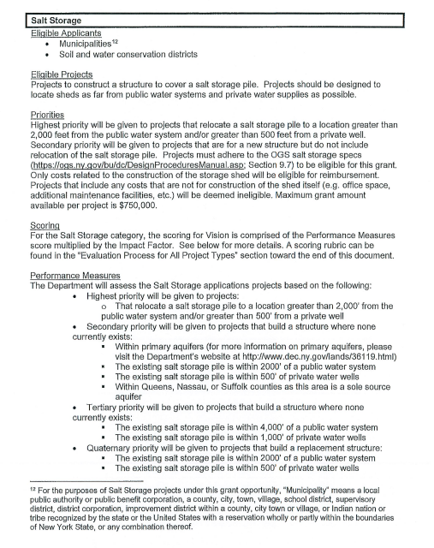

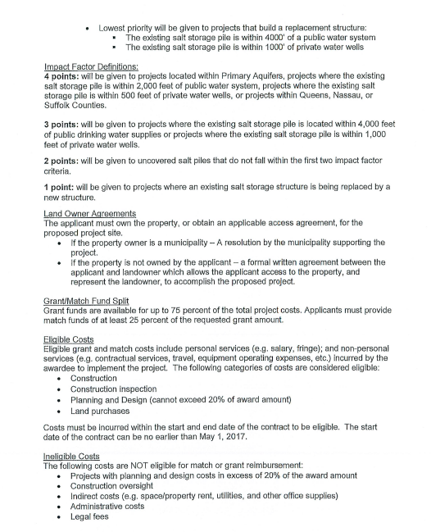
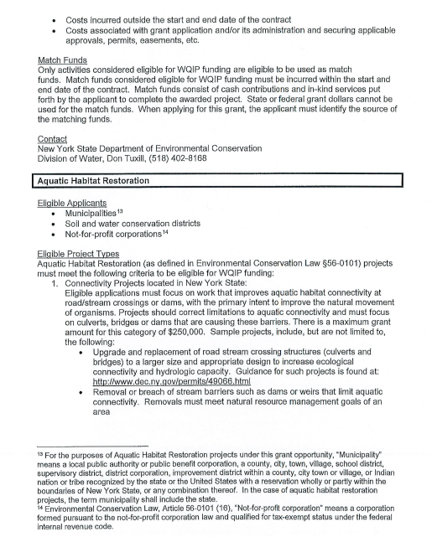

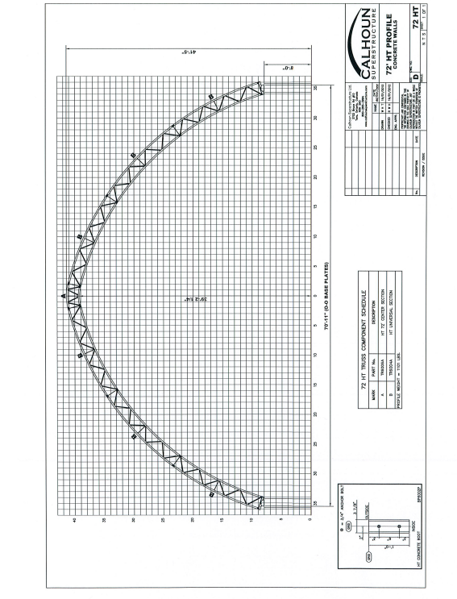

On May 10, 2018 there will be an open house at the Town of Irondeqouit at 1260 Titus Ave. from 11:00 AM – 2:00 PM. Hybrid Building Solutions, LLC will have some of their building structures available for guests to view and staff to help answer questions. Mari stated food trucks will be available as well.

When the building is built and finished, Mari stated that a, “Warranty Walk Around” is initiated with photos taken. She stated they can teach the Highway Superintendent and staff how to maintain the building or it can be written in the grant when applying to have the Hybrid Building Solutions, LLC to come out and do a 1 year warranty check and then every 5 years after. The cost is based on prevailing wage at the time. The 2018 warranty cost on the size of the building they suggest for the Town of Sodus is about $1800.00. 80% of the cost of the building is covered by the grant and the other 20% is usually covered by inkind service.

Mari stated our local Water and Soil Authority can help with writing a grant for the Town of Sodus for the Calhoun Building Structure. Highway Superintendent Dale Pickering stated he will be in touch with Mari.

PUBLIC COMMENTS
(Honorable Thomas Putnam, Town Justice – Honorable Robert Fratangelo, Town Justice – Michelle Dolan, Court Clerk)
A letter was submitted to the Sodus Town Court on 2/27/2018 from the Sodus Town Board as follows:

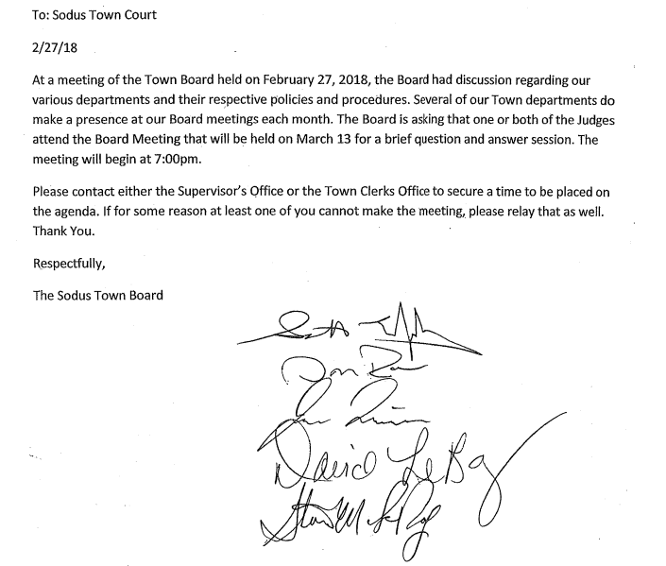

Robert Fratangelo Town Justice told the Town Board, the reason a town judge cannot be present at regular session meetings. Fratangelo explained that Judicial Branch and Executive Branch of governement are two separate entities. He explained that a judge can appear before or after a regular session meeting as long as the board has a specific reason for a judge to be present.

Councilperson David LeRoy stated the Town Board would like an open discussion with the Sodus Town Court and a better understanding on the Court’s policy regarding working hours for the court clerks. In addition, Councilperson LeRoy stated the Board had concerns about one of their Court Clerk’s working so late.

Thomas Putnam, Town Justice handed Superivsor LeRoy a travel request for training. Superivsor Steve LeRoy asked Putnam, “If he had any idea on the cost for the travel request?” Putnam stated, “They do not even charge for mileage to go to these things but, they do expect the clerks to get paid for the time.” Supervisor LeRoy asked about the cost and Putnam stated, “Nothing.”

Robert Fratangelo, Town Justice discussed that onsite training has been one on one and now that Michelle Dolan’s, Court Clerk training is coming along they have been able to extend open window hours and are open more to the public. Fratangelo told the Board the Sodus Town Court reduced their hours for a lengthy period of time. Fratangelo shared that it was difficult to train Dolan and remain open to the public. Even though the Sodus Court was closed during that time the Court Clerks were still working in the court.

Thomas Putnam, Town Justice stated he would take time to address the Board regarding Heidi Sutherland, Court Clerk working late hours. According to Putnam, currently Sutherland’s hours overlap Michelle Dolan’s, Court Clerk hours. Dolan works primarily answering the phones, waiting on the window, collecting fines, etc. Putnam explained that when the clerks are waiting on the window, that they do not have a chance to do their paperwork during the day.

There was discussion regarding Heidi working later than normal hours. Putnam explained that he made a deal with the Village of Fairport Judge and has allowed Heidi to work at the Village of Fairport Court. Putnam stated that this arrangement with Heidi was very temporary because of the driving, etc. Heidi has been working at the Village of Fairport Court during the morning and day and then working late afternoon’s, evenings, into the early morning for the Sodus Town Court. Putnam informed the Board there are very few times Heidi is by herself working additional late hours. Putnam explained that when she worked until 1:00 AM on a Monday night Putnam was in the Court until 1:00 AM and when Heidi worked until 12:00 AM she actually left before Putnam did. Putnam said he has been coming in and working with Heidi in the Court when she is working those very late hours.

Robert Fratangelo, Town Justice and Thomas Putnam, Town Justice have requsted additional time to meet with the Board either before or after the next meeting. The Board decided it would be best to meet after the next Board Meeting March 27, 2018 at 6:30 PM.

Superivsor Steve LeRoy asked Thomas Putnam, Town Justice about purchasing new chairs for the Town Board Meetings and if it would be okay the chairs are stored along the side of the wall where the side door to the Judges Chambers are located? The judges had no issue with this and explained that the current furniture was given to them from the Wayne County Court as a hand me down.

PUBLIC SAFETY/DRAINAGE/ENVIRONMENT COMMITTEE: Councilperson Don Ross, Chair (Fire, Ambulance, Emergency Preparedness)
Councilperson Don Ross stated the Zoning Board was cancelled and the Planning Board was a full house. Ross brought up the current County Plan for the solar power; the Town of Sodus Planning Board didn’t want to change what was already in place. There explained that there are building codes that protect the Town, with the current solar plan.

Ross reported there is a new report generated from the 911 center which will be the new SESA report.

Ross asked if LeRoy had any update from anyone in Lyons and the MVA fee. Supervisor Steven LeRoy stated he did not have time to check into that as of yet.

Ross shared the Wayne County Water Sewer Authority Meetings are very well run and a great organization. The residents of Sodus are well served with the Water Authority managing the Town’s water. Supervisor LeRoy stated that he has not had one single complaint since the Water Authority has taken over.

BUILDINGS AND GROUNDS COMMITTEE: Councilperson Jim Quinn, Chair
(Town Property, Parks, Animal Control, Cemeteries)
CODE ENFORCEMENT REPORT:
(Al Hendrikse, Code Enforcement Office)- Absent
Councilperson David LeRoy motioned to accept and file the February 2018 Code Enforcement Report was seconded by Councilperson Don Ross. Upon roll call the following votes were heard, Steven LeRoy, aye; David LeRoy, aye; Quinn, aye; Ross, aye; and Johnson, aye. Motion carried.

CAMP BEECHWOOD REPORT:
(Trevor Davey, Camp Beechwood Caretaker)- Absent
Councilperson Scott Johnson motioned to accept and file the February 2018 Camp Beechwood Report was seconded by Councilperson David LeRoy. Upon roll call the following votes were heard, Steven LeRoy, aye; David LeRoy, aye; Quinn, aye; Ross, aye; and Johnson, aye. Motion carried.

DOG CONTROL OFFICER REPORT:
Shane Martin- Primary DCO
Craig Schwartz- Secondary DCO

There was no DCO report for the month of February. Shane Martin and Craig Schwartz just started as DCO’s.

PUBLIC WORKS COMMITTEE: Councilperson David LeRoy, Chair
(Highway, Drainage - Deputy Town Supervisor)
Highway Report
(Dale Pickering Highway Superintendent)
Councilperson Scott Johnson motioned to accept and file the February 2018 Highway Report was seconded by Don Ross. Upon roll call the following votes were heard, Steven LeRoy, aye; David LeRoy, aye; Quinn, aye; Ross, aye; and Johnson, aye. Motion carried.

Highway Superintendent Dale Pickering discussed the request for DBI Services to do weed spraying around road signs and guardrails in the Town of Sodus. There was a request from some of the towns to get added to the spraying list that Wayne County is initiating. The total cost for the Town of Sodus is $1,789.00 and according to Pickering it will come out of the General Repair budget in the DB fund. The Board agreed that this should be done. Pickering mentioned if there is a road sign in someone’s yard, they will skip over that.

Councilperson David LeRoy asked Highway Superintendent to look at the mower for mowing. Pickering asked LeRoy to give him a call or stop by anytime.

RECREATION COMMITTEE: Councilperson (Scott Johnson, Chair)
(Recreation, Assessor)
Recreation Report
(Sheila Fisher, Recreation Director)
Councilperson David LeRoy motioned to accept and file the February 2018 Recreation Report was seconded by Councilperson Don Ross. Upon roll call the following votes were heard, Steven LeRoy, aye; David LeRoy, aye; Quinn, aye; Ross, aye; and Johnson, aye. Motion carried.

Scott Johnson discussed that he went to the Sodus Recreational Board meeting last night. The meeting was a reorganizational meeting. The members are as listed as follows:
Laurie McFaul – President
Tom Miller
Sheila Fisher
Jody Bodine
Matt Miller
Cammie VanGee (not present at the meeting)
Scott Johnson

Scott Johnson stated Sodus Recreation had a good start with the winter soccer and swim recreation program.

The pool at the school for summer Tot Swim and summer Rec Swim will be shortened or most likely not available this summer.

Johnson shared since they are aware of a budget shortfall with the Recreational Program; they have applied for the, “21st Century Grant.” If awarded it would help pay the wages of those hired for the summer recreation program. Johnson explained the grant is only temporary though.

Councilperson Johnson sated that there is still fundraising events being held for Sodus Recreation. A circus will be held at the school. They are trying to get the Youth Wrestling Program going again. Tom Miller is doing a Math Camp this summer. The Recreation Program will celebrate in the Centennial Celebration this summer the Village of Sodus is having.

Assessor’s Report
(Nathan Mack, Assessor)
Councilperson Jim Quinn motioned to accept and file the February 2018 Assessor’s Report was seconded by Councilperson Scott Johnson. Upon roll call the following votes were heard, Steven LeRoy, aye; David LeRoy, aye; Quinn, aye; Ross, aye; and Johnson, aye. Motion carried.

TOWN HALL COMMITTEE: Supervisor LeRoy, Chair
(Personnel, Clerks, Justices, Assessor, Building Inspector, Town Council, Boards, Insurances, Finance)

REGULAR MONTHLY CORRESPONDENCE

Councilperson Scott Johnson motioned to authorize the purchase of 8 new chairs from Caitlin (State Bid) for a total sum of $1,849.60 was seconded by Councilperson Don Ross. Upon roll call the following votes were heard, Steven LeRoy, aye; David LeRoy, aye; Quinn, aye; Ross, aye; and Johnson, aye. Motion carried.

Councilperson David Leroy motioned to approve Lori Diver, Town Clerk to advertise for the bids for the spring and fall cleanup (June 1, 2 and October 6) was seconded by Councilperson Scott Johnson. Upon roll call the following votes were heard, Steven LeRoy, aye; David LeRoy, aye; Quinn, aye; Ross, aye; and Johnson, aye. Motion carried.

Councilperson Scott Johnson motioned to accept Hailey Grenon as a volunteer in the Town Clerk’s Office, 2-3 hours per week for a total of 15 hours. This will help Hailey to complete her Senior Project which was seconded by Councilperson Don Johnson. Upon roll call the following votes were heard, Steven LeRoy, aye; David LeRoy, aye; Quinn, aye; Ross, aye; and Johnson, aye. Motion carried.

Councilperson Scott Johnson motioned to approve travel request for Assessor’s Office (Batavia, 4/9 – 4/13) was seconded by Councilperson David LeRoy. Upon roll call the following votes were heard, Steven LeRoy, aye; David LeRoy, aye; Quinn, aye; Ross, aye; and Johnson, aye. Motion carried.

Councilperson Scott Johnson motioned to approve travel request for Shane Martin, Dog Control Officer (5/1-5/2) was seconded by Councilperson David LeRoy. Upon roll call the following votes were heard, Steven LeRoy, aye; David LeRoy, aye; Quinn, aye; Ross, aye; and Johnson, aye. Motion carried.

Councilperson Scott Johnson motioned to approve travel request for Craig Schwartz, Dog Control Officer (5/1-5/2) was seconded by Councilperson David LeRoy. Upon roll call the following votes were heard, Steven LeRoy, aye; David LeRoy, aye; Quinn, aye; Ross, aye; and Johnson, aye. Motion carried.

Councilperson Jim Quinn motioned to accept the resignation from Todd DeWispelaere as a Court Bailiff for the Town of Sodus was seconded by Councilperson David LeRoy. Upon roll call the following votes were heard, Steven LeRoy, aye; David LeRoy, aye; Quinn, aye; Ross, aye; and Johnson, aye. Motion carried.

Councilperson Jim Quinn motioned to accept the resignation of Jay DeWispelaere as a Court Bailiff for the Town of Sodus was seconded by Councilperson David LeRoy. Upon roll call the following votes were heard, Steven LeRoy, aye; David LeRoy, aye; Quinn, aye; Ross, aye; and Johnson, aye. Motion carried.

Councilperson Jim Quinn motioned to accept travel request based on further clarification for Web DVS Training on March 23, 2018, for Tom Putnam, Heidi Sutherland, and Michelle Dolan was seconded by David LeRoy. Upon roll call the following votes were heard, Steven LeRoy, aye; David LeRoy, aye; Quinn, aye; Ross, aye; and Johnson, aye. Motion carried. Councilman Jim Quinn will follow through with Tom Putnam Town Justice with clarification of travel request.

DISSCUSSION:

- Supervisor LeRoy discussed “Notice of Withdrawal Request for Public Assistance” for FEMA reimbursement. Sodus Point submitted reimbursement on behalf of the Town of Sodus in 2017 and in return Sodus Point will reimburse the Town of Sodus for its cost regarding the flood damage. Supervisor LeRoy stated he had to sign off on the, “Notice of Withdrawal” since Sodus Point is reimbursing the Town of Sodus.

- Supervisor LeRoy discussed the flood update and how Wayne County is setting aside $150,000.00 in the event of continued lakefront flood damage. Two meetings were held at the County in helping with the anticipation of lakeshore flooding. Wayne County will take the initiative to help out the Towns. Supervisor LeRoy discussed that the Board of Supervisors will take back to their respective Towns, asking each town dealing with the flooding that when money is spent on flood repair that the towns will then reimburse Wayne County for money that is spent.

Wayne County will also participate in spending money on the flood as well. When the water reaches 246 feet Wayne County will ask NY State to declare a State of Emergency. If the state follows suit with the State of Emergency at 246 feet, the state can then dispatch help with the guardsman, sand bags, pumps, etc. Right now we are within a couple cm of 246 feet and declaring a State of Emergency.

- Supervisor LeRoy stated the Wayne Highway Superintendent Kevin Rooney mailed the grant application for repair on the Sodus Center Bridge. If the grant is approved the funding would be granted from “Bridge NY.

- David LeRoy discussed union negotiations and stated it would be discussed at next meeting.

- Supervisor LeRoy shared that Bree is still waiting for the auditors to finish the audit and finalize closing her books for 2017.
FYI:
- Zoning and Planning Minutes

- Monthly Report from Wayne County Sheriff’s Office

- Thank You card from Dorothy Delyser and the Sodus Go Getters

- Invoice Billing and Distribution Statement for Court

A motion by Councilperson Scott Johnson to adjourn the Regular Town Board Meeting was seconded by Councilperson Don Ross. Upon roll call the following votes were heard, Steven LeRoy, aye; David LeRoy, aye; Quinn, aye; Ross, aye; Johnson, aye. Motion carried.

Meeting adjourned at 8:42 PM

Recording Secretary,

Lori K. Diver
Sodus Town Clerk

