MINUTES

Minutes of the “South Geneva Road Water District Public Hearing” and Water District No. 11 Informational Meeting of the Sodus Town Board held July 25, 2017 beginning at 7:00 pm in the Sodus Town Court Room located at 14-16 Mill St. Sodus, NY 14551

All Town of Sodus Board Meetings are open to the public.

Present: Steven M. LeRoy, Town Supervisor
David LeRoy, Deputy Supervisor-Councilperson
Kelly Grey, Councilperson
Jim Quinn, Councilperson
Don Ross, Councilperson

Recording Secretary: Lori Diver, Town Clerk

Absent: N/A

Others Present: Marty Aman, Wayne County Water & Sewer Authority
Dave Doyle, MRB Group Engineers
John Addyman, Sun & Record
Per Sign in Sheet:
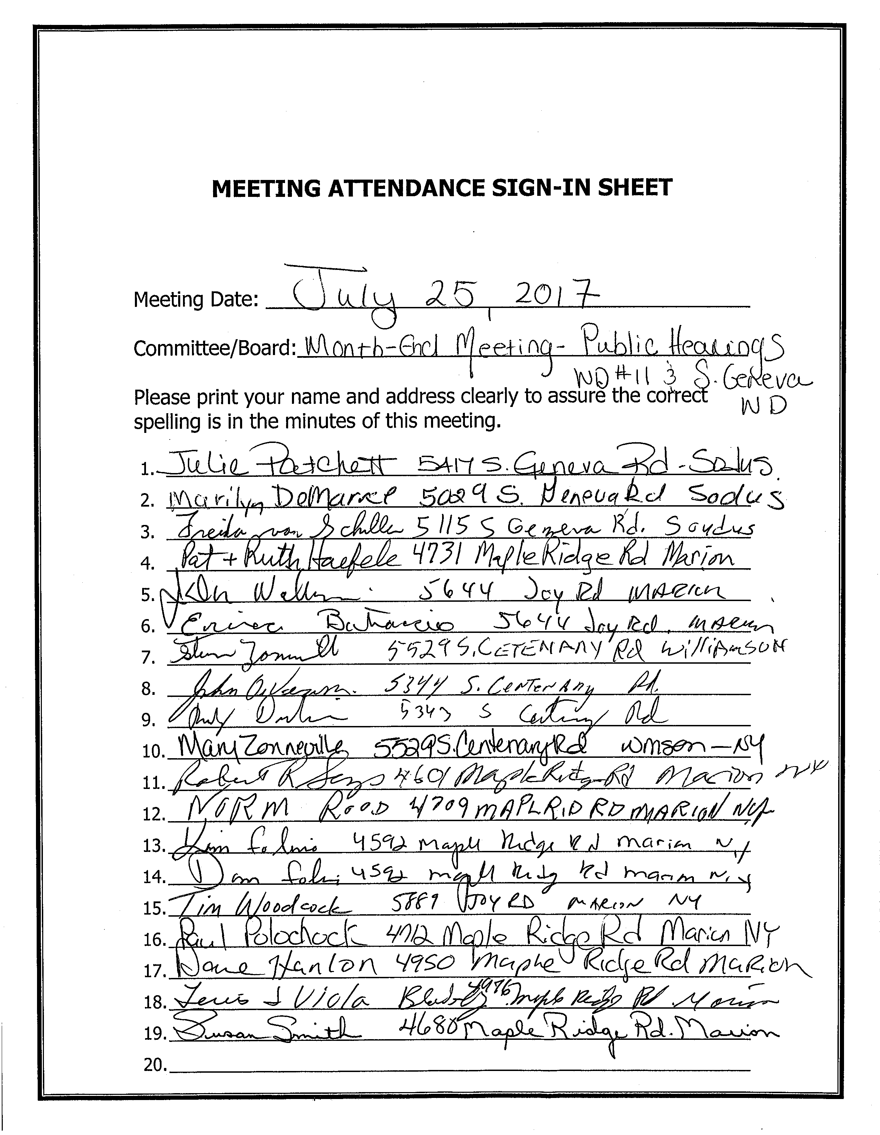

Supervisor LeRoy opened the meeting and acknowledged the Public Hearing for South Geneva Water District Project at 7:00 pm. Lori Diver Town Clerk read the Public Hearing Notice.

PUBLIC HEARING:
LEGAL NOTICE OF PUBLIC HEARING

PLEASE TAKE NOTICE that a public hearing will be held on Tuesday July 25, 2017 at 7:00 P.M. at the Sodus Town Courtroom at 14-16 Mill Street, Sodus, New York, to hear and consider comments from the public in regard to creation of Sodus South Geneva Road Water District.

WHEREAS, the proposed Water District includes a portion of South Geneva Road as more particularly bounded and described in Schedule A annexed to the engineers report on file at the Town Clerks Office, and

WHEREAS, it is proposed to construct a water distribution system in said District, and

WHEREAS, the estimated cost to the typical property or typical dwelling unit (single-family home or equivalent dwelling unit) in the proposed District is $905.00, which includes debt service and cost of water, to be assessed to each such unit in the proposed District, and

WHEREAS, there is anticipated a one-time connection fee estimated at $1600 per unit inclusive of the meter, appurtenances and inspection charges, and

WHEREAS, each homeowner would bear the cost to construct a water service line on his/her property to connect to the new water service, and houses 200 linear feet or more from the road may be required to install a residential meter pit on the property at associated additional cost, and

WHEREAS, the maximum amount proposed to be expended for the establishment of said Water District and the construction of said water distribution system is $309,000.00, and

WHEREAS, copies of the map, plan and report submitted by MRB Group, David M. Doyle, P.E., Project No. 1914.14001.000, describing the proposed district are on file and available for review at the Town Clerks Office during regular business hours.

Dated: June 29, 2017 By order of the Town Board
Town of Sodus
Lorraine Diver
Town Clerk

Supervisor LeRoy opened the Public Hearing for Public Comments.

David Doyle, MRB Group Engineer discussed with the Public the process of the Permissive Referendum for South Geneva Water District.

In addition, it was discussed that the Permissive Referendum will not begin until August 9, 2017 at the Regular Town Board Meeting. Action must be taken by resolution. The Public Hearing Legal did not specify a Special Board Meeting to follow the Public Hearing hence; why the action will have to wait until the next Regular Town Board Meeting.

David Doyle stated since most of the public was present at the last informational meeting, he felt it was safe to say that everyone is probably aware of the history, background, and scope of the project. Doyle asked the Public for any questions; hearing none Supervisor LeRoy closed the Public Hearing at 7:11 pm.

Note: South Geneva Water District’s Project handout (from last informational meeting) is included in these minutes for reference of the water district project. (See Page 4-5)

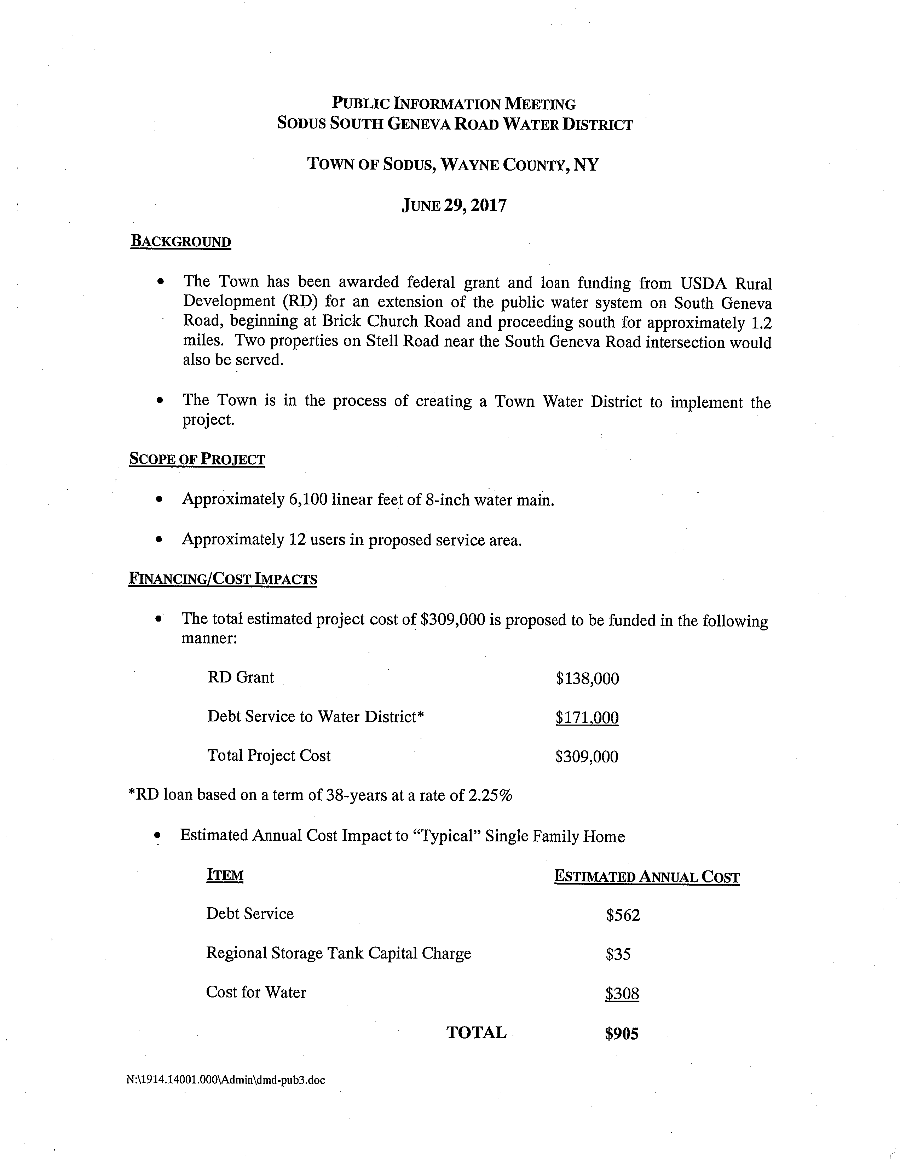

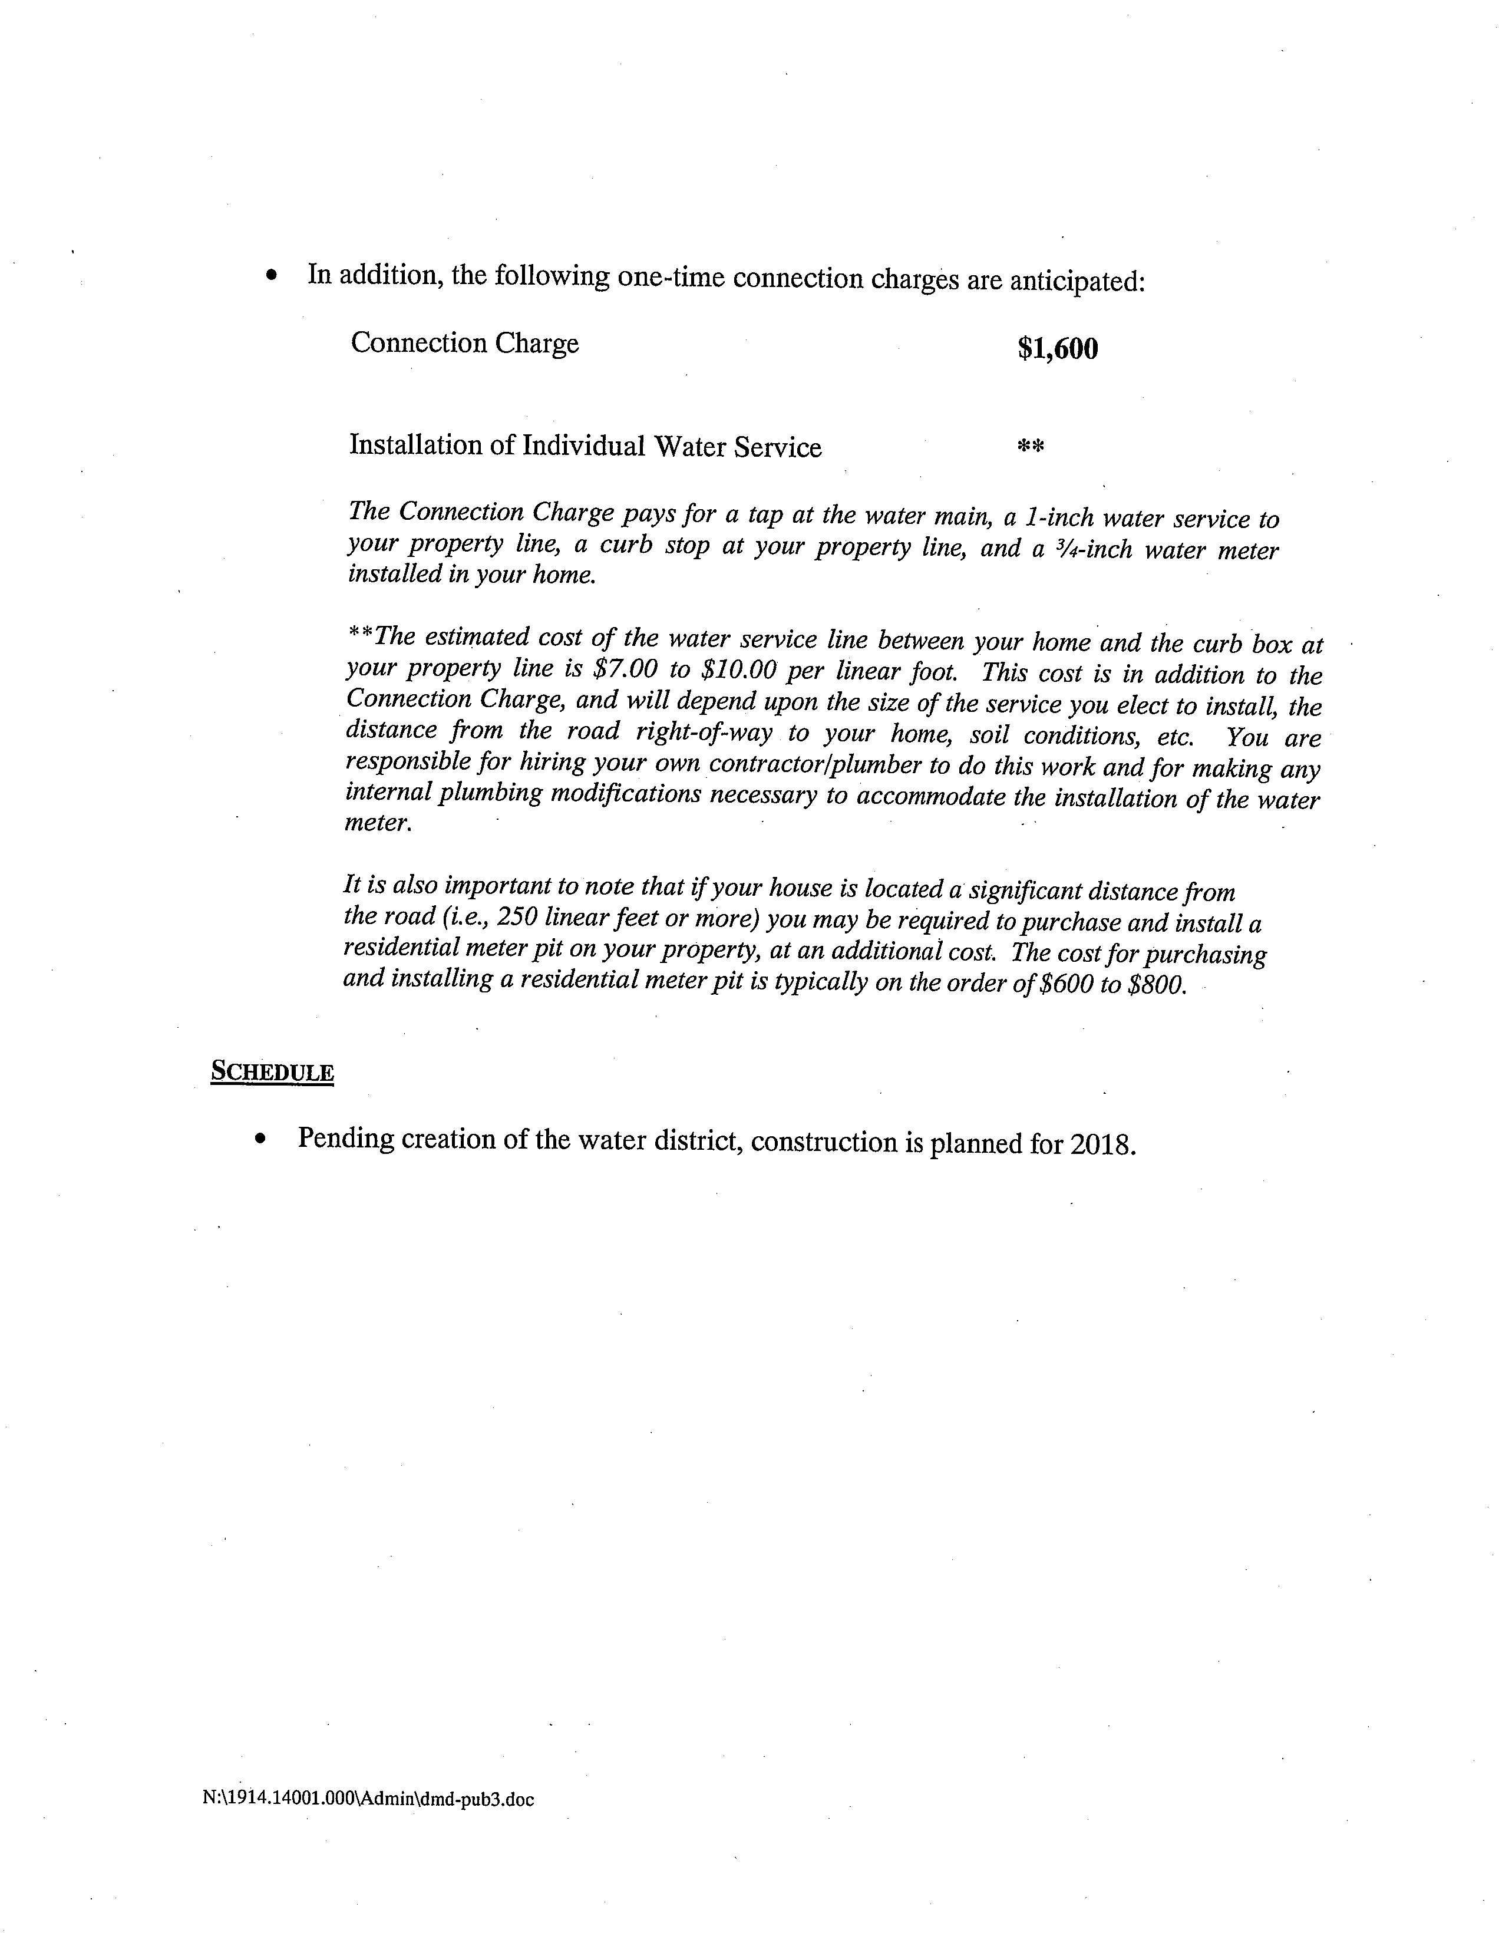
WATER DISTRICT No. 11 INFORMATIONAL MEETING

Supervisor LeRoy stated Water District No. 11 should have been a Public Hearing meeting as advertised in the Sun & Record however; the Supervisor and Board felt it was best not to continue Water District No. 11 as a Permissive Referendum.

Supervisor LeRoy, Dave Doyle MRB Engineer, and Marty Aman with Wayne County Water & Sewer Authority praised the Town Board for giving the residents the ability to vote in favor of public water.

It was explained, instead of the Town Board voting (after the 30 –Day Permissive Referendum) aye or nay on Water District No. 11; they would prefer residents in the water district to sign the petition if they are in favor of public water. Signing of the petition allows the residents to decide if they want the public water in Water District No. 11. If enough residents sign the petition for public water and the total is greater than 50% of the total assessed value, those residents will get public water (Water District No. 11).
Supervisor LeRoy, Dave Doyle, and Marty Aman all stated the project is already funded by USDA.
LeRoy explained to the residents, several attempts were made by going door to door however; many were not home to sign the petition when the district was first being created.

There was much discussion regarding the cost for tapping into the service, the history of the project, the background, what side of the road is the water main on, the scope and timeframe of the project and how many years is the debt service. The Board, Marty Aman, and Dave Doyle answered the publics concerns and questions.

Hearing no further comments from the public, Supervisor LeRoy stated those residents in WD No. 11 would be kept informed on the development of WD No. 11 through letters, the Town of Sodus Website (www.townofsodus.net), the Sun & Record (the town’s legal paper for legal notices), the Town of Sodus Public Notice Board, and the Town Clerk’s Public Notice Board.
Dave Doyle shared with the public that those that want to sign the petition, may come to the Town Clerk’s Office between the hours of 9:00 am - to 5:00 pm Monday – Friday to sign and have the Town Clerk notarize the document.
Supervisor LeRoy shared with the Public; the Town Board will hold a couple signing night meetings to encourage residents in WD No.11 to sign the petition that want public water. It was noted, not everyone can come in to the Town Clerk’s Office during the Clerk’s business hours.

Councilperson David LeRoy motioned to adjourn the meeting was seconded by Councilperson Don Ross. Upon roll call the following votes were heard, Supervisor Steven LeRoy, aye; Grey, (no vote-left meeting early); Councilperson David LeRoy, aye, Quinn, aye; Ross, aye. Motion carried.
Meeting adjourned at 8:16 p.m.

Recording Secretary,

Lori Diver
Sodus Town Clerk

