MINUTES

Minutes of the Regular Town Board Meeting August 9, 2017 commencing at 7:00 pm in the Sodus Town Board Meeting Room located at 14-16 Mill St. Sodus, NY 14551
All Town of Sodus Board Meetings are open to the public.

Present: Steven LeRoy, Supervisor
David LeRoy, Councilperson (Deputy Supervisor)
Kelly Grey, Councilperson
Jim Quinn, Councilperson
Don Ross, Councilperson

Recording Secretary: Lori Diver, Town Clerk

Absent : Al Hendrikse, Code Enforcement
Trevor Davey, Camp Beechwood
Dale Pickering, Highway Superintendent
Others Present:
John Addyman, Sun & Record
Kim Buell, Town of Sodus Zoning Member
Nathan Mack, Assessor
Robert Locke, Assistant to Assessor
Bree Crandell, Confidential Clerk
Mike Buckley, T/Sodus Resident
Sue Buckley, T/Sodus Resident
Chris Tertinek, Sodus Point Mayor
Kim Buell, ZBA Member

Supervisor LeRoy called the Regular Town Board Meeting with the Pledge of Allegiance, commencing at 7:00 pm.

MINUTES
Councilperson David LeRoy motioned to approve the Minutes of the July 12, 2017
Regular Town Board Meeting was seconded by Councilperson Kelly Grey. Upon roll call the following votes were heard, Steven LeRoy, aye; David LeRoy, aye; Quinn, aye; Grey, aye; Ross, aye. Motion carried.

Councilperson David LeRoy motioned to approve the Minutes of the July 25, 2017 Month End-Regular Town Board Meeting was seconded by Councilperson Don Ross.
Upon roll call the following votes were heard, Steven LeRoy, aye; David LeRoy, aye; Quinn, aye; Grey, aye; Ross, aye. Motion carried.

Councilperson Kelly Grey motioned to approve the Minutes of the July 25, 2017 Public Hearing for South Geneva Water District was seconded by Councilperson David LeRoy. Upon roll call the following votes were heard, Steven LeRoy, aye; David LeRoy, aye; Quinn, aye; Grey, aye; Ross, aye. Motion carried.

Councilperson Kelly Grey motioned to approve the Minutes of the June 25, 2017 Water District No. 11 Informational Meeting was seconded by Councilperson David LeRoy.
Upon roll call the following votes were heard, Steven LeRoy, aye; David LeRoy, aye; Quinn, aye; Grey, aye; Ross, aye. Motion carried.

SUPERVISOR’S REPORT
The Supervisor’s Report for July 2017 (including all town-wide expenditures and compensated absences & budget sheets) were presented for approval. Councilperson Jim Quinn motioned to accept and file this report, which was seconded by Councilperson Kelly Grey. Upon roll call the following votes were heard, Steven LeRoy, aye; David LeRoy, aye; Grey, aye; Quinn, aye; Ross, aye. Motion carried.

TOWN CLERK’S REPORT
The Town Clerk’s Reports, Town Clerk’s bank statements for audit and bank register for July 2017 were presented. Councilperson Jim Quinn motioned to accept and file this report, which was seconded by Councilperson David LeRoy. Upon roll call the following votes were heard, Steven LeRoy, aye; David LeRoy, aye; Quinn, aye; Grey, aye; Ross, aye. Motion carried

ABSTRACT
RESOLUTION TO PAY ABSTRACT No. 15
(01 08-2017)
WHEREAS, the following bills were presented for payment on Abstract 15:

General 353-374 $ 20,793.74
Highway 231-243 $ 91,068.10
Special Districts 31-31 $ 903.53
GRAND TOTAL: $ 112,765.37

NOW BE IT RESOLVED, Councilperson David LeRoy motioned to approve payment of these bills as reviewed for Abstract No. 15, which was seconded by Councilperson Jim Quinn. Upon roll call the following votes were heard, Steven LeRoy, aye; David LeRoy, aye; Quinn, aye; Grey, aye; Ross, aye. Motion carried

PUBLIC COMMENTS
(Nathan Mack, Town of Sodus Sole Assessor &
Robert Locke Clerk to the Assessor)
Nathan Mack, Sole Assessor discussed with the Board a relief option passed by Governor Andrew Cuomo available for those affected by the floods along Lake Ontario in Sodus Point.
(Please see page 3-4 with specific details)
The Board stated they cannot act on the relief at the Town of Sodus level because the information presented to the Assessor and the Board was submitted late by NYS with deadline requirements.

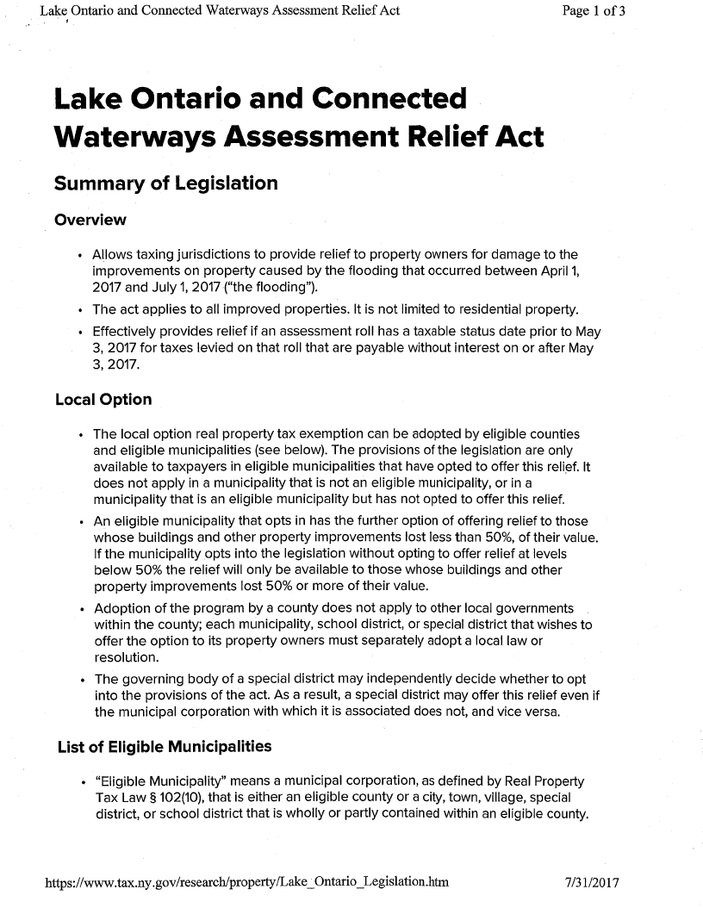

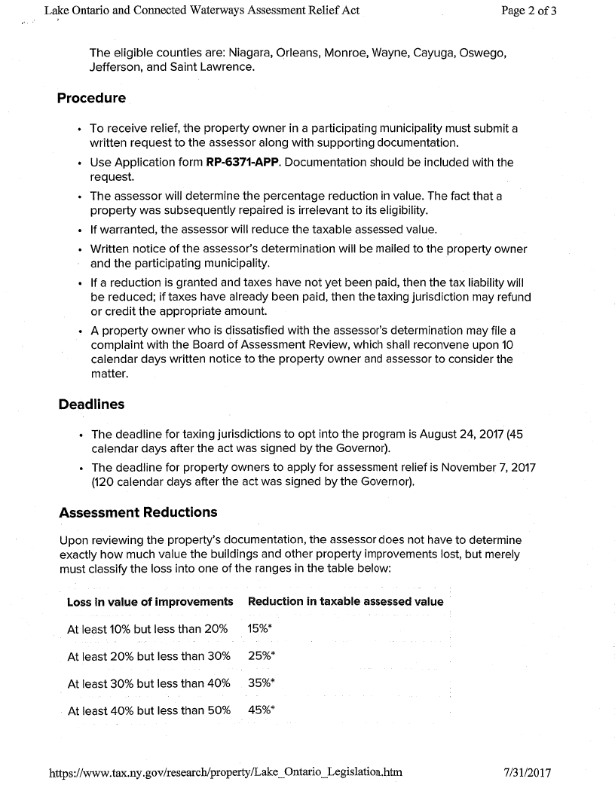

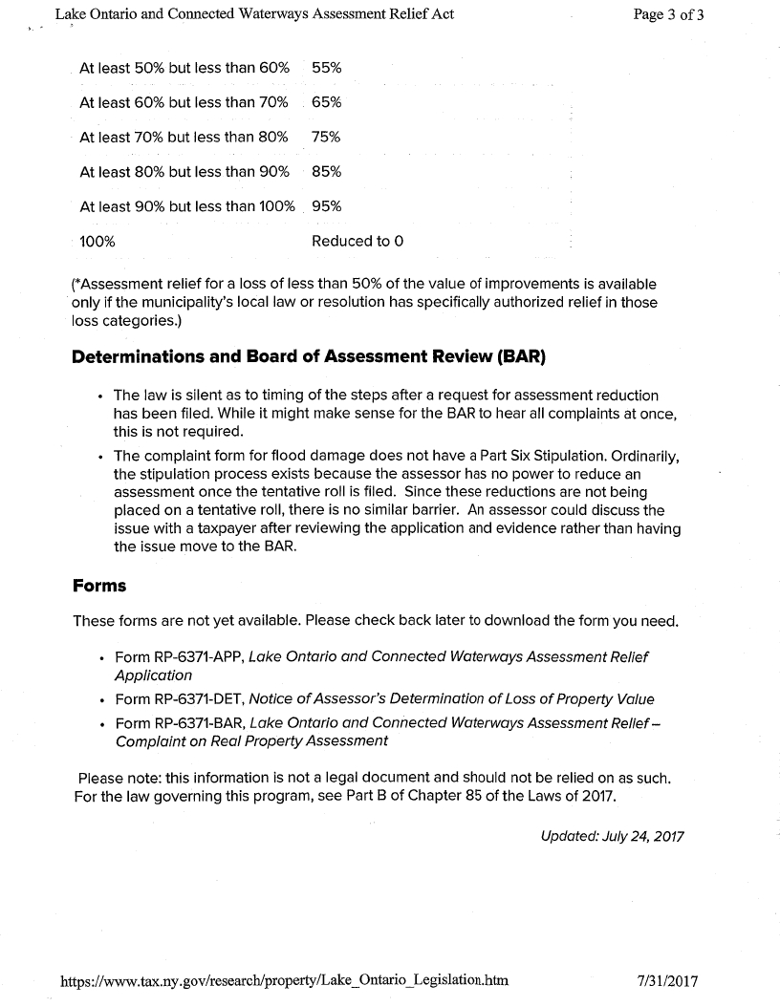

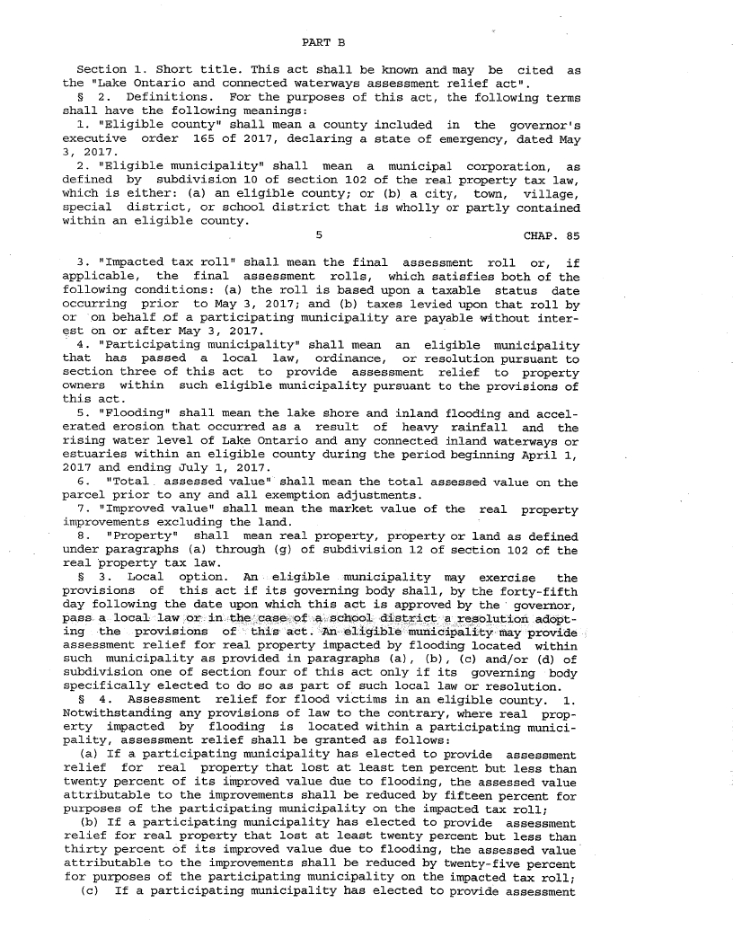

(Bill Martin)
Bill Martin asked to be on the agenda however he did not attend as he originally requested.

(Mike and Sue Buckley)
Mike ad Sue Buckley discussed with the Sodus Town Board complaints regarding the speed in the Hamlet of Alton. Supervisor LeRoy explained, The Town followed through by receiving petitions signed from residents, letters of request to lower the speed limit by residents in Alton, and an investigation was completed by the New York State Department of Transportation’s Investigator. NYSDOT stated that the Hamlet of Alton did not warrant a speed reduction however additional signs could be posted to help reduce the speed. Supervisor LeRoy discussed with the Buckley’s that the Town followed the protocol as requested by the residents in the Hamlet of Alton. NYSDOT makes the final determination and it was founded it did not warrant a reduction; there is nothing more that can be done.

In addition, the Buckley’s had major concerns about some of the properties in the Hamlet of Alton and not complying with Town of Sodus Code. The Buckley’s believe some of the properties are believed to be drug houses owned by absentee landlords. Discussion was held regarding the Nuisance Abetment Law. Steve LeRoy stated to the Buckley’s if they see illegal activity taking place, call 911.
Don Ross will talk with Al Hendrikse, Code Enforcement Officer regarding the properties that the Buckley’s are referring too. It is believed Al has addressed these concerns but, further discussion will follow to address the Buckley’s concerns.

No further public comments made

PUBLIC SAFETY/DRAINAGE/ENVIRONMENT COMMITTEE: Councilperson Don Ross, Chair (Fire, Ambulance, Emergency Preparedness)

Councilperson Don Ross submitted his report as follows:
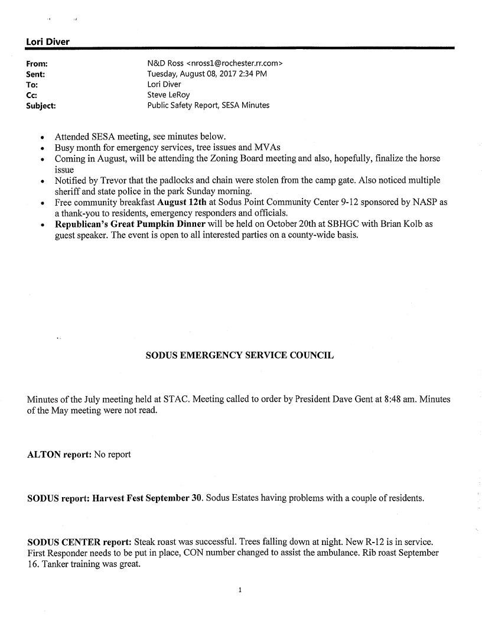

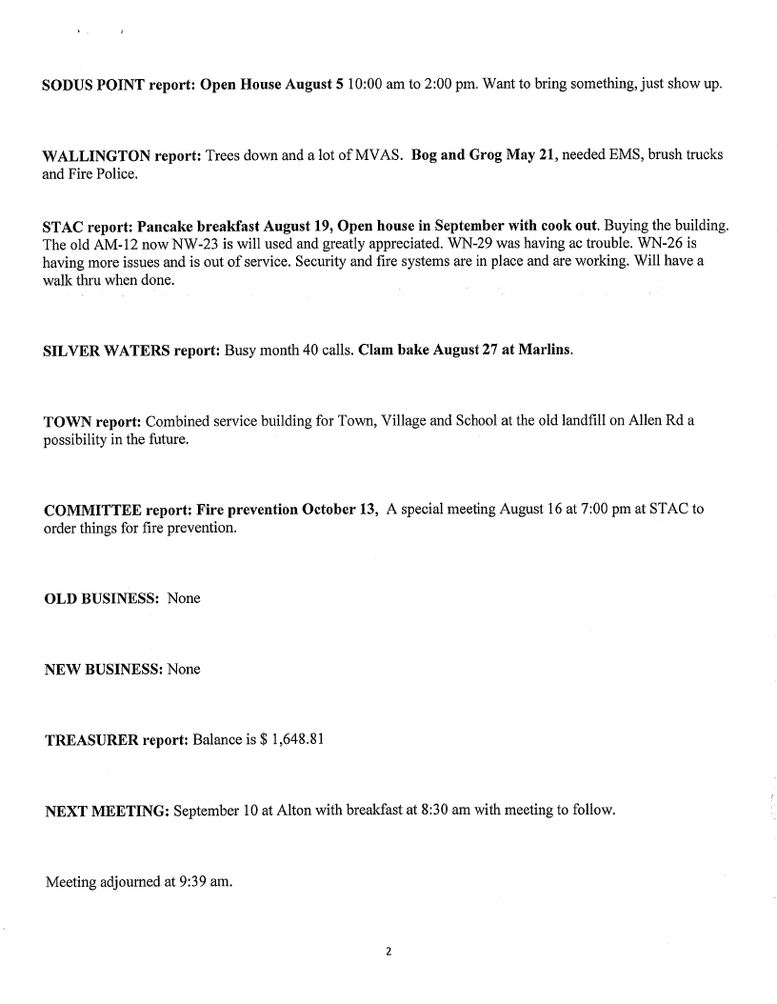

The Wallington Fire Department and Sodus Town Ambulance Corp. submitted their monthly reports for review.

BUILDINGS AND GROUNDS COMMITTEE: Councilperson Jim Quinn, Chair
(Town Property, Parks, Animal Control, Cemeteries)
CODE ENFORCEMENT REPORT:
(Al Hendrikse, Code Enforcement Office)
Councilperson Kelly Grey motioned to accept and file the July 2017 Code Enforcement Report was seconded by Councilperson Don Ross. Upon roll call the following votes were heard, Steven LeRoy, aye; David LeRoy, aye; Quinn, aye; Grey, aye; Ross, aye. Motion carried.

CAMP BEECHWOOD REPORT:
(Trevor Davey, Camp Beechwood Caretaker)
Councilperson Kelly Grey motioned to accept and file the July 2017 Camp Beechwood Report was seconded by Councilperson David LeRoy. Upon roll call the following votes were heard, Steven LeRoy, aye; David LeRoy, aye; Quinn, aye; Grey, aye; Ross, aye. Motion carried.

DOG CONTROL OFFICER REPORT:
(Thomas Luckenbach, DCO)
Councilperson Kelly Grey motioned to accept and file the July 2017 Dog Control Officer Report was seconded by Councilperson Don Ross. Upon roll call the following votes were heard, Steven LeRoy, aye; David LeRoy, aye; Quinn, aye; Grey, aye; Ross, aye. Motion carried.

PUBLIC WORKS COMMITTEE: Councilperson David LeRoy, Chair
(Highway, Drainage - Deputy Town Supervisor)
Highway Report
(Dale Pickering Highway Superintendent)
Councilperson Kelly Grey motioned to accept and file the July 2017 Highway Report was seconded by Councilperson Don Ross. Upon roll call the following votes were heard, Steven LeRoy, aye; David LeRoy, aye; Quinn, aye; Grey, aye; Ross, aye. Motion carried.

Village of Sodus Point Mayor thanked the Town of Sodus Highway Department for helping Sodus Point during that flooding over the spring and summer.

Discussion was held regarding a small fire at Tracey Road Equipment while a Town of Sodus Highway Truck was in for repair. The fire did minimal damage to the truck. Currently the situation is being investigated and handled with the Town of Sodus Insurance Company.

RECREATION COMMITTEE: Councilperson Kelly Grey, Chair
(Recreation, Assessor)
Recreation Report
(Sheila Fisher, Recreation Director)
Councilperson David LeRoy motioned to accept and file the July 2017 Recreation Report was seconded by Councilperson Don Ross. Upon roll call the following votes were heard, Steven LeRoy, aye; David LeRoy, aye; Quinn, aye; Grey, aye; Ross, aye. Motion carried.

Discussion was held regarding the Summer Recreation Program. It was noted that Summer Rec is winding down and again it was another successful summer.

TOWN HALL COMMITTEE: Supervisor LeRoy, Chair
(Personnel, Clerks, Justices, Assessor, Building Inspector, Town Council, Boards, Insurances, Finance)
Assessor’s Report
(Nathan Mack, Assessor)
Councilperson Kelly Grey motioned to accept and file the July 2017 Assessor’s Report was seconded by Councilperson Don Ross. Upon roll call the following votes were heard, Steven LeRoy, aye; David LeRoy, aye; Quinn, aye; Grey, aye; Ross, aye. Motion carried.

CORRESPONDENCE & INFORMATION:

Councilperson Kelly Grey motioned to advertise for bids for over the road diesel fuel (bid opening September 26, 2017 @ 7:15 pm) was seconded by Councilperson David LeRoy.
Upon roll call the following votes were heard, Steven LeRoy, aye; David LeRoy, aye; Quinn, aye; Grey, aye; Ross, aye. Motion carried.

At a duly noticed and held meeting of the Town Board of the Town of Sodus, New York held at the Town Offices, 14-16 Mill Street, Sodus, New York on July 25, 2017, the following resolution was introduced by Councilperson David LeRoy and seconded by Councilperson Kelly Grey and unanimously adopted.

RESOLUTION
TO CREATE SODUS SOUTH GENEVA ROAD WATER DISTRICT
SUBJECT TO PERMISSIVE REFERENDUM
(02 08-2017)

At a duly noticed and held meeting of the Town Board of the Town of Sodus, New York held at the Town Offices, 14-16 Mill Street, Sodus, New York on August 9, 2017, the following resolution was introduced by Councilperson David LeRoy and seconded by Councilperson Kelly Grey and unanimously adopted.

WHEREAS, Section 209 of the Town Law of the State of New York empowers the Town Board of the Town of Sodus to provide for the establishment in the Town of Sodus a Water District, and

WHERAS, a map, plan and report have been prepared by the Towns Engineers, MRB Engineering, P.C., David M. Doyle, P.E., relating to the proposed Sodus South Geneva Road Water District in the Town of Sodus and the construction of related improvements and duly filed in the office of the Town Clerk as required by law; and

WHEREAS, an Order Calling a Public Hearing was duly adopted by this Town Board on July 25, 2017, reciting the filing of said map, plan and report, the improvements proposed, the boundaries of the proposed extended district, the fact that the map, plan and report described in said Order also contained the method of financing any improvements, and that said map, plan and report were on file in the Town Clerk's Office for public inspection, and stating all other matters required by law to be stated and specifying July 25, 2017, as the date, at 7:00 p.m. on said day as the time, and the Town Hall, 14-16 Mill Street, Sodus, New York as the place where the Town Board would meet for a Public Hearing to consider said map, plan and report, and to hear all persons interested in the subject thereof, concerning the same, and to take such action thereon as is required or authorized by law; and

WHEREAS, such Order was duly published in the official newspapers for the Town and duly posted, with both Publication and Posting in full compliance with Town Law 209-d; and
WHEREAS, a Public Hearing on the proposed Sodus South Geneva Road Water District was duly held by the Town Board on July 25, 2017 at 7:00 p.m. on said day, in the Town Hall, 14-16 Mill Street, Sodus, New York, at which all interested persons desiring to be heard were heard, including those in favor of, and those opposed to, the extension of the Water District and construction of related improvements; and

WHEREAS, upon the conclusion of the public hearing, the Board hereby finds and determines the following: [a] The Majority of the property owners within said proposed water district are in favor of the establishment of the district; [b] All the property and property owners within said proposed district are benefitted thereby; [c] All the property and property owners benefitted are included within the limits of said proposed water district; and [d] The establishment of said proposed water district is in the public interest, and

WHEREAS, in connection with Sodus South Geneva Road Water District, a Full Environmental Assessment Form was filed with the Town Board and in the office of the Town Clerk from which the Town Board duly considered and reviewed all potentially significant environmental impacts as required by Environmental Conservation Law Article 8 (State Environmental Quality Review ActSEQRA and 6 NYCRR Part 617); and

WHEREAS, by Resolution dated August 9, 2017, the Town Board declared itself Lead Agent, adopted findings that the proposed Water District will give rise to no adverse environmental impacts, and issued a Negative Declaration under SEQRA, and

WHEREAS, in light of the passage of time, the Town Board has reviewed and revisited the Full Environmental Assessment Form filed for Sodus South Geneva Road Water District, the findings, and Negative Declaration above referenced, and, finding no significant changes, reaffirms and adopts its prior findings, declarations, and resolutions dated August 9, 2017.

Now, therefore, upon the evidence adduced at said Public Hearing, and all evidence in the record before the Town Board, the Town Board finds:

1. The boundaries of the proposed Sodus South Geneva Road Water District are as described and set forth in Schedule A annexed hereto and made a part hereof; and

2. The maximum amount proposed to be expended for the establishment of said Water District and the construction of said water distribution system is $309,000.00, and

3. The proposed method of financing for the District includes a combination of grants and loans through the United States Department of Agriculture/Rural Development, with the estimated annual cost to the typical property or typical dwelling unit (single-family home or equivalent dwelling unit) in the proposed District of $905, which includes debt service and cost of water, to be assessed to each such unit in the proposed District, calculated as follows:

Water Use $308.00 (Based on average annual use of 50,000 Gal/Year per unit)
Debt Service $562.00 (Average annual charge over 38 years)
$ 35.00 (Average Annual charge regional storage tank over 38 years)
$905.00

4. There is anticipated a one-time connection fee estimated at $1,600 per unit inclusive of the meter, appurtenances and inspection charges to the right of way line, and

5. Costs for each homeowner to construct a service line from the right of way line to the home and any plumbing modifications necessary to connect, are the responsibility of the individual owners and will vary depending on the distance of the house/unit from the right of way, size of service and conditions, and houses 200 linear feet or more from the road may be required to install a residential meter pit on the property at associated additional cost; and

6. The Majority of the property owners within said proposed water district are in favor of the establishment of the district; All the property and property owners within said proposed district are benefitted thereby; All the property and property owners benefitted are included within the limits of said proposed water district; and The establishment of said proposed water district is in the public interest, and

Based upon the foregoing,

NOW, THEREFORE, BE IT DETERMINED AND RESOLVED by the Town Board of the Town of Sodus, County of Wayne, as follows:

(1) That the Order Calling for Public Hearing was published and posted as required by New York Town law and is otherwise sufficient;

(2) That all of the property and property owners within the proposed Water District are benefitted thereby;

(3) That all of the property and property owners benefitted are included within the proposed Water District.

(4) That it is in the public interest to establish the proposed Water District as hereinafter described, and be it further

Resolved And Determined, that the proposed Sodus South Geneva Road Water District as set forth in the map, plan and report be approved and that the boundaries of said water district as hereby established shall be as described in Schedule A hereto attached, and it is further

Resolved And Determined that the expense of the establishment of said proposed Water District and the construction of said water distribution system therein and the maintenance thereof shall be assessed, levied and collected from year to year from the several lots and parcels of land within the Water District in proportion as nearly as may be to the benefit which each lot or parcel of land in said District will derive therefrom; and it is further

Resolved And Determined, that the proposed Sodus South Geneva Road Water District as set forth in the map, plan and report be approved and that the boundaries of said water district as hereby established shall be as described in Schedule A hereto attached, and it is further

Resolved And Determined that the expense of the establishment of said proposed Water District and the construction of said water distribution system therein and the maintenance thereof shall be assessed, levied and collected from year to year from the several lots and parcels of land within the Water District in proportion as nearly as may be to the benefit which each lot or parcel of land in said District will derive therefrom; and it is further

Resolved And Determined that this Order is subject to a Permissive Referendum as provided in Town Law 209-e. Petitions for the requesting of said Permissive Referendum are available at the office of the Town Clerk. Said Petitions must be completed and filed in the office of the Town Clerk, 14-16 Mill Street, Sodus, New York within thirty (30) days of the filing of this Order with the Town Clerk.

NOW BE IT RESOLVED, Councilperson David LeRoy motioned to adopt the resolution which was seconded by Councilperson Kelly Grey. Upon roll call the following votes were heard, Steven LeRoy, aye; David LeRoy, aye; Quinn, aye; Grey, aye; Ross, aye. Resolution adopted.
RESOLUTION
CHANGE OF BOARD MEETING DATES AND PLACE
(03 08-2017)

Supervisor Steven LeRoy offered the following resolution for its adoption,

WHEREAS, due to space constraints causing an inappropriate environment and to better coordinate with the Village Board Meetings a resolution was passed at the August 9, 2017 Board Meeting the Regular Town Board and Month End Board Meetings will change to the 2nd and 4th Tuesday of each month and,

WHEREAS, the Town Board is changing the location of the meetings from the upstairs breakroom (former board room) to the Town of Sodus Court, and

RESOLVED, the Town Board will hold all Town Board meetings in the Town of Sodus Court Room the 2nd and 4th Tuesday of each month, and

FUTHER BE IT RESOLVED, Councilperson David LeRoy moved for its adoption, which was seconded by Councilperson Kelly Grey. Upon roll call the following votes were heard, Steven LeRoy, aye; David LeRoy, aye; Quinn, aye; Grey, aye; Ross, aye. Resolution adopted.

Councilperson Don Ross motioned to advertise adoption of resolution subject to Permissive Referendum (South Geneva Rd) (provided) was seconded by Councilperson David LeRoy. Upon roll call the following votes were heard, Steven LeRoy, aye; David LeRoy, aye; Quinn, aye; Grey, aye; Ross, aye. Motion carried.

Councilperson Kelly Grey motioned to authorize Town Clerk Lori Diver to attend the Town Clerk Association Executive Board Regional Conference (September 17-18) in Dunkirk, NY was seconded by Councilperson David LeRoy. Upon roll call the following votes were heard, Steven LeRoy, aye; David LeRoy, aye; Quinn, aye; Grey, aye; Ross, aye. Motion carried.

RESOLUTION
SAMPLE BRIDGE NY BY MUNICIPALITY
(Locally Administered Project)
(04 08-2017)

Authorizing the implementation, and funding in the first instance 100% of the Federal-aid and State-aid eligible costs, of a federal-aid and/or state-aid transportation project, and appropriating funds therefore.

Whereas, Sponsor will design, let and construct the “project”.

WHEREAS, a Project for the Main Street Bridge over Salmon Creek Rehabilitation, P.I.N. 4BNY.12 (the Project") is eligible for funding under Title 23 U.S. Code, as amended, that calls for the apportionment of the costs such program to be borne at the ratio of 95% Federal funds and 5% non-federal funds; and

WHEREAS, the Town of Sodus desires to advance the Project by making a commitment of 100% of the non-federal share of the costs of $45,000

NOW, THEREFORE, the Sodus Town Board, duly convened does hereby

RESOLVE, that the Sodus Town Board hereby approves the above-subject project; and it is hereby further

RESOLVED, that the Town of Sodus Board hereby authorizes the Town Supervisor to pay in the first instance 100% of the federal and non-federal share of the cost of PE/Design work for the Project or portions thereof; and it is further

RESOLVED, that the Town of Sodus Board hereby agrees that the Town of Sodus shall be responsible for all cost of the project which exceed the amount of the NY Bridge Funding awarded to the Town of Sodus.

RESOLVED, that the sum of $45,000 is hereby appropriated and made available to cover the cost of participation in the above phase of the Project; and it is further

RESOLVED, that in the event the full federal and non-federal share costs of the project exceeds the amount appropriated above, the Sodus Town Board shall convene as soon as possible to appropriate said excess amount immediately upon the notification by the Town Supervisor thereof, and it is further

RESOLVED, that Town of Sodus hereby agrees that construction of the Project shall begin no later than eighteen (18) months after award and that the project shall be completed within THREE years of commencing construction; and it is further

RESOLVED, that the Supervisor of the Town of the of Sodus be and is hereby authorized to execute all necessary Agreements, certifications or reimbursement requests for Federal Aid and/or State-Aid on behalf of the Town of Sodus with the New York State Department of Transportation in connection with the advancement or approval of the Project and providing for the administration of the Project and the municipality's first instance funding of project costs and permanent funding of the local share of federal-aid and state-aid eligible Project costs and all Project costs within appropriations therefore that are not so eligible, and it is further

RESOLVED, that a certified copy of this resolution be filed with the New York State Commissioner of Transportation by attaching it to any necessary Agreement in connection with the Project; and it is further

RESOLVED, this Resolution shall take effect immediately.

FURTHER BE IT RESOLVED, Councilperson David LeRoy motioned to adopt resolution (04 08-2017) for Supervisor LeRoy and Town Attorney to sign Bridge NY Local Project subject to Attorney approval, relative to the Bridge Over Salmon Creek on Main St. Joy was seconded by Councilperson Don Ross. Upon roll call the following votes were heard, Supervisor Steve LeRoy, aye; Kelly Grey, aye; David LeRoy, aye; Jim Quinn, aye; and Don Ross, aye. Resolution adopted.

Councilperson David LeRoy motioned to hold a meeting August 22, 2017 5:00 pm to 8:00 pm for signing petitions and to authorize Lori Diver to advertise for Water District No. 11 was seconded by Councilperson Don Ross. Upon roll call the following votes were heard, Steven LeRoy, aye; David LeRoy, aye; Quinn, aye; Grey, aye; Ross, aye. Motion carried.

Councilperson David LeRoy authorized Supervisor LeRoy to sign proposal from Kim Leonard for accounting budgeting services was seconded by Councilperson Kelly Grey. Upon roll call the following votes were heard, Steven LeRoy, aye; David LeRoy, aye; Quinn, aye; Grey, aye; Ross, aye. Motion carried.

The Town Board picked 10 comparable towns needed for HR Consulting, they are as follows:

- Town of East Rochester
- Town of Collins
- Town of LeRoy
- Town of Royalton
- Town of Palmyra
- Town of Schroeppel
- Town of Geneseo
- Town of Williamson
- Town of Macedon
- Town of Batavia

DISSCUSSION:

- Supervisor LeRoy discussed a meeting to be held in Sodus Point. The discussion will be discussion on update information in regards to the flooding.

- Supervisor LeRoy discussed a petition that was received for water on Rt. 14 from Ridge Rd to the Sodus Bay heights Golf Course. LeRoy will discuss this with our Engineer, MRB Group Dave Doyle.

- Supervisor LeRoy discussed letter written to Paul D’ Amato (DEC) (provided)

- Supervisor LeRoy asked Councilperson Don Ross if he would be willing to update the Town of Sodus Employee Handbook. Councilperson Don Ross stated he would oversee this project.

- Councilperson Don Ross discussed the decision at the last Planning Board Meeting regarding, “Large Animals” recommendation from the Town Board.

In the minutes of the August 1, 2017 Planning Board, “The Board then entered into a discussion regarding the keeping of large animals, specifically horses. After reviewing the plan the Planning Board submitted to the Town Board, the Town Board suggested the phrase, “of pasture” be inserted into the description of acreage item B-1. After discussing the suggested change, the Planning Board unanimously did not agree with this suggestion. The Planning Board unanimously voted to reject the revision suggested by the Town Board.”

Councilperson Don Ross stated he will go back to the Planning Board and discuss what the reasoning was denying the Town Board request. In addition Ross will talk with Code Enforcement Officer Al Hendrikse regarding derelict properties in the Town of Sodus. He would like Al to explain the enforcement procedure of such properties.

FYI:

- Minutes of Zoning and/ or Planning Board Meetings (provided)

- Monthly report from Wayne County Sheriff’s Office (provided)

EXECUTIVE SESSION:
Councilperson David LeRoy motioned to enter into Executive Session at 8:50 pm regarding a personnel matter regarding a particular person was seconded by Councilperson Jim Quinn. Upon roll call the following votes were heard, Steven LeRoy, aye; David LeRoy, aye; Quinn, aye; Grey, aye; Ross, aye. Motion carried

A motion by Councilperson Kelly Grey to adjourn the Regular Town Board Meeting was seconded by Councilperson David LeRoy. Upon roll call the following votes were heard, Steven LeRoy, aye; David LeRoy, aye; Quinn, aye; Grey, aye; Ross, aye. Motion carried.

Meeting adjourned at 9:30 PM
Recording Secretary,

Lori K. Diver
Sodus Town Clerk

