DRAFT MINUTES

Minutes of the Public Hearing-Month End Board Meeting-Special Town Board Meeting of the Sodus Town Board held October 24, 2017 beginning at 5:00 pm in the Sodus Court Room located at 14-16 Mill St. Sodus, NY 14551
All Town of Sodus Board Meetings are open to the public.

Present: Steven M. LeRoy, Town Supervisor
David LeRoy, Deputy Supervisor-Councilperson
Jim Quinn, Councilperson
Don Ross, Councilperson

Recording Secretary: Lori Diver, Sodus Town Clerk

Absent: N/A

Others Present: Lorilyn Reynolds-Private Drives
Dave Reynolds-Private Drives
Marcia Schweder-Private Drives
Jim Hopkins-Private Drives
James Gashlin-Private Drives
Pat McElroy-Sodus Resident
Belinda McElroy-Sodus Resident
Ed Chipper- Private Drive
Susan Chipper- Private Drive
Scott Johnson- Sodus Resident
Jesse Zeck- Sodus Resident
Sandy Zeck- Sodus Resident
Anthony Villani, Town Attorney
Dale Pickering, Highway Superintendent
Bree Crandell- Confidential Clerk
Kim Leonard- Budget Designer

Supervisor LeRoy opened the meeting and Public Hearing at 5:00 pm in the Sodus Court Room.

PUBLIC HEARING:
LEGAL NOTICE
TOWN OF SODUS
NOTICE OF PUBLIC HEARING
LOCAL LAW NO. 01 (2017)

PLEASE TAKE NOTICE that a public hearing will be held by the Town Board of the Town of Sodus on the 24 day of October, 2017 at 5:00 p.m. in the Sodus Town Court Room at the Sodus Town Hall, 14-16 Mill Street, Sodus, New York to hear and consider comments from the public in regard to Local Law No.01 of 2017:
Local Law No. 01 - 2017 Authorizes the Town Board of the Town of Sodus to adopt a budget for the fiscal year 2018 that requires a real property tax levy in excess of the limit specified in General Municipal Law, §3-c.

Copies of the entire Local Law No. 01 (2017) are available for review at the Town Clerks Office during regular business hours.

BY ORDER OF THE TOWN BOARD
OF THE TOWN OF SODUS
Lorraine Diver, Town Clerk
Dated: October 3, 2017

LOCAL LAW TO OVERRIDE THE TAX LEVY LIMIT
ESTABLISHED IN GENERAL MUNICIPAL § 3-C
Local Law No. 01 of the year 2017
Town of Sodus, County of Wayne

Be it enacted by the Town Board of the Town of Sodus, as follows:

Section 1. Legislative Intent
It is the intent of this local law to override the limit on the amount of real property taxes that may be levied by the Town of Sodus, County of Wayne pursuant to General Municipal Law § 3-c, and to allow the Town of Sodus, County of Wayne to adopt a town budget for (a) town purposes (b) fire protection districts and (c) any other special or improvement district governed by the town board for the fiscal year 2018 that requires a real property tax levy in excess of the "tax levy limit" as defined by General Municipal Law § 3-c.

Section 2. Authority
This local law is adopted pursuant to subdivision 5 of General Municipal Law § 3-c, which expressly authorizes the town board to override the tax levy limit by the adoption of a local law approved by vote of sixty percent (60%) of the town board.

Section 3. Tax Levy Limit Override
The Town Board of the Town of Sodus, County of Wayne is hereby authorized to adopt a budget for the fiscal year 2018 that requires a real property tax levy in excess of the limit specified in General Municipal Law, §3-c.

Section 4. Severability.
If any clause, sentence, paragraph, subdivision, or part of this Local Law or the application thereof to any person, firm or corporation, or circumstance, shall be adjusted by any court of competent jurisdiction to be invalid or unconstitutional, such order or judgment shall not affect, impair, or invalidate the remainder thereof, but shall be confined in its operation to the clause, sentence, paragraph, subdivision, or part of this Local Law or in its application to the person, individual, firm or corporation or circumstance, directly involved in the controversy in which such judgment or order shall be rendered.

Section 5. Effective date.
This local law shall take effect immediately upon filing with the Secretary of State.

Pat McElroy discussed with the Sodus Town Board his concerns with the Board moving to pass this local law. McElroy explained that he does not want to see the Town of Sodus Board raise the town tax rate.
Supervisor LeRoy and Councilperson Quinn explained that passing this local law is more a formality done on a yearly basis. If for any reason through the Board’s discussions
and budget process the town happens to go over the tax cap limit, this local law must be passed to prevent serious consequences. Pat McElroy stated he still is requesting the Town Board to not pass this local law. Supervisor LeRoy noted McElroy’s request.

No further public comments were made; hearing none Supervisor LeRoy closed the Public Hearing at 5:07 pm.

MONTH END BOARD MEETING-SPECIAL MEETING:

ABSTRACT
RESOLUTION TO PAY ABSTRACT No. 19
(04 10-2017)
WHEREAS, the following bills were presented for payment on Abstract 19:

General 477-498 $ 13,374.63
Highway 287-293 $ 34,440.53
Trust Agency 15-16 $ 1,174.84
GRAND TOTAL: $ 48,990.00

NOW BE IT RESOLVED, Councilperson Don Ross motioned to approve payment of these bills as reviewed for Abstract No. 19, which was seconded by Councilperson David LeRoy. Upon roll call the following votes were heard, Steven LeRoy, aye; David LeRoy, aye; Quinn, aye; Ross, aye. Resolution adopted.

RESOLUTION
WILLIAMSON FLYING CLUB
(05 10-2017)

Supervisor LeRoy offered the following resolution for its adoption,
(See pages 4-5)

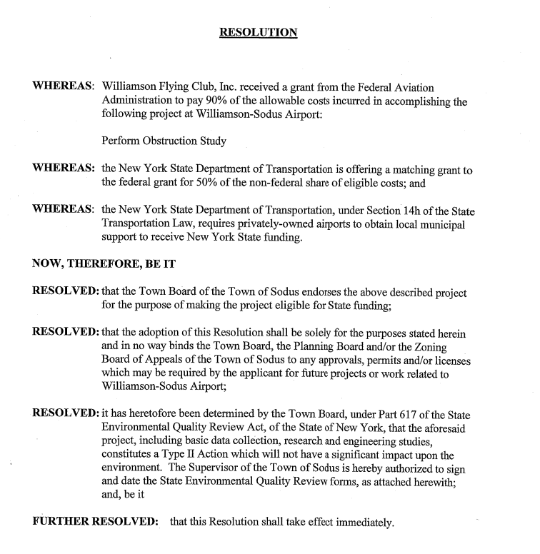
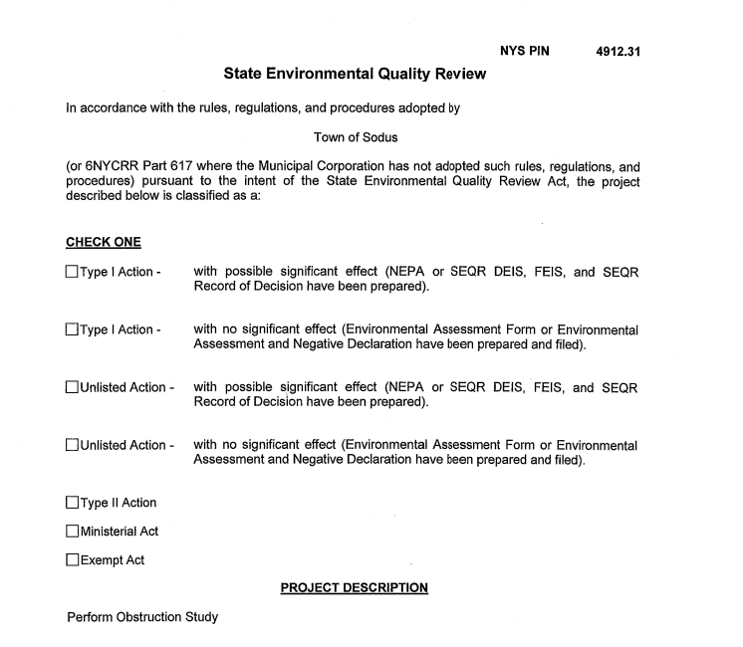

NOW BE IT RESOLVED, Councilperson David LeRoy motioned to approve this resolution was seconded by Councilperson Don Ross. Upon roll call the following votes were heard, Steven LeRoy, aye; David LeRoy, aye; Quinn, aye; Ross, aye. Resolution adopted.

Supervisor LeRoy discussed with the public attending for the private drives, the Town of Sodus will be able to plow private drives under Section 287 in Town Law. No comments were made from the public.

Councilperson Jim Quinn motioned to pass Local Law No. 1-2017 was seconded by Councilperson David LeRoy. Upon roll call the following votes were heard, Supervisor Steven LeRoy, aye; Councilperson LeRoy, aye; Quinn, aye; and Ross, aye. Local Law passed.

Lengthy discussions of the 2018 Town of Sodus Budget took place.

Councilperson Jim Quinn motioned to adjourn the meeting was seconded by Councilperson David LeRoy. Upon roll call the following votes were heard, Supervisor Steven LeRoy, aye; Councilperson LeRoy, aye; Quinn, aye; and Ross, aye. Motion carried.
Meeting adjourned at 8:20 p.m.
Recording Secretary,

Lori Diver
Sodus Town Clerk, RMC

